MAY NEWSLETTER
May is such a FUN month! Children are getting out of school for the summer, some are graduating, mothers are celebrating their special day, remembering those that lost their life while defending our country and so much more….

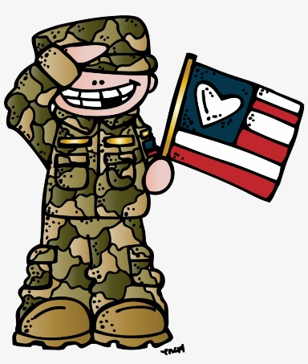

May is so lovely. It’s a month of flowers, beauty, and celebrations. May is home to amazing moments in history, birthdays of some of our favorite celebs, and so much more! So, sit back, relax, and let’s celebrate this amazing month!

Did you know?
- Blue jeans were official invented in May of 1873 after Levi Strauss and Jacob Davis obtained a patent for the pants on May 20th.
- The birthstone for May is the emerald which represents love and success.
- The zodiac signs for May are Taurus (April 20-May 20) and Gemini (May 21-June 20).
- The birth flower for May is Lily of the Valley.
- The month May was named for Maia, the Greek goddess of fertility.
- May was once considered a bad luck month to get married. There is a poem that says “Marry in May and you’ll rue the day.”
- May is the month of autumn in the Southern Hemisphere, and spring in the Northern Hemisphere.
Historical moments of May
- The Empire State Building opened on May 1, 1931.
- Minnesota was admitted to the Union on May 11, 1858.
- On May 14, 1804, Lewis and Clark began their trip up the Missouri River.
- The first regular airmail service in the United States began May 15, 1918.
- During the civil war, Abraham Lincoln signed the Homestead Act on May 20, 1862.
- On May 20, 1932 Amelia Earhart flew across the Atlantic Ocean, marking the first solo flight by a woman.
- South Carolina became the 8th state on May 23, 1788.
- The first permanent English settlement in America was established on May 24, 1607 in Jamestown, VA.
- San Francisco’s beautiful Golden Gate Bridge opened May 27, 1937.
- Rhode Island became the 13th state on May 29, 1790.
- On May 29, 1848, Wisconsin became the 30th state.
Special days of May
- May is ALS Awareness Month.
- May is also Better Hearing & Speech Month.
- May is National Stroke Awareness Month.
- May is host to Nurse Appreciation Week.
- The Kentucky Derby is the first Saturday in May.
- Star Wars Day is celebrated on May 4, as in May the Fourth be with You!
- Cinco de Mayo is celebrated every May 5th.
- Mother’s Day is celebrated the second Sunday of the month.
- Armed Forces Day is the third Saturday of May
- Sally Ride Day is May 26th.
- Memorial Day is celebrated the last Monday of the month.

Mother's Day is a celebration honoring the mother of the family or individual, as well as motherhood, maternal bonds, and the influence of mothers in society. It is celebrated on different days in many parts of the world, most commonly in the months of March or May. It complements similar celebrations, honoring family members, such as Father's Day, Siblings Day, and Grandparents' Day.
While some countries have a multi-century history of a day to celebrate mothers, the modern American version of the holiday began in the United States in the early 20th century at the initiative of Anna Jarvis, who organized the first Mother's Day service of worship and celebration at Andrews Methodist Episcopal Church in Grafton, West Virginia, which serves as the International Mother's Day Shrine today. It is not directly related to the many traditional celebrations of mothers and motherhood that have existed throughout the world over thousands of years, such as the Greek cult to Cybele, the mother deity Rhea, the Roman festival of Hilaria, or the other Christian ecclesiastical Mothering Sunday celebration (associated with the image of Mother Church). However, in some countries, Mother's Day is still synonymous with these older traditions.
The American version of Mother's Day has been criticized for having become too commercialized. Jarvis herself, who began the celebration as a liturgical observance, regretted this commercialism and expressed that this was never her intention. In response, Constance Adelaide Smith successfully advocated for Mothering Sunday as a commemoration of a broader definition of motherhood in many other parts of the English-speaking world.

Congratulations to the Class of 2023!!!

Originally called Decoration Day, from the early tradition of decorating graves with flowers, wreaths and flags, Memorial Day is a day for remembrance of those who have died in service to our country. It was first widely observed on May 30, 1868 to commemorate the sacrifices of Civil War soldiers, by proclamation of Gen. John A. Logan of the Grand Army of the Republic, an organization of former Union sailors and soldiers.
During that first national commemoration, former Union Gen. and sitting Ohio Congressman James Garfield made a speech at Arlington National Cemetery, after which 5,000 participants helped to decorate the graves of the more than 20,000 Union and Confederate soldiers who were buried there.
This national event galvanized efforts to honor and remember fallen soldiers that began with local observances at burial grounds in several towns throughout the United States following the end of the Civil War, such as the May 1, 1865 gathering in Charleston, South Carolina organized by freed slaves to pay tribute and give proper burial to Union troops.
In 1873, New York was the first state to designate Memorial Day as a legal holiday. By the late 1800s, many more cities and communities observed Memorial Day, and several states had declared it a legal holiday.
After World War I, it became an occasion for honoring those who died in all of America’s wars and was then more widely established as a national holiday throughout the United States.

In 1971, Congress passed the Uniform Monday Holiday Act and established that Memorial Day was to be commemorated on the last Monday of May. Several southern states, however, officially commemorate an additional, separate day for honoring the Confederate war dead, sometimes referred to as a Confederate Memorial Day: January 19 in Texas; third Monday in Jan. in Arkansas; fourth Monday in Apr. in Alabama and Mississippi; April 26 in Florida and Georgia; May 10 in North and South Carolina; last Monday in May in Virginia; and June 3 in Louisiana and Tennessee.
Memorial Day is commemorated at Arlington National Cemetery each year with a ceremony in which a small American flag is placed on each grave. Traditionally, the President or Vice President lays a wreath at the Tomb of the Unknown Soldier. About 5,000 people attend the ceremony annually.

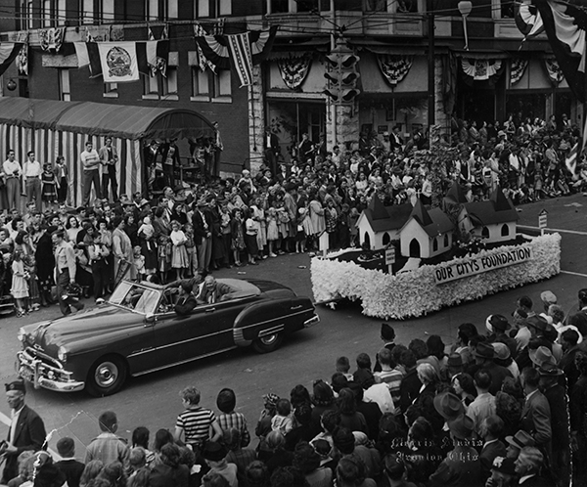
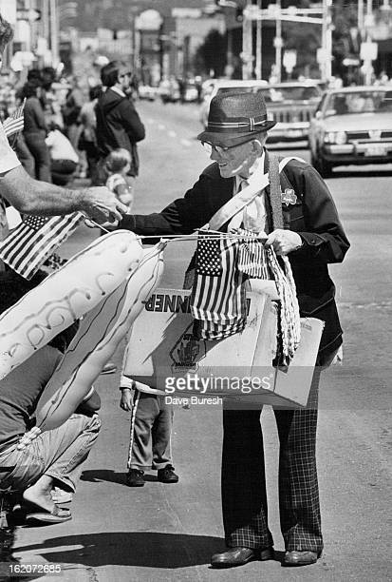
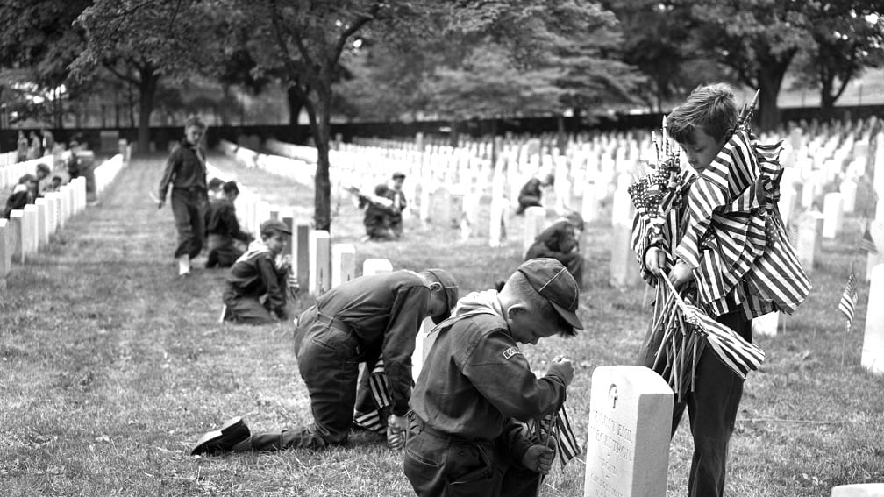

LOCAL NEWS
- Are you in need of grocery delivery service? Call 620-228-5570 for more information on this new service.

- La Harpe Days T-Shirts available at City Hall.

- This just in…. the library is getting 2 new computers that will be accessible while visiting the library. We are also looking for a person that would like to volunteer their time a couple of days to help in the library. Library hours are Month thru Friday, 8:00-12:00pm and 1:00pm- 5:00pm.

If you need assistance after-hours please call the Iola Dispatch Center at (620) 365-1437, they will notify the proper personnel.
HAPPY BIRTHDAY TO ALL LAHARPE CITIZENS CELEBRATING A BIRTHDAY THIS MONTH!!!! MAY YOUR DAY BE AS SPECIAL AS YOU ARE TO US!

TO ALL CITIZENS IN LA HARPE
It is in the city ordinance that you are not to blow your grass in the street. If you happen to get grass in the street, I’m asking you to blow or sweep the grass back into your yard or you will receive a Notice to Appear in Court. That will be an $80.00 court cost and whatever the Judge fines you. Please don’t blow grass in the street when you mow or at any time.
If you have any questions, please contact us by phone (620) 496-2241 here at City Hall.

Sincerely,
Animal and Code Officer

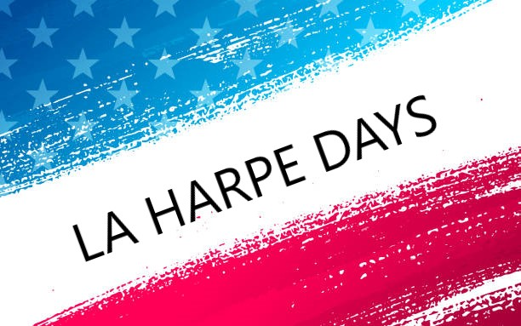
La Harpe Days will be sponsoring a dart tournament April 22nd at city hall from 6:00pm-8:30pm. Free admission to watch and concessions will be available.
Follow us on Facebook for other events – La Harpe Days
ACTIVITIES FOR THE MONTH:
May 2nd
TOPS (Take Off Pounds Sensibly) 6:00pm

May 9th
Yoga 5:30pm – 6:00pm

May 16th
TOPS (Take Off Pounds Sensibly) 6:00pm

May 23rd
Yoga 5:30pm – 6:00pm
TOPS (Take Off Pounds Sensibly) 6:00pm

May 26th
Schools out! Snow cones @ 2:00pm at City Hall

May 30th
TOPS (Take Off Pounds Sensibly) 6:00pm

This will be the last month for TOPS if more people don’t come.

You can follow our health & wellness director on Facebook: La Harpe Health & Wellness. Kathy will share weekly brain teasers, hygiene facts and healthy quick meals. Don’t have access to Facebook, please let us know and we will find a way to get you the information.

City of LaHarpe City Wide Garage Sales
June 10th
To be added to the list you must sign-up at city hall by 5:00 pm on
June 2nd
These lists will be available June 6th and may be picked up at the post office or the City Hall.

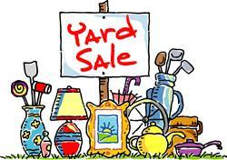

June 22, 2023
You must sign-up at city hall before 5:00 pm on
Monday, June 19th to schedule your pickup.
We need name, address, and list of items you want picked up.

No tires, batteries, household trash or items with Freon.

Items must be out by the road by 8:00 a.m. Thursday, June 22nd.
Please keep items separated in corresponding piles.

Dates to remember:
May 10th: Council Meeting at City Hall at 7:00 pm

May 15th: PRIDE Meeting at 7:00 p.m. at the City Hall

May 25th: Past due Utility shut off date.
If you can’t pay your account in full at this time then you must submit your reasoning to the City Clerk BEFORE May 25th.

May 29th: City Hall closed in observance of Memorial Day

CITY COUNCIL NEWS

CITIZENS CALL FOR BUSINESS
- Angela Barker asked if a variance could be given for filling pools. Mayor Crowell stated, we are looking at that and if anything changes, we will let you know.
- Sunshine Jones requested a variance for 2 goats. Mayor Crowell asked how many she had, she stated 2 goats on about 2 1/2 lots and they are fenced in. Austin Lee expressed concerns with the property being so close to Main Street. Penny Miller stated, there have been no problems with the goats. Danny Ware Jr recommended looking at the property before granting a variance and look at this again in May.

UNFINISHED BUSINESS
- No unfinished business discussed.

NEW BUSINESS
- Bids on vandalism at city hall – Home Renovations submitted a bid in the amount of $9,010.00. Mayor Crowell stated they would be done before the end of May. Austin Lee made the motion to accept the bid only if the insurance company paid the difference. Sharlyn Thompson seconded. Motion carried 4-0.
- Sewer reserve fund – Mayor Crowell asked the council how they wanted to pay for the lids and risers, stating we have the loan we can use and also there are a couple of grant options that we are looking into as well. Danny Ware Jr made the motion to take $15,000.00 out of special highway and the other $55,060.75 out of the electric fund. Sharlyn Thompson seconded. Motion carried 4-0.
- Water rate ordinance – Danny Ware Jr made the motion to adopt ordinance #1795, raising the city water rates. Cynthia Carr seconded. Motion carried 4-0.
- Property Tax Sale – Mayor Crowell stated everyone should have a copy of the La Harpe properties that will may be on the tax sale June 8th. She suggested the city try to acquire 811 S. Washington since it is next to our buildings and it would give us more room for our equipment. Mayor Crowell directed the council to look over the list and if there are other properties you would like to acquire, bring it to the next meeting in May.

REPORTS OF CITY OFFICERS
- Fred Works, City Attorney – Nothing to report

- Roy Caler, Water Representative – Nothing to report

- Joe Stotler, Police Chief – Shared his monthly time cards and report.

- Penny Miller, Code/Animal Control – Shared her monthly reports. Penny shared a resolution to condemn a property on McKinley. Austin Lee made the motion to adopt resolution #2023-3. Sharlyn Thompson seconded. Motion carried 4-0.

- Marc Waggoner, Fire Chief- Shared the meeting minutes: The La Harpe Volunteer Fire Department met for the monthly meeting. Marc Waggoner and Bill Gay took an 8-hour class with KSU on grain entrapment training, which we will train the other firefighters on the grain entrapment training. Also, Luke Chenowith was dismissed because of lack of attendance at meetings and fires. Marc asked the council to think about purchasing a grain rescue bin, stating they run about $4,000.00. Mayor Crowell asked if he had been looking into grant options for a new truck. She suggested to keep looking and get with Marcia Davis. Danny ware Jr asked how the work on the broken fire hydrants was going. Marc stated, they have been working on them.

- Maintenance Department –The workorders were shared. Mayor Crowell mentioned, Dereck is doing great and going forward every other class will be hands on.

- Michelle Altis, City Clerk – Nothing to report

Mayor: Ella Mae Crowell (620) 496-6219
City Attorney: Fred Works
City Municipal Judge: Patty Miklos
Police Chief: Joseph Stotler
Fire Chief: Marc Waggoner
Assistant Fire Chief: Dennis Sidebottom
City Clerk: Michelle Altis
Assistant Clerk: Teresa Driskel
City Treasurer: Audra Riggins
Maintenance Staff: Dereck Ranes, Larry Laird & Gentry Dougherty
Code & Animal Control: Penny Miller

City Council Members:
Austin Lee (496-2323) Danny Ware Jr. (496-2156)
Cynthia Carr (496-7500) Sharlyn Thompson (496-3348)
Ron Knavel (496-2508)
Laharpe City Hall Hours: Monday-Friday
902 S. Washington 8:00-12:00 & 1:00-5:00
P.O. Box 10 Ph. (620) 496-2241
Laharpe, KS. 66751 Fax (620) 496-2240
CHECK OUT OUR WEBSITE; CITYOFLAHARPE.ORG Follow us on Facebook – City of La Harpe

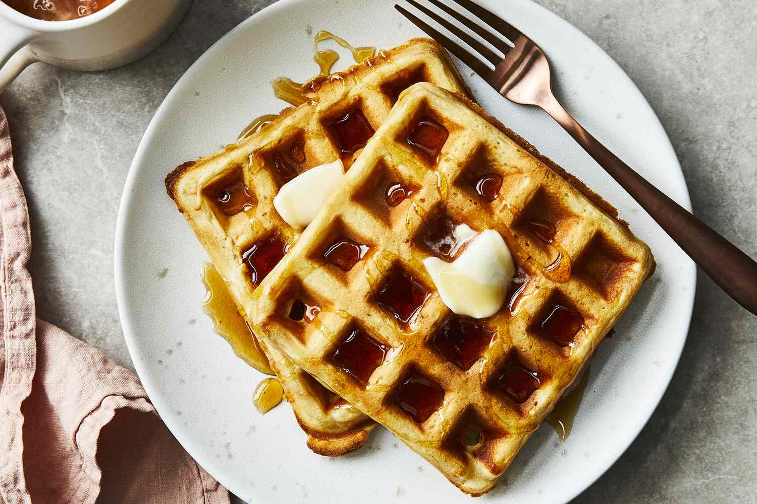

Classic Waffles

Ingredients

2 cups all-purpose flour

1 teaspoon salt

4 teaspoons baking powder

2 tablespoons white sugar

2 eggs

1 ½ cups warm milk

⅓ cup butter, melted

1 teaspoon vanilla extract

Directions

Step 1 Gather all ingredients.

Step 2 In a large bowl, mix together flour, salt, baking powder and sugar; set aside. Preheat waffle iron to desired temperature.

Step 3 In a separate bowl, beat the eggs. Stir in the milk, butter and vanilla. Pour the milk mixture into the flour mixture; beat until blended.

Step 4 Ladle the batter into a preheated waffle iron. Cook the waffles until golden and crisp. Serve immediately

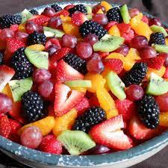

Fruit Salad

Ingredients

Sauce:

⅔ cup fresh orange juice

⅓ cup fresh lemon juice

⅓ cup packed brown sugar

½ teaspoon grated orange zest

½ teaspoon grated lemon zest

1 teaspoon vanilla extract

Salad:

2 cups cubed fresh pineapple

2 cups strawberries, hulled and sliced

3 kiwi fruit, peeled and sliced

3 bananas, sliced

2 oranges, peeled and sectioned

1 cup seedless grapes

2 cups blueberries

Directions

Step 1 For the sauce: Bring orange juice, lemon juice, brown sugar, orange zest, and lemon zest to a boil in a saucepan over medium high heat. Reduce heat to medium-low and simmer until slightly thickened, about 5 minutes. Remove from heat and stir in vanilla extract. Set aside to cool.

Step 2 For the salad: Layer fruit in a large, clear glass bowl in this order: pineapple, strawberries, kiwi fruit, bananas, oranges, grapes, and blueberries. Pour cooled sauce over fruit; cover and refrigerate for 3 to 4 hours before serving

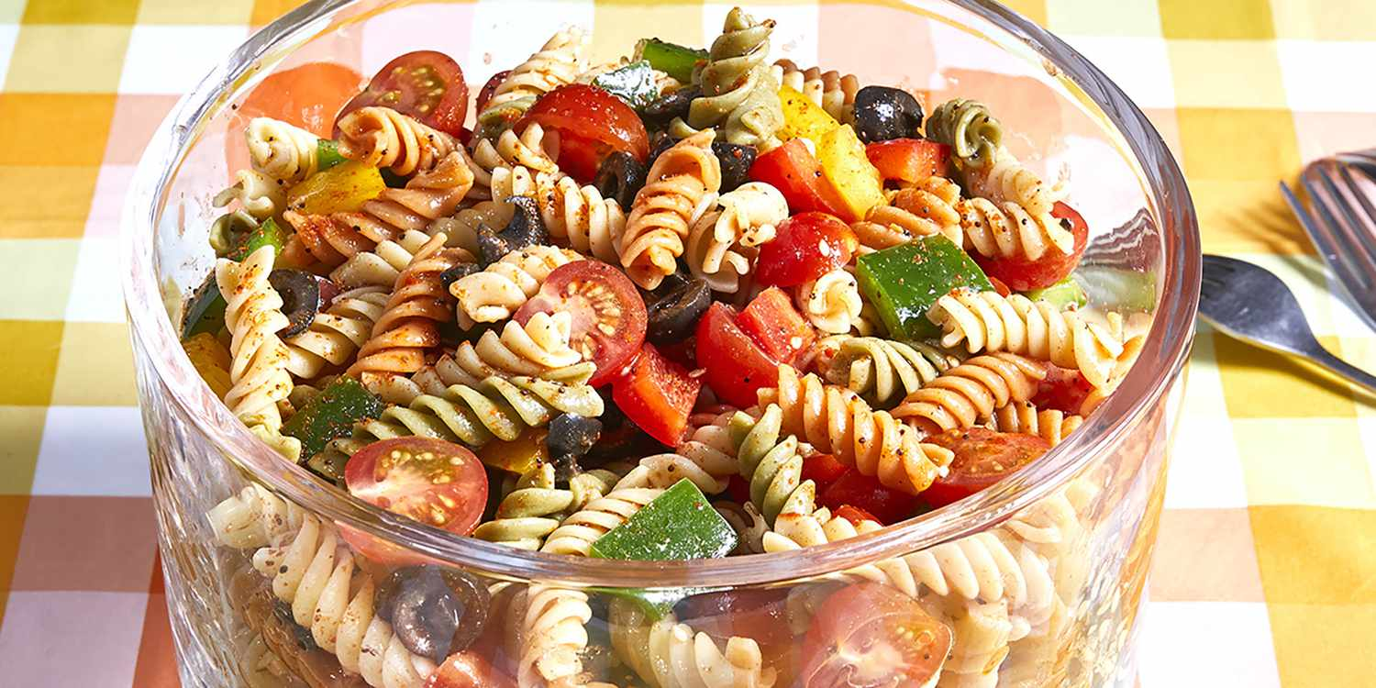
Pasta Salad
Ingredients
1 pound tri-colored spiral pasta
1 (16 ounce) bottle Italian-style salad dressing
6 tablespoons salad seasoning mix
2 cups cherry tomatoes, diced
1 green bell pepper, chopped
1 red bell pepper, diced
½ yellow bell pepper, chopped
1 (2.25 ounce) can black olives, chopped

Directions
Step 1 Gather all ingredients.
Step 2 Bring a large pot of lightly salted water to a boil. Cook pasta in the boiling water, stirring occasionally, until tender yet firm to the bite, about 10 to 12 minutes; rinse under cold water and drain.
Step 3 Whisk Italian dressing and salad spice mix together until smooth. Combine pasta, tomatoes, bell peppers, and olives in a salad bowl.
Step 4 Pour dressing over salad and toss to coat.
Step 5 Refrigerate salad, 8 hours to overnight

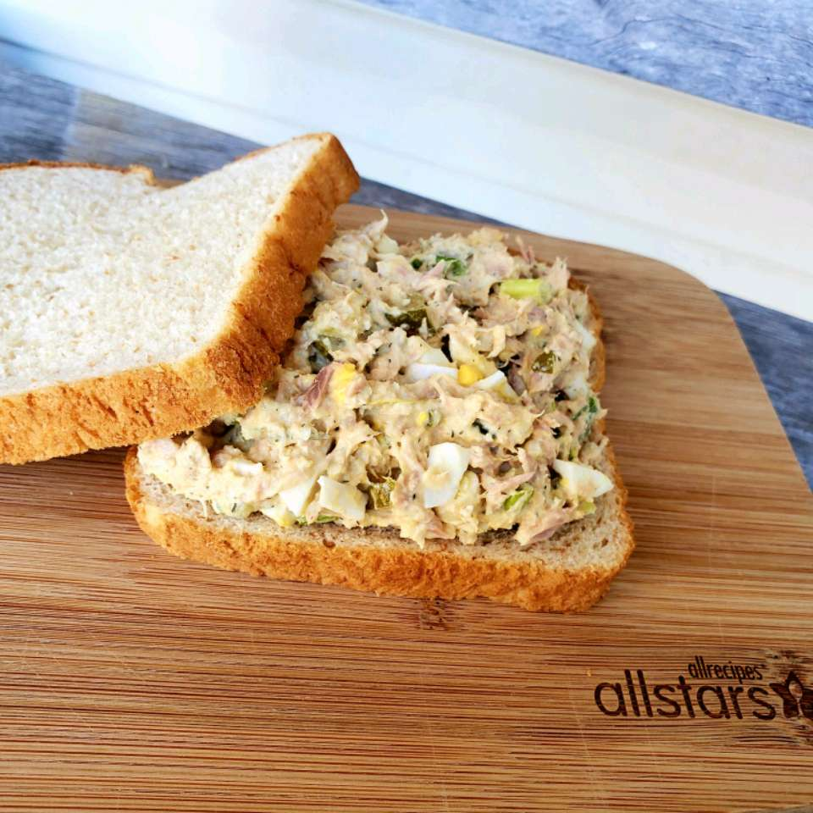

Best Ever Tuna Salad
Ingredients
2 eggs
2 (5 ounce) cans tuna, drained
1 (6 ounce) can crabmeat, shredded
½ cup mayonnaise
1 teaspoon sour cream
1 teaspoon yellow mustard
½ teaspoon dried dill weed
⅛ teaspoon lemon pepper
2 tablespoons dill pickle relish
2 tablespoons sweet pickle relish
¾ cup finely chopped onion

Directions
Step 1 Place eggs in a saucepan and cover with cold water. Bring water to a boil and immediately remove from heat. Cover and let eggs stand in hot water for 10 to 12 minutes. Remove from hot water, cool, peel, and chop finely.
Step 2 In a mixing bowl, combine tuna, crabmeat, mayonnaise, sour cream, and mustard. Stir in chopped egg, dill weed, lemon pepper, dill, sweet relish, and chopped onion. Mix thoroughly

