JUNE NEWSLETTER
The month of June is known as the time schools let out for the summer, and June 20, 21, or 22 (depending on the year) is the longest day of the year with the most daylight hours in the Northern Hemisphere.

Juno is the ancient Roman goddess of marriage and childbirth. And the month of June is still a popular month for weddings today! As a natural extension of marriage, Juno was also the goddess of childbirth. Another interpretation of the origins of “June” says that the name came from the Latin juvenis, “young people,” who were celebrated at this time.
Juno, in Roman religion, was the chief goddess and female counterpart of Jupiter, similar to the relationship between the Greek Hera and Zeus. Perhaps not surprisingly, given her role of protector of women and children, this powerful queen of the gods was also considered the fierce protector and special counselor of the state and a guardian angel warning those in times of danger.

The Full Strawberry Moon
June’s full Moon, the full Strawberry Moon, occurs on Saturday, June 3. It reaches peak illumination at 11:43 P.M. (EDT) that morning.

Why Is It Called the Strawberry Moon?
The full Moon names used by The Old Farmer’s Almanac come from a number of places, including Native American, Colonial American, and European sources. Historically, names for the full or new Moons were used to track the seasons. Today, we think of Moon names as “nicknames” for the Moon.
June’s full Moon—typically the last full Moon of spring or the first of summer—has traditionally been called the Strawberry Moon. While strawberries certainly are a reddish-pink color and are roundish in shape, the origin of the name “Strawberry Moon” has nothing to do with the Moon’s hue or appearance, despite the evocative imagery (shown in the artist rendering below). A Moon usually appears reddish when it’s close to the horizon because the light rays must pass through the densest layers of atmosphere.
Many Americans celebrate Flag Day by displaying the Red, White and Blue in front of homes and businesses. The day commemorates the adoption of the Stars and Stripes as the official flag of the United States.

While Father's Day is celebrated annually on the third Sunday in June, it doesn't always land on the exact same date. For example, Father's Day falls on Sunday, June 18, this year, but last year it was celebrated on June 19. Looking ahead, Father's Day will arrive a few days early in 2024, falling on Sunday, June 16.
Father’s Day is that one special day every year to celebrate the fathers in your life. It can look different for everyone, whether you’re celebrating your father, spouse, step-father, brother, or a role model.
Finding things to do for Father’s Day can be difficult. If you’re having a hard time thinking of something, try some of the ideas below. Or, use them to get started as you look for ways to honor and celebrate the men in your life!
Fun things to do with your father; learn about his family tree (you may find some very interesting facts), take him fishing, plan a BBQ, a good game of golf might be nice, a camping trip, maybe a trip to a ball game or even a good movie. Whatever you choose to do with your father, enjoy this special day made just for him and show him how much he is loved and appreciated!
In 2023, the first day of summer is Wednesday, June 21. The first day of summer is also known as the summer solstice, and it will arrive in the Northern Hemisphere at exactly 10:58 a.m. EST.
There is something about summer that just brings the life out of us, isn’t there? Well, those sun-filled, warm-breeze days are here with us yet again (thank goodness) and of course you will be looking for fun summer activities and things to do.
Besides sunbathing, walking around in those cute sun dresses and letting the sand run through your toes (if you are lucky enough to be at the beach), there are several other fun ideas to add to your summer bucket list.
Go to an amusement park, leap off a rope swing, try a new restaurant, attend a concert, ride a Ferris wheel, have a picnic, take a road trip, go to a beach, ride a hot air balloon, the possibilities would be endless! What ever you choose to do with your summer, make the most of it and enjoy spending time with those you choose. Have fun but don’t forget the sunscreen!!!

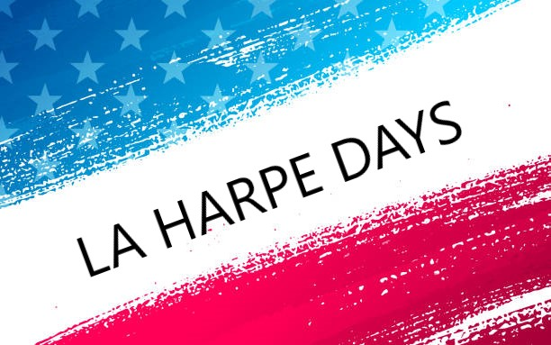
La Harpe Days will be sponsoring a dart tournament June 3rd at city hall from 6:00pm-8:30pm. Anyone is welcome to come play, it costs $10.00 a person to join the tournament. Free admission to watch and concessions will be available.
Follow us on Facebook for other events – La Harpe Days

EFFECTIVE JUNE 26, 2023
Past due utility accounts will be handled differently on shut off day. If payment in full, of your past due utility account, is not in office the day before shut off/ disconnection you will be assessed a $50.00 penalty per meter. If you come in to pay on the day of shut off/disconnection, you will be required to pay the $50.00 per meter penalty as well. If you cannot afford to pay the extra penalty, then it will be added to your utility account and you will be required to pay in full the following month. If your utilities are shut off/disconnected due to no payment, they will not be restored until the utility account is paid in full of the past due balance plus any added penalty. If you have questions, contact City Hall (620)496-2241.

LOCAL NEWS

- 2023 La Harpe Days T-Shirts available at City Hall.

- CCR Report available at http://krwa.net/ccr/LaHarpe and www.cityoflaharpe.org

- This just in…. the library is getting 2 new computers that will be accessible while visiting the library. We are also looking for a person that would like to volunteer their time a couple of days to help in the library. Library hours are Month thru Friday, 8:00-12:00pm and 1:00pm- 5:00pm.

If you need assistance after-hours please call the Iola Dispatch Center at (620) 365-1437, they will notify the proper personnel.
HAPPY BIRTHDAY TO ALL LAHARPE CITIZENS CELEBRATING A BIRTHDAY THIS MONTH!!!! MAY YOUR DAY BE AS SPECIAL AS YOU ARE TO US!

TO ALL CITIZENS IN LA HARPE
It is in the city ordinance that you are not to blow your grass in the street. If you happen to get grass in the street, I’m asking you to blow or sweep the grass back into your yard or you will receive a Notice to Appear in Court. That will be an $80.00 court cost and whatever the Judge fines you. Please don’t blow grass in the street when you mow or at any time.
If you have any questions, please contact us by phone (620) 496-2241 here at City Hall.

Sincerely,
Animal and Code Officer

City of LaHarpe City Wide Garage Sales
June 10th
To be added to the list you must sign-up at city hall by 5:00 pm on
June 2nd
These lists will be available June 6th and may be picked up at the post office or the City Hall.

June 22, 2023
You must sign-up at city hall before 5:00 pm on
Monday, June 19th to schedule your pickup.
We need name, address, and list of items you want picked up.

No tires, batteries, household trash or items with Freon.

Items must be out by the road by 8:00 a.m. Thursday, June 22nd.
Please keep items separated in corresponding piles.

Grab your family, friends, neighbors, whoever is interested in a good time and plan on attending La Harpe Days 2023!!!
The committee has been working hard to make this event the best ever! Show them your appreciation and join in on the fun!
We have activities for all ages: Carnival, yard games, BINGO, horseshoes, cornhole, 3k/5k run or walk, car show, pony pull and much, much more!
Hope to see you at La Harpe Days 2023!!!
Get around with ease! The parade will start at 6th & Main!
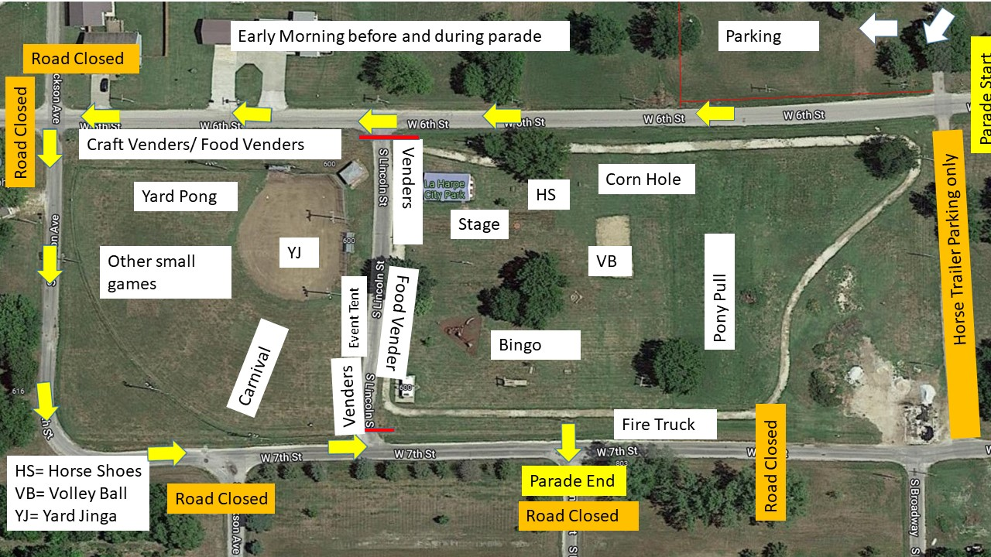
Early morning before & during parade!
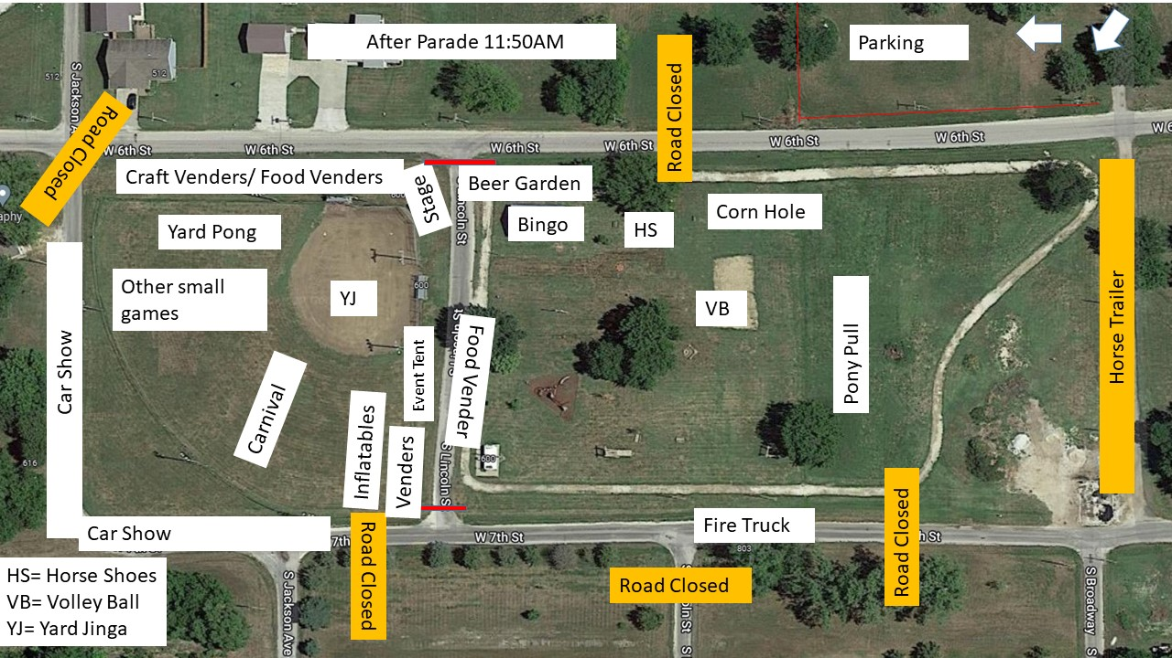
After Parade!
Dates to remember:
June 14th: Council Meeting at City Hall at 7:00 pm

June 19th: City Hall closed for the holiday

June 19th: PRIDE Meeting at 7:00 p.m. at the City Hall

June 24th: At the city park beginning at 10:00am!

June 27th: Past due Utility shut off date.
If you can’t pay your account in full at this time then you must submit your reasoning to the City Clerk BEFORE June 26th.

CITY COUNCIL NEWS
CITIZENS CALL FOR BUSINESS
- Angela Barker asked where the council was on her variance request for filling her swimming pool. Mayor Crowell stated, the issue has not been addressed yet.
- Harry Lee – addressed the council with an incident that happened at the park. Harry shared some history of the park and wanted to explain how things got the way they are today. The ball diamond use to be a track for the high school, with city approval we put up poles for ball diamond. He stated the park improvements have come from the community, not the city. The bleachers and fence were gifted to the city, the shelter house was built by the La Harpe Lions Club, the center of the park has a nice pole with cameras just need electric to run the cameras. Harry stated, Pride installed the pole and electric for the cameras. Many families come to enjoy the park; Harry stated. There was also a group of volunteers that installed the playground equipment and citizens have tried to maintain what was there. The public built the concession stand, Pride members doing restoration work to keep the park up. Ed Hoover mowed the park for a number of years and picked up trash throughout the park until his health started to decline. Harry shared a number of photos from the community doing/working on restoration of the park and facilities, one of them being 2 local residents painting the fence around the park. Another added feature, brought to the park by the community, is the zipline. With the help of others, the zipline was constructed and built by Ridge Barney which helped him earn a badge in eagle scouts. Harry stressed; none of these facilities were prompted by the city saying, “we need this”, the park is a great park because the community has pitched in to help the city. Then restoration started of the sand volleyball court which has been there a number of years. Harry stated, with permission of the governing body, La Harpe Pride set about to restore the volleyball court. Raymond Maloney came down with a track hoe, for it to be useable we dug down and placed a drain and barrier, now when it rains the water won’t sit in a pool, it will drain efficiently. Part of our plan was to get the lights put up, Harry stated he reached out to the Pride members last Wednesday for help to dig the trench for the electricity. Jason Lee, Joyce Lee and myself were all that showed up, and I did not do a locate because I didn’t feel the need to do so. Harry stated, he has done locates in the pass and knew, pretty much, where everything was. Our plan was to dig the trench with the trencher but there were to many bigger rocks, so we closed most of it and placed cones where needed. Harry stated, Pride has installed cement piers to put the lights on, I had to ask the city to help and was told this isn’t the city project. It really bothered me with the attitude, that spirit of cooperation and trying to help get things done doesn’t seem to be there. Harry expressed concerns and asked the council if the city wanted Pride to turn over the remaining materials and have the city finish it. Mayor Crowell stated the city has always been willing to help, the only reason we didn’t help this time was because there was no locate done nor was the city notified of when you would be getting started. She expressed, the crew has been busy with water leaks, fixing electric poles and whatever else needs to be done that they just can’t stop everything they are doing to go help in the park without some sort of notice. Harry stated, this Pride project was for the benefit of the city, the point here, it concerns me with decades of support between the community and the city and now it seems the city doesn’t want to help. Mayor Crowell reminded Harry that the city has dug holes and even offered to get the wire at a discounted price but nothing was ever submitted to the city on what was needed and how much. City attorney, Fred Works mentioned, it puts the city at risk to dig without a locate. Mayor Crowell pointed out, the city’s insurance agent was in the audience and he would probably agree that digging without a locate puts the city at risk. Council member, Sharlyn Thompson, stated; I am a Pride member and I think we all need to work together and the city should have been notified. City clerk, Michelle Altis, asked who is going to get the park back in shape and will it be done before La Harpe Days. Harry stated the pipe is not done but there is not a locate in place. Mayor Crowell stated, David Lee did a locate and it was marked on Monday, the city has not had trouble helping out before but we can’t ask our crew to go against the law and dig with no locate. Harry gave a list of items that needed to be done; pipe which I have, need electric wire, backfill the area and smooth it out, a control box which I also have, this would complete the underground work and then need poles and lights. Mayor Crowell suggested the city contact Harry after they dig the trench so he can put the rest of the pipe in and asked Harry if he was okay with that. Harry responded, that will be fine. Ron Knavel suggested the city needs to help him. Cynthia Carr suggested we start communicating better, this could have all been avoided. Mayor Crowell stated, we will get a work order up and notify you on a date and time that works.

UNFINISHED BUSINESS
- Sunshine Jones variance request – Tabled until the June meeting.
- Property Tax Sale – A list of addresses was provided to the council, Mayor Crowell asked if there were any interest on any of these properties. She stated, I know we want to pursue the one at 811 S. Washington, are there any others. Austin Lee suggested 1012 S. Washington, since it’s across the street from the other 2 lots the city owns. Michelle stated that 406 S. McKinley had 3 lots that but up against the 2 lots the city already owns. Mayor Crowell suggested they sit a price. Cynthia Carr made the motion to allocate the $5,220.00 we just received. Danny ware Jr seconded and suggested the mayor attend the sale on June 8th. Motion carried 5-0.

NEW BUSINESS
- Sewer Snake – Mayor Crowell expressed concerns, stating over the last 2 or 3 months we have spent almost $600.00 in callouts to snake out the sewer and we can buy our own for a little over $500.00. Danny ware Jr suggested a diaphragm before buying a snake, he expressed concerns about someone getting hurt if they don’t know how to use them. Gentry Dougherty stated he had used the snake machines before and we also had a sewer backup at the park. Harry Lee offered his expandable diaphragm if the city wanted to try it out. Danny Ware Jr made a motion for the city to buy a wet vac for water clean ups and 100’ hose. Austin Lee seconded. Motion carried 5-0.
- Office Printer – Michelle shared pricing for a back and white printer from copy products; $1,295.00 and one from Modern Copy; $1,216.00. Michelle suggested staying with modern copy because of the service we receive. Danny Ware Jr made the motion to get the new printer from Modern copy. Ron Knavel seconded. Motion carried 5-0.
- Street Whistles – Michelle stated that Dereck was needing six 12”X30’ whistles for about $645.60 each. Ron Knavel made the motion to get the whistles needed. Cynthia Carr seconded. Motion carried 5-0.
- PSI – Loren Korte presented the city with a check, the check from EMC dividend program, in the amount of $5,220.30. He stated this check is 25% of last year’s premium.
- Highway water leak – Mayor Crowell explained what the crew had to do to stop the water from leaking, they had to cap the line. Everyone has water but what that did was get rid of the loop, so when one of those homes have a water leak, we have no way of isolating it to shut off just that house, we will have to shut them all down. Mayor Crowell recommending contracting this job out since the work will be going under the highway. Danny Ware Jr suggested a vac truck to dig out so that we can get the line through the sleeve. Mayor Crowell explained, under the highway is a sleeve that protects the water line and we are needing new pipe to go through that sleeve to fix this leak the right way. Danny Ware Jr suggested Keith Babcock and Gentry Dougherty recommended Dwayne Jarred. Mayor Crowell suggested we get a bid from both and a time frame on when they can start and bring it back in June.
- KDHE Grant Application – Mayor Crowell stated that KDHE has funds to help with our sewer project, I just need a motion to move forward with the application and have Taylor from SEKRPC do the application before June 30th. Austin Lee made the motion to do everything needed to get it submitted before the deadline. Ron Knavel seconded. Motion carried 5-0.
- Lots on Washington – Danny Ware Jr stated that Harry Lee wants to build 4 homes there but the powerline easement is in the way. Danny suggested the city could move the line with the contingency that progress on the homes is started within a year and if not, then Harry will have to reimburse the city. Mayor Crowell stated there is also a sewer main that lays through there as well. Gentry mentioned that line goes from Clayton Carr’s shop on the highway down to the phone company on 6th street. Danny Ware Jr stated he told Harry he would bring it up, and so I have.
- Tax Abatement – Danny Ware Jr was wondering if the abatement was good for anyone. Michelle stated it is good for any homeowner that qualifies, I would have to look at it covering a developer. I’ll check it out and let you know.
- Park – was covered earlier in the meeting.
- Appointments – Mayor Crowell suggested the following appointments: City clerk, Michelle Altis; City Treasurer, Audra Riggins; City Attorney, Fred Works; Municipal Judge, Patty Boyd; Fire Chief, Marc Waggoner; Police Chief, Joe Stotler, Code Enforcement/Animal Control, Penny Miller; Banks – Piqua, Landmark National, Emprise &Community National Bank; official newspaper, Iola Register. Ron Knavel made the motion to accept all appointments. Sharlyn Thompson seconded. Motion carried 5-0.

REPORTS OF CITY OFFICERS
- Fred Works, City Attorney – Nothing to report. Will visit with council in the executive session.

- Roy Caler, Water Representative – Nothing to report

- Joe Stotler, Police Chief – Shared his monthly time cards and report. He also requested a new computer stating the one he has now is a 2016 model that was given to the city from dispatch. He shared a quote from Advantage Computer in the amount of $1,550.00 for setup and transfer of files. He also mentioned the city has been paying Huber & Associates $800.00 a year to use Interpol, after some phone conversations, he was able to get that fee waived every year going forward. Danny Ware Jr made the motion to get a new computer for Joe for $1,550.00. Austin Lee seconded. Motion carried 5-0.

- Penny Miller, Code/Animal Control – Shared her monthly reports. Penny shared a resolution to condemn a property on Harrison. Austin Lee made the motion to adopt resolution #2023-4. Sharlyn Thompson seconded. Motion carried 5-0. The kennel license will be visited with in executive session.

- Marc Waggoner, Fire Chief- Shared the meeting minutes: The LaHarpe Volunteer Fire Department met for the monthly meeting. Present: Matthew Waggoner, Mehan Sparks, Josh Sparks, Mar Waggoner Sr., Bill Gay & Ronald Splector. Had meeting. Took out 359 rural unit tanker and 351 city unit pumper, flushed out two whistles at 202 E. 4th then returned units back to fire station and adjourned meeting. Marc mention that Gentry Dougherty joined the fire department. Marc also asked the council about 10-foot fire rings, stating he think they are way to big. After discussion, the council would like to review the ordinance covering fire pits and burning at the June meeting. Marc also stated, the hydrant at the park will be fixed Saturday and La Harpe Days has asked us to be in the parade and we are also going to bring our water tanker so we can spray the kids without interfering with citizens water pressure.

- Maintenance Department –The workorders and Dereck’s progress report were shared.

- Michelle Altis, City Clerk – Michelle shared with the council a policy on our shut offs, stating we had a few issues last month of some being shut off and then calling to make a payment and when I try to collect the reconnect fee, they said they weren’t shut off, which they were. This policy allows me to add a penalty of $50.00 for each meter service that is shut off. If they come in and pay it on the 25th, they will still have to pay the $50.00 per meter even if they weren’t shut off, If they don’t have the penalty money then it will be added to their utility account and will have to pay it next month. If they get shut off, utilities will not be turned on until the past due bill and the penalty per meter is paid in full.

DISCUSSION ON AGENDA ITEMS –
Mayor Crowell requested an executive session for attorney/client for 30 minutes. Danny Ware Jr made the motion to go into an executive session for attorney/client for 30 minutes with Penny Miller invited. Sharlyn Thompson seconded. Motion carried 5-0.
After returning to regular session, Michelle stated the tax abatement can be submitted by the land owner but after it’s sold, it goes to the property owner but the 10-year abatement does not restart with new owner.
Mayor Crowell reminded the council to come up with a decision on hoofed animals for next month’s meeting. Council would like to look at the animal ordinance.

Mayor: Ella Mae Crowell (620) 496-6219
City Attorney: Fred Works
City Municipal Judge: Patty Miklos
Police Chief: Joseph Stotler
Fire Chief: Marc Waggoner
Assistant Fire Chief: Dennis Sidebottom
City Clerk: Michelle Altis
Assistant Clerk: Teresa Driskel
City Treasurer: Audra Riggins
Maintenance Staff: Dereck Ranes, Larry Laird & Gentry Dougherty
Code & Animal Control: Penny Miller

City Council Members:
Austin Lee (496-2323) Danny Ware Jr. (496-2156)
Cynthia Carr (496-7500) Sharlyn Thompson (496-3348)
Ron Knavel (496-2508)
Laharpe City Hall Hours: Monday-Friday
902 S. Washington 8:00-12:00 & 1:00-5:00
P.O. Box 10 Ph. (620) 496-2241
Laharpe, KS. 66751 Fax (620) 496-2240
CHECK OUT OUR WEBSITE; CITYOFLAHARPE.ORG Follow us on Facebook – City of La Harpe

CHESY BACON AND EGG HASH

Best Ever Banana Bread

Ingredients
- 1-3/4 cups all-purpose flour
- 1-1/2 cups sugar
- 1 teaspoon baking soda
- 1/2 teaspoon salt
- 2 large eggs, room temperature
- 2 medium ripe bananas, mashed (1 cup)
- 1/2 cup canola oil
- 1/4 cup plus 1 tablespoon buttermilk
- 1 teaspoon vanilla extract
- 1 cup chopped walnuts

Directions
- 1. Preheat oven to 350°. In a large bowl, stir together flour, sugar, baking soda and salt. In another bowl, combine the eggs, bananas, oil, buttermilk and vanilla; add to flour mixture, stirring just until combined. Fold in nuts.
- 2. Pour into a greased or parchment-lined 9x5-in. loaf pan. If desired, sprinkle with additional walnuts. Bake until a toothpick comes out clean, 1-1/4 to 1-1/2 hours. Cool in pan for 15 minutes before removing to a wire rack.

Grilled Brown Sugar-Mustard Chicken

Ingredients
- 1/2 cup yellow or Dijon mustard
- 1/3 cup packed brown sugar
- 1/2 teaspoon ground allspice
- 1/4 teaspoon crushed red pepper flakes
- 8 boneless skinless chicken thighs (about 2 pounds)

Directions
- 1. In a large bowl, mix mustard, brown sugar, allspice and pepper flakes. Remove 1/4 cup mixture for serving. Add chicken to remaining mixture; toss to coat.
- 2. Grill chicken, covered, over medium heat or broil 4 in. from heat 6-8 minutes on each side or until a thermometer reads 170°. Serve with reserved mustard mixture.

Deluxe German Potato Salad

Ingredients
- 1/2 pound sliced bacon, diced
- 1 cup thinly sliced celery
- 1 cup chopped onion
- 1 cup sugar
- 2 tablespoons all-purpose flour
- 1 teaspoon salt
- 3/4 teaspoon ground mustard
- 1 cup cider vinegar
- 1/2 cup water
- 5 pounds unpeeled small red potatoes, cooked and sliced
- 2 medium carrots, shredded
- 2 tablespoons minced fresh parsley
- Additional salt, optional

Directions
- 1. In a large skillet, cook the bacon over medium heat until crisp. Remove bacon to paper towels. Drain the skillet, reserving 1/4 cup drippings. Saute celery and onion in drippings until tender.
- 2. In a large bowl, combine the sugar, flour, salt, mustard, vinegar and water until smooth. Add to the skillet. Bring to a boil. Cook and stir for 1-2 minutes until thickened.
- 3. In a large serving bowl, combine the potatoes, carrots and parsley. Drizzle with sauce and stir gently to coat. Season with additional salt if desired. Crumble bacon; sprinkle on salad. Serve warm. Refrigerate leftovers.

Spectacular Overnight Slaw

Ingredients
- 1 medium head cabbage, shredded
- 1 medium red onion, thinly sliced
- 1/2 cup chopped green pepper
- 1/2 cup chopped sweet red pepper
- 1/2 cup sliced pimiento-stuffed olives
- 1/2 cup white wine vinegar
- 1/2 cup canola oil
- 1/2 cup sugar
- 2 teaspoons Dijon mustard
- 1 teaspoon salt
- 1 teaspoon celery seed
- 1 teaspoon mustard seed

Directions
- 1. Combine cabbage, onion, peppers and olives. In a large saucepan, mix remaining ingredients; bring to a boil. Cook and stir 1 minute. Pour over vegetables, and stir gently. Cover and refrigerate overnight. Mix well before serving.

