NOVEMBER NEWSLETTER
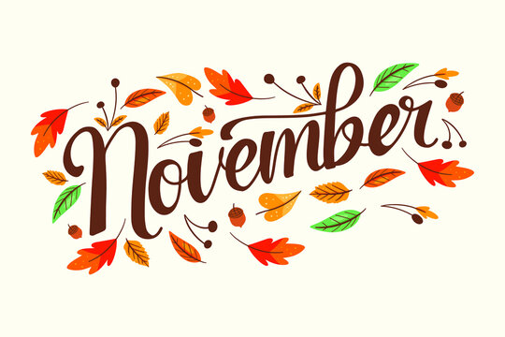
November is such a lovely month…. daylight savings time changes, elections take place, our Veterans get their day of remembrance and families gather for a Thanksgiving feast!

FUN FACTS ABOUT NOVEMBER
- Novem is the Latin word for
- November’s full Moon is traditionally called the Beaver Moon. This was based on the month that beaver traps were set before winter in the colonial era.
- November's traditional birthstone is the topaz which is a symbol of honor and strength.
- There is weather lore associated with every month. A few of the November weather folklore
  - A heavy November snow will last until April.
  - November take flail; let ships no more sail.
  - If there’s ice in November that will bear a duck, there’ll be nothing after but sludge and muck.
  - There is no better month in the year to cut wood than November.
  - Ice in November brings mud in December.
- Some famous people whose birthdays are in November include - Mark Twain, Matthew McConaughey, Leonardo DiCaprio, Ryan Gosling, Jimmy Kimmel, Whoopi Goldberg, Owen Wilson, Scarlett Johansson, Miley Cyrus, and Ben Stiller.

~~~~~~~~~~~~~~~~~~~~~~~~~~~~~~~~~~~~~~~~~~~~~~~~~~~~~~~~~~~~~~~~~~

Daylight savings time ends November 5th, don’t forget to set your clocks back and change the batteries in your smoke detectors.
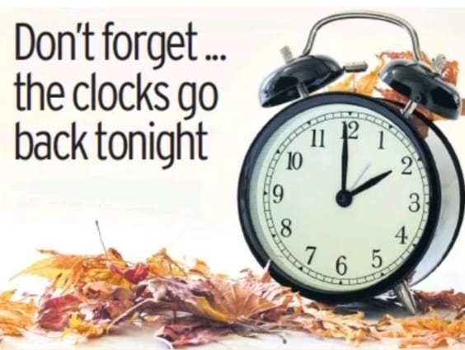
It doesn't matter if you live in a northern, central, or southern state—the end of summer is a sad time indeed. And then it happens just a few weeks after the fall equinox: On the first Sunday of November, our post-work sunlight dwindles down to a few precious hours (that is, if you're working a 9-to-5 job).

What is Daylight Saving Time?
Daylight Saving Time is a way to conserve energy by utilizing more hours of sunlight as a natural source. The timeframe in which the sun rises and sets already depends on the season we're in. So, moving the clock forward an hour in the spring from Standard time to DST is a way to do that. Likewise, moving the clock backward from DST to Standard Time in the fall, heading into the winter, has a counter-impact, allowing us to adapt to the new season. This method was introduced to the U.S. in 1918, initially being deemed "fast time." Now being used for more than just one sole purpose, the U.S. is one of 70 countries around the globe to have adapted DST.

Why do we have Daylight Saving Time?
Oh boy, is there a lot here! A few stories prevail about how the United States adopted the time change. Benjamin Franklin wrote an early "proposition" in a 1784 letter to The Journal of Paris, where he suggested the city could save 64,050,000 pounds of candle wax burned if only its citizens would rise with the sun. He also suggested firing cannons in every street as a city-wide alarm clock, so the letter is taken mainly as satire (thank goodness).
In 1916, Germany was the first country to enact Daylight Saving Time to save money on energy costs during WWI; the United States and much of Europe followed suit. Then, comes a slightly chaotic time for Daylight Saving Time in America—the federal law was repealed after the war, reinstated during WWII, and made optional after that war ended. This "choose-your-own-adventure" DST made traveling between states an absolute nightmare. (Who could have seen that coming? 😂)
Finally, in 1966, the federal government passed the Uniform Time Act, which standardized DST for six months, from April to October. It was extended twice more to seven months in 1986, and our current eight months in 2005.
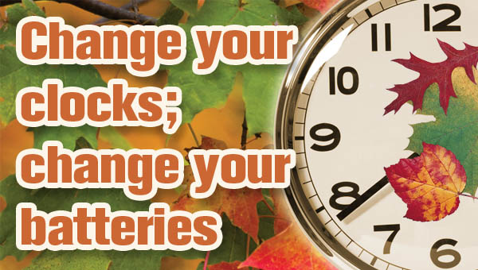

Want to make a difference in your community? Get out and vote! Election day is November 7, 2023.
Some interesting facts and histories about Election Day that you may not know.
- You may be asking, why Tuesday and why November? In the late 1800s, most citizens worked as farmers. Many lived far from their polling place and often had to travel a day or two to vote. November was considered a good time for elections because the busy harvest season was coming to a close.
- Before 1845, the states could hold presidential elections within a 34-day period before the first Wednesday in November. This system was problematic and had some flaws. Communications and transportation had evolved, which could influence votes in different time zones.
- While George Washington was the first president elected into office, the first Election Day took place on November 7, 1848. Whig Party candidate Zachary Taylor won the election becoming the 12th president of the United States.
- Becoming popular in the time of the American Revolution, Election Day Cake consisted of yeasted fruit. While not as popular today, you can find recipes online to make your own.

What Does Veterans Day Mean?
Veterans Day is an important day set aside to honor and show appreciation for ALL who have served in the United States military—in wartime or peacetime, living or deceased.
” We can’t all be heroes; someone has to sit on the curb and clap as they go by.”
—Roy Rogers
In Canada, November 11 is called Remembrance Day. This day, which is more similar to Memorial Day than Veterans Day, honors veterans who have died in service to their country.

What’s the Difference between Veterans Day and Memorial Day?
On both Veterans Day and Memorial Day, it’s customary to spend time remembering and honoring the countless veterans who have served the United States throughout the country’s history. However, there is a distinction between the two holidays:
- Veterans Day is the day set aside to thank and honor ALL who have served, living or deceased, but in particular the living veterans among us.
- Memorial Day specifically commemorates the men and women who died while serving their country and made the ultimate sacrifice for their country.

A Short History of Veterans Day
Veterans Day was originally called Armistice Day in the United States, commemorating the signing of the agreement that ended World War I at 11:00 A.M., November 11, 1918. President Woodrow Wilson celebrated the first Armistice Day in 1919.
In 1938, November 11 became a legal holiday by an act of Congress.
In 1954, this federal holiday was changed from “Armistice” to “Veterans” Day.
Although this holiday initially honored those who perished in service to their country, when the holiday’s name was changed to Veterans Day, it became a day to honor ALL the men and women who have served in the armed forces of the United States.
Each year, special ceremonies are held at Arlington National Cemetery in Virginia.
To all veterans and to your families: Thank you for your courage and your sacrifice.
Happy Veterans Day!

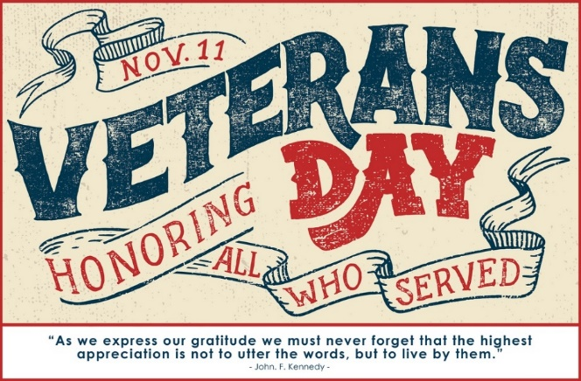

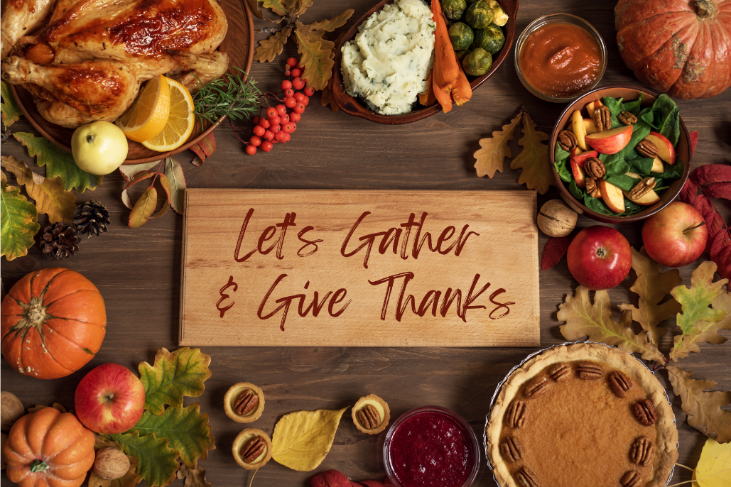
Thanksgiving falls on Thursday, November 23, 2023. Knowing the date year after year might sound tricky, but it could be easier to remember it like this: Thanksgiving always falls on the fourth Thursday of November! Also, a good fact to note is that the absolute latest Thanksgiving can occur is on the 28th of November, while the earliest it could occur is on the 22nd.

Why is Thanksgiving on the fourth Thursday of November?
Every year, Thanksgiving falls on the fourth Thursday of November. However, Thanksgiving used to be celebrated on the last Thursday of the month. In 1863, during the Civil War, President Abraham Lincoln gave the Thanksgiving proclamation and asked for Americans to set aside the last Thursday of November as a day of thanksgiving. After that, it became the norm to hold the holiday on that day. However, in the 1930s, there were two years when Thanksgiving fell on the fifth Thursday of November. Business owners complained to President Franklin D. Roosevelt that this would hurt retailers because there was less time to shop for Christmas. To remedy this, Congress passed a law in 1941 that officially made Thanksgiving the fourth Thursday of every November. Whew!
Wishing you are your families a very blessed Thanksgiving. As you give thanks for your meal and your loved ones, please keep those less fortunate in your prayers.

LOCAL NEWS
- Are you in need of grocery delivery service? Call 620-228-5570 for more information on this new service.

- La Harpe Days T-Shirts available at City Hall.

- La Harpe Days is hosting a Thanksgiving Dinner fundraiser. Thursday, November 23rd at city hall from 11:00am-2:00pm, come enjoy all of the Thanksgiving favorites. Cost- $5.00 (kids 5-12) $10.00 (adults)

- Don’t forget, we have a community food box in front of City Hall…. Take what you need, leave what you can.

- Stay informed with activities in the community by calling the information line (620) 496-3112

If you need assistance after-hours please call the Iola Dispatch Center at (620) 365-1437, they will notify the proper personnel.
HAPPY BIRTHDAY TO ALL LAHARPE CITIZENS CELEBRATING A BIRTHDAY THIS MONTH!!!! MAY YOUR DAY BE AS SPECIAL AS YOU ARE TO US!

Dates to remember:

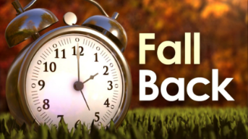 November 5th: Daylight savings time ends, don’t forget to turn those clocks back one hour!
November 8th: Council Meeting at City Hall at 7:00 pm

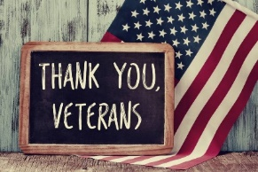 November 10th: Veterans Day. City office will be closed in observance of the holiday.

November 20th: PRIDE Meeting at 7:00 p.m. at the City Hall

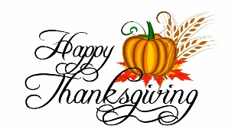November 23rd: Thanksgiving Day. City office will be closed in observance of the holiday and Friday, November 24th.
November 28th: Past due Utility shut off date.
If you can’t pay your account in full at this time then you must submit your reasoning to the City Clerk BEFORE November 28th.
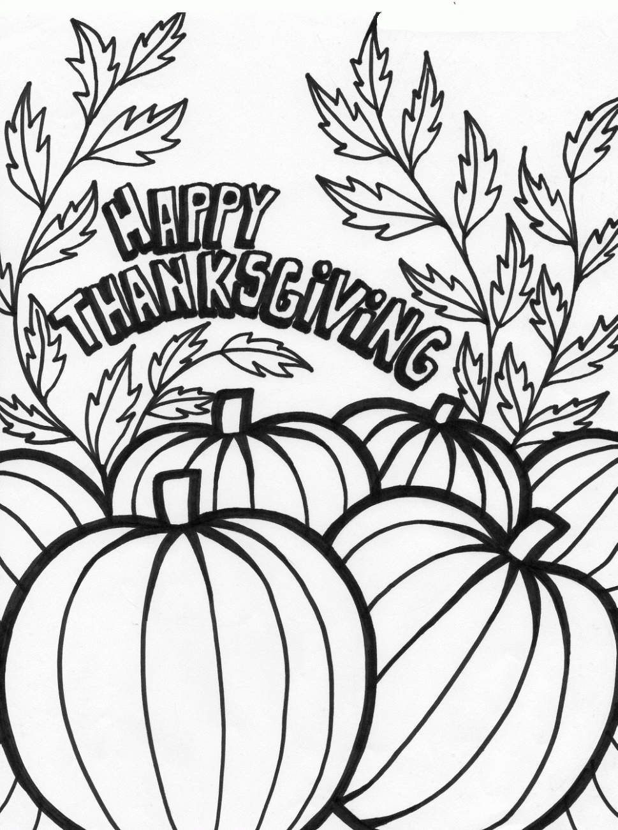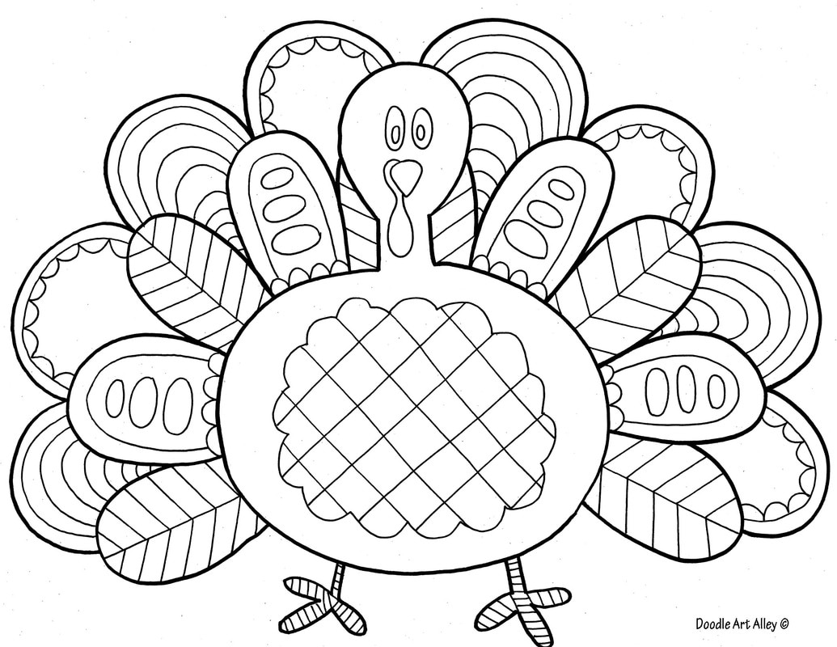

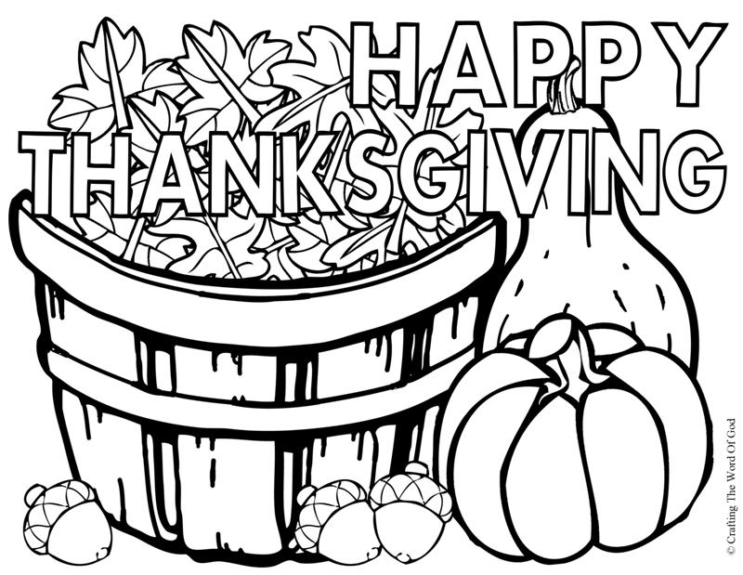
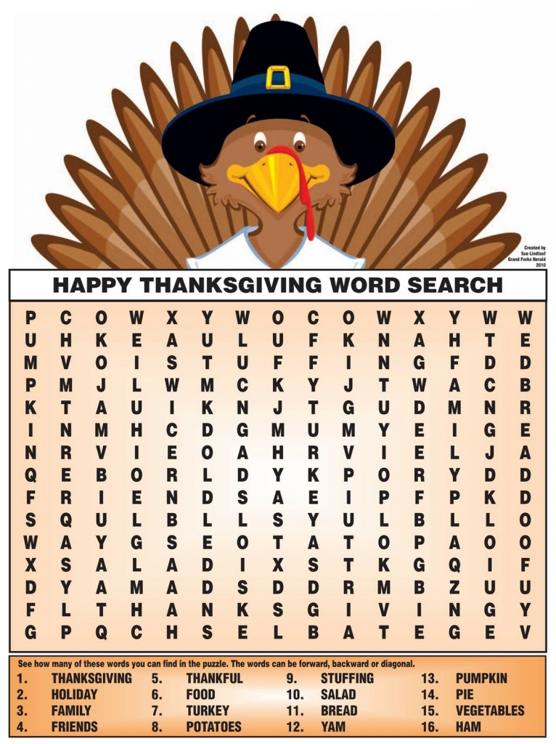

CITY COUNCIL NEWS
HEARING FOR 1105 S. MAIN
Mayor Crowell opened the hearing for 1105 S. Main. Suggestions were made; property needs to be in compliance with our city codes and an ordinance will need to be published vacating the streets and alleys, city will still have the utility right-of-way’s. There were no objections to the request, Mayor Crowell closed the hearing.
CITIZENS CALL FOR BUSINESS
- Greg Thurman presented a letter of interest in the city owned lots at 410 S. McKinley, Mayor Crowell read the letter; he would like to build a home and plans are to live in a portable home while building. Austin Lee expressed concerns of it being a camper and recommended we have a time frame of completion. Mayor Crowell stated, he would like to meet with the council to discuss his plans. Fred suggested presenting an agreement and go from there. I will include the following; 1) What is the temporary building 2) when will project be completed. Fred asked if the council knew what they were wanting to charge for the property. Michelle mentioned, the property was purchased for $841.00. Fred suggested make an offer of $900.00. Mayor Crowell stated she would contact him to find out more information and offer the sale price.

UNFINISHED BUSINESS
- Animal Ordinance – Fred shared the animal ordinance with an updated section; the City Council may, in extenuating circumstances, grant a variance or special use permit to allow an existing bona-fide business that involves non-conforming animals to continue its business operation notwithstanding the replacement of non-conforming animals as required in the normal course of that business. Danny Ware Jr expressed concerns with giving them a variance and then the property has code violations. Fred stated, a written variance can have those stipulations or issued a citation and let the court handle it. Mayor Crowell stated, if you are okay with the ordinance changes, I need a motion to approve. Austin Lee made the motion to adopt ordinance number 1797. Ron Knavel seconded. Motion carried 4-0. Mayor Crowell asked Fred about the request for a variance, Fred stated we can go over this next month, we can’t approve a variance on an ordinance that is not published.
- Fire Ordinance – Fred stated, I need to know what size the council is going to allow for fire pits. Council agreed a 4X4 fire pit size should be plenty with a minimum height of 6”. Fred stated he would have something ready for next month.
- Outside city limit water users – Fred suggested we get an ordinance in place, adopt it and get it published, then those water users can be sent notification with X number of days to sign agreement and return or the city will discontinue the water service. Austin Lee suggested, we default back to the $30.00 fee charge if they haven’t turned in their agreement. Fred stated, he could add a limit on maintenance will be collected subject to the discretion of the city council. He shared, if you put an amount, you’ll have to keep changing it as costs go up. He should have something to review in November.
- Smoke Test – Danny Ware Jr asked if we had heard anything on the smoke test. Mayor Crowell reminded him that La Harpe is on the list, just waiting for KRWA.

NEW BUSINESS
- Streets, Mark Griffith – absent from meeting. Mayor Crowell stated she will contact him and the invoice from the county we won’t pay until we have a discussion with Mark.
- Emergency Water Supply Plan – Michelle stated, Dereck has reviewed this an no changes need to be made. Cynthia Carr made the motion to approve the emergency water supply plan. Austin Lee seconded. Motion carried 4-0.
- KDHE Loan Documents – Michelle stated, Fred has seen these documents and doesn’t see any problems so we need a motion to authorize the mayor to sign on behalf of the city. Danny Ware Jr made the motion to authorize the mayor to sign the KDHE loan documents. Ron Knavel seconded. Motion carried 4-0. Michelle also shared ordinance #1798 that goes with the loan, we need to publish and send proof of publication but I need authorization allowing the mayor to sign. Danny Ware Jr made the motion to authorize the mayor to sign ordinance #1798 for the KDHE loan. Austin Lee seconded. Motion carried 4-0.
- Park Ball Field – Mayor Crowell suggested, unless it’s a league or a benefit, we should charge for the use of the ball lights. Danny Ware Jr made the motion to charge a $100.00 fee for using the ball field lights. Ron Knavel seconded. Motion carried 4-0. Fred will work up a rental agreement.
- Concrete pad for bays – Dereck shared pricing for one 12’X16’ concrete slab at 6” deep would be about $500.00. Mayor Crowell stated he is requesting 8 pads; pea rock, ab3 rock, wash rock, 2” rock, sand, cold patch, fill dirt and misc. Danny Ware Jr mentioned; we don’t need a pad for fill dirt, misc. or 2” rock. Mayor Crowell stated, that leaves us with 5 pads, totaling $2500.00. Danny Ware Jr made the motion to get 5 pads and not to exceed $2500.00. Ron Knavel seconded. Motion carried 4-0.

REPORTS OF CITY OFFICERS
- Fred Works, City Attorney – Nothing to report.

- Roy Caler, Water Representative – Nothing to report.

- Joe Stotler, Police Chief – Shared his monthly time cards. Had nothing else to report

- Penny Miller, Code/Animal Control – Absent from meeting but shared her monthly reports. Council requested she starts sharing the building permits and her monthly letters at each meeting. Mayor Crowell mentioned the Explorer is back at Mike’s, having transmission issues.

- Marc Waggoner, Fire Chief- Shared the meeting minutes: The LaHarpe Volunteer Fire Department met for the monthly meeting. Present: Matthew Waggoner, Josh Sparks, Marc Waggoner Sr., Bill Gay, Dennis Sidebottom, Kiefer Endicott, Gentry Dougherty, Meghan Sparks & Ronald Splector and Pamela Waggoner. La Harpe firefighters started meeting pulled out all trucks and did flush maintenance, then took them out to round up tires and all hydrants have been flushed. Marc mentioned, the hydrant at the park is still leaking but someone is coming to town sometime next week to help Gentry with these hydrants. Michelle mentioned that Gentry is requesting paint and gaskets for about 15 hydrants. The hydrant guy will be here next Monday and Tuesday, Gentry would like a spending limit so these can be fixed while he is here. Gentry also made note that the hydrants at 9th & Main and 8th &Washington need to be replaced. Danny Ware Jr made the motion to allow $1250.00 for the fire hydrant repairs to fix and if he is needing more for paint, bring it back to the council. Ron Knavel seconded. Motion carried 4-0. Marc mentioned, the fire department will be attending Robin Manbeck’s daycare next Friday for fire prevention month. The fire department will also be attending the trunk or treat on October 28th. Marc shared that he is donating the 357 truck from the rural to the city, would like to know what the council wants to do with the old red truck. Council suggested putting it up for sealed bids to be shared at the next council meeting in November.

- Maintenance Department –The workorders and Dereck’s progress report were shared. Cynthia Carr expressed concerns about the notification of planned power outages, stating we were unaware. Michelle stated she posted it on Facebook. Mayor Crowell suggested we get the costs for advertisement by using the radio, we don’t have many choices to choose from without spending a lot of money.

- Michelle Altis, City Clerk – Shared the pricing of the sewer charges on the tank water. Fred stated, the city should not be billing yourself for sewer to sale bulk water. Mayor Crowell instructed Michelle to remove the sewer charge from the tank water.

DISCUSSION ON AGENDA ITEMS –
Mayor Crowell requested a motion to go into executive session 15 minutes on non-elected personnel with Larry invited. Danny Ware Jr made the motion to go into executive session 15 minutes on non-elected personnel with Larry invited. Austin Lee seconded. Motion carried 4-0. Danny Ware Jr made the motion to go back into executive session 20 minutes on non-elected personnel. Austin Lee seconded. Motion carried 4-0.
After returning to regular session, the mayor asked Joe Stotler if he would be available to meet Monday with Fred and I. Joe stated he wants to address the issue now; first of all, I would like to apologize and I will be retracting Gentry. Mayor Crowell thanked him and stated the council does not want any ride-a-longs or reserves. Joe shared a policy book for the police department that he piggybacked off of Moran and requested the council review it and approve it. Joe stated it is guidelines for law to follow. Fred asked Joe to send it to him and he would review and bring it back to council next month. Danny Ware Jr asked about a work order on Amber Tisdale’s water meter, wondering if the city is recouping it’s time and parts in fixing what she backed over. Fred stated, that is active case in court with restitution attached.
Austine Lee made the motion to give Larry Laird $1.00 increase effective October 1, 2023. Ron Knavel seconded. Motion carried 4-0.

Mayor: Ella Mae Crowell (620) 496-6219
City Attorney: Fred Works
City Municipal Judge: Patty Miklos
Police Chief: Joseph Stotler
Fire Chief: Marc Waggoner
Assistant Fire Chief: Dennis Sidebottom
City Clerk: Michelle Altis
Assistant Clerk: Teresa Driskel
City Treasurer: Audra Riggins
Maintenance Staff: Dereck Ranes, Gentry Dougherty & Larry Laird
Code & Animal Control: Penny Miller

City Council Members:
Austin Lee (496-2323) Danny Ware Jr. (496-2156)
Cynthia Carr (496-7500) Sharlyn Thompson (496-3348)
Ron Knavel (496-2508)
Laharpe City Hall Hours: Monday-Friday
902 S. Washington 8:00-12:00 & 1:00-5:00
P.O. Box 10 Ph. (620) 496-2241
Laharpe, KS. 66751 Fax (620) 496-2240

CHECK OUT OUR WEBSITE; CITYOFLAHARPE.ORG Follow us on Facebook

Amish Breakfast Casserole

Ingredients
- 1-pound sliced bacon, diced
- 1 medium sweet onion, chopped
- 6 large eggs, lightly beaten
- 4 cups frozen shredded hash brown potatoes, thawed
- 2 cups shredded cheddar cheese
- 1-1/2 cups 4% cottage cheese
- 1-1/4 cups shredded Swiss cheese

Directions
- 1. Preheat oven to 350°. In a large skillet, cook bacon and onion over medium heat until bacon is crisp; drain. In a large bowl, combine remaining ingredients; stir in bacon mixture. Transfer to a greased 13x9-in. baking dish.
- 2. Bake, uncovered, until a knife inserted in the center comes out clean, 35-40 minutes. Let stand 10 minutes before cutting.

Hearty Potato Soup

Ingredients
- 6 medium potatoes, peeled and sliced
- 2 carrots, chopped
- 6 celery ribs, chopped
- 8 cups water
- 1 onion, chopped
- 6 tablespoons butter, cubed
- 6 tablespoons all-purpose flour
- 1 teaspoon salt
- 1/2 teaspoon pepper
- 1-1/2 cups 2% milk

Directions
- 1. In a Dutch oven, cook the potatoes, carrots and celery in water until tender, 15-20 minutes. Drain, reserving liquid and setting vegetables aside.
- 2. In the same pan, saute onion in butter until tender. Stir in the flour, salt and pepper; gradually add milk. Bring to a boil, cook and stir for 2 minutes or until thickened. Gently stir in cooked vegetables. Add 1 cup or more of reserved cooking liquid until soup is desired consistency.

Pumpkin Bars

Ingredients
- 4 large eggs, room temperature
- 1-2/3 cups sugar
- 1 cup canola oil
- 1 can (15 ounces) pumpkin
- 2 cups all-purpose flour
- 2 teaspoons ground cinnamon
- 2 teaspoons baking powder
- 1 teaspoon baking soda
- 1 teaspoon salt
- ICING:
- 6 ounces cream cheese, softened
- 2 cups confectioners' sugar
- 1/4 cup butter, softened
- 1 teaspoon vanilla extract
- 1 to 2 tablespoons 2% milk

Directions
- 1. In a bowl, beat the eggs, sugar, oil and pumpkin until well blended. Combine the flour, cinnamon, baking powder, baking soda and salt; gradually add to pumpkin mixture and mix well. Pour into an ungreased 15x10x1-in. baking pan. Bake at 350° for 25-30 minutes or until set. Cool completely.
- 2. For icing, beat the cream cheese, confectioners' sugar, butter and vanilla in a small bowl. Add enough milk to achieve spreading consistency. Spread icing over bars. Store in the refrigerator.

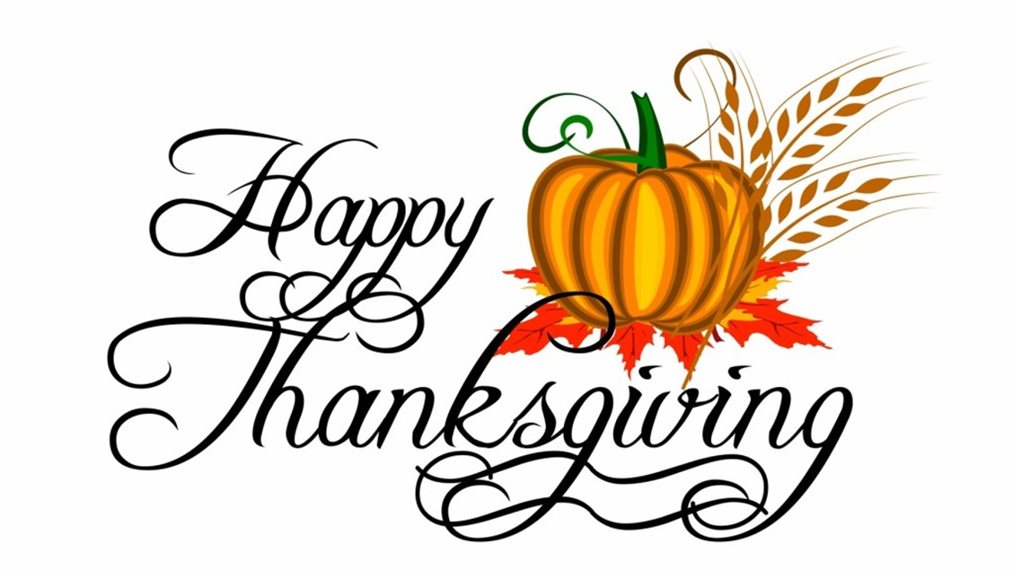

From the City of La Harpe crew & staff, we wish you a vey nice Thanksgiving!

