SEPTEMBER NEWSLETTER
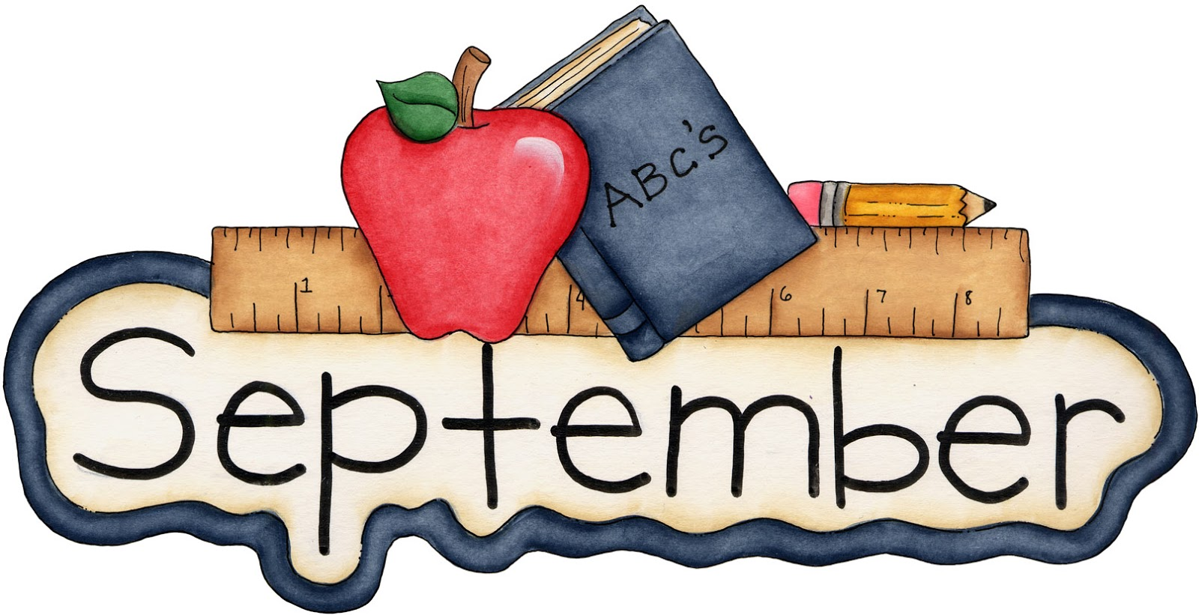
Labor Day is always observed on the first Monday in September. Labor Day 2023 take place on Monday, September 4.

Why Do We Celebrate Labor Day?
Labor Day, an annual celebration of workers and their achievements, originated during one of American labor history’s most dismal chapters.
In the late 1800s, at the height of the Industrial Revolution in the United States, the average American worked 12-hour days and seven-day weeks in order to eke out a basic living. Despite restrictions in some states, children as young as 5 or 6 toiled in mills, factories and mines across the country, earning a fraction of their adult counterparts’ wages.
People of all ages, particularly the very poor and recent immigrants, often faced extremely unsafe working conditions, with insufficient access to fresh air, sanitary facilities and breaks.
As manufacturing increasingly supplanted agriculture as the wellspring of American employment, labor unions, which had first appeared in the late 18th century, grew more prominent and vocal. They began organizing strikes and rallies to protest poor conditions and compel employers to renegotiate hours and pay.
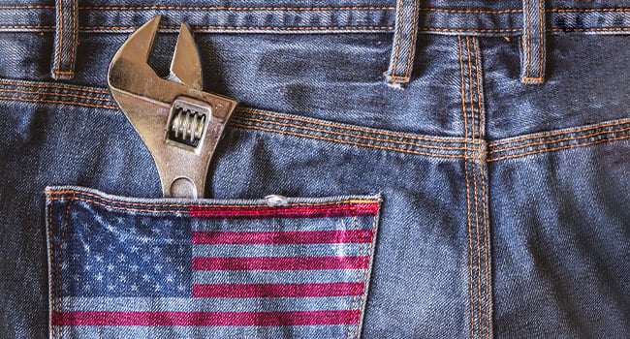 Many of these events turned violent during this period, including the infamous Haymarket Riot of 1886, in which several Chicago policemen and workers were killed. Others gave rise to longstanding traditions: On September 5, 1882, 10,000 workers took unpaid time off to march from City Hall to Union Square in New York City, holding the first Labor Day parade in U.S. history.
The idea of a “workingmen’s holiday,” celebrated on the first Monday in September, caught on in other industrial centers across the country, and many states passed legislation recognizing it. Congress would not legalize the holiday until 12 years later, when a watershed moment in American labor history brought workers’ rights squarely into the public’s view. On May 11, 1894, employees of the Pullman Palace Car Company in Chicago went on strike to protest wage cuts and the firing of union representatives.
On June 26, the American Railroad Union, led by Eugene V. Debs, called for a boycott of all Pullman railway cars, crippling railroad traffic nationwide. To break the Pullman strike, the federal government dispatched troops to Chicago, unleashing a wave of riots that resulted in the deaths of more than a dozen workers.

Who Created Labor Day?
In the wake of this massive unrest and in an attempt to repair ties with American workers, Congress passed an act making Labor Day a legal holiday in the District of Columbia and the territories. On June 28, 1894, President Grover Cleveland signed it into law. More than a century later, the true founder of Labor Day has yet to be identified.
Many credits Peter J. McGuire, cofounder of the American Federation of Labor, while others have suggested that Matthew Maguire, a secretary of the Central Labor Union, first proposed the holiday.

Labor Day Celebrations
Labor Day is still celebrated in cities and towns across the United States with parades, picnics, barbecues, fireworks displays and other public gatherings, especially over the long Labor Day weekend. For many Americans, particularly children and young adults, it represents the end of the summer and the start of the back-to-school season.
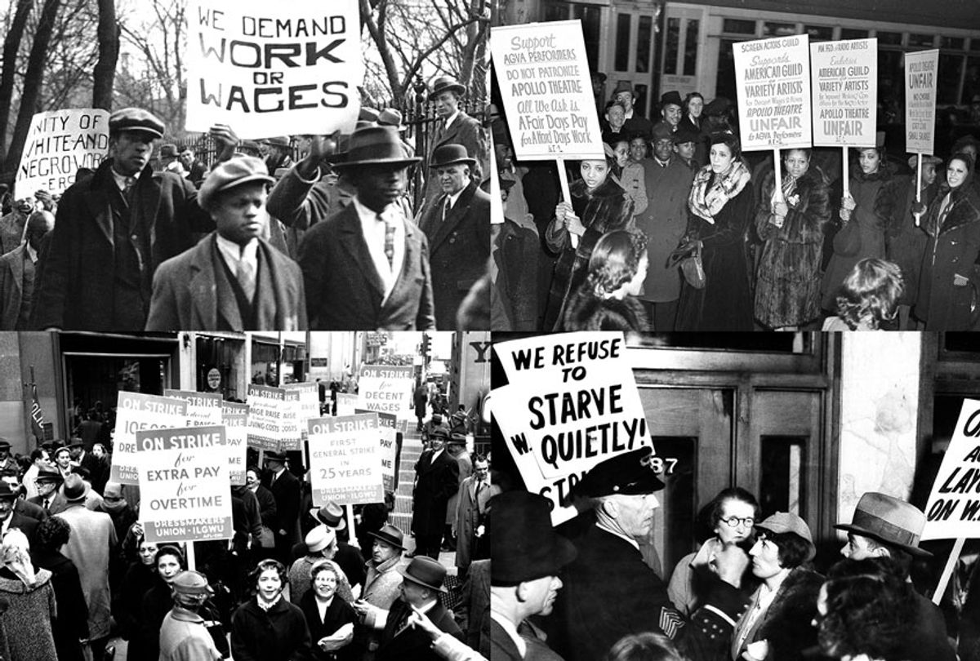
Sunday, September 10, 2023
Our grandparents play a huge role in our lives. They are at the top of our family trees. They provide us with guidance and wisdom, and a lot of us have fond memories of bedtime stories and family occasions with our grandparents. Grandparent’s Day provides us with the perfect opportunity to honor our grandmothers and grandfathers. Read on to discover everything you need to know.
Grandparents come in all shapes and sizes; you have paternal grandparents, step-grandparents, and those grandparents that are not blood-related but hold a very special place in your heart. All of these grandparents have one thing in common, and this is the happiness that they experience knowing that they can support their grandchildren.
Grandparent’s Day is a day that is dedicated to celebrating and acknowledging the vital contribution that our grandparents make when it comes to the education and well-being of younger people within the family. This is the perfect day for us all to show our respect and gratitude for the older generating, honoring our grandparents – everything they do and everything that they stand for.
It is so important to make sure that we acknowledge this date. Grandparent’s Day is the perfect opportunity for children to be more aware of the different ways that grandparents influence their education and emotional development. It is a great time for people to reflect on the guidance they have gotten from older generations and to show their appreciation for this.
It is also crucial to consider the fact that grandparents can feel lonely when they get older, especially when they live on their own. This is why it is important to let your grandparents know how loved and appreciated they are. Simply checking in with your grandparents now and again to make sure that they are doing okay is going to make a massive difference. We know it can be difficult when you have a lot of priorities, but try to make that time!
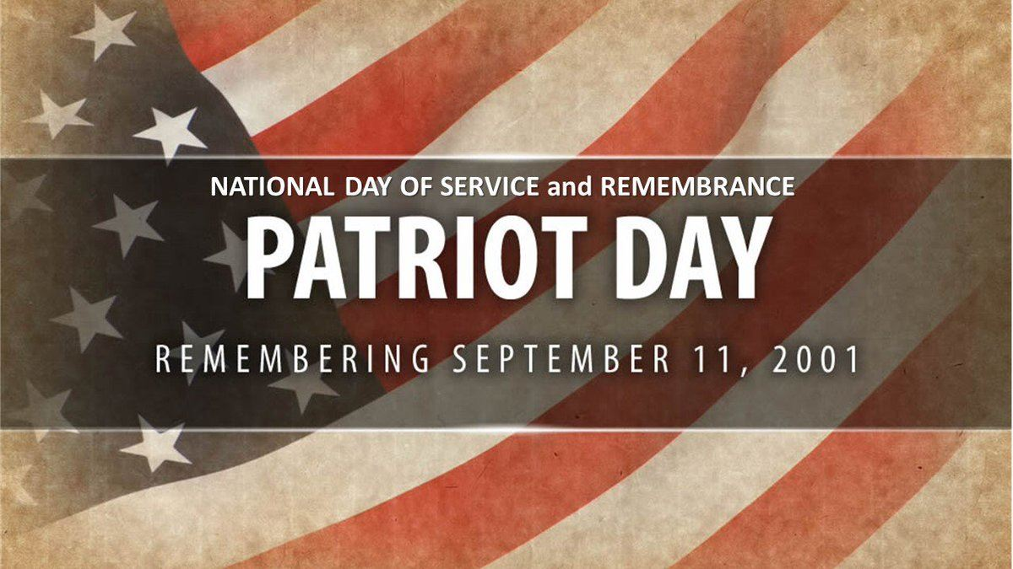Patriot Day on September 11th honors the memory of the nearly 3,000 innocent victims who died in the September 11, 2001, terrorist attacks. Each year Americans dedicate this day to remembering those who died and the first responders who risked their own lives to save others.

We Remember
For many, September 11, 2001, began like any other weekday. We made our way to work. Children attended school. We shopped, had coffee, waited in line at a drive-thru. Those of us who weren’t in New York City heard the first reports on the radio or television. A friend or neighbor alerted us to a plane flying into one of the Twin Towers. We felt disbelief. An accident, perhaps, a miscalculation. Then, a second plane flew into the second tower. Our disbelief turned into uncertainty and concern.

Those on the ground faced terror and obstacles they had never known. But, then, as a set of coordinated suicide attacks organized by the militant group Al Qaeda targeted the World Trade Center, the rest of the nation witnessed the unbelievable. And then a third plane crashed into The Pentagon. And yet another crashed into a field in Shanksville, PA. Memorial
Every year since that fateful day, the United States comes together to remember the fallen. We remember the first responders and those who made difficult decisions. Since that day, memorials have risen from the ashes.

HOW TO OBSERVE PATRIOT DAY
- Attend Patriot Day ceremonies.
- Observe moments of silence:
  - 8:46 AM EDT – American Airlines Flight #11 collides into the World Trade Center
  - 9:03 AM EDT – United Airlines Flight #175 collides into the World Trade Center South Tower
  - 9:37 AM EDT – American Airlines Flight #77 crashes into the Pentagon
  - 9:59 AM EDT – World Trade Center South Tower Collapses
  - 10:03 AM EDT – United Airlines Flight #93 crashes in Shanksville, PA
  - 10:28 AM EDT – World Trade Center North Tower Collapses
- Remember – Remember those killed in the attacks. Remember to stand united as a Nation. Join others in prayer vigils or memorial events.
Use #PatriotDay or #NeverForget to post on social media and show your support.

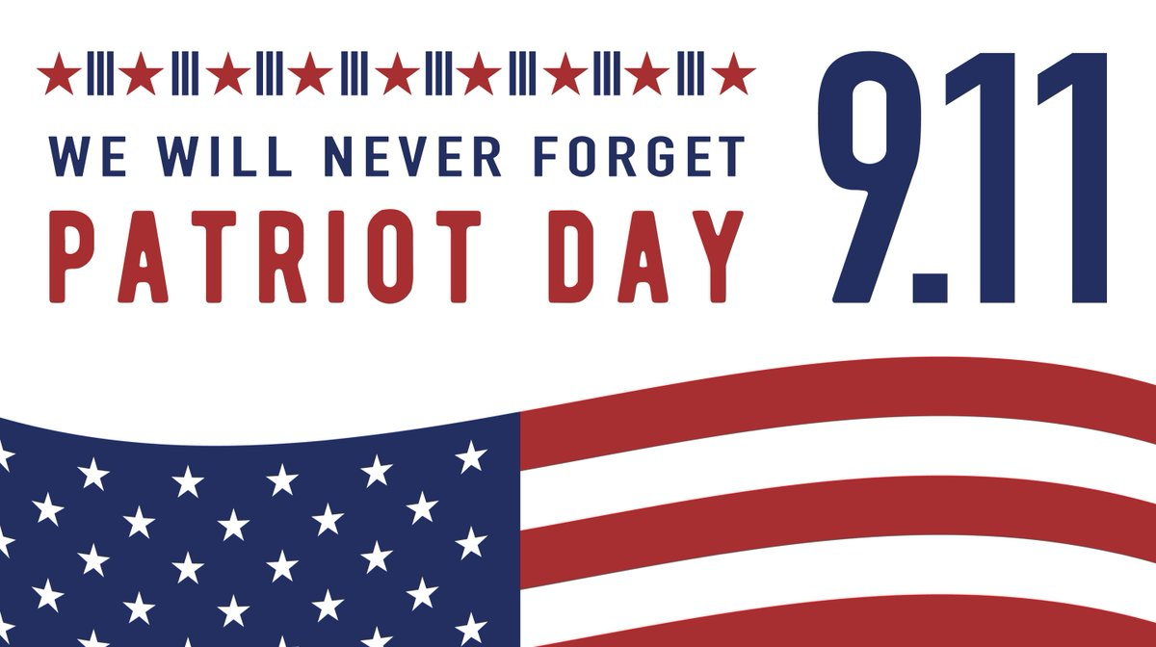

Saturday, September 23, 2023
LOCAL NEWS
- Are you in need of grocery delivery service? Call 620-228-5570 for more information on this new service.

- La Harpe Pride has scheduled a town clean-up day for September 30th. They have volunteers from K-State coming down to help as well as Nelson Quarries. They are also wanting to do some cleaning in the La Harpe Elm Cemetery. If you are able to volunteer your time to help, please call 620-496-2241 or if you know of someone that needs help cleaning their yard, please let us know.
If you need assistance after-hours please call the Iola Dispatch Center at (620) 365-1437, they will notify the proper personnel. HAPPY BIRTHDAY TO ALL LAHARPE CITIZENS CELEBRATING A BIRTHDAY THIS MONTH!!!! MAY YOUR DAY BE AS SPECIAL AS YOU ARE TO US!

Dates to remember:

September 4th: City Hall closed in observance of Labor Day
September 13th: Council Meeting at City Hall at 7:00 pm

September 18th: PRIDE Meeting at 7:00 p.m. at the City Hall

September 26th: Past due Utility shut off date.
If you can’t pay your account in full at this time then you must submit your reasoning to the City Clerk BEFORE September 26th.

Effective September 1, 2023, the city will not accept any kind of payment arrangements on past due utility bills. If your payment is not in office by the 24th of the month, the utilities will be shut off until payment is made in full.

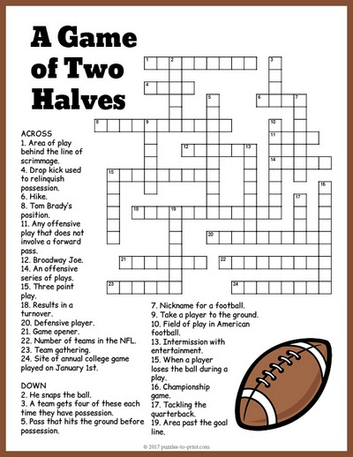

CITY COUNCIL NEWS
2024 CITY BUDGET HEARING
Mayor Crowell opened the budget hearing and asked for any comments or questions. No comments or questions were presented. Austin Lee made the motion to accept the budget. Sharlyn Thompson seconded. Motion carried 4-0. Danny Ware Jr made the motion to close the budget hearing. Ron Knavel seconded. Motion carried 4-0.

CITIZENS CALL FOR BUSINESS
- Angela Barker thanked the city for all they did after the storm damage, stating she was very impressed how everyone came together to help and had our power restored before Bronson and Iola.
- Jeremy Filer (attending by phone) requested streets and alley on his property at 1105 S. Main be vacated. Attorney, Fred Works stated he would get the paper work gathered that was needed to do so, but should have everything ready to present to council on September 13, 2023. Fred stated we need to get a list of property owners within 200 feet of said property, need a legal description, post something in newspaper about a public hearing and recover our costs before recording the vacates.
- Harry Lee stated he wants to build homes in La Harpe. He stated there were a couple of grants available to make these home more affordable. Harry stated he has a contractor and a grant writer but the grant needs to be made by the city or county, so I’m asking if the city would be willing to apply for this grant. Harry shared his vision would be to build 20 new homes in La Harpe totaling about $650,000.00. The grant could be used by an individual and decrease the amount of the home by $32,500.00. The grant can also be used to help someone build a home. Danny Ware Jr asked when it needed to be submitted. Harry stated, my goal is to start building next spring, my vision would be to build 4 to 5 houses a year. Fred stated we can submit a letter of intent, have the grant writer submit the documents and then the council will review then for approval. Danny Ware Jr made the motion to submit a letter of intent once the grant is submitted and approved. Ron Knavel seconded. Motion carried 5-0. Harry also commented about the tall trees in town with broken limbs hanging, stating it will be a challenge for the citizens or city to take care of them. He stated, he is offering his time to get those cleaned up if the city would provide a bucket truck and an operator, it’s not safe and it looks trashy.
- Mike Knavel asked where the city was with the rural water users, Mayor Crowell stated we are in the process of working up something now. Mike demanded that city crews do not go pass his mater meter when reading meters. Mayor Crowell stated, we can do that if that’s what you want.
- Corky Lynes expressed concerns about her son’s sewer charge on their water spicket, stating that used only to fill pool and water the garden. She stated, we shouldn’t have to pay a sewer charge, if that’s how it is going to be then pull the meter. Mayor Crowell stated, that’s how the council voted for the sewer charge and if you want your meter pulled, call city hall and put in a work order.

UNFINISHED BUSINESS
- Animal Ordinance – Tabled until October.
- Fire Ordinance – Tabled until October.

NEW BUSINESS
- Gary McIntosh, with Your Community Foundation, shared with the Council, their organization is helping ACARF raise funds and would love to visit with some of the La Harpe citizens. He also stated that that November 28, 2023 is National Day of Giving, every pledge is matched. Gary also informed thew city and those attending that ACARF still has vouchers to get your dogs or cates spaded at no cost to you, contact ACARF for more information.

REPORTS OF CITY OFFICERS
- Fred Works, City Attorney – Nothing more to report.

- Roy Caler, Water Representative – Nothing to report.

- Joe Stotler, Police Chief – Shared his monthly time cards and had no report.

- Penny Miller, Code/Animal Control – Shared her monthly reports.

- Marc Waggoner, Fire Chief- Shared the meeting minutes: The La Harpe Volunteer Fire Department met for the monthly meeting. Present: Matthew Waggoner, Josh Sparks, Marc Waggoner Sr., Bill Gay, Dennis Sidebottom, Kiefer Endicott, Gentry Dougherty & Ronald Splector. Absent was Mehan Sparks and Pamela Waggoner. La Harpe firefighters started meeting by discussing emergency protocols for severe weather, then we proceeded to take 361 unit & 359 unit and practiced staging exercises, then ended the meeting. Marc mentioned that Ray’s Metal Depot had a casting for the fie hydrant at the park that he is asking $500.00 for. Austin Lee made the motion to buy the casting from Ray’s Metal Depot. Ron Knavel seconded. Motion carried 5-0.

- Maintenance Department –The workorders and Dereck’s progress report were shared.

- Michelle Altis, City Clerk – Requested permission to sign the yearly contract for our utility software through Advantage Computers for $499.00. Danny Ware made the motion to accept the contract for $499.00. Sharlyn Thompson seconded. Motion carried 5-0. She also shared a quote from Stella Jones for 30 poles in the amount of $13,410.00, she stated she brought this up because they were approved to get 30 poles at the first of the year at $300.00 a piece but they have increased to $447.00 a pole. Austin Lee suggested we look around and check with Iola or cedar valley metal in Garnett. Cynthia Carr suggested reaching out to KMEA. Austin Lee made the motion to buy 10 poles from whomever but not to exceed $447.00 per pole. Danny Ware Jr. seconded. Motion carried 5-0.

Mayor: Ella Mae Crowell (620) 496-6219
City Attorney: Fred Works
City Municipal Judge: Patty Miklos
Police Chief: Joseph Stotler
Fire Chief: Marc Waggoner
Assistant Fire Chief: Dennis Sidebottom
City Clerk: Michelle Altis
Assistant Clerk: Teresa Driskel
City Treasurer: Audra Riggins
Maintenance Staff: Dereck Ranes, Larry Laird & Gentry Dougherty
Code & Animal Control: Penny Miller

City Council Members:
Austin Lee (496-2323) Danny Ware Jr. (496-2156)
Cynthia Carr (496-7500) Sharlyn Thompson (496-3348)
Ron Knavel (496-2508)
Laharpe City Hall Hours: Monday-Friday
902 S. Washington 8:00-12:00 & 1:00-5:00
P.O. Box 10 Ph. (620) 496-2241
Laharpe, KS. 66751 Fax (620) 496-2240
CHECK OUT OUR WEBSITE; CITYOFLAHARPE.ORG Follow us on Facebook – City of La Harpe

Taco Lasagna

Ingredients
- 1 pound ground beef
- 1/2 cup chopped green pepper
- 1/2 cup chopped onion
- 2/3 cup water
- 1 envelope taco seasoning
- 1 can (15 ounces) black beans, rinsed and drained
- 1 can (14-1/2 ounces) Mexican diced tomatoes, undrained
- 6 flour tortillas (8 inches)
- 1 can (16 ounces) refried beans
- 3 cups shredded Mexican cheese blend

Directions
- 1. In a large skillet, cook the beef, green pepper and onion over medium heat until meat is no longer pink; drain. Add water and taco seasoning; bring to a boil. Reduce heat; simmer, uncovered, for 2 minutes. Stir in black beans and tomatoes. Simmer, uncovered, for 10 minutes.
- 2. Place 2 tortillas in a greased 13x9-in. baking dish. Spread with half of the refried beans and half of the beef mixture; sprinkle with 1 cup cheese. Repeat layers. Top with remaining tortillas and cheese.
- 3. Cover and bake at 350° for 25-30 minutes or until heated through and cheese is melted.

Loaded Cowboy Queso

Ingredients
- 1/2 pound bulk spicy pork sausage
- 1 cup pale ale or other light beer
- 1 package (16 ounces) Velveeta, cubed
- 1/2 cup shredded pepper jack cheese
- 1 teaspoon salt
- 1 teaspoon garlic powder
- 1 teaspoon onion powder
- 1/2 teaspoon cayenne pepper
- 1 can (10 ounces) diced tomatoes with mild green chiles, undrained
- 1 cup black beans, rinsed and drained
- 1/4 cup minced fresh cilantro
- Optional: jalapenos and tortilla or corn chips

Directions
- 1. In a large skillet, cook sausage over medium heat until no longer pink, about 5 minutes, crumbling meat. Add beer, cook until reduced slightly, 3-4 minutes, stirring occasionally. Add Velveeta, pepper jack cheese and seasonings; stir occasionally until melted. When melted, stir in tomatoes, beans, and cilantro.
- 2. If desired, garnish with jalapenos and additional cilantro and serve with tortilla or corn chips.

Pumpkin Bars

Ingredients
- 4 large eggs, room temperature
- 1-2/3 cups sugar
- 1 cup canola oil
- 1 can (15 ounces) pumpkin
- 2 cups all-purpose flour
- 2 teaspoons ground cinnamon
- 2 teaspoons baking powder
- 1 teaspoon baking soda
- 1 teaspoon salt
- ICING:
- 6 ounces cream cheese, softened
- 2 cups confectioners' sugar
- 1/4 cup butter, softened
- 1 teaspoon vanilla extract
- 1 to 2 tablespoons 2% milk

Directions
- 1. In a bowl, beat the eggs, sugar, oil and pumpkin until well blended. Combine the flour, cinnamon, baking powder, baking soda and salt; gradually add to pumpkin mixture and mix well. Pour into an ungreased 15x10x1-in. baking pan. Bake at 350° for 25-30 minutes or until set. Cool completely.
- 2. For icing, beat the cream cheese, confectioners' sugar, butter and vanilla in a small bowl. Add enough milk to achieve spreading consistency. Spread icing over bars. Store in the refrigerator.

