DECEMBER NEWSLETTER

Grandma's Christmas Gifts

Grandma Burns sat knitting busily in the sun one bright morning the week before Christmas. The snow lay deep, and the hard crust glistened like silver. All at once she heard little sighs of grief outside her door. When she opened it there sat Peter and Jimmy Rice, two very poor little boys, with their faces in their hands; and they were crying. "My patience!" cried grandma. "What can be the matter with two bright little boys this sunny morning?"
"We don't have no good times," sighed little Peter.
"We can't slide. We haven't any sleds," whimpered Jimmy.
"Why, of course boys can't have a good time without sleds," said grandma, cheerily. "Let

us look about and see if we can't find something." And grandma's cap-border bobbed behind barrels and boxes in the shed and all among the cobwebs in the garret; but nothing could be found suitable.
"Hum! I do believe this would do for little Pete;" and the dear old lady drew a large,

pressed-tin pan off the top shelf in the pantry. A long, smooth butter-tray was found for Jimmy.

Grandma shook her cap-border with laughter to see them skim over the hard crust in their queer sleds. And the boys shouted and swung their hands as they flew past the window.
"I do expect they'll wear 'em about through," murmured grandma; "but boys must slide, --that's certain."
And the pan was scoured as bright as a new silver dollar and the red paint was all gone off the wooden tray when Peter and Jimmy brought their sleds back.
Grandma knitted faster than ever all that day, and her face was bright with smiles. She was planning something. She went to see Job Easter that night. He promised to make two small sleds for the pair of socks she was knitting.
When the sleds were finished, she dyed them red and drew a yellow horse upon each one. Grandma called them horses, but no one would have suspected it. Then the night before Christmas she drew on her great socks over her shoes to keep her from slipping, put on her hood and cloak, and dragged the little sleds over to Peter and Timmy's house.
She hitched them to the door-latch, and went home laughing all the way.

The First Christmas-Tree

Two little children were sitting by the fire one cold winter's night. All at once they heard a timid knock at the door and one ran to open it.
There, outside in the cold and darkness, stood a child with no shoes upon his feet and

clad in thin, ragged garments. He was shivering with cold, and he asked to come in and warm himself.
"Yes, come in," cried both the children. "You shall have our place by the fire. Come in."
They drew the little stranger to their warm seat and shared their supper with him, and gave him their bed, while they slept on a hard bench.

In the night they were awakened by strains of sweet music, and looking out, they saw a band of children in shining garments, approaching the house. They were playing on golden harps and the air was full of melody.
Suddenly the Strange Child stood before them: no longer cold and ragged, but clad in silvery light.

His soft voice said: "I was cold and you took Me in. I was hungry and you fed Me. I was tired and you gave Me your bed. I am the Christ-Child, wandering through the world to bring peace and happiness to all good children. As you have given to Me, so may this tree every year give rich fruit to you."
So saying, He broke a branch from the fir-tree that grew near the door, and He planted it in the ground and disappeared. And the branch grew into a great tree, and every year it bore wonderful fruit for the kind children.

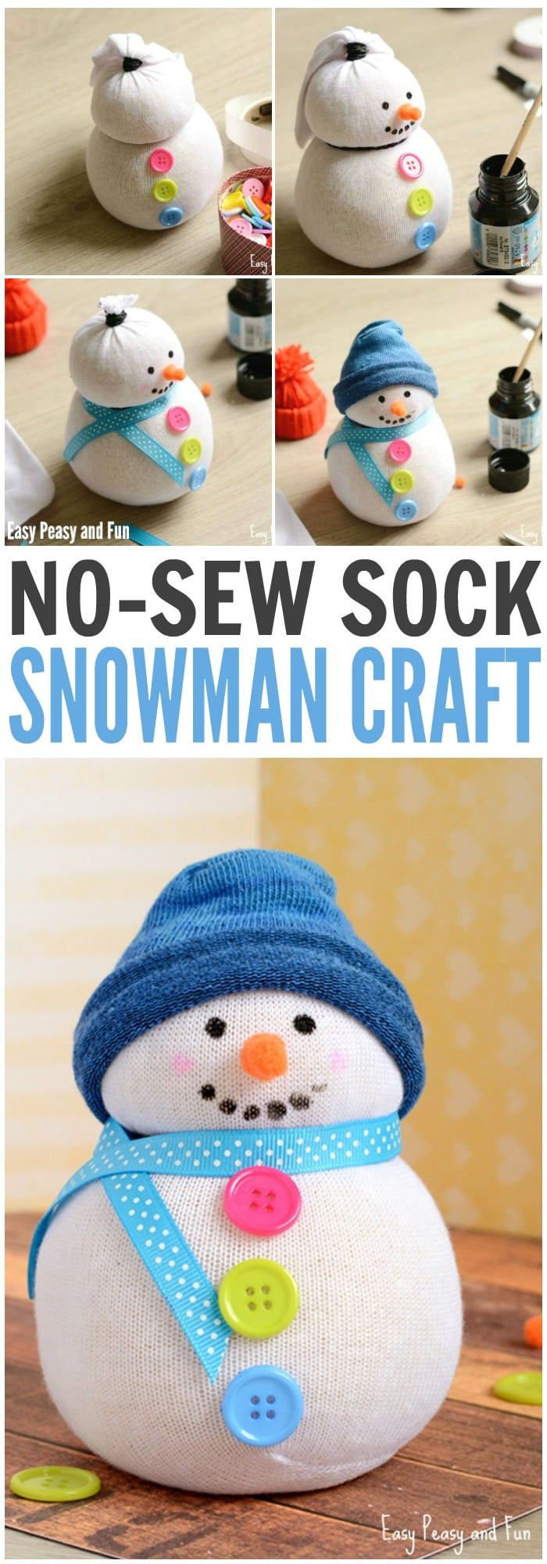
1 white sock, 1 sock in color for the hat, rice, rubber bands (or thread), colorful buttons, ribbons, glue gun, markers or paint and orange pom poms

Start by filling your white sock with rice. You will need a hefty amount

Once you are happy with the amount (and size) of your sock snowman tie the top with the rubber band.

Take another rubber band and place in the middle – more to the upper side – of the rice filled sock to form the head shape.

Now glue the buttons to the bottom side by using a glue gun

Draw the mouth and eyes with a black marker or with black paint.

You can also add pink cheeks (Crayola washable paints work great for the job). You can make the nose out of two orange pom poms

Add a ribbon for the scarf –glue gun dots work best for ribbons.

Cut the colored sock (cut the foot part, without heel). Roll it a bit and place it on the head of your snowman. You can leave it as it is or you can secure it with some glue.

This sock snowman is ready to rock.

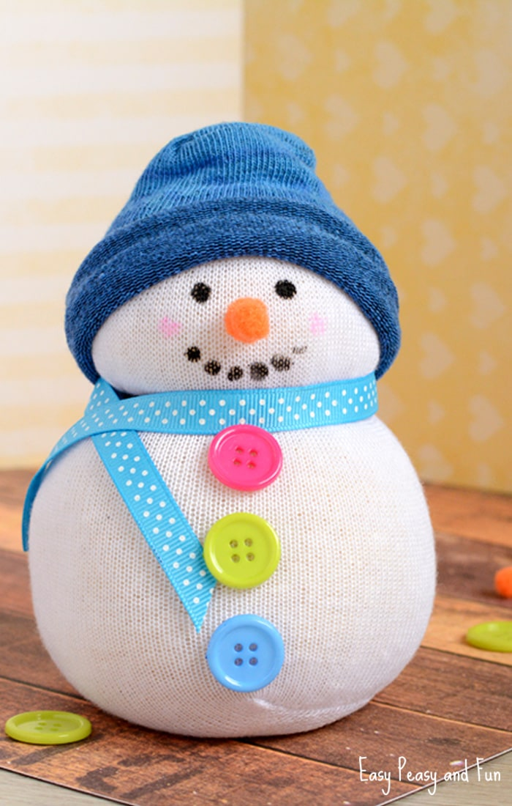

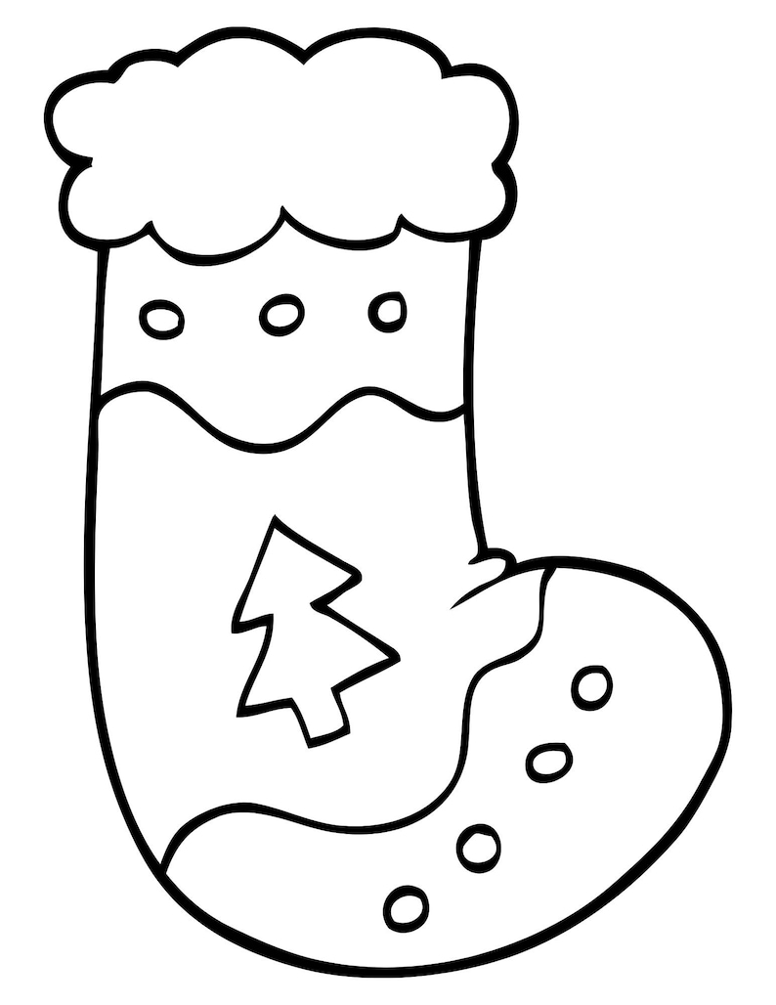

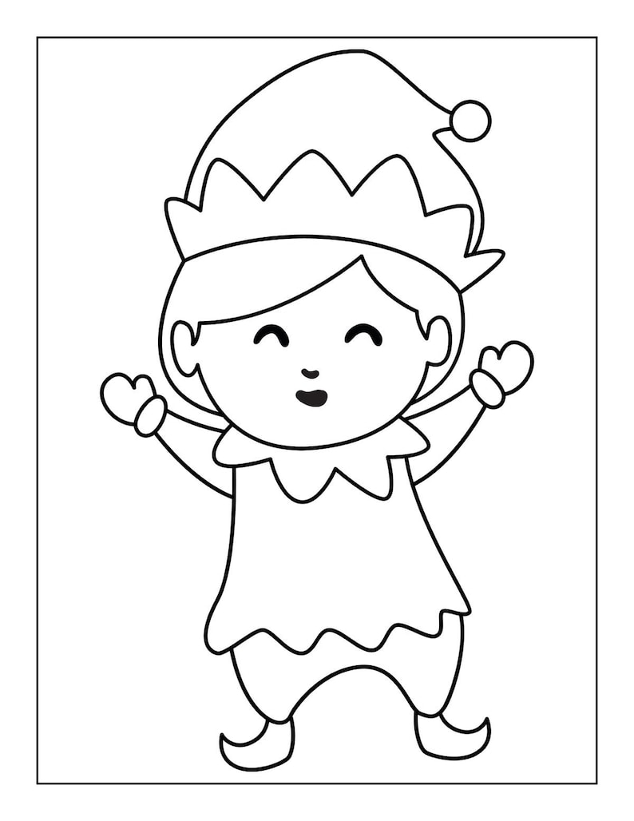

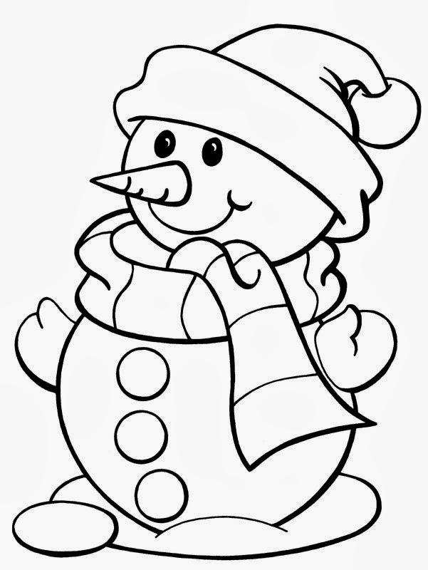

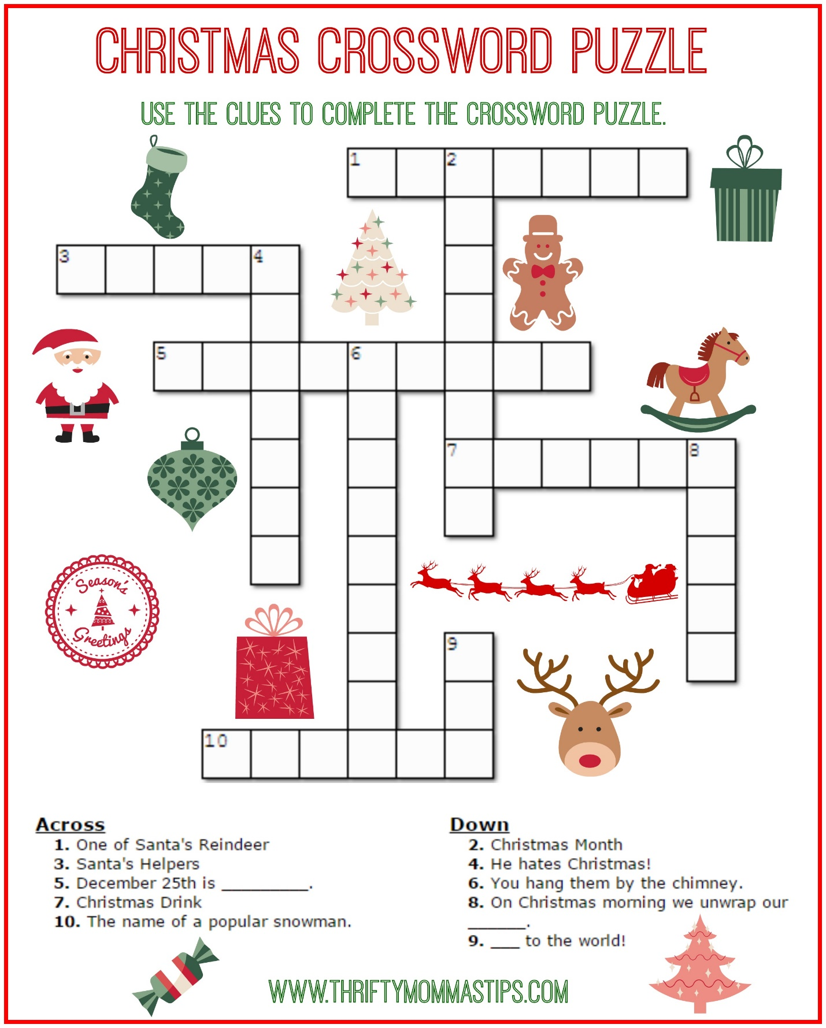

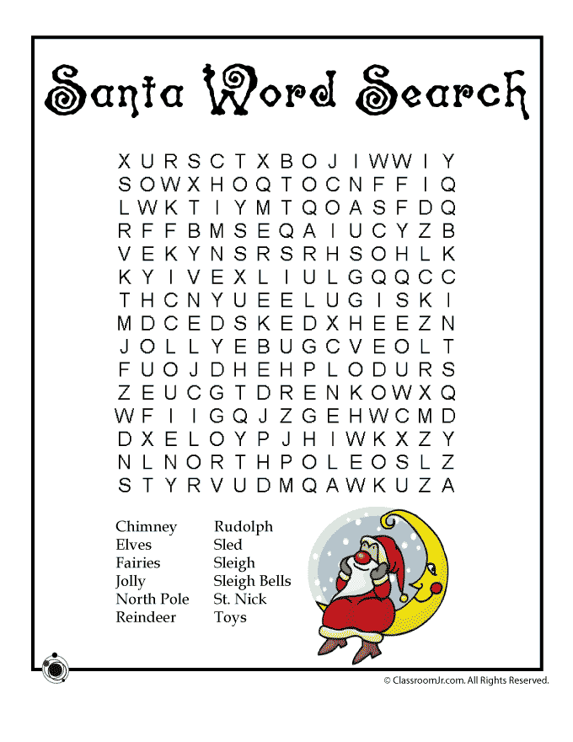

LOCAL NEWS

- Are you in need of grocery delivery service? Call 620-228-5570 for more information on this new service.

- La Harpe Days T-Shirts available at City Hall.

If you need assistance after-hours please call the Iola Dispatch Center at (620) 365-1437, they will notify the proper personnel.
HAPPY BIRTHDAY TO ALL LAHARPE CITIZENS CELEBRATING A BIRTHDAY THIS MONTH!!!! MAY YOUR DAY BE AS SPECIAL AS YOU ARE TO US!

Dates to remember:
December 13th: COUNCIL MEETING AT CITY HALL AT 7:00 P.M.
December 18TH: PRIDE Meeting at 7:00 p.m. at the City Hall
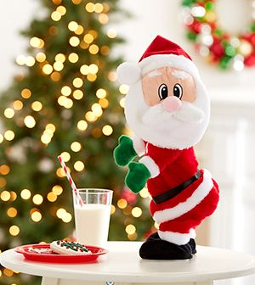 December 25th: City Hall will be Closed.
The city staff would like to wish everyone a VERY MERRY CHRISTMAS!!

December 27th: Past due Utility shut off date.
If you can’t pay your account in full at this time then you must submit your reasoning to the City Clerk BEFORE December 27th.

CITY COUNCIL NEWS
CITIZENS CALL FOR BUSINESS
- Nothing discussed

UNFINISHED BUSINESS
- Animal variance request – Fred stated the variance request also needs to give the citizens that live within a 200-foot radius, an opportunity to share their opinion before granting.
- Fire Ordinance – Fred stated, the only changes are section “E”, on construction and size. Ron Knavel made the motion to adopt ordinance #1801. Sharlyn Thompson seconded. Motion carried 4-0.
- Streets – Danny Ware Jr attended by phone at 7:07pm. Mark Griffith, with the county public works department was in attendance to answer any questions. Mayor Crowell stated, the council have questions on the price because the city was quoted $80,000.00 but being billed for $146,000.00. Mark stated they had done a double chip; first time was the MC800 and the second time was with RSH. Mark apologized for the misleading quote and stated he would take this to the county commissioners and see if they will tack it on to next year. Mark stated the county has already paid Vance Brothers. Mayor Crowell asked about the county grinding a few of the roads that weren’t done and Mark stated, the county has roads that they need to get caught up on but perhaps we can try to come back next fall, grind them and let them set through the winter. Mark mentioned that he talked to the city crew about brooming the roads and is willing to let them use his broom and he will teach them.
- Water Ordinance – Fred stated this will take affect on the February billing. Sharlyn Thompson made the motion to adopt ordinance #1799. Danny Ware Jr. seconded. Motion carried 2-1 with Cynthia Carr opposed. Ron Knavel and Austin Lee abstained. Danny Ware Jr disconnect his phone call at 7:20pm.
- Ordinance to vacate streets and alleys – Fred presented ordinance #1800 to vacate streets and alleys at the 1105 S. Main property. Ron Knavel made the motion to adopt ordinance #1800. Sharlyn Thompson seconded. Motion carried 4-0.
- Greg Thurman – Mayor Crowell shared that he was okay with everything the council asked of him. Austin Lee asked about the small home and how long will construction take. Mayor Crowell stated, he is having a small home brought in to live in while building and then use the smaller building for a garage. Council requested the project be completed within 18 months. Fred stated he will draw something up.
- Citizen, Rick Myers, expressed concerns over having a horse and was uncertain what needed to be done. Fred stated that Penny will get with him.

NEW BUSINESS
- Thanksgiving / Christmas Employees – Ron Knavel made the motion to give all full-time employees $150.00 with taxes withheld and part-time employees $100.00 with taxes withheld and checks will be issued December 1, 2023. Austin Lee seconded. Motion carried 4-0.

- Fire Hydrants – Michelle shared an invoice from Core and Main in the amount of $3,927.32 and stated that Gentry has purchased the approved $1,250.00 as need for the fire hydrants but needs the other items on this quote to fix all hydrant on the East side of Main. Austin Lee made the motion to give Gentry $2,677.32 to fix those hydrants with the money coming out of the fire fund. Ron Knavel seconded. Motion carried 4-0.
- Concrete pad for bays – Dereck shared a note that he did not figure it correctly and needs 11 more blocks totaling $715.00 and that they need more rebar for the concrete. The lowest price on rebar was $597.20. Austin Lee made the motion to get what is needed to finish and not to exceed $1,312.20. Ron Knavel seconded. Motion carried 4-0.

REPORTS OF CITY OFFICERS
- Fred Works, City Attorney – Nothing to report.

- Roy Caler, Water Representative – Nothing to report.

- Joe Stotler, Police Chief – Shared his monthly time cards. Had nothing else to report. Cynthia Carr asked Joe to put “AM” and “PM” on his time card and Joe agreed.

- Penny Miller, Code/Animal Control –Shared her monthly reports. Had nothing else to report

- Marc Waggoner, Fire Chief- Shared the meeting minutes: The La Harpe Volunteer Fire Department met for the monthly meeting. Present: Matthew Waggoner, Josh Sparks, Marc Waggoner Sr., Bill Gay, Dennis Sidebottom, Kiefer Endicott and Gentry Dougherty. Absent were, Meghan Sparks, Ronald Splector and Pamela Waggoner. La Harpe firefighters started meeting, took 357, 360 and 359 out, set up staging area, did training on arial unit to train firemen then ended meeting. Marc stated the fire fighters will be doing smoke test training next month.
Mayor Crowell opened 3 bids for the purchase of the 1976 Fire Truck: Gentry Dougherty- $1,001.50, Steve Robb - $800.00 and Larry Laird - $300.00. Austin Lee made the motion to accept Gentry’s bid of $1,001.50. Ron Knavel seconded. Motion carried 4-0.

- Maintenance Department –The workorders and Dereck’s progress report were shared.

- Michelle Altis, City Clerk – Nothing to report.

Mayor: Ella Mae Crowell (620) 496-6219
City Attorney: Fred Works
City Municipal Judge: Patty Miklos
Police Chief: Joseph Stotler
Fire Chief: Marc Waggoner
Assistant Fire Chief: Dennis Sidebottom
City Clerk: Michelle Altis
Assistant Clerk: Teresa Driskel
City Treasurer: Audra Riggins
Maintenance Staff: Dereck Ranes, Gentry Dougherty & Larry Laird
Code & Animal Control: Penny Miller

City Council Members:
Austin Lee (496-2323) Danny Ware Jr. (496-2156)
Cynthia Carr (496-7500) Sharlyn Thompson (496-3348)
Ron Knavel (496-2508)
Laharpe City Hall Hours: Monday-Friday
902 S. Washington 8:00-12:00 & 1:00-5:00
P.O. Box 10 Ph. (620) 496-2241
Laharpe, KS. 66751 Fax (620) 496-2240

CHECK OUT OUR WEBSITE; CITYOFLAHARPE.ORG Follow us on Facebook

Martha Washington Candy

Ingredients
- 1 cup butter, softened
- 4 cups confectioners' sugar
- 1 can (14 ounces) sweetened condensed milk
- 1 teaspoon vanilla extract
- 3 cups sweetened shredded coconut
- 2 cups chopped pecans, toasted
- 6 cups semisweet chocolate chips
- 1/4 cup shortening

Directions
- In a large bowl, beat butter, confectioners' sugar, milk and vanilla until blended. Stir in coconut and pecans. Divide dough in half; refrigerate, covered, 1 hour.
- Working with half the dough at a time, shape mixture into 1-in. balls; place on waxed paper-lined baking sheets. Refrigerate 30 minutes longer.
- In top of a double boiler or a metal bowl over barely simmering water, melt chocolate chips and shortening; stir until smooth. Dip balls in melted chocolate; allow excess to drip off. Return to waxed paper. Top with additional coconut if desired. Refrigerate until set.
- To Make Ahead: Store in an airtight container in the refrigerator.

Big Soft Ginger Cookies

Ingredients
- 3/4 cup butter, softened
- 1 cup sugar
- 1 large egg, room temperature
- 1/4 cup molasses
- 2-1/4 cups all-purpose flour
- 2 teaspoons ground ginger
- 1 teaspoon baking soda
- 3/4 teaspoon ground cinnamon
- 1/2 teaspoon ground cloves
- 1/4 teaspoon salt
- Additional sugar

Directions
- 1. In a large bowl, cream butter and sugar until light and fluffy, 5-7 minutes. Beat in egg and molasses. Combine the flour, ginger, baking soda, cinnamon, cloves and salt; gradually add to the creamed mixture and mix well.
- 2. Roll into 1-1/2-in. balls, then roll in sugar. Place 2 in. apart on ungreased baking sheets. Bake at 350° until puffy and lightly browned, 10-12 minutes. Remove to wire racks to cool.

Peanut Butter Snowballs

Ingredients
- 1 cup confectioners' sugar
- 1/2 cup creamy peanut butter
- 3 tablespoons butter, softened
- 1 pound white candy coating, coarsely chopped
- Chopped peanuts, optional

Directions
- 1. In a bowl, combine the sugar, peanut butter and butter. Chill in freezer for 30 minutes or until the mixture is easy to handle. Shape into 1-in. balls and place on a waxed paper-lined baking sheet. Freeze for 30 minutes or until firm.
- 2. Meanwhile, melt the candy coating in a microwave-safe bowl. Dip each ball and place on waxed paper to harden. If desired, sprinkle with chopped peanuts.

Twas the night before Christmas, when all through the house
Not a creature was stirring, not even a mouse.
The stockings were hung by the chimney with care,
In hopes that St Nicholas soon would be there.
The children were nestled all snug in their beds,
While visions of sugar-plums danced in their heads.
And mamma in her ‘kerchief, and I in my cap,
Had just settled our brains for a long winter’s nap.
When out on the lawn there arose such a clatter,
I sprang from the bed to see what was the matter.
Away to the window I flew like a flash,
Tore open the shutters and threw up the sash.
The moon on the breast of the new-fallen snow
Gave the lustre of mid-day to objects below.
When, what to my wondering eyes should appear,
But a miniature sleigh, and eight tinny reindeer.
With a little old driver, so lively and quick,
I knew in a moment it must be St Nick.
More rapid than eagles his coursers they came,
And he whistled, and shouted, and called them by name!
"Now Dasher! now, Dancer! now, Prancer and Vixen!
On, Comet! On, Cupid! on, on Donner and Blitzen!
To the top of the porch! to the top of the wall!
Now dash away! Dash away! Dash away all!"
As dry leaves that before the wild hurricane fly,
When they meet with an obstacle, mount to the sky.
So up to the house-top the coursers they flew,
With the sleigh full of Toys, and St Nicholas too.

And then, in a twinkling, I heard on the roof
The prancing and pawing of each little hoof.
As I drew in my head, and was turning around,
Down the chimney St Nicholas came with a bound.
He was dressed all in fur, from his head to his foot,
And his clothes were all tarnished with ashes and soot.
A bundle of Toys he had flung on his back,
And he looked like a peddler, just opening his pack.
His eyes-how they twinkled! his dimples how merry!
His cheeks were like roses, his nose like a cherry!
His droll little mouth was drawn up like a bow,
And the beard of his chin was as white as the snow.
The stump of a pipe he held tight in his teeth,
And the smoke it encircled his head like a wreath.
He had a broad face and a little round belly,
That shook when he laughed, like a bowlful of jelly!
He was chubby and plump, a right jolly old elf,
And I laughed when I saw him, in spite of myself!
A wink of his eye and a twist of his head,
Soon gave me to know I had nothing to dread.
He spoke not a word, but went straight to his work,
And filled all the stockings, then turned with a jerk.
And laying his finger aside of his nose,
And giving a nod, up the chimney he rose!
He sprang to his sleigh, to his team gave a whistle,
And away they all flew like the down of a thistle.
But I heard him exclaim, ‘ere he drove out of sight,
"Happy Christmas to all, and to all a good-night!"

