JANUARY NEWSLETTER
New Year's Day is observed on January 1, the first day of the year on the modern Gregorian calendar as well as the Julian calendar used in ancient Rome. With most countries using the Gregorian calendar as their main calendar, New Year's Day is the closest thing to being the world's only truly global public holiday, often celebrated with fireworks at the stroke of midnight as the new year starts.
Celebrations such as parades, concerts, church services, family meals etc. are held world-wide on January 1

.

10 Fun Things to Do on New Year's Day to Set the Right Tone for 2023

- Go to the Movies If you didn't make it out to see anything new in theaters in 2022, treat yourself to a movie on New Year's Day. Make it extra special and go all out with all of your favorite snacks.

- Start a New Book If your resolution included reading more books in the new year, this is the perfect way to get started. Pick out a novel that piques your interest and spend the day diving in.

- Treat Yourself to an at Home Spa Day Even if the spas are closed on New Year's Day you can still indulge in a little self-care. Make a day out of it and DIY your own spa treatments at home.

- Try out a New Restaurant Part of the beauty of the new year is having a fresh start. Why not ring it in by trying out some new cuisine with your besties?

- Go on a Hike Plan a hike with family or friends and enjoy some fresh air. Bonus points if you bring your pup!

- Host Brunch Begin the year surrounded by family, friends — and lots of carbs. Or eggs. And coffee. Your plan to eat healthier in 2023 can wait until after breakfast, right?
- Do a Deep Clean If you didn't use the KonMari method on your house before the holidays in anticipation of getting a bunch of new Christmas presents, you're probably sitting on mounds of stuff that need to be organized, sorted, cleaned or tossed. Tackle one area of the house starting on Day One.
- Start a Bullet Journal You've got big plans for this year. Keep track of them in a bullet journal, and feel a sense of satisfaction every time you cross something off your list.
- Binge a TV Marathon To some, it is a hallowed tradition to spend January 1 on the couch, watching TV and recovering from the night before. Many channels have helpfully enabled this with daylong (or week-long) marathons of classic shows: Syfy usually hosts a Twilight Zone bonanza each December; WPIX often shows The Honeymooners; and BBC America sometimes does a days-long Dr. Who binge. If that doesn't suit your tastes, well, you can always watch something on Netflix, Hulu or Disney+.
- Cheer for Your Favorite College Football Team There are always Bowl games scheduled for New Year's Day, and you can usually dip in or out at any point in the afternoon or night. At that rate, who needs a Super Bowl?

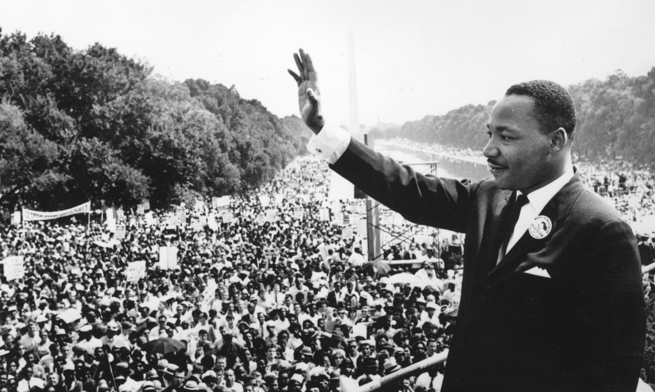
Martin Luther King, Jr., (January 15, 1929-April 4, 1968) was born Michael Luther King, Jr., but later had his name changed to Martin. His grandfather began the family’s long tenure as pastors of the Ebenezer Baptist Church in Atlanta, serving from 1914 to 1931; his father has served from then until the present, and from 1960 until his death Martin Luther acted as co-pastor. Martin Luther attended segregated public schools in Georgia, graduating from high school at the age of fifteen; he received the B. A. degree in 1948 from Morehouse College, a distinguished Negro institution of Atlanta from which both his father and grandfather had graduated. After three years of theological study at Crozer Theological Seminary in Pennsylvania where he was elected president of a predominantly white senior class, he was awarded the B.D. in 1951. With a fellowship won at Crozer, he enrolled in graduate studies at Boston University, completing his residence for the doctorate in 1953 and receiving the degree in 1955. In Boston he met and married Coretta Scott, a young woman of uncommon intellectual and artistic attainments. Two sons and two daughters were born into the family.
In 1954, Martin Luther King became pastor of the Dexter Avenue Baptist Church in Montgomery, Alabama. Always a strong worker for civil rights for members of his race, King was, by this time, a member of the executive committee of the National Association for the Advancement of Colored People, the leading organization of its kind in the nation. He was ready, then, early in December, 1955, to accept the leadership of the first great Negro nonviolent demonstration of contemporary times in the United States, the bus boycott described by Gunnar Jahn in his presentation speech in honor of the laureate. The boycott lasted 382 days. On December 21, 1956, after the Supreme Court of the United States had declared unconstitutional the laws requiring segregation on buses, Negroes and whites rode the buses as equals. During these days of boycott, King was arrested, his home was bombed, he was subjected to personal abuse, but at the same time he emerged as a Negro leader of the first rank.
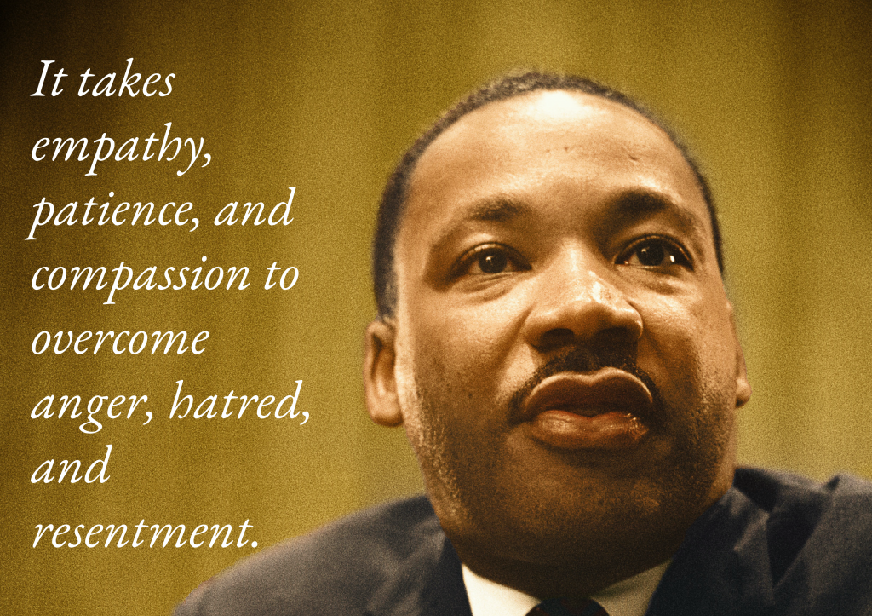
In 1957 he was elected president of the Southern Christian Leadership Conference, an organization formed to provide new leadership for the now burgeoning civil rights movement. The ideals for this organization he took from Christianity; its operational techniques from Gandhi. In the eleven-year period between 1957 and 1968, King traveled over six million miles and spoke over twenty-five hundred times, appearing wherever there was injustice, protest, and action; and meanwhile he wrote five books as well as numerous articles. In these years, he led a massive protest in Birmingham, Alabama, that caught the attention of the entire world, providing what he called a coalition of conscience. and inspiring his “Letter from a Birmingham Jail”, a manifesto of the Negro revolution; he planned the drives in Alabama for the registration of Negroes as voters; he directed the peaceful march on Washington, D.C., of 250,000 people to whom he delivered his address, “l Have a Dream”, he conferred with President John F. Kennedy and campaigned for President Lyndon B. Johnson; he was arrested upwards of twenty times and assaulted at least four times; he was awarded five honorary degrees; was named Man of the Year by Time magazine in 1963; and became not only the symbolic leader of American blacks but also a world figure.
At the age of thirty-five, Martin Luther King, Jr., was the youngest man to have received the Nobel Peace Prize. When notified of his selection, he announced that he would turn over the prize money of $54,123 to the furtherance of the civil rights movement.
On the evening of April 4, 1968, while standing on the balcony of his motel room in Memphis, Tennessee, where he was to lead a protest march in sympathy with striking garbage workers of that city, he was assassinated.

LOCAL NEWS
- Are you in need of grocery delivery service? Call 620-228-5570 for more information on this new service.

- La Harpe Days T-Shirts available at City Hall.

- Don’t forget, we have a community food box in front of City Hall…. Take what you need, leave what you can.

- Stay informed with activities in the community by calling the information line (620) 496-3112

If you need assistance after-hours please call the Iola Dispatch Center at (620) 365-1437, they will notify the proper personnel.
HAPPY BIRTHDAY TO ALL LAHARPE CITIZENS CELEBRATING A BIRTHDAY THIS MONTH!!!! MAY YOUR DAY BE AS SPECIAL AS YOU ARE TO US!

In January 2023 you will probably see city crews and construction crews on your properties locating sewer manholes and lines. HK Solutions will be in town January 9th to start their work of our city sewer lines. If you have questions, please call city hall at 620-496-2241.

Dates to remember:

City Hall will be closed January 2nd in observance of New Years Day. Happy New Years!!!
January 11th: Council Meeting at City Hall at 7:00 pm

January 16th: PRIDE Meeting at 7:00 p.m. at the City Hall
January 25th: Past due Utility shut off date.
If you can’t pay your account in full at this time then you must submit your reasoning to the City Clerk BEFORE January 25th.

CITY COUNCIL NEWS
CITIZENS CALL FOR BUSINESS
No business discussed.

UNFINISHED BUSINESS
- Water Tower – Tabled until January for a special meeting.
- Sewer Rates – Cynthia Carr stated she would rather wait until all council members are present. Mayor Crowell suggested a special meeting Tuesday, December 20th at 6:00pm if everyone can make it.
- Sewer Fund – Mayor Crowell stated we need to move money into the sewer account because we can’t finish the year in the negative. She suggested transferring $12,000.00 out of the electric fund. (Danny Ware Jr arrived) Sharlyn Thompson made the motion to transfer $12,000.00 out of the electric fund and in to the sewer fund. Cynthia Carr seconded. Motion carried 4-0.
- Hay Permit with Stipulations – Tabled until January.
- Park Cameras – Council decided to add item to special meeting on Tuesday, December 20, 2022.

NEW BUSINESS
- Road Grader Bids – Mayor Crowell opened 3 bids; Eldon Thomas submitted a bid for $7,283.00 with the option to raise his bid after all bids were opened. Steve Powers submitted a bid for $13,505.00 and Steve Terry submitted a bid for $3,000.00. Mayor Crowell gave Eldon Thomas the option to raise his bid, he declined. Sharlyn Thompson made the motion to accept the bid from Steve Powers in the amount of $13,505.00. Cynthia Carr seconded. Motion carried 4-0.
- 2023 Holidays – A list of 2023 holidays were presented to the council for approval;
New Year’s Day, Presidents Day, Memorial Day, Juneteenth, Labor Day, Columbus Day, Veterans Day, Thanksgiving, Friday after Thanksgiving and Christmas. Ron Knavel made the motion to approve the 2023 holidays as presented. Sharlyn Thompson seconded. Motion carried 4-0.
- 2023 COLA – Mayor Crowell stated that Michelle was the only one eligible to receive the COLA increase because she has topped out on her pay and recommended, she gets what the county received which was 3%. Sharlyn Thompson stated Michelle is topped out and should receive the COLA increase of 8.7% which would be $1.60 an hour pay raise. Sharlyn Thompson made the motion to give Michelle a raise of $1.60 per hour effective January 1, 2023. Ron Knavel seconded. Motion carried 4-0. Sharlyn asked how do we know when everyone else tops out, we need to work up a pay scale for the positions.
- HK Solutions Change Order – The council was given a change order from HK regarding manholes that are not able to be located. To CCTV the entire system went from $32,415.60 to $75,819.00. The mobilization fee went up from $1,300.00 to $6,000.00 because of the additional trips they will have to make to town. Locating unfound buried manholes will be charged at $375.00 and hour and the change order had a total of 16 hours listed in the amount of $6,000.00. Dereck Ranes called Jason Solomon with KRWA, Jason is going to get with the crew on Monday to find those manholes. Mayor Crowell requested Michelle to set up a call with BG Consultants and HK Solutions to discuss this change order because we have found a discrepancy in the footage according to Penny Miller.

REPORTS OF CITY OFFICERS
- Fred Works, City Attorney – Had nothing to report.

- Roy Caler, Water Representative – Had nothing to report

- Joe Stotler, Police Chief – Shared his monthly time cards and report. He stated the 20 hours overtime he had is being paid by the state with the grant proceeds.

- Penny Miller, Code/Animal Control – Shared her monthly reports.

- Marc Waggoner, Fire Chief- Absent from meeting but shared the meeting minutes: We started meeting with Magellan Technician, going over pipeline procedures and safety. Then we took fire units out and identified pipeline markers and called out numbers in case of pipeline emergency. Returned to the barn and adjourned the meeting. Michael Waggoner has moved and is no longer on the fire department.

- Maintenance Department –The workorders were shared. Dereck Ranes turned in his monthly report on his schooling. Dereck mentioned that he would like bays for the loose items at the park, stating they are $55.00 apiece. After doing some figuring on dimensions it was decided that 58 rock were needed, these rocks are 2X2X6 in size. Danny Ware Jr made the motion to purchase 58 rock in the amount of $3,190.00 and take the money out of the $13,505.00 we are receiving for the road grader. Ron Knavel seconded. Motion carried 4-0.

- Michelle Altis, City Clerk – Nothing to report

DISCUSSION ON AGENDA ITEMS –
Mayor Crowell requested an executive session on non-elected personnel for 30 minutes. Sharlyn Thompson made the motion to go into executive session on non-elected personnel for 30 minutes. Danny Ware Jr seconded. Motion carried 4-0.
Danny Ware Jr made the motion to extend the executive session on non-elected personnel for 20 minutes. Ron Knavel seconded. Motion carried 4-0.
After returning to regular session Danny Ware Jr made the motion to give Penny Miller a $1.00 an hour raise, Larry Laird a $3.00 an hour raise and Dereck Ranes a $1.50 an hour raise effective December 1, 2022. Dereck asked about Larry being a parttime employee. Mayor Crowell stated Larry is parttime, required to work 30 hours a week and will receive 1/2 of the sick and vacation time. He will also stay on the on-call schedule, even after we hire someone, that way you are only on call one weekend a month.
Mayor: Ella Mae Crowell (620) 496-6219
City Attorney: Fred Works
City Municipal Judge: Patty Miklos
Police Chief: Joseph Stotler
Fire Chief: Marc Waggoner
Assistant Fire Chief: Dennis Sidebottom
City Clerk: Michelle Altis
Assistant Clerk: Teresa Driskel
City Treasurer: Audra Riggins
Maintenance Staff: Dereck Ranes & Larry Laird
Code & Animal Control: Penny Miller

City Council Members:
Austin Lee (496-2323) Danny Ware Jr. (496-2156)
Cynthia Carr (496-7500) Sharlyn Thompson (496-3348)
Ron Knavel (496-2508)
Laharpe City Hall Hours: Monday-Friday
902 S. Washington 8:00-12:00 & 1:00-5:00
P.O. Box 10 Ph. (620) 496-2241
Laharpe, KS. 66751 Fax (620) 496-2240

CHECK OUT OUR WEBSITE; CITYOFLAHARPE.ORG Follow us on Facebook

Tangy Honey-Glazed Ham

Ingredients
- 1 (10 pound) fully-cooked, bone-in ham
- 1 ¼ cups packed dark brown sugar
- ⅓ cup pineapple juice
- ⅓ cup honey, or more to taste
- ⅓ large orange
- 2 tablespoons Dijon mustard
- ¼ teaspoon ground cloves
- 1 ½ teaspoons lemon juice, or to taste (Optional)

Directions
- Preheat the oven to 325 degrees F (165 degrees C). Place ham in a roasting pan.
- Bake ham, uncovered, in the preheated oven for 2 hours.
- While the ham is baking, combine brown sugar, pineapple juice, and 1/3 cup honey in a saucepan. Zest orange into the saucepan, then squeeze in the juice. Add Dijon mustard and ground cloves; whisk mixture over medium-high heat as it comes to a boil. Reduce heat and simmer until glaze thickens slightly, 5 to 10 minutes.
- Taste glaze and adjust seasonings. Add lemon juice for more tang, or honey to make it sweeter. Set aside.
- Remove ham from the oven after it has baked for 2 hours. Brush with glaze. Bake for an additional 30 to 45 minutes, brushing ham with glaze every 10 minutes.

Tips
Add leftover glaze to the pan drippings along with a little flour or cornstarch to make a nice sauce to accompany the meat. Use the ham bone and any trimmings to make soup afterward.

Chef John's Parker House Rolls

Ingredients
- ½ cup warm milk
- ½ cup warm water
- 1 package active dry yeast
- 2 large eggs
- 3 tablespoons white sugar
- 1 ½ teaspoons kosher salt
- ¾ cup unsalted butter, melted, divided
- 4 ½ cups all-purpose flour, plus more as needed

Directions
- Combine warm milk, warm water, and dry yeast in the mixing bowl of a stand mixer. Let sit for 10 minutes. Add eggs, sugar, salt, and 1/2 cup melted butter. Whisk all wet ingredients together. Add all-purpose flour and knead with the dough hook (or manually) until dough comes together as a ball, 5 to 6 minutes.
- Place dough into a lightly buttered bowl, cover, and let sit until the dough is doubled in size, about 2 hours.
- Press the dough until it is flat, and divide into 24 equal portions. Form each portion into a smooth ball.
- Line a baking sheet with a Silpat mat or parchment paper.
- Take each ball of dough and roll out on a lightly floured surface into an oval, 4 to 5 inches long. Brush the top with some of the remaining butter and fold in half.
- Transfer the rolls to the prepared baking sheet, arranging in 6 rows of 4 rolls. Cover with a clean kitchen towel and let the rolls rise in a warm spot until almost doubled in size, about 1 hour.
- Preheat the oven to 350 degrees C (175 degrees C).
- Bake rolls in the preheated oven until golden brown on top, about 25 minutes.
- While rolls are still warm, brush the tops of the rolls with melted butter.

Chocolate Thumbprint Cookies

Ingredients
Cookies
- ¾ cup unsalted butter, softened
- 1 cup powdered sugar
- 1 large egg
- 1 teaspoon vanilla extract
- 2 cups all-purpose flour
- ¼ cup unsweetened cocoa powder
- ¾ teaspoon kosher salt
- ½ teaspoon ground cinnamon
- sanding sugar
Filling
- ¼ cup heavy whipping cream
- 2 ounces semi-sweet chocolate, chopped

Directions
- Preheat oven to 350 degrees F (175 degrees C). Position racks in the upper and lower thirds of oven. Line 2 baking sheets with parchment paper.
- Beat butter and sugar at medium speed with an electric mixer until fluffy, about 4 minutes. Add egg and vanilla, beating until incorporated.
- Whisk together flour, cocoa, salt, and cinnamon in a medium bowl until combined. With mixer on low speed, gradually add flour mixture to butter mixture, beating until well combined, about 2 minutes.
- Roll dough into 1 1/4-inch balls, then roll balls in sanding sugar. Place on the prepared baking sheets, spacing 2 inches apart. Press the center of each ball with your thumb (about 1/2-inch deep and 1/2-inch wide).
- Bake in preheated oven in upper and lower thirds, 2 baking sheets at a time, rotating top to bottom and bottom to top halfway through, until cookies are set and almost firm, 8 to 10 minutes.
- Let cool on baking sheets, about 15 minutes. When cool, press the center of each ball with your thumb again—the indentations will have puffed in the oven.
- Heat cream in a small microwavable bowl on HIGH until just steaming, about 45 seconds. Remove from the heat, and add chopped chocolate. Let the mixture sit, undisturbed, for 2 minutes. Stir until melted and smooth. Let cool until slightly thickened, about 5 minutes. Place about 1 teaspoon filling in the center of each cookie. Slide the cookies into the refrigerator for about 10 minutes to set the filling. The cookies will keep for about 5 days in an airtight container at room temperature.

