

JANUARY NEWSLETTER



Happy New Year!

In the United States and many other countries around the world, January 1, the first day of the Gregorian calendar, ushers in a new year replete with [New Year’s](https://www.history.com/topics/holidays/new-years) resolutions and promises to do better than in the year before. The day begins with hangover concoctions for some and, for others, prayers of gratitude for surviving to see a new year filled with promise. But how did this holiday begin? It’s a very old story.

Most civilizations aligned their calendars with the moon. The ancient Mesopotamians and Babylonians observed the new year over 4,000 years ago. For them, a new year followed the phases of the moon and the vernal equinox — when sunlight and darkness were equally balanced.

The Babylonians ritualized the vernal equinox with Akitu, a religious observance spanning 11 days. The Egyptians marked the new year with the flooded waters of the Nile and the star, Sirius. To this very day, the Chinese New Year arrives with the second new moon after the winter solstice.

The evolution from the lunar calendar to today’s Gregorian calendar commences with the early Roman calendar devised by Romulus, allegedly suckled by wolves who, along with his brother, Remus, founded Rome. The original Roman calendar was introduced in the 8th century at the start of the vernal equinox (when the light and the darkness are equal, remember?) with 10 months and 304 days. Another Roman king, Numa Pompilius added Januarius and Februarius.

Most historians credit the Roman emperor Julius Caesar with developing the Julian calendar, designating January 1 as the start of a new year. The Gregorian calendar, which many nations around the world use today, arrived in 1582 when Pope Gregory XIII aligned the calendar, not with the moon, but with the earth’s rotation around the sun — marking 365 days.



.



**Martin Luther King Jr. Day, January 20, 2025**

On November 2, 1983, President Ronald Reagan signed the King Holiday Bill into law, designating the third Monday in January a federal holiday in observance of civil rights leader Dr. Martin Luther King, Jr. The legislation to recognize Martin Luther King Jr. Day was first introduced just four days after his assassination on April 4, 1968. Still, it would take 15 years of persistence by civil rights activists for the holiday to be approved by the federal government and an additional 17 years for it to be recognized in all 50 states. Today, it is the only federal holiday designated as a National Day of Service to encourage all Americans to volunteer and improve their communities.

Despite the [national fervor](https://nmaahc.si.edu/blog-post/mourning-death-martin-luther-king-jr) inspired by King's death, the bill to create a holiday in his honor languished for years with limited congressional support. However, Democratic Michigan Congressman, John Conyers, who first proposed the bill on April 8, 1968, was not deterred. He continued to reintroduce the legislation every year with the support of the Congressional Black Caucus, which Conyers helped found.

In 1979, on the 50th anniversary of King’s birth, the bill finally came to a vote in the House. However, even with a petition of 300,000 signatures in support, the backing of President Jimmy Carter, and testimonials from King’s widow, Coretta Scott King, the bill still was rejected by five votes in the House. Republican Missouri Congressman Gene Taylor led the opposition, which cited the costs of an additional federal holiday and traditions which exclude private citizens from receiving recognition with public holidays named in their honor.

Even though it failed to pass in the House, public support for the bill continued to grow, in no small part due to musician Stevie Wonder. The Motown singer and songwriter’s 1980 album “Hotter Than July” featured the song “Happy Birthday,” which served as an ode to King's vision and a rallying cry for recognition of his achievements with a national holiday.

Wonder continued to spread his message with regular appearances alongside Coretta Scott King at rallies. He also capped a four-month tour with a benefit concert on the National Mall, where King delivered his famous “I have a Dream” speech 18 years earlier.

When the bill again made it to the house floor in 1983, fifteen years after King’s murder, support was overwhelming. Working together, Coretta Scott King, the Congressional Black Caucus, and Stevie Wonder amassed a six million signature petition in favor of the holiday. The bill easily passed in the House with a vote of 338 to 90. However, when the bill moved onto the Senate, Republican North Carolina Senator, Jesse Helms attempted to dismiss the legislation by submitting documents alleging that the civil rights leader harbored ties to the communist party. Outraged by the personal attack on King's character, Democratic New York Congressman Daniel Patrick Moynihan threw the more than 300-page binder to the ground and stomped on what he described as a "packet of filth." After two days of debate, the bill passed in the Senate and President Ronald Regan reluctantly agreed to sign it into law.

Despite the holiday’s federal recognition, statewide observance of Martin Luther King Jr. Day is far from uniform. Some states include additional holidays, which are celebrated concurrently with Martin Luther King Jr. Day. Arizona and New Hampshire, for example, celebrate “Civil Rights Day” and Wyoming celebrates “Wyoming Equality Day.” Other states, like Alabama and Mississippi, have combined the King holiday with “Robert E. Lee Day” to honor the birthday of Confederate General Robert E. Lee, who was born on January 19. However, Martin Luther King Day has been recognized in all 50 states since early 2000.

On August 23, 1994, the King Holiday and Service Act was signed into law by President Bill Clinton. Inspired by King’s life of service, Congressman John Lewis and former Senator Harris Wofford proposed the legislation to encourage Americans to find common causes and methods of improving their communities. In honor of Congressman Lewis’ initiative to make the Martin Luther King, Jr. holiday “a day on, not a day off” the National Museum of African American History and Culture has organized donation drives to those in need and partnered with corporations to provide music, film screenings and interactive activities to the public. If you are interested in giving back to your community this year, we encourage you to explore our website for volunteer opportunities or participate in the [transcription of the Freedmen’s Bureau papers](https://nmaahc.si.edu/explore/initiatives/freedmens-bureau-records).

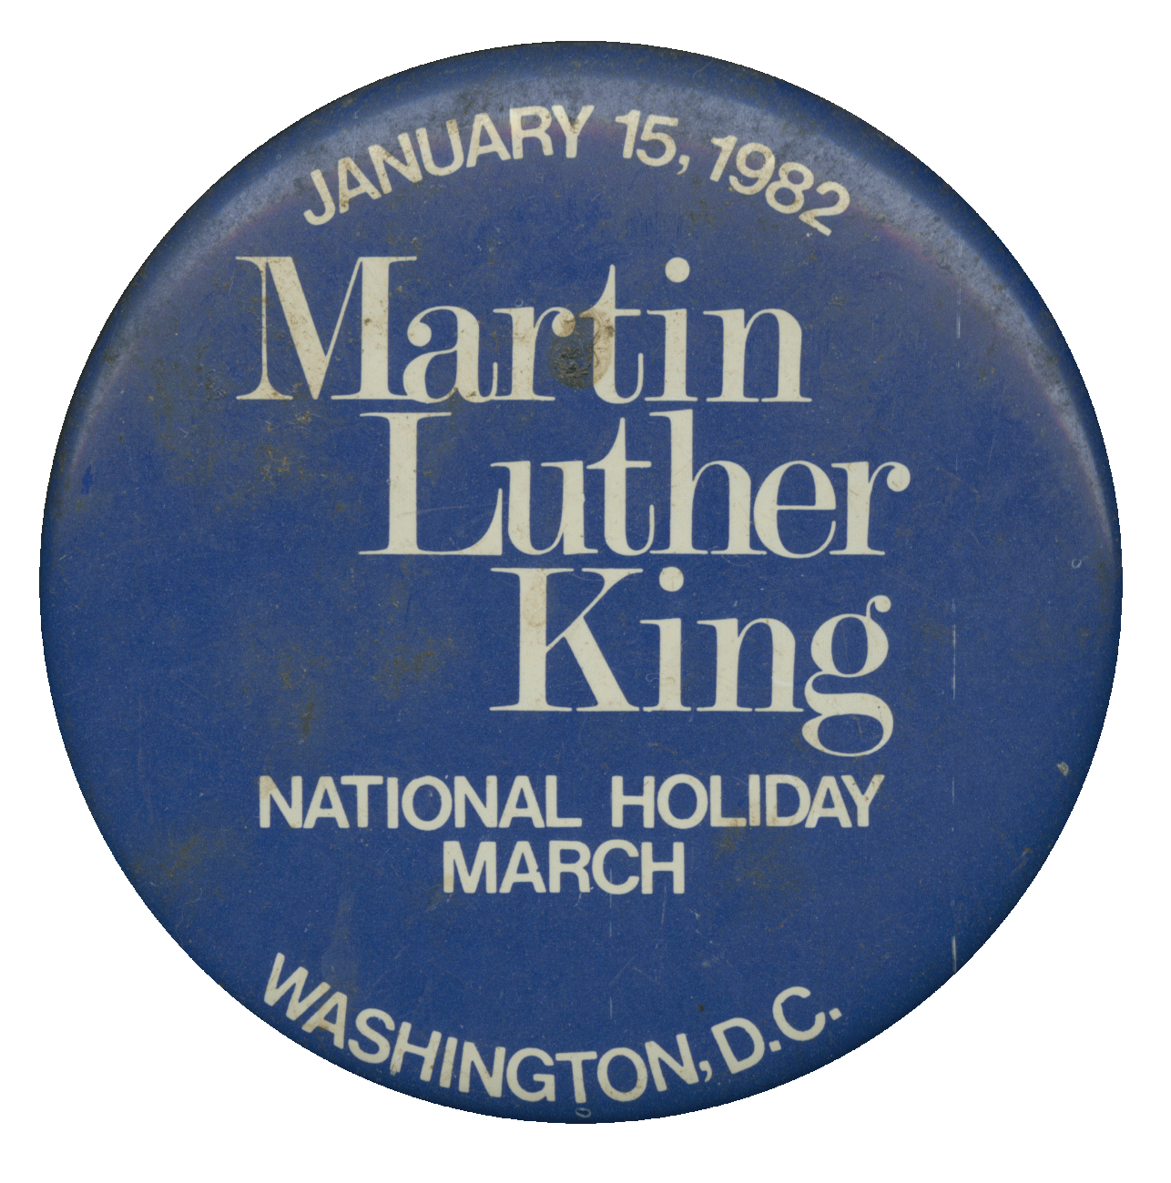



 LOCAL NEWS

* Don’t forget, we have a community food box in front of City Hall…. Take what you need, leave what you can.
* 2025 City Dog Tags available for purchase. Please bring proof of rabies vaccination.

**The City Hall phone number will be changing after the first of the year! Not sure how fast it will all take place, but make note of our new numbers: (620)365-5956, (620)365-7974 and our fax will be (620)365-3944.**

**If you need assistance after-hours, please call the Iola Dispatch Center at (620) 365-1437, they will notify the proper personnel.**

 *HAPPY BIRTHDAY TO ALL LAHARPE CITIZENS CELEBRATING A BIRTHDAY THIS MONTH!!!! MAY YOUR DAY BE AS SPECIAL AS YOU ARE TO US!*

**Dates to remember:**

City Hall will be closed January 1st in observance of New Years Day. Happy New Years!!!

January 8th: Council Meeting at City Hall at 7:00 pm

January 20th: PRIDE Meeting at 7:00 p.m. at the City Hall

[](http://www.google.com/url?sa=i&rct=j&q=&esrc=s&source=images&cd=&cad=rja&uact=8&ved=0ahUKEwiI3_mmgoLLAhVW9mMKHe22Ar8QjRwIBw&url=http://www.paymentus.com/industry-utilities.html&psig=AFQjCNF-5ANx5SktbJug46KiWwMehsjzzw&ust=1455908868261283) January 28th: **Past due Utility shut off date.**

**CITY COUNCIL NEWS**

**PUBLIC HEARING – NEIGHBORHOOD REVITALIZATION PLAN**

Mayor Crowell opened the public hearing on the neighborhood revitalization plan for public comments. No public comments were presented. Mayor Crowell requested authorization to execute by signing the plan. Cynthia Carr made the motion to authorize the mayor to sign the documents needed for the NRP. Ron Knavel seconded. Motion carried 4-0. Mayor Crowell closed the public hearing.

**CITIZENS CALL FOR BUSINESS**

1. Citizen, Roger Womelsdorf shared that he had an electrical issue and the city hired KJ Electric to fix it but whatever they did fried everything in the house. Roger stated, the electrician said he would take care of everything, I am just wanting to bring this to your attention and wondering about some sort of compensation. City attorney, Fred Works, suggested he get a second opinion and turn it in to the insurance company, and the city will back your claim because the city hired a contractor that should be insured.
2. JC Westervelt, father to Braden Westervelt, expressed concerns about a large bill his son received because of a tree that took out a powerline. JC Westervelt asked the council if they would consider rescinding the bill because it was an act of nature. Fred explained how the homeowner is responsible for the dead tree which could have fallen on a car or house. Sharlyn Thompson suggested the city could work with Braden on a payment plan but the city is out of money because of the tree and we need to recoup our costs. Braden did mention that he filed a claim with his insurance company and waiting to hear back. Mayor Crowell suggested he keep us n form and the city can give you some time to work it out.

**UNFINISHED BUSINESS**

1. Emergency Water Supply Plan – Sharlyn Thompson made the motion to accept the plan. Angela Barker seconded. Motion carried 40.
2. Employee Insurance Benefits – Mayor Crowell recommended the city go with KMIT and change the deductible. She stated if the employee wants a lower deductible, they will pay the difference and the employees will pay for dental and vision coverage. Sharlyn Thompson made the motion to go with the Blue Edge Plan with a $5,000.00 deductible for $511.11 a month per employee and if the employee wants a lower deductible, they will pay the difference and the employee will also pay for dental and vision if they want it. Ron Knavel seconded. Motion carried 3-1, Cynthia Carr opposed.
3. Ninnescah Flats Solar Project – Sharlyn Thompson made the motion to sign the agreement and resolution for the solar project. Cynthia Carr seconded. Motion carried 3-1, Ron Knavel opposed.
4. Kwikom Business Phones – Mayor Crowell stated the city could save about $115.00 a month by changing our phone service to Kwikom. Sharlyn Thompson made the motion to switch over to Kwikom. Angela Barker seconded. Motion carried 3-1, Cynthia Carr opposed.
5. Kennel Fees – Tabled to January.
6. Employee Handbook & Job Descriptions – Tabled for a workshop at a latter date.

**NEW BUSINESS**

1. 2025 Holiday Proposal – Ron Knavel made the motion to accept the proposal except keep new year’s day at January 1, 2025. Cynthia Carr seconded. Motion carried 4-0.

The 2025 Holiday schedule will be:

Wednesday, January 1st, New Years Day

Monday, February 17th, Washington’s Birthday

Monday, May 26th, Memorial Day

Friday, July 4th, Independence Day

Monday, September 1st, Labor Day

Monday, October 13th, Columbus Day

Thursday, November 27th and Friday, November 28th, Thanksgiving and the day after

Thursday, December 25th and Friday December 26th, Christmas and the day after

1. 2025 COLA – Mayor Crowell requested this moved to the end of the meeting for an executive session on non-elected personnel.

**REPORTS OF CITY OFFICERS**

1. Fred Works, City Attorney – Shared court costs from other courts.
2. Roy Caler, Water Representative – Nothing to report.
3. Penny Miller, Code/Animal Control –Shared her monthly reports.
4. Marc Waggoner, Fire Chief- Shared the fire meeting minutes; The LaHarpe Volunteer Fire Department met for the monthly meeting. Present: Josh Sparks, Marc Waggoner Sr., Kiefer Endicott, Matthew Waggoner, Dennis Sidebottom, Bill Gay, Trevor Stover and Meghan Sparks. Absent were Pamela Waggoner, Ronald Splector and Justin Pritchard. Started meeting, welcomed new firefighter Trevor Stover, started training him on operations on truck then continued on modifications on fire station, then ended meeting.
5. Maintenance Department - The workorders were shared. Mayor Crowell suggested the city reach out to Steve Robb an offer him an hourly wage to help the crew when they need it. Ron thought it would be a good idea to visit with him.
6. Michelle Altis, City Clerk – Michelle shared that she passed her small system water test.

**DISCUSSION ON AGENDA ITEMS –**

Mayor Crowell requested a motion to go into an executive session on non-elected personnel for 5 minutes. Angela Barker made the motion to go into an executive session on non-elected personnel for 5 minutes. Sharlyn Thompson seconded. Motion carried 4-0.

After returning to regular session Ron Knavel made the motion to give Michelle Altis a $1.00 per hour raise effective January 1, 2025. Angela Barker seconded. Motion carried 4-0.



***Mayor****: Ella Mae Crowell (620) 496-6219*

***City Attorney****: Fred Works*

***City Municipal Judge****: Patty Miklos*

***Police Chief****:*

***Fire Chief****: Marc Waggoner*

***Assistant Fire Chief****: Dennis Sidebottom*

***City Clerk****: Michelle Altis*

***Assistant Clerk****: Teresa Driskel*

***City Treasurer****: Audra Riggins*

***Maintenance Staff****: Larry Laird & Penny Miller*

***Code & Animal Control****: Penny Miller*

***City Council Members:***

***Angela Barker (224-6209) Danny Ware Jr. (496-2156)***

***Cynthia Carr (496-7500) Sharlyn Thompson (405-0272)***

***Ron Knavel (496-2508)***

***Laharpe City Hall Hours: Monday-Friday***

902 S. Washington 8:00-12:00 & 1:00-5:00

P.O. Box 10 Ph. (620) 496-2241

Laharpe, KS. 66751 Fax (620) 496-2240

# *CHECK OUT OUR WEBSITE; CITYOFLAHARPE.ORG* *Follow us on Facebook*

# 

# Slow-Cooker Vegetable Soup

## Ingredients

* 1 pound beef top round steak, cut into 1/2-inch cubes
* 1 can (14-1/2 ounces) diced tomatoes, undrained
* 2 medium potatoes, peeled and cubed
* 2 medium onions, diced
* 3 celery ribs, sliced
* 2 carrots, sliced
* 3 beef bouillon cubes
* 1/2 teaspoon salt
* 1/2 teaspoon dried basil
* 1/2 teaspoon dried oregano
* 1/4 teaspoon pepper
* 3 cups water
* 1-1/2 cups frozen mixed vegetables

## Directions

* **1.** In a 3-qt. slow cooker, combine the first 12 ingredients. Cover and cook on high for 6-8 hours. Add the mixed vegetables; cover and cook 2 hours longer or until meat and vegetables are tender.



# The Ultimate Grilled Cheese

## Ingredients

* 3 ounces cream cheese, softened
* 3/4 cup mayonnaise
* 1 cup shredded part-skim mozzarella cheese
* 1 cup shredded cheddar cheese
* 1/2 teaspoon garlic powder
* 1/8 teaspoon seasoned salt
* 10 slices Italian bread (1/2 inch thick)
* 2 tablespoons butter, softened

## Directions

* **1.** In a large bowl, beat cream cheese and mayonnaise until smooth. Stir in the cheeses, garlic powder and seasoned salt. Spread 5 slices of bread with the cheese mixture, about 1/3 cup on each. Top with remaining bread.
* **2.** Butter the outsides of sandwiches. In a skillet over medium heat, toast sandwiches for 4-5 minutes on each side or until bread is lightly browned and cheese is melted.



**Navy Bean Soup**

**Ingredients**

* 3 cups (1-1/2 pounds) dried navy beans
* 1 can (14-1/2 ounces) diced tomatoes, undrained
* 1 large onion, chopped
* 1 meaty ham hock or 1 cup diced cooked ham
* 2 cups chicken broth
* 2-1/2 cups water
* Salt and pepper to taste
* Minced fresh parsley, optional

**Directions**

1. Rinse and sort beans; soak according to package directions.
2. Drain and rinse beans, discarding liquid. Place in a Dutch oven. Add the tomatoes with juice, onion, ham hock, broth, water, salt and pepper. Bring to a boil. Reduce heat; cover and simmer until beans are tender, about 1-1/2 hours.
3. Add more water if necessary. Remove ham hock and let it stand until cool enough to handle. Remove meat from bone; discard bone. Cut meat into bite-sized pieces; set aside. (For a thicker soup, cool slightly, then puree beans in a food processor or blender and return to pan.) Return ham to soup and heat through. Garnish with parsley if desired.



**Honey Cinnamon Roll-Ups**

**Ingredients**

* 2 cups ground walnuts, toasted
* 1/4 cup sugar
* 2 teaspoons ground cinnamon
* 12 sheets frozen phyllo dough, thawed
* 1/2 cup butter, melted

**SYRUP:**

* 1/2 cup honey
* 1/2 cup sugar
* 1/2 cup water
* 1 tablespoon lemon juice

**Directions**

1. Preheat oven to 350°. Combine walnuts, sugar and cinnamon.
2. Place 1 sheet of phyllo dough on a 15x12-in. piece of waxed paper; brush with butter. Place a second phyllo sheet on top, brushing it with butter. (Keep remaining phyllo covered with a damp towel to prevent it from drying out.) Sprinkle with 1/4 cup walnut mixture. Using waxed paper, roll up tightly jelly-roll style, starting with a long side, removing paper as you roll. Slice roll into 4 smaller rolls; transfer rolls to a greased 13x9-in. baking dish. Repeat with remaining phyllo dough and walnut mixture, by 1/4 cupful’s. Bake until light brown, 14-16 minutes. Cool dish on a wire rack.
3. Meanwhile, in a small saucepan, combine all syrup ingredients. Bring to a boil. Reduce heat; simmer 5 minutes. Cool 10 minutes. Drizzle cinnamon rolls with syrup; sprinkle with remaining walnut mixture.

