FEBRUARY NEWSLETTER



On Feb. 14, sweethearts of all ages will exchange cards, flowers, candy, and more lavish gifts in the name of St. Valentine. But as a [historian of Christianity](https://dornsife.usc.edu/bitel-homepage/), I can tell you that at the root of our modern holiday is a beautiful fiction. St. Valentine was no lover or patron of love.

Valentine’s Day, in fact, originated as a liturgical feast to celebrate the decapitation of a third-century Christian martyr, or perhaps two. So, how did we get from beheading to betrothing on Valentine’s Day?

Ancient sources reveal that there were several St. Valentines who died on Feb. 14. Two of them were executed during the reign of [Roman Emperor Claudius Gothicus](https://archive.org/stream/scriptoreshistor01camb/scriptoreshistor01camb_djvu.txt) in 269-270 A.D., at a time when persecution of Christians was common.

How do we know this? Because, an order of Belgian monks spent three centuries collecting evidence for the lives of saints from manuscript archives around the known world.

They were called [Bollandists](http://www.bollandistes.org/thebollandists-hist0.php?pg=hist00) after Jean Bolland, a Jesuit scholar who began publishing the massive 68-folio volumes of [“Acta Sanctorum,”](http://acta.chadwyck.co.uk/) or “Lives of the Saints,” beginning in 1643.

Since then, successive generations of monks continued the work until the last volume was published in 1940. The Brothers dug up every scrap of information about every saint on the liturgical calendar and printed the texts arranged according to the [saint’s feast day](http://saintscatholic.blogspot.com/p/saint-of-day.html).

The volume encompassing Feb. 14 contains the stories of a handful of “Valentini,” including the earliest three of whom died in the third century.

 The earliest Valentinus is said to have died in Africa, along with 24 soldiers. Unfortunately, even the Bollandists could not find any more information about him. As the monks knew, sometimes all that the saints left behind was [a name and day of death](https://archive.org/stream/actasanctorum05unse#page/762/mode/2up/search/valentinus).

We know only a little more about the other two Valentines.

According to a late medieval legend reprinted in the “Acta,” which was accompanied by Bollandist critique about its historical value, a Roman priest named Valentinus was arrested during the reign of Emperor Gothicus and put into the custody of an aristocrat named Asterius.

As the story goes, Asterius made the mistake of letting the preacher talk. Father Valentinus went on and on about [Christ leading pagans](https://archive.org/stream/actasanctorum05unse#page/754/mode/2up/search/valentinus) out of the shadow of darkness and into the light of truth and salvation. Asterius made a bargain with Valentinus: If the Christian could cure Asterius’s foster-daughter of blindness, he would convert. Valentinus put his hands over the girl’s eyes and [chanted](https://archive.org/stream/actasanctorum05unse#page/754/mode/2up/search/valentinus):

*“Lord Jesus Christ, en-lighten your handmaid, because you are God, the True Light.”*

Easy as that. The child could see, according to the medieval legend. Asterius and his whole family were baptized. Unfortunately, when Emperor Gothicus heard the news, he ordered them all to be executed. But Valentinus was the only one to be beheaded. A pious widow, though, made off with his body and [had it buried at the site](https://archive.org/stream/actasanctorum05unse#page/754/mode/2up/search/valentinus) of his martyrdom on the [Via Flaminia](http://penelope.uchicago.edu/Thayer/E/Gazetteer/Periods/Roman/Topics/Engineering/roads/Flaminia/home.html), the ancient highway stretching from Rome to present-day Rimini. Later, a chapel was built over the saint’s remains.



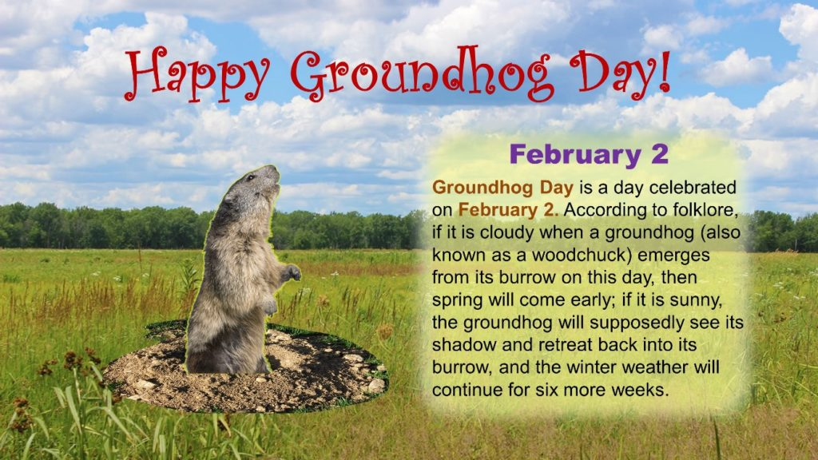

**Groundhog Day** falls on **February 2**! Will Punxsutawney Phil see his shadow? Find out what the result means for gardening. Plus, learn about the ancient origins of this holiday, once named Imbolc (the midpoint between the winter solstice and spring equinox), which is also celebrated as Candlemas.

**Will the Groundhog See His Shadow in 2025?**

According to our weather predictions, February 2, 2025, will bring snow showers and cold weather. We think that when Punxsutawney Phil—that Seer of Seers, Sage of Sages, Weather Prognosticator Extraordinary— emerges from his burrow (with a little help from his handlers) to make his [much-anticipated forecast](https://www.visitpa.com/live-stream-phils-prediction), he **will NOT see his shadow,**which indicates an early spring!

Groundhog Day is famously connected to weather prediction, with the most prominent tradition involving a groundhog predicting the conclusion of winter by seeing (or not seeing) his own shadow. According to weather lore:

* **Sees His Shadow:**If the plump prognosticator emerges from his hole on a clear day and sees his shadow, he will retreat, and there will be six more weeks of wintry weather.  
  OR
* **No Shadow:** If he emerges from his burrow and does NOT see his shadow, then early spring weather is right around the corner.

## What is the Meaning Behind Groundhog Day?

### Imbolc Origins

Originally, Groundhog Day was a Celtic festival marking the year’s first **cross-quarter day**, or a midpoint between seasons.

Celebrated at the beginning of February, the day was called **Imbolc**—a term from Old Irish that is most often translated as “in the belly”—a reference to the soon-to-arrive lambs of spring. The celebration of Imbolc signaled that the Sun was halfway through its advance towards the spring equinox, and the season of new birth and light was on the horizon.

This day has also been called **St. Brigid’s Day**, which stems from a mixing of figures and traditions from pagan and Christian beliefs. The Celtic goddess Brigantia is associated with dawn, light, and spring, which are qualities later associated with Brigid of Kildare, a Christian saint (and one of Ireland’s patron saints).



## 

## Presidents’ Day is Monday, February 17, 2025! Did you know that the official federal holiday is called “Washington’s Birthday”? So, why do some states call it Presidents’ Day?

## Is This Holiday Called Presidents’ Day or Washington’s Birthday?

## Although the holiday is most often called “Presidents’ Day,” the observed federal holiday is officially called “Washington’s Birthday.”

## Neither Congress nor the president has ever stipulated that the name of the holiday observed as Washington’s Birthday be changed to Presidents’ Day. Additionally, Congress has never declared a national holiday binding in all states; each state has the freedom to determine its legal holidays. This is why there are some calendar discrepancies when it comes to this holiday’s date.

## So Why Is Washington’s Birthday Commonly Called Presidents’ Day?

## In a sense, calling the holiday Presidents’ Day helps us reflect on not just the first president but also our nation’s founding, its values, and what Washington calls in his Farewell Address the “beloved Constitution and union, as received from the Founders.” Also, Abraham Lincoln’s birthday is February 12, so by calling the holiday “Presidents’ Day,” we can also include another remarkable president in our celebrations.

## Today, many calendars list the third Monday of February as Presidents’ Day, just as many U.S. states do. Of course, all of the 3-day retail store sales are called “Presidents’ Day” sales, and this vernacular has also been influential in how we reference the holiday.

## Historically, Americans began celebrating George Washington’s Birthday just months after his death, long before Congress declared it a federal holiday. It was not until 1879, under President Rutherford B. Hayes, that Washington’s Birthday became a legal holiday, to be observed on his birthday, February 22.

## george washington

## Washington’s birthday was celebrated on February 22 until well into the 20th century. In 1968, Congress passed the Monday Holiday Law to “provide uniform annual observances of certain legal public holidays on Mondays.” By creating more 3-day weekends, Congress hoped to “bring substantial benefits to both the spiritual and economic life of the Nation.”



**The City Hall phone number has changed!**

**Please make note of our new numbers:**

**(620)365-5956, (620)365-7974**

**our fax will be (620)365-3944.**



*Note from the animal control officer:*

To whom it may concern

It’s a new year and time to get your dog(s) tagged with the city. There is an ordinance that tells you what you need to register your dog(s) and the ordinance that clearly states that you can’t have more than (3) three dogs per household.

If your dog(s) are not tagged and registered by April 30, 2025 you will be given a NTA (Notice to Appear in court)

If you have any questions, please contact us by phone (620) 365-5956.

Respectfully,

City of La Harpe

City dog tag fees:

Neutered/Spayed = $5.00 a dog

Unneutered/Unspayed = $7.50 a dog

Must have proof of current rabies vaccination to purchase city dog tags.

***A copy of the ordinance, in its entirety, can be viewed at*** [***www.cityoflaharpe.org***](http://www.cityoflaharpe.org)

 LOCAL NEWS

* Are you in need of grocery delivery service? Call 620-228-5570 for more information on this new service.
* La Harpe Days T-Shirts available at City Hall.

**If you need assistance after-hours please call the Iola Dispatch Center at (620) 365-1437, they will notify the proper personnel.**

 *HAPPY BIRTHDAY TO ALL LAHARPE CITIZENS CELEBRATING A BIRTHDAY THIS MONTH!!!! MAY YOUR DAY BE AS SPECIAL AS YOU ARE TO US!*

**Dates to remember:**

February 12th: Council Meeting at City Hall at 7:00 pm

 February 17th: City office will be closed to honor Presidents’ Day.

February 17th: PRIDE Meeting at 7:00 p.m. at the City Hall

[](http://www.google.com/url?sa=i&rct=j&q=&esrc=s&source=images&cd=&cad=rja&uact=8&ved=0ahUKEwiI3_mmgoLLAhVW9mMKHe22Ar8QjRwIBw&url=http://www.paymentus.com/industry-utilities.html&psig=AFQjCNF-5ANx5SktbJug46KiWwMehsjzzw&ust=1455908868261283) February 25th: **Past due Utility shut off date.**

**CITY COUNCIL NEWS**

**CITIZENS CALL FOR BUSINESS**

No citizens call for business was discussed.

**UNFINISHED BUSINESS**

1. Bruce Boettcher with BG Consultants presented updated contracts that need the mayor’s signatures. He stated they are close to the same contract as before just had to change some verbiage for USDA. Ron Knavel made the motion to authorize the mayor to sign the updated contracts. Sharlyn Thompson seconded. Motion carried 4-0.
2. Kennel Fees – tabled until February.
3. Employee handbook changes – A number of changes were discussed in a workshop and those changes were presented to council for approval. Cynthia Carr suggested life insurance be included with the medical, the council agreed. Mayor Crowell requested a motion to accept the handbook with the new changes. Sharlyn Thompson made the motion to accept the changes as presented. Ron Knavel seconded. Motion carried 4-0.

**NEW BUSINESS**

1. Lift Stations - Mayor Crowell stated 3 of our lift stations are operating on one pump, we are waiting for pricing to decide what needs to be done.
2. Core & Main - Michelle shared a quote from Core & Main in the amount of $1,982.65 for the purchase of needed water meters. Ron Knavel made the motion to purchase the water meters. Cynthia Carr seconded. Motion carried 4-0.
3. Council Pay – No action was taken.
4. Condemning of 2 properties – Penny requested approval to move forward with the condemnation of 1202 and 1212 S. Washington. Ron Knavel made the motion to allow Penny to start the process. Angela Barker seconded. Motion carried 4-0.

**REPORTS OF CITY OFFICERS**

1. Fred Works, City Attorney – Nothing to report.
2. Roy Caler, Water Representative – Absent from meeting
3. Penny Miller, Code/Animal Control –Shared her monthly reports.
4. Marc Waggoner, Fire Chief- Absent from meeting
5. Maintenance Department - The workorders were shared.
6. Michelle Altis, City Clerk – Michelle asked the council if the vision and dental policies could remain through the city’s name and the employees pay their monthly premiums to the city. The council was agreeable in doing so.



***Mayor****: Ella Mae Crowell (620) 496-6219*

***City Attorney****: Fred Works*

***City Municipal Judge****: Patty Miklos*

***Police Chief****:*

***Fire Chief****: Marc Waggoner*

***Assistant Fire Chief****: Dennis Sidebottom*

***City Clerk****: Michelle Altis*

***Assistant Clerk****: Teresa Driskel*

***City Treasurer****: Audra Riggins*

***Maintenance Staff****: Larry Laird & Penny Miller*

***Code & Animal Control****: Penny Miller*

***City Council Members:***

***Angela Barker (224-6209) Ron Knavel (496-2508)***

***Cynthia Carr (496-7500) Sharlyn Thompson (405-0272)***

***Laharpe City Hall Hours: Monday-Friday***

902 S. Washington 8:00-12:00 & 1:00-5:00

P.O. Box 10 **Ph. (620) 365-5956**

Laharpe, KS. 66751 **Fax (620) 365-3944**

# *CHECK OUT OUR WEBSITE; CITYOFLAHARPE.ORG* *Follow us on Facebook*

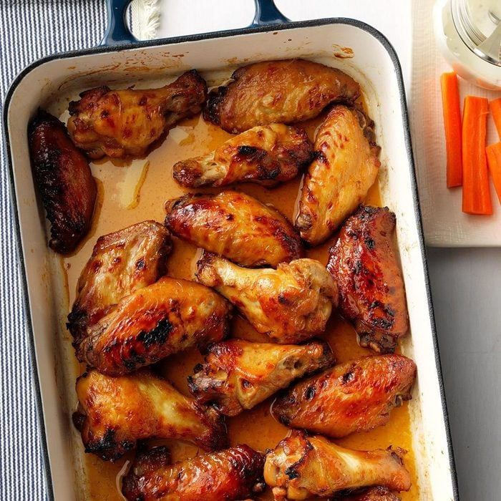

# Sticky Chicken Wings

**Ingredients**

* 3-1/2 to 4 pounds whole chicken wings
* 1 cup packed brown sugar
* 3/4 cup soy sauce
* 1/2 cup teriyaki sauce
* 1/2 cup butter, melted
* 1 tablespoon Creole seasoning
* 1 teaspoon ground mustard

**Directions**

1. Cut chicken wings into 3 sections; discard wing tips. In a large bowl, combine the brown sugar, soy sauce, teriyaki sauce, butter, Creole seasoning and mustard; add chicken and turn to coat; cover and refrigerate for 8 hours or overnight.
2. Drain wings, discarding marinade. Place chicken in a greased 13x9-in. baking dish. Bake, uncovered, at 375° until chicken juices run clear, 45-50 minutes.
3. Transfer the wings to a rack on a broiler pan. Broil 4 in. from the heat until crisp, 2-3 minutes on each side.

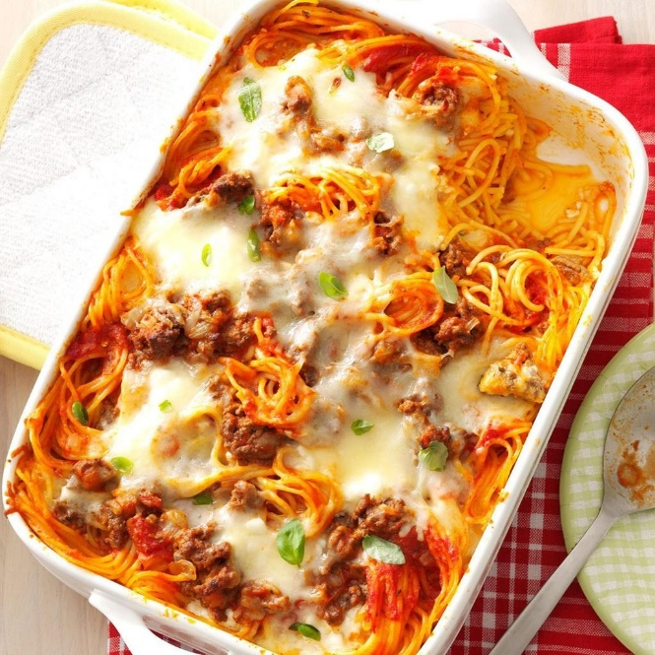

# Baked Spaghetti

**Ingredients**

* 1 package (16 ounces) spaghetti
* 1 pound ground beef
* 1 medium onion, chopped
* 1 jar (24 ounces) pasta sauce
* 1/2 teaspoon seasoned salt
* 2 large eggs
* 1/3 cup grated Parmesan cheese
* 5 tablespoons butter, melted
* 2 cups 4% cottage cheese
* 4 cups shredded part-skim mozzarella cheese
* Chopped fresh basil, optional

**Directions**

1. Preheat oven to 350°. Cook spaghetti according to package directions for al dente. Meanwhile, in a large skillet, cook beef and onion over medium heat for 6-8 minutes or until onion is tender and beef is no longer pink, breaking meat into crumbles; drain. Stir in pasta sauce and seasoned salt.
2. In a large bowl, whisk the eggs, Parmesan cheese and butter. Drain spaghetti; add to the egg mixture and toss to coat.
3. Place half the mixture in a greased 13x9-in. baking dish. Top with half of the cottage cheese, meat sauce and mozzarella cheese. Repeat layers. Place baking dish on a rimmed baking sheet.
4. Cover and bake for 40 minutes. Uncover and bake for 20-25 minutes longer or until heated through. Let stand for 15 minutes before serving. If desired, sprinkle with basil.

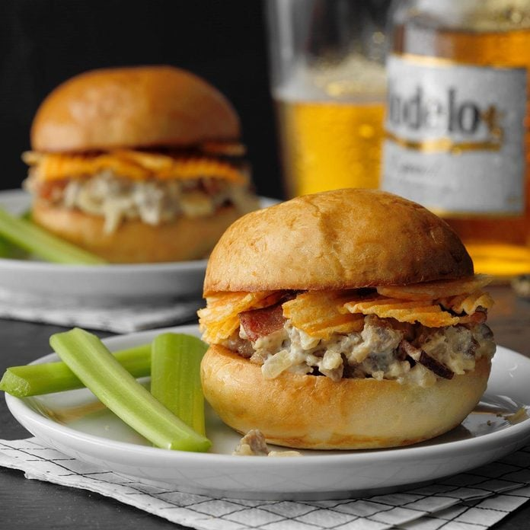

# Touchdown Brat Sliders

**Ingredients**

* 5 thick-sliced bacon strips, chopped
* 1 pound uncooked bratwurst links, casings removed
* 1 large onion, finely chopped
* 2 garlic cloves, minced
* 1 package (8 ounces) cream cheese, cubed
* 1 cup dark beer or nonalcoholic beer
* 1 tablespoon Dijon mustard
* 1/4 teaspoon pepper
* 16 dinner rolls, split and toasted
* 2 cups cheddar and sour cream potato chips, crushed

**Directions**

1. In a large cast-iron or other heavy skillet, cook bacon over medium heat until crisp. Remove to paper towels with a slotted spoon; drain, reserving drippings. Cook bratwurst and onion in drippings over medium heat until meat is no longer pink, breaking into crumbles. Add garlic; cook 1 minute longer. Drain well.
2. Stir in the cream cheese, beer, mustard and pepper. Bring to a boil. Reduce heat; simmer, uncovered, until thickened, 15-20 minutes, stirring occasionally. Stir in bacon. Spoon 1/4 cup onto the bottom half of each roll; sprinkle with chips. Replace tops.



**Football Cake Pops**

**Ingredients**

* 1 chocolate cake mix (regular size)
* 1 cup cream cheese frosting
* 1 cup dark chocolate chips
* 1 cup peanut butter chips
* 1 tablespoon shortening
* 48 4-inch lollipop sticks
* 1/4 cup white decorating icing

**Directions**

1. Bake cake according to package directions; cool completely. In a large bowl, break cake into fine crumbles. Add frosting and stir until fully incorporated, adding more frosting if needed, until mixture maintains its shape when squeezed together with palm of hand. Shape 1 tablespoon into a ball, then mold into the shape of a football. Repeat with remaining mixture. Place on parchment-lined baking sheets; refrigerate until firm, about 30 minutes.
2. Meanwhile, place chocolate chips, peanut butter chips and shortening in a microwave-safe bowl. Microwave 30 seconds and stir; repeat, stirring every 30 seconds until melted and smooth, adding more shortening if needed. Do not overheat.
3. Dip a lollipop stick into chocolate mixture; insert halfway through a football shape, taking care not to break through the other side. Return to baking sheet until set; repeat to form remaining cake pops. Coat each cake pop with the chocolate mixture, allowing excess to drip off; reheat and stir chocolate mixture as needed. Return cake pops to baking sheets, ensuring they do not touch one another. Allow chocolate coating to set until firm to the touch. To decorate, use icing to draw laces onto cake pops.

# Valentine Heart Brownies

# Valentine Heart Brownies

**Ingredients**

* 1 package fudge brownie mix (13x9-in. pan size)
* 1/4 teaspoon mint extract
* 1/2 cup butter, softened
* 1-1/2 cups confectioners' sugar
* 1/4 teaspoon vanilla extract
* Red paste food coloring, optional
* 1/4 cup baking cocoa
* Heart-shaped sprinkles, optional

**Directions**

1. Prepare brownie mix according to package directions, adding mint extract to batter. Transfer to a greased 13x9-in. baking pan. Bake at 350° for 20-25 minutes or until a toothpick inserted in the center comes out clean. Cool completely on a wire rack.
2. Meanwhile, in a small bowl, cream the butter, confectioners' sugar, vanilla and, if desired, food coloring until light and fluffy, 3-4 minutes. Transfer to a pastry bag. Set aside.
3. Line a baking sheet with parchment. Dust with cocoa; set aside. Cut brownies into 15 rectangles. Using a 1-1/2-in. heart-shaped cookie cutter, cut out a heart from the center of each brownie. Reserve cutout centers for another use. Place brownies on prepared baking sheet. Pipe frosting into centers of brownies. If desired, top with sprinkles.