APRIL NEWSLETTER



 April Fools’ Day on April 1st has long been a day when practical jokes and tricks are played on the unaware. It’s a time when children convince their parents they’ve broken a bone. Parents get in on the planning, too. Classic April Fools’ jokes include caramel covered onions or fake doggy doo-doo in inconvenient places. Businesses launch impractical or unbelievable products for the fun of the day and newspapers print incredible headlines catching readers off guard.

Of course, the trick to a good April Fools’ prank is planning. And you also need to be the first to pull it off. There’s no point in pursuing your prank if someone else beats you to it. Once the foolery has been triggered, everyone else will be on high alert and the element of surprise will be lost.

Some practical jokers go to great lengths to pull off their ruse. The more people involved the greater the risk of being discovered before the great plan can be deployed.

### Holy Week Palm Sunday 2021 Images & HD Wallpapers for Free Download Online: Wish Happy Holy Sunday With WhatsApp Messages and GIF Greetings | 🙏🏻 LatestLY Palm Sunday 4/13/2025

Catholic and Protestant communities celebrate Palm Sunday. (The Orthodox Christian community celebrates later as they follow the Julian calendar.) This marks the beginning of Holy Week, historically the most sacred time of year for Christians.

Palm Sunday recalls an event in the Christian Scripture (The New Testament) of Jesus entering Jerusalem and being greeted by the people waving palm branches. For Christians, it is a reminder of the welcoming of Jesus into our hearts and of our willingness to follow him.

The service on Palm Sunday also includes a reading of the Passion, that is, the story of the suffering and crucifixion of Jesus of Nazareth. In today's church, great care is given to make sure that the story of the death of Jesus is not presented in an anti-Semitic manner. Jesus' death is seen by Christians as salvation and as a reminder of how prophets are often killed when they stand for justice and peace.

### Holy Week

**Holy Thursday** (sometimes referred to as Maundy Thursday after the Latin mandatum or command to love one another) is a day when Christians commemorate the Last Supper of Jesus. In some traditions, there is the washing of the feet of various members of the community to recall a gesture of Christ at the Last Supper when he washed the feet of his disciples. This is a sign of the need to do more to love one another and to serve all people, especially the poor.

**Good Friday**, **4/18/2025**, is a solemn day on which Christians recall the death of Jesus and its promise of hope and new life. In some traditions a wooden cross is set up and people spend time meditating before it.

Other people make the Stations of the Cross a devotion that recalls the journey of Jesus on the Via Dolorosa (Way of Sorrows) in Jerusalem to Calvary where he was crucified. (In Jerusalem the place of Christ's death and resurrection is commemorated inside the Church of the Holy Sepulchre.)

Many Christians keep this devotion but also see in the suffering of Jesus a reminder to be more concerned for the suffering of people in today's world. For many Christians, this day is also a day of fasting and penance.



#### The Origins of Easter: What's the Story with the Easter Bunny and Eggs? Easter 4/20/2025

Easter Sunday is the greatest feast in the Christian calendar. While our society puts a major emphasis on Christmas, no other day is traditionally as sacred for the Christian community as Easter. This is the day Christians commemorate the resurrection of Christ.

In some traditions, the services begin the night before with the lighting of a new fire and the blessing of a large Easter candle. Water is blessed and many are baptized. But for all Christians, this is a day to renew one's faith.

In the Catholic Church, there is a sprinkling of all people with the newly blessed Easter water as a sign of renewal of our baptismal commitment. In many Protestant communities, Easter is celebrated at a sunrise service early on Easter morning.

Easter usually ends with festive celebrations with special foods and Easter delicacies.



**Earth Day April 22, 2025**

 Earth Day was founded in 1970 as a day of education about environmental issues, and Earth Day 2025 is on Tuesday, April 22. The holiday is now a global celebration that’s sometimes extended into Earth Week, a full seven days of events focused on green living and confronting the climate crisis. The brainchild of Senator Gaylord Nelson and inspired by the protests of the 1960s, Earth Day began as a “national teach-in on the environment” and was held on April 22 to maximize the number of students that could be reached on university campuses. By raising public awareness of pollution, Nelson hoped to bring environmental causes into the national spotlight.

By the early 1960s, Americans were becoming aware of the effects of pollution on the environment. Rachel Carson’s 1962 bestseller *Silent Spring* raised the specter of the dangerous effects of pesticides on the American countryside. Later in the decade, a 1969 [fire on Cleveland’s Cuyahoga River](https://www.history.com/news/epa-earth-day-cleveland-cuyahoga-river-fire-clean-water-act) shed light on the problem of chemical waste disposal. Until that time, protecting the planet’s natural resources was not part of the national political agenda, and the number of activists devoted to large-scale issues such as industrial pollution was minimal. Factories pumped pollutants into the air, lakes and rivers with few legal consequences. Big, gas-guzzling cars were considered a sign of prosperity. Only a small portion of the American population was familiar with–let alone practiced–recycling.

Elected to the [U.S. Senate](https://www.history.com/topics/history-of-the-us-senate) in 1962, Senator Gaylord Nelson, a Democrat from Wisconsin, was determined to convince the federal government that the planet was at risk. In 1969, Nelson, considered one of the leaders of the modern environmental movement, developed the idea for [Earth Day](https://www.history.com/topics/holidays/earth-day) after being inspired by the anti-[Vietnam War](https://www.history.com/topics/vietnam-war) “teach-ins” that were taking place on college campuses around the United States. According to Nelson, he envisioned a large-scale, grassroots environmental demonstration “to shake up the political establishment and force this issue onto the national agenda.”

Nelson [announced the Earth Day concept](https://www.history.com/topics/holidays/earth-day-timeline) at a conference in Seattle in the fall of 1969 and invited the entire nation to get involved. He later recalled:

“The wire services carried the story from coast to coast. The response was electric. It took off like gangbusters. Telegrams, letters and telephone inquiries poured in from all across the country. The American people finally had a forum to express its concern about what was happening to the land, rivers, lakes and air—and they did so with spectacular exuberance.”

Denis Hayes, a young activist who had served as student president at Stanford University, was selected as Earth Day’s national coordinator, and he worked with an army of student volunteers and several staff members from Nelson’s Senate office to organize the project. According to Nelson, “Earth Day worked because of the spontaneous response at the grassroots level. We had neither the time nor resources to organize 20 million demonstrators and the thousands of schools and local communities that participated. That was the remarkable thing about Earth Day. It organized itself.”



 LOCAL NEWS

* Are you in need of grocery delivery service? Call 620-228-5570 for more information on this new service.
* La Harpe Days T-Shirts available at City Hall.
* Health & Wellness activities are free to all!
* Don’t forget, we have a community food box in front of City Hall…. Take what you need, leave what you can.

**If you need assistance after-hours please call the Iola Dispatch Center at (620) 365-1437, they will notify the proper personnel.**

 HAPPY BIRTHDAY TO ALL LAHARPE CITIZENS CELEBRATING A BIRTHDAY THIS MONTH!!!! MAY YOUR DAY BE AS SPECIAL AS YOU ARE TO US!



**Annual Animal Clinic 4/12/2025**

Lora Holman will be the veterinary on site to administer the vaccines. All animals are required to be on a leash. This clinic is by appointment only, contact City Hall for more information.



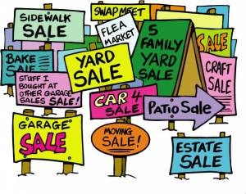

**City of LaHarpe City Wide Garage Sales**

**June 7th**

To be added to the list you must sign-up at city hall by 5:00 pm on

May 30th

These lists will be available June 4th and may be picked up at the post office or the City Hall.

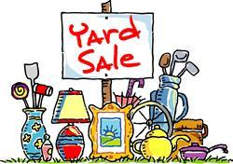



**June 25, 2025**

**You must sign-up at city hall before 5:00 pm on**

**Friday, June 20th to schedule your pickup.**

We need name, address, and list of items you want picked up.

**No tires, batteries, household trash or items with Freon.**

**Items must be out by the road by 8:00 a.m. Wednesday, June 25th.**

**Please keep items separated in corresponding piles.**

**Dates to remember:**

April 9th: Council Meeting at City Hall at 7:00 pm

 April 12th: Animal clinic at City Hall from 1:30pm-3:30pm. Must have an appointment to attend.

April 21st: PRIDE Meeting at 7:00 p.m. at the City Hall

[](http://www.google.com/url?sa=i&rct=j&q=&esrc=s&source=images&cd=&cad=rja&uact=8&ved=0ahUKEwiI3_mmgoLLAhVW9mMKHe22Ar8QjRwIBw&url=http://www.paymentus.com/industry-utilities.html&psig=AFQjCNF-5ANx5SktbJug46KiWwMehsjzzw&ust=1455908868261283) April 25th: **Past due Utility shut off date.**

**CITY COUNCIL NEWS**

**CITIZENS CALL FOR BUSINESS**

1. La Harpe citizen, Harry Lee, talked about effective city government stating he has interest in La Harpe for the past 75 years. At times the city council has been effective and other times less effective. Back in the mid 50’s a representative from Klien Tool came to the city and wanted to build their plant here, but the mayor at that time was not interested. Then in the mid to late 60’s the US Department of Agriculture presented they would like to build low income/senior apartment living in La Harpe but the city government was not interested. USDA now have those living arrangements in Moran, Iola and Bronson, Harry stated: Not a good decision made. Harry referred to La Harpe as a “Food Desert”, meaning the city doesn’t have groceries. Harry mentioned; at one time, back in the 50’s, La Harpe had two stores, but people did not support them, they drove a few extra miles to save a few cents. Overall, Harry stated; When people don’t support local businesses in La Harpe, they tend to lose them. For La Harpe to prosper, three things need to happen; 1) stable tax base- when rate payers decrease, those here the rate increases. 2) reliable and affordable utilities-the more people you have buying, the smaller the costs will be, the fewer you have, the bigger the costs will be. 3) good reputation- Harry shared a post from the city’s Facebook page regarding the decision to abandon a service with a business in town, shared that a few people were questioning the change and communicating with one another. Harry stated, I can’t see this is helping the city by abandoning a business that has been in town for 125 years.
2. Derrick and Jennifer Foster stated they are going to build a home in La Harpe and requested permission to stay in a camper as they were building. After some discussion, Sharlyn Thompson made the motion to have Fred write up a contract giving the Foster’s 18 months to stay in the camper while building. Ron Knavel seconded. Motion carried 4-0.

**UNFINISHED BUSINESS**

1. Kennel Fees – No action taken

**NEW BUSINESS**

1. Employee handbook changes – Michelle update the health insurance changes and stated Fred suggested a motion be made to accept those changes. Cynthia Carr made a motion to approve the updated changes. Sharlyn Thompson seconded. Motion carried 3-0.
2. KRWA Voting Delegates – The council agreed to have Sharlyn Thompson and Angela Barker as the delegates for La Harpe.
3. KMEA Board of Directors – The council agreed to have Sharlyn Thompson and Ron Knavel as the board of directors for La Harpe.
4. AMS Collection Services for court – Michelle shared an agreement with AMS, a collection agency that Fred and the judge wanted me to look into, Humboldt uses this service and is very pleased and it does not cost the city any money. Sharlyn Thompson made the motion to go with AMS and sign the agreement. Ron Knavel seconded. Motion carried 4-0.
5. LACO Proposal – Mayor Crowell stated; the road out front is bubbling up because of the two drain pipes we have coming off of city hall and to stop it from getting any worse we need to re-route our guttering system. Cynthia Carr stated, we normally get 3 bids, why just this one, does anyone else do this. Mayor Crowell stated she couldn’t find anyone else. Angela Barker stated the bid is cheaper than repairing the road and made the motion to accept LACO’s bid in the amount of $1,670.00 and take out of the street fund to pay. Sharlyn Thompson seconded. Motion carried 3-1 with Cynthia Carr opposing.
6. Gym Floors – Vicky Moss with Thrive was present to share a new grant, the Lowes Building Grant is a no match grant and after talking with Michelle and the mayor it seems the gym floor needs some attention. To submit the grant, I will need a cost estimate, which was given to me this evening and the importance of the safety of this project, which I have typed up a narrative stating the number of loose tiles and how the area is used by the public on a daily basis. Vicky mentioned, if awarded, the project would need to be completed by November 14, 2025.

Marcia Davis shared that the Kansas Department of Commerce has a grant available for small communities of 5,000 or less, the grant is for up to $10,000.00 with a 10% match and is due by February 28, 2025. Mayor Crowell stated she would like to see city hall more ADA compliant. We have people in wheelchairs and those that use walkers visiting quite often and I would like to see a push button door opening for the front door and the entrance in the gym. Sharlyn Thompson mentioned a ramp outside by the handicap parking. Cynthia Carr questioned if our restrooms were ADA compliant. Marcia asked if we had pricing on these projects, the mayor said she will make a few phone calls and get back with her.

**REPORTS OF CITY OFFICERS**

1. Fred Works, City Attorney – Absent from meeting.
2. Roy Caler, Water Representative – Nothing to report.
3. Penny Miller, Code/Animal Control –Shared her monthly reports with the mayor.
4. Marc Waggoner, Fire Chief- Shared the fire department minutes: The La Harpe Volunteer Fire Department met for the monthly meeting. Present: Josh Sparks, Marc Waggoner Sr., Kiefer Endicott, Matthew Waggoner, Dennis Sidebottom, Trevor Stover, Pamela Waggoner and Meghan Sparks. Absent were Bill Gay, Ronald Splector and Justin Pritchard. Started meeting, had a Humboldt fireman come down and talk to the guys about his experience of fatal fires to help them cope with the fire on January 27th, which we found the body of the homeowner, which has affected all of us. Then ended meeting. Marc requested the city allow the fire department to donate $200.00 to Ramona Jeffers to help her out. Michelle shared the final bill to the Jeffers home and asked the council what they wanted to do with it. Cynthia Carr made the motion to forgive the $479.47 utility bill for Gale Jeffers. Ron Knavel seconded. Motion carried 4-0. Cynthia Carr made the motion to donate $500.00 to Ramona Jeffers. Ron Knavel seconded. Motion carried 4-0. Michelle stated the donation will be made under the city and the fire department.
5. Maintenance Department - The workorders were shared.
6. Michelle Altis, City Clerk – Michelle told the council she is looking for a new computer for the assistant clerk/treasurer and is hoping to have something next month.

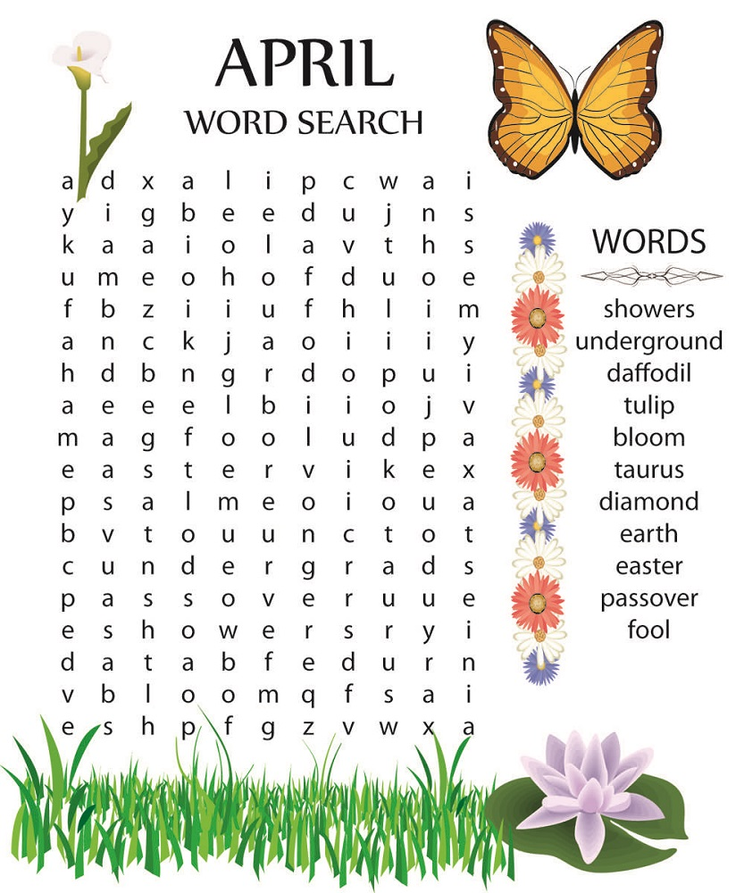



***Mayor****: Ella Mae Crowell (620) 496-6219*

***City Attorney****: Fred Works*

***City Municipal Judge****: Patty Miklos*

***Police Chief****:*

***Fire Chief****: Marc Waggoner*

***Assistant Fire Chief****: Dennis Sidebottom*

***City Clerk****: Michelle Altis*

***Assistant Clerk****: Teresa Driskel*

***City Treasurer****: Audra Riggins*

***Maintenance Staff****: Larry Laird, Penny Miller & Keith Knavel*

***Code & Animal Control****: Penny Miller*

***City Council Members:***

***Angela Barker (224-6209) Ron Knavel (496-2508)***

***Cynthia Carr (496-7500) Sharlyn Thompson (405-0272)***

***Laharpe City Hall Hours: Monday-Friday***

902 S. Washington 8:00-12:00 & 1:00-5:00

P.O. Box 10 Ph. (620) 365-5956

Laharpe, KS. 66751 Fax (620) 365-3944  *CHECK OUT OUR WEBSITE; CITYOFLAHARPE.ORG* ** *Follow us on Facebook*

# 

### Berry Cheesecake Cinnamon Roll Cups Recipe - Pillsbury.com

### Fruit Pie Cinnamon Roll Cups

### INGREDIENTS

* 2 cans Pillsbury cinnamon rolls (8 count)
* 8 oz cream cheese, softened
* 1 cup sugar
* 1 tsp vanilla extract
* 1 can pie filling of your choice (apple, cherry, strawberry, blueberry, mixed berry, or lemon creme)

### INSTRUCTIONS

1. Preheat oven to 350 degrees F. Place parchment paper liners in 16 muffin cups. Liners are optional but highly recommended. If not using liners, grease muffin cups well.
2. Unroll both cans of cinnamon rolls and separate rolls. Press each roll into the bottom of a muffin cup and up the sides.
3. In a small bowl, cream together the cream cheese, sugar, and vanilla extract until the mixture is smooth. Spoon the cream cheese mixture into the center of each cinnamon roll cup, dividing the cream cheese mixture evenly.
4. Top the cream cheese with a heaping spoonful of pie filling.
5. Bake 16-18 minutes until the cinnamon rolls are puffed and golden brown.
6. Remove from oven and allow to cool for about 10 minutes then drizzle with icing from the cinnamon rolls.

# Manicotti

**Manicotti**

**Ingredients**

* 1 carton (15 ounces) reduced-fat ricotta cheese
* 1 small onion, finely chopped
* 1 large egg, lightly beaten
* 2 tablespoons minced fresh parsley
* 1/2 teaspoon pepper
* 1/4 teaspoon salt
* 1 cup shredded part-skim mozzarella cheese, divided
* 1 cup grated Parmesan cheese, divided
* 4 cups marinara sauce
* 1/2 cup water
* 1 package (8 ounces) manicotti shells
* Additional minced fresh parsley, optional

**Directions**

1. Preheat oven to 350°. In a small bowl, mix the first 6 ingredients; stir in 1/2 cup mozzarella and 1/2 cup Parmesan cheese. In another bowl, mix marinara sauce and water; spread 3/4 cup sauce onto bottom of a 13x9-in. baking dish coated with cooking spray. Fill uncooked manicotti shells with ricotta mixture; arrange over sauce. Top with remaining sauce.
2. Bake, covered, until pasta is tender, 50 minutes. Sprinkle with remaining 1/2 cup mozzarella and 1/2 cup Parmesan cheese. Bake, uncovered, until cheese is melted, 10-15 minutes longer. If desired, top with additional parsley.



**Icebox Butterhorns**

**Ingredients**

* 2 packages (1/4 ounce each) active dry yeast
* 1/4 cup warm water (110° to 115°)
* 2 cups warm 2%milk (110° to 115°)
* 3/4 cup butter, melted
* 1/2 cup sugar
* 1 large egg, room temperature
* 1 teaspoon salt
* 6-1/2 cups all-purpose flour
* Additional melted butter

**Directions**

1. In a small bowl, dissolve yeast in warm water. In a large bowl, combine the milk, butter, sugar, egg, salt, yeast mixture and 3 cups flour; beat on medium speed until smooth. Stir in enough remaining flour to form a soft dough (dough will be sticky).
2. Do not knead. Place in a greased bowl, turning once to grease the top. Cover and refrigerate overnight.
3. Punch down dough. Turn onto a lightly floured surface; divide in half. Roll each into a 12-in. circle; cut each into 12 wedges. Roll up wedges from the wide ends. Place 2 in. apart on greased baking sheets, point side down. Cover with kitchen towels; let rise in a warm place until doubled, about 1 hour.
4. Bake at 350° for 15-20 minutes or until golden brown. Immediately brush with additional melted butter. Remove from pans to wire racks to cool.



**Dutch Apple Cake**

**Ingredients**

* 3 medium tart apples, peeled and cut into 1/4-inch slices (3 cups)
* 3 tablespoons plus 1 cup sugar, divided
* 1 teaspoon ground cinnamon
* 2/3 cup butter, softened
* 4 large eggs, room temperature
* 1 teaspoon vanilla extract
* 2 cups all-purpose flour
* 1/8 teaspoon salt

**Directions**

1. In a large bowl, combine the apples, 3 tablespoons sugar and cinnamon; let stand for 1 hour.
2. In another bowl, cream butter and remaining sugar until light and fluffy, 5-7 minutes. Add eggs, 1 at a time, beating well after each addition. Add vanilla. Combine flour and salt; gradually add to creamed mixture and beat until smooth.
3. Transfer to a greased 9x5-in. loaf pan. Push apple slices vertically into batter, placing them close together.
4. Bake at 300° for 1-1/2 to 1-3/4 hours or until a toothpick inserted in the center comes out clean. Cool for 10 minutes before removing from pan to a wire rack. Serve warm.