MAY NEWSLETTER

 

May is a spring month in the northern half of the world, and a fall month in the southern half. It is likely named after Maia, the goddess of growth.



*May’s birth flower is the lily of the valley.*

May is the fifth month in the [Gregorian calendar](https://www.timeanddate.com/calendar/gregorian-calendar.html) and has 31 days. It is the last month of [astronomical spring](https://www.timeanddate.com/calendar/aboutseasons.html) in the [Northern Hemisphere](https://www.timeanddate.com/geography/southern-northern-hemisphere.html) and of [astronomical fall](https://www.timeanddate.com/calendar/aboutseasons.html) in the [Southern Hemisphere](https://www.timeanddate.com/geography/southern-northern-hemisphere.html).

**What Is the Meaning of May?**

May comes from the Latin *Maius*, probably referring to the **goddess Maia**. She embodied the concept of growth, both in nature and in business. Others connect *Maius* with *Maiores*, the ancestors or “the greater ones.”

In May, the ancient Romans celebrated *Floralia*, a festival for fertility. Floralia lasted from April 27 to May 3 and included theater plays, dancing, and banquets. The Romans sacrificed a pregnant sow to the earth goddess Terra for a fruitful harvest.

**Important Dates in May**

**May Day**

Since ancient times, the beginning of May has been celebrated as the coming of summer—from the Roman *Floralia* to the [Walpurgisnacht](https://www.timeanddate.com/holidays/germany/walpurgis-night) (Night of St Walpurga), a Germanic celebration with bonfires on April 30 still celebrated today.

[Many countries](https://www.timeanddate.com/holidays/search.html?query=may+day) in Europe and North America celebrate [May Day](https://www.timeanddate.com/holidays/common/labor-day) on **May 1** with dances around a *maypole*, a high wooden pole adorned with colors and flowers.



*In many villages in Austria, a maypole is erected on April 30 or May 1.*

**Labor Day**

In many countries, May Day and [Labor Day](https://www.timeanddate.com/holidays/common/labor-day) are both celebrated on May 1. Labor Day started as *International Workers’ Day*. It goes back to labor unions fighting for an **eight-hour working day**. After a bloody demonstration known as the *Haymarket Riot* on May 4, 1886, Chicago’s workers’ union started their yearly protests on May 1, 1889.

**May the 4th**

May 4 is [Star Wars Day](https://www.timeanddate.com/holidays/fun/star-wars-day) because the date, stated as “May the fourth” sounds like the well-known phrase from Star Wars, **“May the force be with you.”** The sentence first appears in *Star Wars: Episode IV – A New Hope* (1977). The characters say it to wish each other good luck.

Two years after the movie was released, the Conservative Party in the United Kingdom congratulated their candidate, Margaret Thatcher, for being elected Prime Minister. On **May 4, 1979**, they published an ad in a newspaper saying, “May The Fourth Be With You, Maggie. Congratulations.” This might have been the beginning of May 4 as Star Wars Day.

**Cinco the Mayo**

[Cinco de Mayo](https://www.timeanddate.com/holidays/mexico/cinco-de-mayo) means “the fifth of May” in Spanish. The day is observed in Mexico and in [parts of the United States](https://www.timeanddate.com/holidays/us/cinco-de-mayo) on May 5 and celebrates the defeat of the French army during the *Batalla de Puebla* (Battle of Puebla) in Mexico on May 5, 1862.

In the US, Cinco de Mayo is seen as a day to celebrate the culture, achievements, and experiences of people with a Mexican background. Businesses promote Mexican food, drinks, and music, and traditional symbols of Mexican life are celebrated.



*Dancers at a Cinco de Mayo celebration.*

**Memorial Day**

On the [last Monday of May](https://www.timeanddate.com/holidays/us/memorial-day), people in the United States remember and mourn the soldiers and military personnel who died in military service. It is tradition to visit cemeteries and memorials, some also place flags on the soldiers’ graves. Memorial Day is a [federal holiday](https://www.timeanddate.com/holidays/type/federal-holiday) in the United States and seen as the start of the summer season.

**Astronomical Events in May 2025**

[**Earthshine Nights**](https://www.timeanddate.com/astronomy/earthshine.html)**:** The [Waxing](https://www.timeanddate.com/astronomy/moon/waxing-crescent.html) and [Waning Crescent Moon](https://www.timeanddate.com/astronomy/moon/waning-crescent.html) phases in [April](https://www.timeanddate.com/calendar/months/april.html) and [May](https://www.timeanddate.com/calendar/months/may.html) are the best time to see [earthshine](https://www.timeanddate.com/astronomy/earthshine.html), where the unlit part of the Moon becomes visible. It is also known as Da Vinci glow.

[**Eta Aquarid Meteors**](https://www.timeanddate.com/astronomy/meteor-shower/eta-aquarids.html)**:** On May 6, 2025, you have a chance to spot the shower that is named after the brightest star of the [constellation](https://www.timeanddate.com/astronomy/what-are-constellations.html) Aquarius (water bearer), Eta Aquarii. Use our handy [Interactive Meteor Shower Sky Map](https://www.timeanddate.com/astronomy/meteor-shower/eta-aquarids.html) to increase your chances of meteor spotting.

[**Flower Moon**](https://www.timeanddate.com/astronomy/moon/flower.html)**:** The [Full Moon](https://www.timeanddate.com/astronomy/moon/super-full-moon.html) of May is known as the [Flower Moon](https://www.timeanddate.com/astronomy/moon/flower.html), named after the blooming flowers in the Northern Hemisphere, where these traditional [Full Moon names](https://www.timeanddate.com/astronomy/moon/full-moon-names.html) originated.

**History of May**

In the old [Roman calendar](https://www.timeanddate.com/calendar/roman-calendar.html), May was called *mens maius* and was the third month because the year started in March. In the year 154 [BCE](https://www.timeanddate.com/calendar/ce-bce-what-do-they-mean.html), a rebellion forced the Roman senate to change the beginning of the civil year from March to January 1. With this reform, May officially became **the fifth month** in the year 153 [BCE](https://www.timeanddate.com/calendar/ce-bce-what-do-they-mean.html).

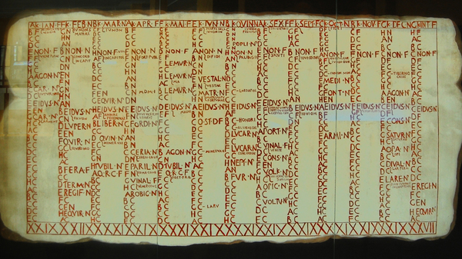

*This Roman wall calendar dating from 84-55*[*BCE*](https://www.timeanddate.com/calendar/ce-bce-what-do-they-mean.html)*shows “MAI” as the fifth month.*



National Memorial Day in the USA is celebrated on the last Monday in May.  
All men and women, who gave their lives while serving in the United States Armed Forces, are commemorated on this day. National Memorial Day is formally known as Decoration Day, the day that commemorated the Union and Confederate soldiers, who died during the American Civil War. Later the day extended to honor all American soldiers, who died while in the military service.

Traditionally, the flag of the USA is raised briskly to the top of the flagstaff, then it is lowered to the half-staff position. This position is chosen in remembrance of those people, who died for their country. At noon the flag is raised to full-staff as the symbol that the memory of dead soldiers is being raised by the living. Their sacrifice was not in vain, that is why we rise up in their honor and continue fighting for liberty and justice.

Thousands of parades are held during National Memorial Day in all large and small cities. Most parades feature marching bands, servicemen, veterans and military vehicles from various wars also participate.

 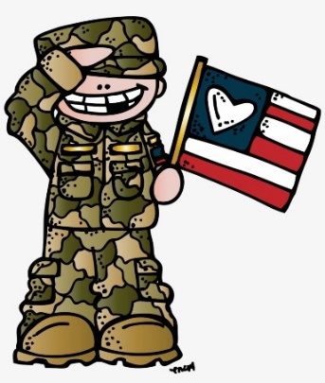

Originally called Decoration Day, from the early tradition of decorating graves with flowers, wreaths and flags, Memorial Day is a day for remembrance of those who have died in service to our country. It was first widely observed on May 30, 1868 to commemorate the sacrifices of Civil War soldiers, by proclamation of Gen. John A. Logan of the Grand Army of the Republic, an organization of former Union sailors and soldiers.

During that first national commemoration, former Union Gen. and sitting Ohio Congressman James Garfield made a speech at Arlington National Cemetery, after which 5,000 participants helped to decorate the graves of the more than 20,000 Union and Confederate soldiers who were buried there.

This national event galvanized efforts to honor and remember fallen soldiers that began with local observances at burial grounds in several towns throughout the United States following the end of the Civil War, such as the May 1, 1865 gathering in Charleston, South Carolina organized by freed slaves to pay tribute and give proper burial to Union troops.

In 1873, New York was the first state to designate Memorial Day as a legal holiday. By the late 1800s, many more cities and communities observed Memorial Day, and several states had declared it a legal holiday.

After World War I, it became an occasion for honoring those who died in all of America’s wars and was then more widely established as a national holiday throughout the United States.

In 1971, Congress passed the Uniform Monday Holiday Act and established that Memorial Day was to be commemorated on the last Monday of May. Several southern states, however, officially commemorate an additional, separate day for honoring the Confederate war dead, sometimes referred to as a Confederate Memorial Day: January 19 in Texas; third Monday in Jan. in Arkansas; fourth Monday in Apr. in Alabama and Mississippi; April 26 in Florida and Georgia; May 10 in North and South Carolina; last Monday in May in Virginia; and June 3 in Louisiana and Tennessee.

Memorial Day is commemorated at Arlington National Cemetery each year with a ceremony in which a small American flag is placed on each grave. Traditionally, the President or Vice President lays a wreath at the Tomb of the Unknown Soldier. About 5,000 people attend the ceremony annually.

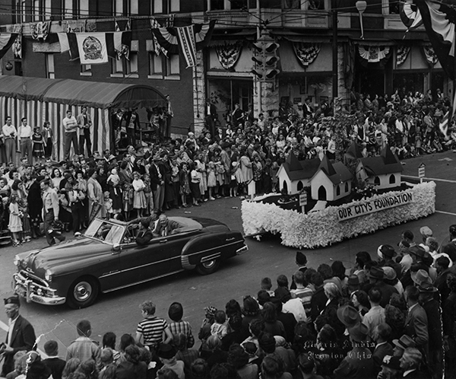



***THANK YOU TO ALL MEN AND WOMEN WHO HAVE SERVED OR ARE STILL SERVING OUR COUNTRY.***

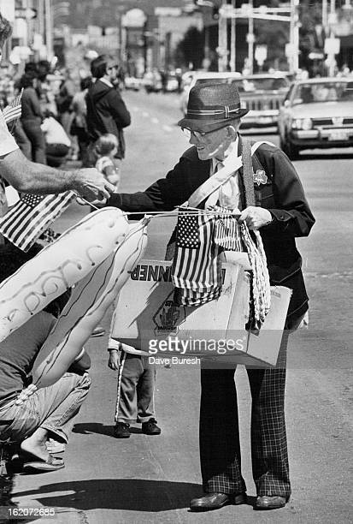



 

### Graduation Clipart Images - 8th Grade Graduation Clip Art - Free Transparent PNG Clipart Images Download

**Congratulations to the Class of 2025!!!**



 LOCAL NEWS

* Are you in need of grocery delivery service? Call 620-228-5570 for more information on this new service.
* La Harpe Days T-Shirts available at City Hall.

**If you need assistance after-hours please call the Iola Dispatch Center at (620) 365-1437, they will notify the proper personnel.**

 **HAPPY BIRTHDAY TO ALL LAHARPE CITIZENS CELEBRATING A BIRTHDAY THIS MONTH!!!! MAY YOUR DAY BE AS SPECIAL AS YOU ARE TO US!**

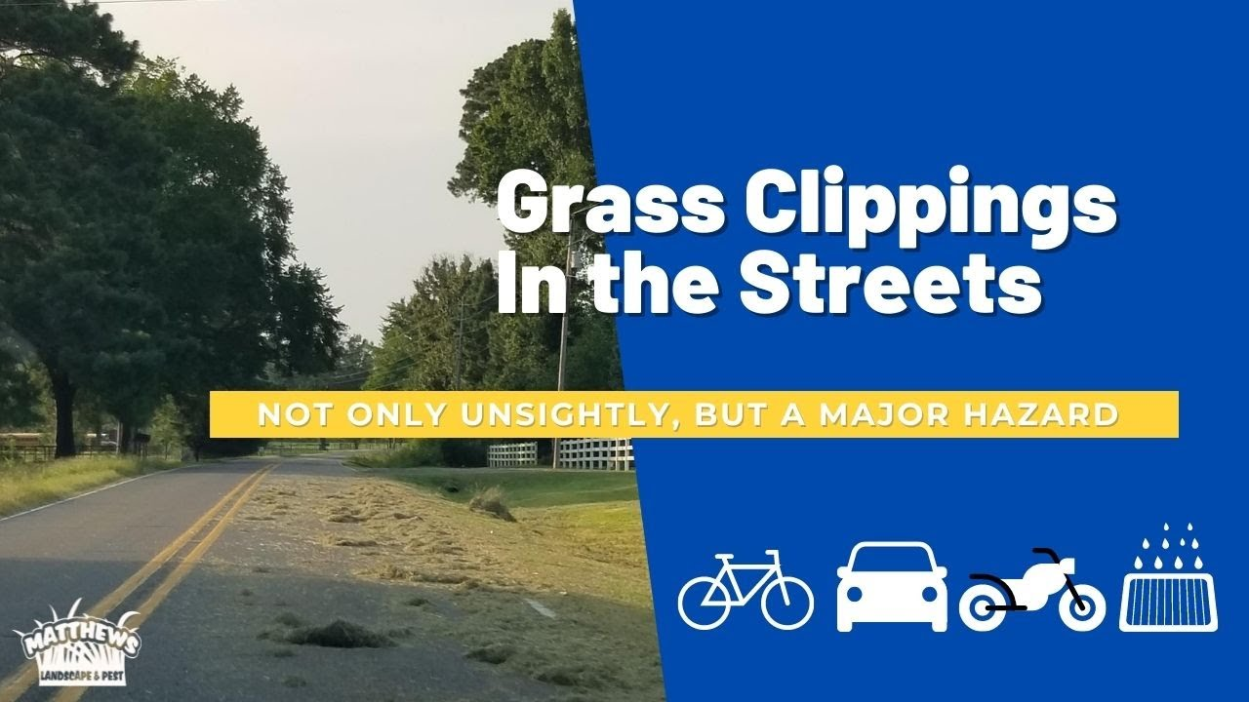

**TO ALL CITIZENS IN LA HARPE**

**It is in the city ordinance that you are not to blow your grass in the street. If you happen to get grass in the street, I’m asking you to blow or sweep the grass back into your yard or you will receive a Notice to Appear in Court. That will be an $80.00 court cost and whatever the Judge fines you. Please don’t blow grass in the street when you mow or at any time.**

**If you have any questions, please contact us by phone (620) 365-5956 here at City Hall.**

**Sincerely,**

**Animal and Code Officer**

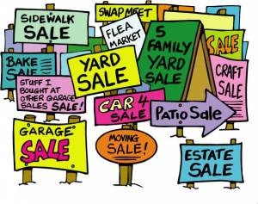

**City of La Harpe City Wide Garage Sales**

**June 7th**

To be added to the list you must sign-up at city hall by 5:00 pm on

May 30th

These lists will be available June 4th and may be picked up at the post office or the City Hall.





**June 25, 2025**

**You must sign-up at city hall before 5:00 pm on**

**Friday, June 20th to schedule your pickup.**

We need name, address, and list of items you want picked up.

**No tires, batteries, household trash or items with Freon.**

**Items must be out by the road by 8:00 a.m. Wednesday, June 25th.**

**Please keep items separated in corresponding piles.**

**Dates to remember:**

May 14th: Council Meeting at City Hall at 7:00 pm

May 19th: PRIDE Meeting at 7:00 p.m. at the City Hall

 May 26th: City Hall closed in observance of Memorial Day

[](http://www.google.com/url?sa=i&rct=j&q=&esrc=s&source=images&cd=&cad=rja&uact=8&ved=0ahUKEwiI3_mmgoLLAhVW9mMKHe22Ar8QjRwIBw&url=http://www.paymentus.com/industry-utilities.html&psig=AFQjCNF-5ANx5SktbJug46KiWwMehsjzzw&ust=1455908868261283) May 28th: **Past due Utility shut off date.**

**CITY COUNCIL NEWS**

**CITIZENS CALL FOR BUSINESS**

1. Marcia Davis, Thrive, shared the information from community conversation gathering, she thanked Sharlyn Thompson and Cynthia Carr for attending it was a very good discussion. Some of the things that were brought up was this is a small town, people ride bikes, they have a great park, it is safe, it’s like living in the country but with a small-town vibe, people are friendly. There was discussion about homes, health and wellness trying to bring an advertisement sign to the highway, and the new library director. The civic engagement was communication, council involving community to get them into the know. Mayor Crowell stated we put out newsletters, we post on Facebook, we have share information on our TV and our website, don’t know how else to get them involved. Marcia Davis suggested maybe getting some involved to run for office. They also talked about the sewer rate and water tower Sharlyn Thompson mentioned two grants to help was the sewer project, Mayor Crowell stated it is supposed to start sometime this year. Marcia Davis stated there was concern about the rates going up, Harry Lee mentioned why we need to build more homes and grow the population to spread out those cost. Retention on employees was another issue, why are they not staying can we offer them incentives or contracts, those employees take their knowledge with them and that is not good for our city. Marcia mentioned two positions they would like to see is electrician hired and a police officer, Mayor Crowell stated the city can’t afford an electrician all employees need to do be able to do it all. Another topic of discussion was housing some are pleased with new being built but there are complaints of empty ones not upkept. It was also discussed there’s some concern about the speeding around the park; some suggested more stops signs others suggested maybe speed bumps to slow the traffic. There was discussion on the roads that are built below the ditches and street lights that are not working. Also showed concerns of the fox’s and the critters that are in town. Some suggested a list of empty lots are vacant homes for sale so that they can stop at city hall and pick up the list, Mayor Crowell stated we have a copy in the office of what the city a owns. Another concern was La Harpe did not have a voting site, citizens were complaining of having to go to the gas community center to vote. Mayor Crowell stated we did not get a say in that, Marcia Davis mentioned she spoke with the commissioners and they had told her there was not enough volunteers to have two voting sites open. And lastly businesses on main is a dream to bring back the downtown area. Once again Marcia Davis showed appreciation to Sharlyn Thompson and Cynthia Carr for attending the community conversation. Mayor Crowell asked Marcia about the grant on the floor if she found anything new. Marcia said she is still waiting to hear on the grant in may for the ADA changes as she will have to get with CDBG on the floor. Marcia stated she would look into that and get back with the mayor is soon as she could.
2. Citizen, Craig Trester was in attendance he asked the council about the roads, stating they are bad around his house and wondering why the city is not fixing them. Mayor Crowell stated main street is a county issue. Craig also asked about the ditches, are they the owner’s responsibility or the city. City Attorney, Fred Works stated the ditches are the landowner’s responsibility. Craig express concerns of why the city is sending certified code letters to deceased owners, it has to cost the city money. Mayor Crowell stated if the name is still on the land that’s who we have to send it to. Craig also asked about the lift stations, stating I’m aware that they are about 25 years old and need attention, why hasn’t the city put back money to take care of these problems. Mayor Crowell stated we do have two separate funds, one fund is for our lagoon that we will have to dredge and the other fund is just for our sewer project, both of those funds seem to be holding well, keep in mind; the last two years the sewer fund was in the hole and is now starting to look better and hold its own. City clerk Michelle Altis stated the mayor now has set up separate reserve funds, we have one for our electric we have two for our sewer, before we never had those funds and all money was tied in to one account. Fred mentioned you need reserves to setback for expenditures, but a small town doesn’t have a good tax base to keep those reserves when issues arise. Craig also asked about the water maps, stating employees are finding it hard to locate a few shut offs, how often are the maps updated, I also understand there’s a flash drive of the maps is that be an updated on a regular basis. Mayor Crowell stated they are updating the maps as they work on the area, yes, our maps are old but it costs money to replace those. Craig mentioned the phone number change, stating I understand why you did it but others don’t get it. I realized saving money is in the best interest of the community. Sharlyn Thompson stated I took an oath to take care of the city funds, Craig stated I understand that but some don’t. Craig also asked about the city equipment are the citizens allowed to use the city equipment, Mayor Crowell stated no, we do allow the use of our dump truck; the city employees will deliver it to an address on a Friday so that they can fill it with debris and the city staff picks it up on Monday and takes it to the landfill. Craig stated he was just wondering because someone seen the tractor at an employee’s house moving dirt. Craig mentioned he was reading last month’s minutes and city hall had new drains installed but the payment was taken out of the street fund wondering why we took it out the street fund and not the general fund, Mayor Crowell stated because it was interfering with our street work that we just had done.

**UNFINISHED BUSINESS**

1. Nothing to discuss.

**NEW BUSINESS**

1. Region H HMP Resolution – Ron Knavel made the motion to authorize the mayor to sign resolution number 2025-3. Sharlyn Thompson seconded. Motion carried 3-0.
2. Sewer Rate Ordinance – Angela Barker made the motion to approve and adopt ordinance number 2501. Ron Knavel seconded. Motion carried 3-0.
3. PSI Insurance Renewal – Tabled until the April 21st special meeting.
4. 2024 Audit Representation Letter – Sharlyn Thompson made the motion authorizing the mayor to sign the 2024 audit letter. Angela Barker seconded. Motion carried 3-0.
5. IMAX Water Fittings – Mayor Crowell shared a quote from Core and Main to replace the two IMax couplings the city used to repair the water leak on the highway, stating the price is $391.80 apiece and the city needs to replace them, she requested authorization to purchase 2 IMAX water fittings. Ron Knavel made the motion to purchase 2 IMAX fittings. Sharlyn Thompson seconded. Motion carried 3-0.
6. KWO Agreement with SEKRPC – Sharlyn Thompson made the motion to accept the agreement and authorized the mayor to sign. Ron Knavel seconded. Motion carried 3-0.
7. BG Consultants Invoice – city clerk Michelle Altis shared an invoice stating it was the third payment on the design of the sewer project, and wanted to know which account they would like to pay it from. Mayor Crowell suggested the general fund and replace it at a later date. Sharlyn Thompson made the motion to pay the BG consultants invoice out of the general fund. Angela Barker seconded. Motion carried 3-0.
8. Assistant Clerk / Treasurer PC – Mayor Crowell shared two options that city Treasurer, Audra Riggins, had picked for a new computer. Fred suggested the city save some money and use the law computer. Mayor Crowell agreed to Fred’s suggestion and stated she would get with Audra about getting that computer setup.

**REPORTS OF CITY OFFICERS**

1. Fred Works, City Attorney – Stated he had two letters to share with the mayor, which he would do after council, but had nothing else to report.
2. Roy Caler, Water Representative – Nothing to report.
3. Penny Miller, Code/Animal Control –monthly report submitted to mayor.
4. Marc Waggoner, Fire Chief- Shared the fire department minutes: The La Harpe Volunteer Fire Department met for the monthly meeting. Present: Josh Sparks, Marc Waggoner Sr., Matthew Waggoner, Dennis Sidebottom, Trevor Stover, Bill Gay, Pamela Waggoner, and Meghan Sparks. Absent were Kiefer Endicott, Ronald Splector and Justin Pritchard. Started meeting, discussing when to set the rest of the fire fighters trained on confined space or grain bin entrapment. Then went over procedures on trucks with new fireman Trevor, then ended meeting. Marc also stated they were busy helping with the Yates Center fire and will be flushing hydrants this weekend. Penny Miller stated she is working on a list of whistles to clean out. Ron Knavel asked about removing whistles from vacant lots so that the water can flow better in those areas. Mayor Crowell thought that was a great idea and get a list started on which ones the city will remove.
5. Maintenance Department - The workorders were shared. Mayor Crowell shared a letter from Larry Laird on a truck bed trailer the city has been using for scrap metal, he would like to see if the city would be interested in buying the trailer for $200. Ron Knavel made the motion to purchase the trailer for $200. Angela Barker seconded. Motion carried 3-0.
6. Michelle Altis, City Clerk – Requested the council’s permission to allow Keith to attend the electric distribution underground workshop in May. Angela barker made the motion to allow Keith to attend the class in May. Sharlyn Thompson seconded light and. Motion carried 3-0. Michelle shared a GIS mapping system of the city’s underground infrastructure and encouraged the council to sit in on a special meeting to learn more about it. With the GIS System we can locate shut offs that they have not been able to locate, have an up-to-date map on a daily basis all done electronically and the GIS System will also allow us to add our sewer lines as well. Michelle mentioned that her and Penny sit in on a call and was very impressed with the information shared, not only will the city have a constant update of water lines and sewer lines, this will be helpful to any new employees, council members, or mayors that come to town, we’ll also have the information all electronically vs. the paper map we have now that has been passed down by so many hands. After discussion the council seemed very interested in setting up a special meeting to learn more on the GIS System.

**DISCUSSION ON AGENDA ITEMS –**

No discussion on agenda items was taken. Mayor Crowell requested a motion to go into executive session on non-elected personnel for 10 minutes with Penny Miller invited. Angela Barker made the motion to go into executive session on non-elected personnel for 10 minutes with Penny Miller invited. Ron Knavel seconded. Motion carried 3-0.

After returning to regular session Angela Barker made the motion to give Penny Miller a 50¢ an hour raise effective June 12 to 2025. Ron Knavel seconded. Motion carried 3-0.



***Mayor****: Ella Mae Crowell (620) 496-6219*

***City Attorney****: Fred Works*

***City Municipal Judge****: Patty Miklos*

***Police Chief****:*

***Fire Chief****: Marc Waggoner*

***Assistant Fire Chief****: Dennis Sidebottom*

***City Clerk****: Michelle Altis*

***Assistant Clerk****: Teresa Driskel*

***City Treasurer****: Audra Riggins*

***Maintenance Staff****: Keith Knavel, Larry Laird & Penny Miller*

***Code & Animal Control****: Penny Miller*

***City Council Members:***

***Angela Barker (224-6209) Ron Knavel (496-2508)***

***Cynthia Carr (496-7500) Sharlyn Thompson (405-0272)***

***Laharpe City Hall Hours: Monday-Friday***

902 S. Washington 8:00-12:00 & 1:00-5:00

P.O. Box 10 Ph. (620) 365-5956

La Harpe, KS. 66751 Fax (620) 365-3944

***CHECK OUT OUR WEBSITE; CITYOFLAHARPE.ORG*** ** *Follow us on Facebook – City of La Harpe*

# Farmer’s Strata

# Farmer’s Strata

**Ingredients**

* 1 pound sliced bacon, cut into 1/2-inch pieces
* 2 cups chopped fully cooked ham
* 1 small onion, chopped
* 10 slices white bread, cubed
* 1 cup cubed cooked potatoes
* 3 cups shredded cheddar cheese
* 8 large eggs
* 3 cups whole milk
* 1 tablespoon Worcestershire sauce
* 1 teaspoon ground mustard
* Dash salt and pepper

**Directions**

1. In a large skillet, cook bacon over medium heat until crisp; add ham and onion. Cook and stir until onion is tender; drain.
2. In a greased 13x9-in. baking dish, layer half the bread cubes, half the potatoes and half the cheese. Top with all of the bacon mixture. Repeat layers with remaining bread, potatoes and cheese.
3. In a large bowl, beat the eggs; add the milk, Worcestershire sauce, mustard, salt and pepper. Pour over all. Cover and chill overnight.
4. Preheat oven to 325°. Remove from refrigerator 30 minutes before baking. Bake, uncovered, until a knife inserted in the center comes out clean, 65-70 minutes.



**Chili Tortilla Bake**

**Ingredients**

* 1 pound extra-lean ground beef (95% lean)
* 2 cans (8 ounces each) no-salt-added tomato sauce
* 1 can (15 ounces) black beans, rinsed and drained
* 1 cup frozen corn
* 1 can (4 ounces) chopped green chiles
* 2 tablespoons dried minced onion
* 2 tablespoons chili powder
* 1 teaspoon ground cumin
* 1/2 teaspoon garlic powder
* 1/2 teaspoon dried oregano
* 6 whole wheat tortillas (8 inches)
* 1 cup shredded reduced-fat cheddar cheese

**Directions**

1. In a large skillet, cook beef over medium heat until no longer pink. Stir in the tomato sauce, beans, corn, green chiles, onion, chili powder, cumin, garlic powder and oregano; heat through.
2. In an 11x7-in. baking dish coated with cooking spray, layer half of the tortillas, beef mixture and cheese. Repeat layers. Bake, uncovered, at 350° for 25-30 minutes or until bubbly.



**Easy White Sangria**

**Ingredients**

* 1/4 cup sugar
* 1/4 cup brandy
* 1 cup sliced peeled fresh or frozen peaches, thawed
* 1 cup sliced fresh or frozen sliced strawberries, thawed
* 1 medium lemon, sliced
* 1 medium lime, sliced
* 1 bottle (750 milliliters) dry white wine, chilled
* 1 can (12 ounces) lemon-lime soda, chilled
* Ice cubes

**Directions**

1. In a pitcher, mix sugar and brandy until sugar is dissolved. Add next 6 ingredients; stir gently to combine. Serve over ice.



**Lemon Snowflakes**

**Ingredients**

* 1 package lemon cake mix (regular size)
* 2 1/4 cups whipped topping
* 1 large egg, room temperature
* Confectioners' sugar

**Directions**

1. Preheat oven to 350°. In a large bowl, combine the cake mix, whipped topping and egg until well blended. Batter will be very sticky.
2. Drop by tablespoonfulls into confectioners' sugar; roll lightly to coat. Place on ungreased baking sheets. Bake until lightly browned and tops are cracked, 10-12 minutes. Remove to wire racks to cool.