JULY NEWSLETTER

Hey everyone! It’s officially summertime, and that means lots of fun in the sun. When most people think of July, they think of fireworks, hot weather, and patriotic holidays. Did you know there are some interesting things about July that most people don’t know?
July comes with a lot of excitement. It’s filled with holidays, fun outdoor activities, and plenty of opportunities to enjoy time with family and friends.
Here are some fascinating (and even some wacky) fun facts about July that will help you appreciate this particular month even more!

 NATIONAL CREATIVE ICE CREAM FLAVORS DAY | JULY 1

I scream, you scream, we all scream for ice cream! July 1 marks National Creative Ice Cream Flavors Day as a day to sample or wonder about the odd combinations of ice cream flavors. Skip the traditional chocolate, vanilla, and strawberry ice cream when you celebrate this holiday! Make your ice cream even more exciting by adding, candies, cookies, nuts, whip cream, fruit, etc. enjoy in a bowl, a cone or however you want!

 Sidewalk Egg Frying Day | July 4
Apparently, for the past 100 years or so, people have been trying to successfully fry eggs on pavements. So while fireworks light up the sky in the U.S. on July 4, eggs also litter the pavements, as this wacky holiday continues to be celebrated across the country.
One of the earliest references to the concept of frying an egg on the sidewalk comes from an issue of the “Atlanta Constitution” (1899) where, in a column titled ‘How to Keep Cool,’ Dr. Francis Henry Wade mentions how the “bricks of the sidewalks [are] hot enough to fry eggs.” An article published in the “Los Angeles Times” in October 1933 made this idea more popular, by reporting record-breaking temperatures in one of the L.A. neighborhoods, where people were actively discussing the possibilities of making sun-cooked eggs, given the right equipment.
In 1983, in Oatman. Arizona, Fred Eck founded the annual Solar Egg Frying Contest where participants use homemade contraptions to fry an egg in under 15 minutes. Some overachievers go so far as to prepare bacon and fries too! Other places have also attempted to cook eggs in the sun, with varying levels of success. In 2013, an anonymous YouTube video from Death Valley National Park had people braving 120-degree heat to attempt to fry eggs directly on the rocks. In 2015, in Australia, temperatures reached 111 degrees Fahrenheit and sparked a trend where YouTubers tried to fry eggs on the sidewalks.
Of course, the science behind this is all wrong, since concrete and bricks are not conductors of heat, but the phrase has stuck, and now Sidewalk Egg Frying Day is very much a part and parcel of American pastime culture.

 National Blueberry Muffins Day | July 11
National Blueberry Muffin Day is celebrated on 11 July. While blueberry is one of the less popular muffin flavors, those who love it swear by it! National Blueberry Muffin Day was created in order to celebrate the culinary delight that is the blueberry muffin! Blueberries are rich in antioxidants and have tons of health benefits, and having a muffin is the tastiest way to incorporate these berries into your diet. In fact, a lot of people consider blueberries to be a superfood. These berries aid in weight loss and healthy digestion, and they keep you full for a long time. Moreover, blueberries also boost mental health, protect against heart disease, manage blood sugar levels, improve skin clarity, and make our bones strong. The list of blueberry benefits is really quite impressive!

 National Macaroni and Cheese Day | July 14
It’s perhaps the king of comfort foods, the dominant dish of America, and a favorite of all ages all over the country: Macaroni and cheese. Golden and gooey, baked and hearty, this sideline staple or main dish can be served up any number of ways, and on July 14, you’ll have the opportunity to try as many of these as you can on National Mac and Cheese Day, also known as National Macaroni and Cheese Day. Kraft may be the first thing that comes to mind when you think of mac and cheese, for good reason. The company has been dishing out delight in the form of a box since 1937, but the origins of the creamy casserole can be traced back hundreds of years to Italy, where pasta and parmesan have been a staple meal for centuries. In America, some credit Thomas Jefferson for bringing the recipe back to America after spending time in Italy, but this idea has been disputed. There’s no way to know whether it’s all bologna.

 National Junk Food Day | July 21
July 21 dedicates a giant menu of items to National Junk Food Day. This day permits us to chow down on the foods we usually don't include in our daily diet.
#NationalJunkFoodDay
Junk foods, by definition, typically contain high fats, sugars, salt, and calories and very little nutritional value. With the advent of packaged foods during the late 1800s, junk food made its way into American life. Still, home-cooked meals remained the standard for several more decades. Eventually, after World War II, the artery-clogging industry took off. Since the population ate out more, traveled more, the industry was primed to produce products at an increased rate.


Independence Day / also called Fourth of July | July 4
Independence Day is a day of family celebrations with picnics and barbecues, showing a great deal of emphasis on the American tradition of political freedom. Activities associated with the day include watermelon or hotdog eating competitions and sporting events, such as baseball games, three-legged races, swimming activities, and tug-of-war games.
The American flag is often placed outside homes and buildings on July 4th, and communities arrange fireworks after dark. The most impressive firework displays are shown on television. Big cities like New York and Washington, D.C. often organize parades and other large public events on the 4th of July.
Some employees use one or more vacation days to create a long weekend to escape to their favorite beach or vacation spot.
Independence Day is a patriotic holiday for celebrating the United States. Politicians appear at public events to show their support for their country’s history, heritage, and people.
Above all, people in the United States express and give thanks for the freedom and liberties fought by the first generation of many of today’s Americans. The Statue of Liberty is a national monument associated with Independence Day.
The History of Independence Day
In 1775, people in the thirteen colonies began fighting the British under King George III for their own independence. On July 2, 1776, Congress secretly voted for independence from Great Britain. Two days later, on July 4, 1776, the final wording of the Declaration of Independence was approved, and the document was published. The first public reading of the Declaration of Independence was on July 8, 1776. Delegates began to sign the Declaration of Independence on August 2, 1776.
In 1870, Independence Day was made an unpaid holiday for federal employees. In 1941, it became a paid holiday for them.
The first description of how Independence Day would be celebrated was in a letter from John Adams to his wife Abigail on July 3, 1776. He described “pomp and parade, with shows, games, sports, guns, bells, bonfires, and illuminationst” throughout the United States. However, the term “Independence Day” was not used until 1791.
Interestingly, Thomas Jefferson and John Adams, both signers of the Declaration of Independence and presidents of the United States, died on July 4, 1826—exactly 50 years after the adoption of the declaration.
It is also important to note that Native Americans lived in the country, and each tribe had its own nation and government prior to the European settlers.

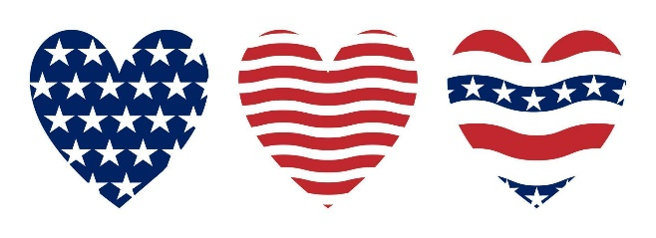



Hard to believe it is July already, summer is flying by!! As you are getting ready to celebrate Independence Day, please remember to be safe at all times. If you are planning to light fireworks, I would like to share a few reminders and safety tips with you; you are allowed to light fireworks:

June 27th – July 3rd - Between the hours of 10:00 AM and 10:00 PM
July 4th - Between the hours of 10:00 AM and 12:00 AM
July 5th – Between the hours of 10:00 AM and 5:00 PM

Lighting fireworks in the street, alley or public property is prohibited, keep a fire extinguisher or a water hose close by.
We want all of our citizens to enjoy the beautiful fireworks without the danger that could follow. Please keep in mind, anything that shoots up in the air can be potentially hazardous for your nearby neighbors, think before you light!!
Please remember to dispose any firework that has been discharged, the city is not responsible in cleaning left over debris.

Have A Very Safe and Happy 4TH Of July!!!!


LOCAL NEWS

- Are you in need of grocery delivery service? Call 620-228-5570 for more information on this new service.

- The La Harpe Senior center has changed managers:
Nicole Henry – 620-875-6036 & Mike Knavel – 620-228-2872
If interested in renting the building at 111 S. Main, please call them.

If you need assistance after-hours please call the Iola Dispatch Center at (620) 365-1437, they will notify the proper personnel.
 HAPPY BIRTHDAY TO ALL LAHARPE CITIZENS CELEBRATING A BIRTHDAY THIS MONTH!!!! MAY YOUR DAY BE AS SPECIAL AS YOU ARE TO US!


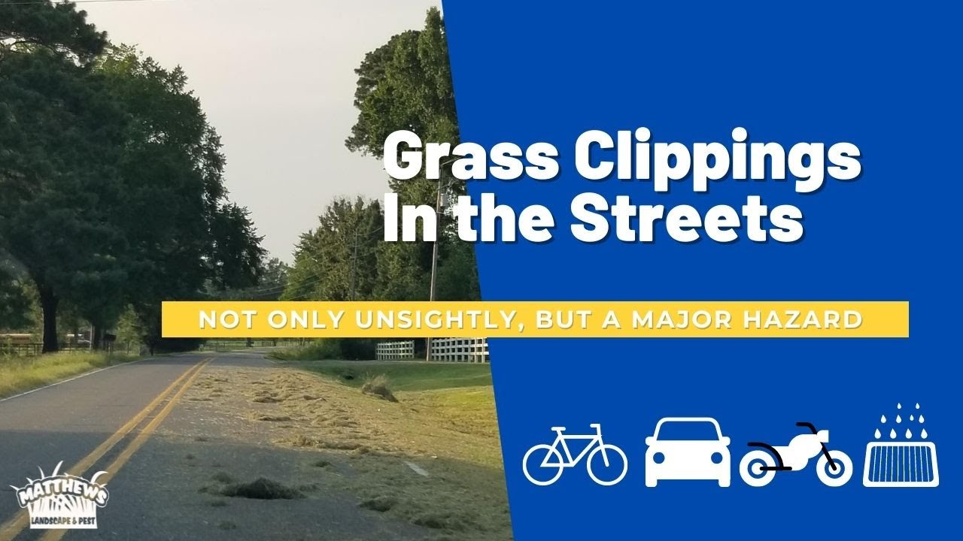

TO ALL CITIZENS IN LA HARPE
It is in the city ordinance that you are not to blow your grass in the street. If you happen to get grass in the street, I’m asking you to blow or sweep the grass back into your yard or you will receive a Notice to Appear in Court. That will be an $80.00 court cost and whatever the Judge fines you. Please don’t blow grass in the street when you mow or at any time.
If you have any questions, please contact us by phone (620) 365-5956 here at City Hall.

Sincerely,
Animal and Code Officer

Dates to remember:

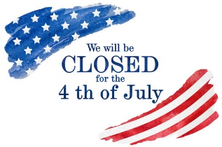 July 4th: City offices will be closed.
 July 7th: Budget Meeting at City Hall at 6:00 pm
July 9th: Council Meeting at City Hall at 7:00 pm

 July 21st: PRIDE Meeting at 7:00 p.m. at the City Hall

 July 25th: Past due Utility shut off date.

CITY COUNCIL NEWS
CITIZENS CALL FOR BUSINESS
- Craig Trester asked about the vacant seat, Mayor Crowell stated she has a couple of letters of intent. Craig asked about the process of filling a vacancy. Fred Works stated there is not a time frame to fill a vacancy, the mayor will appoint someone and the decision is up to the council. The council is required to make sure the individual expressing interest to be on the council, meets the requirements. Craig expressed concerns that a few have been talking about the city council and mayor being on a “buddy” system, stating Angela Barker and the mayor were friends. Angela reminded him that her name was on the ballot. Craig also expressed concerns over the fire departments training, asking if a fire fighter had to be certified. Mayor Crowell stated the fire chief is certified. Carey Dean asked if the fire hydrants around town our maintained, Mayor Crowell stated all fire hydrants are flushed twice a year and were flushed in April. Craig expressed concerns over the recent house fire and questioned the lack of water the city ha. Fire Chief, Marc Waggoner, stated there wasn’t a lack of water, we were fighting a house packed full of stuff with a metal roof. Craig asked if mutual aid was called, Marc stated, we call if needed. Craig asked about the fire fighter that was sent to the hospital, stating he was a county fire fighter. Marc stated, he was there for mutual aid. Tim Farmer expressed concerns about the way things are going on in the city. City Attorney, Fred Works, suggested to the citizens, who have these concerns, to write them down and submit to the city clerk so that she can get them to the council to discuss in an orderly fashion.
- Jerry Adair, asked the council if he could have permission to stay in a camper while he cleaned his property from the fire. Ron Knavel made the motion to allow Jerry to stay in the camper for 90 days, if more time is needed, he would need to come back to the council. Sharlyn Thompson seconded. Motion carried 4-0.
- Vicky Gerdsen was complaining of the dogs running loose and nothing gets done. City clerk, Michelle Altis, stated I sent the pictures and video to animal control. Mayor Crowell stated she would look into it. Vicky also asked about the sewer rates, Michelle reminded her of the KDHE requirement to use the loan proceeds.
- Carey Dean expressed concerns about the new firework law, stating people are shooting them now. Mayor Crowell stated we have a city ordinance on when fireworks can be discharged in town.

UNFINISHED BUSINESS
- Park Speed Bumps – Michelle shared pricing on peed bumps and signs, she stated Larry has built speed bumps before when he worked road construction and has offered to do this instead of purchasing them. Ron Knavel made the motion to let Larry build a speed bump to try out and purchase 6 signs. Sharlyn Thompson seconded. Motion carried 4-0.
NEW BUSINESS
- Vacated council seat - Tabled.
- CDBG Engineer Requirement for Gym Floors – Vickie Moss and Jessica Thompson with Thrive shared a small setback on the CDBG grant to fix the gym floors, before the city can have the required public hearing, the city needs to hire an engineer to do a preliminary architectural report, this will let you know the cost so that it can be shared in your public notice. Mayor Crowell asked for recommendations on who to hire. Jessica Thompson suggested BG Consultants and Fred suggested Rick Zingre. Cynthia Carr asked if there was a deadline, Vickie stated its on a first come first served basis.
- GIS System Quote – Sharlyn Thompson stated, the city can’t afford this right now. Ron Knavel suggested we put it on hold, council agreed.
- Sewer charge variance – Kendra Michael submitted a variance letter on the sewer charge on water meters placed on a vacant lot. She stated there is no structure there and would like access to water for her garden without paying the sewer charge. Fred suggested creating a separate water charge for water meters on vacant lots only. Cynthia Carr recommended reaching out to the others that discontinued their service because of the charge. Sharlyn Thompson made the motion to approve the variance and have Fred come up with something on a new charge. Ron Knavel seconded. Motion carried 4-0.
- Roof bid motion 5/8/24 – Mayor Crowell stated the roof is being worked on as we speak and back in May of 2024 you made a motion to pull from the fitness center and the electric fund. I am requesting that motion be rescinded and pull $15,000.00 from the fitness center and $20,000.00 from the general fund, electric fund, water fund and the sewer fund. Ron Knavel made the motion to rescind the vote from May 8, 2024. Sharlyn Thompson seconded. Motion carried 4-0. Ron Knavel made the motion to take $15,000.00 out of the fitness center fund and $20,000.00 out of electric, water, sewer and general funds to pay for the roof. Sharlyn Thompson seconded. Motion carried 4-0.
- Law Enforcement – Ron Knavel stated, we need a police officer. Fred suggested to the council that they allow him to approach the new sheriff and see what we can do to work together. Fred mentioned that he needs to know what hours and days you are wanting patrol in the city, he also would like to know the money spent on law enforcement recently. Fred suggested looking into this will save the city money. Sharlyn Thompson was concerned about no enforcing city ordinances, and Fred stated, if hired in a paid position there should be a way to do that. Fred mentioned he is meeting with the sheriff next Wednesday and would like the requested information before the meeting. Council agreed to the idea.
- Removal bids for 406 S. McKinley – Mayor Crowell opened only bid submitted by Ray’s Metal Depot in the amount of $1,200.00. Ron Knavel made the motion to accept Ray’s bid. Sharlyn Thompson seconded. Cynthia Carr asked how we were paying, Mayor Crowell said it will come out of the general fund. Motion carried 4-0.

REPORTS OF CITY OFFICERS
- Fred Works, City Attorney – Was discussed earlier under law enforcement.

- Roy Caler, Water Representative – Nothing to report. Michelle stated, Larry Toney from PWWD#5 was in city hall today and stated someone broke their water hydrant. Larry said the board is meeting Thursday evening and Roy should have a report for us at next council meeting.

- Penny Miller, Code/Animal Control –monthly report submitted to mayor.

- Marc Waggoner, Fire Chief- Shared the fire department minutes: The La Harpe Volunteer Fire Department met for the monthly meeting. Present: Josh Sparks, Marc Waggoner Sr., Matthew Waggoner, Kiefer Endicott, Trevor Stover, Bill Gay, Dennis Sidebottom, and Meghan Sparks. Absent were Pamela Waggoner, Ronald Splector and Justin Pritchard. Started meeting, restocked firetrucks from fire on May 30, 2025 and went over safety procedures then ended meeting. Marc stated they will get back on the whistles after the rain stops so that we aren’t tearing up yards.

- Maintenance Department - The workorders were shared. Sharlyn Thompson stated some of the work orders are missing addresses. Cynthia Carr asked if a new mower was purchased, Mayor Crowell stated yes and remained under allowed amount. Ron Knavel asked about the Bad Boy and Keith stated it is at R&R, they no longer make that motor so they are installing a different motor.

- Michelle Altis, City Clerk – Shared a check payable to La Harpe, it is a check that belongs to Jerry Adair but Kansas law states cities have a 15% lien on insurance proceeds, the city is intitled to hold the check until the property is cleared to its satisfaction and if he doesn’t get it cleared in a timely manner, the city can remove it and keep the costs and the remainder will be given to Jerry. Michelle stated our city ordinance reads that we are supposed to put these in a separate account but this is the first one that I have seen in almost 13 years, it’s silly to open an account for just this. Fred suggested putting it in the city account under a separate fund. Michelle mentioned a special meeting to go over the 2026 budget, our auditors suggested Monday, July 7, 2025 at 6:00pm, council agreed to the date. Michelle also shared a few requests have been made to live stream our council meetings. I am not a fan of Facebook live so I am doing a sample recording of tonight’s meeting, wanting to make sure I can hear all of it, and if this works, I thought I would post a video link on the city’s website, I just would like your thoughts on this idea. The council seemed to agree with sharing the video on the city website.

DISCUSSION ON AGENDA ITEMS –
Mayor Crowell requested a motion to go into executive session on non-elected personnel for 10 minutes with Keith invited. Angela Barker made the motion to go into executive session on non-elected personnel for 10 minutes with Keith invited. Ron Knavel seconded. Motion carried 4-0. After returning to regular session Sharlyn Thompson made the motion to give Keith Knavel a raise of $.50 per hour effective this pay period. Angela Barker seconded. Motion carried 3-0, Ron Knavel abstained.


Mayor: Ella Mae Crowell (620) 496-6219
City Attorney: Fred Works
City Municipal Judge: Patty Miklos
Police Chief:
Fire Chief: Marc Waggoner
Assistant Fire Chief: Dennis Sidebottom
City Clerk: Michelle Altis
Assistant Clerk: Teresa Driskel
City Treasurer: Audra Riggins
Maintenance Staff: Keith Knavel & Larry Laird
Code & Animal Control: Penny Miller

City Council Members:
Angela Barker (224-6209) Ron Knavel (496-2508)
Cynthia Carr (496-7500) Sharlyn Thompson (405-0272)
Laharpe City Hall Hours: Monday-Friday
902 S. Washington 8:00-12:00 & 1:00-5:00
P.O. Box 10 Ph. (620) 365-5956
Laharpe, KS. 66751 Fax (620) 365-3944
CHECK OUT OUR WEBSITE; CITYOFLAHARPE.ORG  Follow us on Facebook – City of La Harpe

CHESY BAC AND EGG HASH

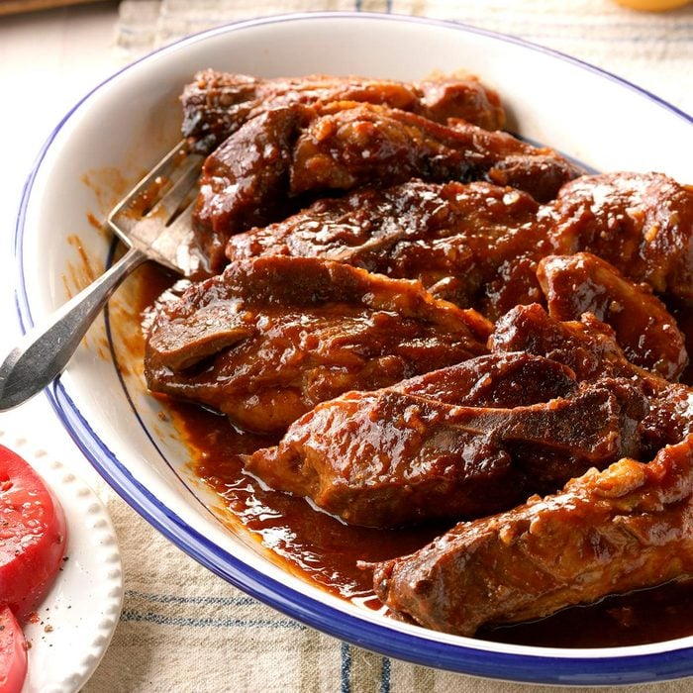

Tasty Pork Ribs

Ingredients

4 pounds bone-in country-style pork ribs

1 cup ketchup

1 cup barbecue sauce

1/4 cup packed brown sugar

1/4 cup Worcestershire sauce

1 tablespoon balsamic vinegar

1 tablespoon molasses

1 garlic clove, minced

2 tablespoons dried minced onion

1 teaspoon Cajun seasoning

1 teaspoon ground mustard

1/2 teaspoon salt

1/4 teaspoon pepper

Directions

Place ribs in a 5-qt. slow cooker. Combine the remaining ingredients; pour over ribs.

Cover and cook on low until meat is tender, 6-7 hours.

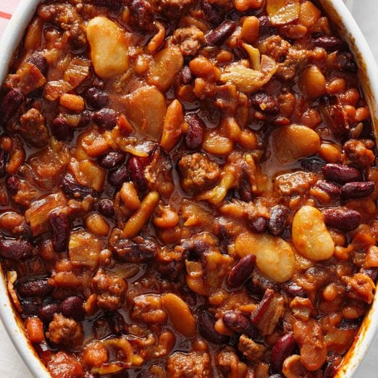

Three-Bean Baked Beans

Ingredients
1/2-pound ground beef
5 bacon strips, diced
1/2 cup chopped onion
1/3 cup packed brown sugar
1/4 cup sugar
1/4 cup ketchup
1/4 cup barbecue sauce
2 tablespoons molasses
2 tablespoons prepared mustard
1/2 teaspoon chili powder
1/2 teaspoon salt
2 cans (15 ounces each) pork and beans, undrained
1 can (16 ounces) butter beans, rinsed and drained
1 can (16 ounces) kidney beans, rinsed and drained

Directions
- Preheat oven to 350°. In a large skillet, cook and crumble beef with bacon and onion over medium heat until beef is no longer pink; drain.

- Stir in sugars, ketchup, barbecue sauce, molasses, mustard, chili powder and salt until blended. Stir in beans. Transfer to a greased 2-1/2-qt. baking dish. Bake, covered, 1 hour or until beans reach desired thickness.

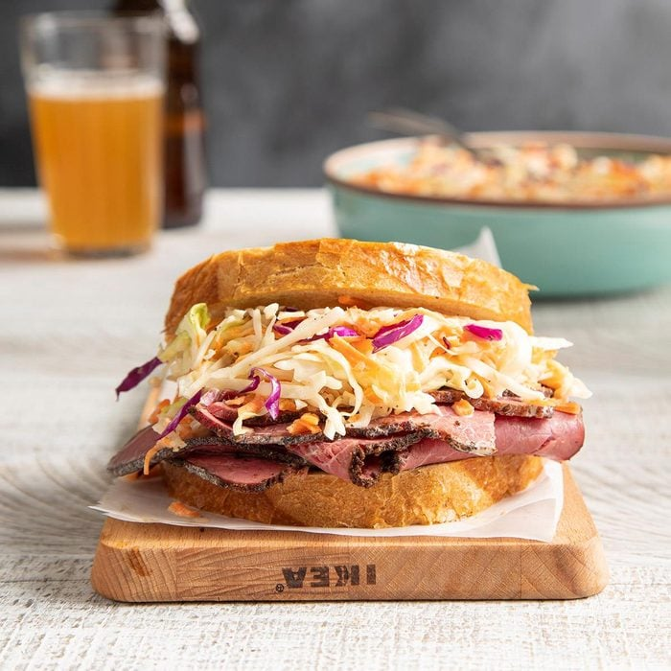
Southern Coleslaw

Ingredients
- 1 medium head green cabbage, shredded (about 8 cups)
- 1 cup shredded red cabbage
- 4 to 5 carrots, shredded
- 1 cup mayonnaise
- 2 tablespoons cider vinegar
- 1/2 cup sugar
- 1 teaspoon salt
- 1/4 teaspoon pepper
Directions
- In a large bowl, combine cabbage and carrots; set aside. In a small bowl, combine the remaining ingredients; pour over cabbage mixture. Toss well and refrigerate overnight.


Dill Potato Salad
Ingredients
- 6 large red potatoes, cooked and cubed
- 3 green onions with tops, sliced
- 1/4 cup minced fresh parsley
- 1/2 cup mayonnaise
- 3 tablespoons half-and-half cream
- 1/2 teaspoon salt
- 1/4 teaspoon each dill weed, white pepper and garlic powder
Directions
- In a large bowl, combine potatoes, onions and parsley. Combine remaining ingredients; mix well. Pour over potato mixture and mix gently. Cover and refrigerate for at least 1 hour.



Red, White and Blueberry Pie

Ingredients
2 ounces white baking chocolate, melted
1 graham cracker crust (9 inches)
3/4 cup sliced fresh strawberries
1 package (8 ounces) cream cheese, softened
3/4 cup confectioners' sugar
3/4 cup 2% milk
1 package (3.3 ounces) instant white chocolate pudding mix
1 cup whipped topping
1 cup fresh blueberries
8 fresh strawberries, halved lengthwise

Directions
1. Spread melted chocolate onto bottom and side of crust. Arrange sliced strawberries over chocolate.
2. In a bowl, beat cream cheese and confectioners' sugar until smooth; gradually beat in milk. Add pudding mix; beat on low speed until thickened, about 2 minutes. Spread over strawberries.
3. Decorate pie with whipped topping, blueberries and halved strawberries. Refrigerate until serving.




