OCTOBER NEWSLETTER

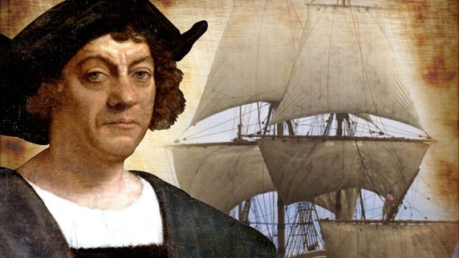
The explorer Christopher Columbus made four trips across the Atlantic Ocean from Spain: in 1492, 1493, 1498 and 1502. He was determined to find a direct water route west from Europe to Asia, but he never did. Instead, he stumbled upon the Americas. Though he did not “discover” the so-called New World—millions of people already lived there—his journeys marked the beginning of centuries of exploration and colonization of North and South America.
Christopher Columbus and the Age of Discovery
During the 15th and 16th centuries, leaders of several European nations sponsored expeditions abroad in the hope that explorers would find great wealth and vast undiscovered lands. The Portuguese were the earliest participants in this “Age of Discovery,” also known as “Age of Exploration.”

Starting in about 1420, small Portuguese ships known as caravels zipped along the African coast, carrying spices, gold and other goods as well as enslaved people from Asia and Africa to Europe.
Early Life and Nationality
Christopher Columbus, the son of a wool merchant, is believed to have been born in Genoa, Italy, in 1451. When he was still a teenager, he got a job on a merchant ship. He remained at sea until 1476, when pirates attacked his ship as it sailed north along the Portuguese coast.
The boat sank, but the young Columbus floated to shore on a scrap of wood and made his way to Lisbon, where he eventually studied mathematics, astronomy, cartography and navigation. He also began to hatch the plan that would change the world forever.
Christopher Columbus' First Voyage
At the end of the 15th century, it was nearly impossible to reach Asia from Europe by land. The route was long and arduous, and encounters with hostile armies were difficult to avoid. Portuguese explorers solved this problem by taking to the sea: They sailed south along the West African coast and around the Cape of Good Hope.
But Columbus had a different idea: Why not sail west across the Atlantic instead of around the massive African continent? The young navigator’s logic was sound, but his math was faulty. He argued (incorrectly) that the circumference of the Earth was much smaller than his contemporaries believed it was; accordingly, he believed that the journey by boat from Europe to Asia should be not only possible, but comparatively easy via an as-yet undiscovered Northwest Passage.
He presented his plan to officials in Portugal and England, but it was not until 1492 that he found a sympathetic audience: the Spanish monarchs Ferdinand of Aragon and Isabella of Castile.
Columbus wanted fame and fortune. Ferdinand and Isabella wanted the same, along with the opportunity to export Catholicism to lands across the globe. (Columbus, a devout Catholic, was equally enthusiastic about this possibility.)
Columbus’ contract with the Spanish rulers promised that he could keep 10 percent of whatever riches he found, along with a noble title and the governorship of any lands he should encounter.
Where Did Columbus' Ships, Niña, Pinta and Santa Maria, Land?

On August 3, 1492, Columbus and his crew set sail from Spain in three ships: the Niña, the Pinta and the Santa Maria. On October 12, the ships made landfall—not in the East Indies, as Columbus assumed, but on one of the Bahamian islands, likely San Salvador.
For months, Columbus sailed from island to island in what we now know as the Caribbean, looking for the “pearls, precious stones, gold, silver, spices, and other objects and merchandise whatsoever” that he had promised to his Spanish patrons, but he did not find much. In January 1493, leaving several dozen men behind in a makeshift settlement on Hispaniola (present-day Haiti and the Dominican Republic), he left for Spain.
He kept a detailed diary during his first voyage. Christopher Columbus’s journal was written between August 3, 1492, and November 6, 1492 and mentions everything from the wildlife he encountered, like dolphins and birds, to the weather to the moods of his crew. More troublingly, it also recorded his initial impressions of the local people and his argument for why they should be enslaved.
“They… brought us parrots and balls of cotton and spears and many other things, which they exchanged for the glass beads and hawks’ bells," he wrote. "They willingly traded everything they owned… They were well-built, with good bodies and handsome features… They do not bear arms, and do not know them, for I showed them a sword, they took it by the edge and cut themselves out of ignorance. They have no iron… They would make fine servants… With fifty men we could subjugate them all and make them do whatever we want.”
Columbus gifted the journal to Isabella upon his return.
Christopher Columbus's Later Voyages
About six months later, in September 1493, Columbus returned to the Americas. He found the Hispaniola settlement destroyed and left his brothers Bartolomeo and Diego Columbus behind to rebuild, along with part of his ships’ crew and hundreds of enslaved indigenous people.
Then he headed west to continue his mostly fruitless search for gold and other goods. His group now included a large number of indigenous people the Europeans had enslaved. In lieu of the material riches he had promised the Spanish monarchs, he sent some 500 enslaved people to Queen Isabella. The queen was horrified—she believed that any people Columbus “discovered” were Spanish subjects who could not be enslaved—and she promptly and sternly returned the explorer’s gift.
In May 1498, Columbus sailed west across the Atlantic for the third time. He visited Trinidad and the South American mainland before returning to the ill-fated Hispaniola settlement, where the colonists had staged a bloody revolt against the Columbus brothers’

mismanagement and brutality. Conditions were so bad that Spanish authorities had to send a new governor to take over.
Meanwhile, the native Taino population, forced to search for gold and to work on plantations, was decimated (within 60 years after Columbus landed, only a few hundred of what may have been 250,000 Taino were left on their island). Christopher Columbus was arrested and returned to Spain in chains.
In 1502, cleared of the most serious charges but stripped of his noble titles, the aging Columbus persuaded the Spanish crown to pay for one last trip across the Atlantic. This time, Columbus made it all the way to Panama—just miles from the Pacific Ocean—where he had to abandon two of his four ships after damage from storms and hostile natives. Empty-handed, the explorer returned to Spain, where he died in 1506.
Christopher Columbus did not “discover” the Americas, nor was he even the first European to visit the “New World.” (Viking explorer Leif Erikson had sailed to Greenland and Newfoundland in the 11th century.)
However, his journey kicked off centuries of exploration and exploitation on the American continents. The Columbian Exchange transferred people, animals, food and disease across cultures. Old World wheat became an American food staple. African coffee and Asian sugar cane became cash crops for Latin America, while American foods like corn, tomatoes and potatoes were introduced into European diets.
Today, Columbus has a controversial legacy—he is remembered as a daring and path-breaking explorer who transformed the New World, yet his actions also unleashed changes that would eventually devastate the native populations he and his fellow explorers encountered.
Is Columbus Day a Public Holiday?
Columbus Day 2025 is a state legal holiday in Tennessee, a state holiday in 22 states, and a federal holiday in 28 states.
Observe Columbus Day – October 13th
Some Americans celebrate the anniversary of the discovery of their country with church services and other activities. In some towns and cities, special church services, parades and large events are held. Many celebrations happen in the Italian-American community. The celebrations in New York and San Francisco are particularly noteworthy. In Hawaii Columbus Day is celebrated as Discoverers' Day, but it is not a state holiday.

About Columbus Day
Christopher Columbus is often portrayed as the first European to sail to the Americas. He is sometimes portrayed as the discoverer of the New World. However, this is controversial on many counts. There is evidence that the first Europeans to sail across the Atlantic were Viking explorers from Scandinavia. In addition, the land was already populated by indigenous peoples, who had 'discovered' the Americas thousands of years before.
Columbus Day originated as a celebration of Italian-American heritage, due to the explorer´s origins in Italy. The holiday was first held in San Francisco in 1869. The first state-wide celebration took place in Colorado in 1907. Thirty years later, Columbus Day become a holiday across the United States. Since 1971, it has been celebrated on the second Monday in October. The date on which Columbus arrived in the Americas is also celebrated as the Día de la Raza (Day of the Race) in Latin America and some Latino communities in the USA. However, it is a controversial holiday in some countries and has been re-named in others.
Columbus Day celebrations are controversial in some American communities because the settlement of Europeans in the Americas led to the deaths of a large proportion of the native people. Some have argued that this settlement was a direct result of Columbus' actions. It has also been argued that Columbus should not be honored for discovering North America, as he only went as far as some islands in the Caribbean and never set foot on mainland America


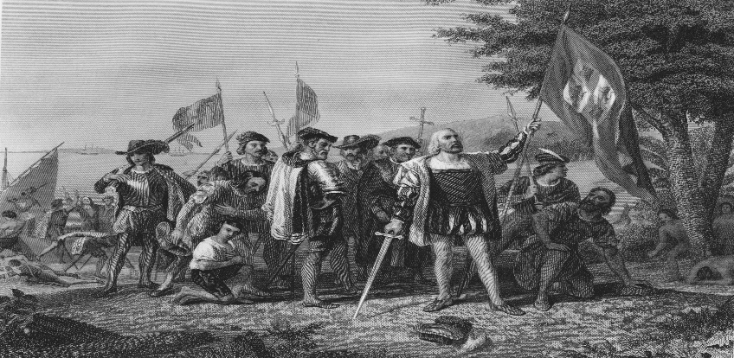


Halloween is a holiday celebrated each year on October 31, and Halloween 2025 will occur on Friday, October 31. The tradition originated with the ancient Celtic festival of Samhain, when people would light bonfires and wear costumes to ward off ghosts. In the 8th century, Pope Gregory III designated November 1 as a time to honor all saints. Soon, All Saints Day incorporated some of the traditions of Samhain. The evening before was known as All Hallows Eve, and later Halloween. Over time, Halloween evolved into a day of activities like trick-or-treating, carving jack-o-lanterns, festive gatherings, donning costumes and eating treats.
What is the History of Halloween?
Halloween’s origins date back to the ancient Celtic festival of Samhain (pronounced sow-in). The Celts, who lived 2,000 years ago, mostly in the area that is now Ireland, the United Kingdom and northern France, celebrated their new year on November 1.
This day marked the end of summer and the harvest and the beginning of the dark, cold winter, a time of year that was often associated with human death. Celts believed that on the night before the new year, the boundary between the worlds of the living and the dead became blurred. On the night of October 31, they celebrated Samhain, when it was believed that the ghosts of the dead returned to earth.

in addition to causing trouble and damaging crops, Celts thought that the presence of the otherworldly spirits made it easier for the Druids, or Celtic priests, to make predictions about the future. For a people entirely dependent on the volatile natural world, these prophecies were an important source of comfort during the long, dark winter.
To commemorate the event, Druids built huge sacred bonfires, where people gathered to burn crops and animals as sacrifices to the Celtic deities. During the celebration, the Celts wore costumes, typically consisting of animal heads and skins, and attempted to tell each other’s fortunes.
When the celebration was over, they re-lit their hearth fires, which they had extinguished earlier that evening, from the sacred bonfire to help protect them during the coming winter.



LOCAL NEWS
- Are you in need of grocery delivery service? Call 620-228-5570 for more information on this new service.

- Did you know that you can watch the city council meetings on the city website; www.cityoflaharpe.org you can find the recording of the meeting the following business day after the meeting.

- Don’t forget, we have a community food box in front of City Hall…. Take what you need, leave what you can.

- Meet the candidates, running for the open council seats, at city hall Monday, October 20th at 6:00pm

If you need assistance after-hours please call the Iola Dispatch Center at (620) 365-1437, they will notify the proper personnel.
 HAPPY BIRTHDAY TO ALL LAHARPE CITIZENS CELEBRATING A BIRTHDAY THIS MONTH!!!! MAY YOUR DAY BE AS SPECIAL AS YOU ARE TO US!



Dates to remember:

 October 8th: Council Meeting at City Hall at 7:00 pm

 October 13th: City Hall closed in observance of Columbus Day

 October 20th: PRIDE Meeting at 7:00 p.m. at the City Hall & MEET THE CANDIDATES @ 6:00PM

 October 28th: Past due Utility shut off date.

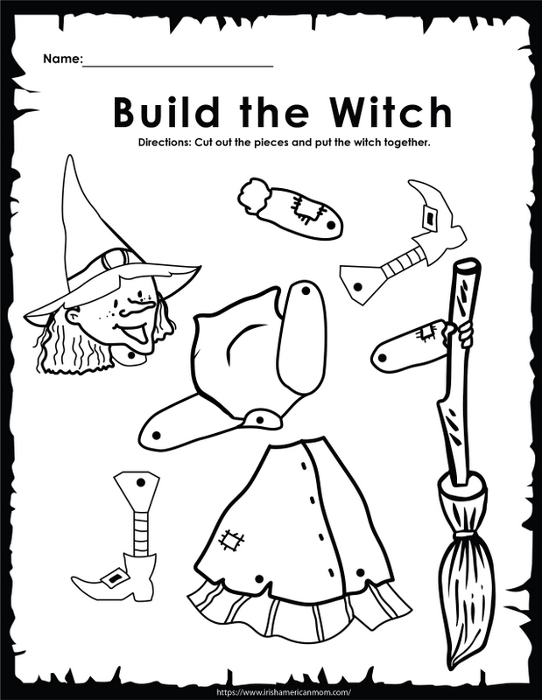



CITY COUNCIL NEWS
CITIZENS CALL FOR BUSINESS
- Veronica Poffenbarger and Ryan Ellis presented pictures of a 1996 mobile home they have interest in purchasing and would like to move it to La Harpe. Austin Lee expressed concerns about the last mobile home that moved into the city which violated the city ordinance. After further discussion, this request is being tabled until October so the homeowners can get everything, they need before the request is granted.
- Eastern Kansas In & Out Construction, Bryron Redifer and Josh, purchased the property at 912 S. Main and was questioning the building size requirement on that property stating they are wanting to start up a rental station business and will need a building for the shop. Bryon also asked I shipping containers could be set on the property and insured they would not be a permanent structure. Mayor Crowell suggested the get a building packet and start there.
- David Lee asked the council where the city was on the cleanup in La Harpe. He expressed concerns that the ordinance the city has in place is not being followed by the elected officials, if the you would follow this ordinance it would take care of the issues. Sharlyn Thompson stated, the city has active cases in court now. Ron Knavel stated he would like for the city to give 10 days and then go in and clean it up but our ordinance won’t allow this.
- Sarah Aiello shared a written complaint, stating she has a small family-owned business of selling fireworks in Iola, Humboldt & Moran and it was brought to my attention the city code officer made accusations about my business, Aiello Fireworks. Sarah stated she has no ties to La Harpe, everything mentioned in my complaint pertains to my husbands’ parents, not us. We have served communities for 9 years and, even though she was off the clock, she used her authority to discourage people to shop with us. I am asking the city council & leadership to investigate this conduct as to whether it violates your city standard and take the appropriate action.
- Vicky Gerdsen expressed concerns with the city’s action of putting dogs down to quickly and suggested we contact ACARF. Mayor Crowell stated we do contact ACARF, they won’t contract with us because Iola brings so many in and most times, they are full, we advertise the dogs, to put them down is our last resort.
- Richard Luken – La Harpe Pride, reminded everyone of the upcoming candidate forum October 20th at 6:00pm and is asking someone from the city to be present to talk about the city sales tax at the event. Richard also stated the La Harpe Pride clean-up will be November 1st.
- Harry Lee applauded city worker, Larry Laird, for taking his time off the clock to keep our community safe. He stated a few weeks ago Larry seen someone trying to steal some beams from the Nelson property, he noticed I was at the phone company so he approached me and together we were able to save a theft from happening. The city has a good worker in Larry.

UNFINISHED BUSINESS
- Police Officer – Mayor Crowell stated Fred is supposed to be meeting with the sheriff.
- Rural & City Fire Department dual coverage – Mayor Crowell stated this matter is being looked into, I’ve spoken to a commissioner and Marc about it and we also need to look into the liability as well so it is in discussion.
- Employee Training – Michelle stated it is printed in the handbook the time frame to pay the city back after leaving employment.
NEW BUSINESS
- Vickie Moss – Thrive, Vickie stated Thrive is working with Harry Lee to submit the Modern Income Housing (MIH) Grant, this is the same that was submitted earlier but were unsuccessful so we are trying again. Vickie mentioned this is the last year for this program, so if the city would like to pursue this grant, I will need signatures before submitting. Mayor Crowell asked for a motion to sign and submit the grant. Cynthia Carr made the motion to move forward with the grant. Ron Knavel seconded. Motion carried 5-0.
- Sales Tax Resolution – Michelle presented resolution #2025-4 and the question for the ballot:
SHALL THE FOLLOWING BE ADOPTED?
Should the City of La Harpe impose a sales tax of ONE AND ONE- HALF percent (1.50%), for the purpose of street projects and other capital improvements for the City of La Harpe with such tax to be implemented on April 1, 2026 and terminating March 31, 2036? This tax would replace the previous 1.00% sales tax that expired March 31, 2025.
Sharlyn Thompson made the motion to pass the resolution. Angela Barker seconded. Motion carried 5-0.
- Bio Mist Spray – Angela Barker made the motion to purchase a 55-gallon drum in the amount of $5,434.00. Ron Knavel seconded. Motion carried 5-0.
- Streets – Cynthia Carr asked if we are going to start doing anything with the streets. Ron Knavel stated the city is wasting money using cold patch. Mayor Crowell stated she would get a hold of the county.
- City truck AC – 3 quotes were shared; Sigg Tires $1,350.00 - $1,600.00, Quality Auto $1,064.08 and Twin Motors $2,957.42. Sharlyn Thompson made the motion to go with Quality Auto. Cyndi Maley seconded with the money coming out of equipment reserve. Motion carried 5-0.
- Whistles – City maintenance stated they need 2 24” pipe for 5th & 6th street and they need to be about 25’ long. Cleaver has them at $1,232.40 a piece and Ray’s Metal has 20” pipe that can be welded for $600.00 to $700.00. Ron Knavel made the motion to get two 20-foot pipes from Ray’s Metal for 5th street. Sharlyn Thompson seconded. Motion carried 5-0.

- Street Lights – 2 quotes from Border States were shared totaling $3,720.20 to cover the costs of 6 street light fixtures and bulbs, 500 feet of wire and 500 feet of conduit. Cynthia Carr made the motion to purchase the items from Border States. Sharlyn Thompson seconded. Motion carried 5-0.
- Small Bucket Truck Brakes – 3 bis were shared for new brakes & rotors; Quality Auto $1,314.09, Sigg Tire $925.00 and Ken Pratt Motors $881.86. Cynthia Carr made the motion to go with Ken Pratt Motors. Angela Barker seconded. Motion carried 5-0.
- KDHE Loan – A payment in the amount of $358.34 was presented to the council and was also asked if the city elects to capitalize the interest during construction to the loan balance. Sharlyn Thompson made the motion to pay the $358.34 and to capitalize. Cyndi Maley seconded. Motion carried 5-0.

REPORTS OF CITY OFFICERS
- Fred Works, City Attorney – Absent from meeting.

- Roy Caler, Water Representative – Nothing to report.

- Penny Miller, Code/Animal Control –monthly report and building permits submitted to mayor.

- Marc Waggoner, Fire Chief- Shared minutes from two meetings: Fire Department Meeting August 9, 2025: The La Harpe Volunteer Fire Department met for the monthly meeting. Present: Josh Sparks, Marc Waggoner Sr., Matthew Waggoner, Trevor Stover, Dennis Sidebottom, Bill Gay, and Meghan Sparks. Absent were Kiefer Endicott, Pamela Waggoner, Ronald Splector and Justin Pritchard. Started meeting, took out aerial and tanker and then did tanker to aerial exercises, then ended the meeting. Fire Department Meeting September 6, 2025: The La Harpe Volunteer Fire Department met for the monthly meeting. Present: Josh Sparks, Marc Waggoner Sr., Matthew Waggoner, Trevor Stover, Dennis Sidebottom, Bill Gay, Kiefer Endicott, and Meghan Sparks. Absent were Pamela Waggoner, Ronald Splector and Justin Pritchard. Fire fighters met Pride at the park for a dinner from Pride, thanking the firefighters for everything they do then we returned to the barn and tried out new lifting device for lift assist calls then ended meeting. Marc stated the fire department was getting ready to flush all hydrants throughout town.

- Maintenance Department - The workorders were shared. Sharlyn Thompson stated the works orders need to be dated.

- Michelle Altis, City Clerk – Had nothing to report.
DISCUSSION ON AGENDA ITEMS –
Mayor Crowell requested a motion to go into executive session on non-elected for 10 minutes. Cynthia Carr made the motion to go into executive session on non-elected personnel for 10 minutes. Angela Barker seconded. Motion carried 5-0. After returning to regular session, Sharlyn Thompson made the motion to give Larry Laird a $1.00 per hour raise effective this pay period. Cyndi Maley seconded. Motion carried 5-0. Michelle asked about the dump truck and Ron Knavel suggested we hold off until after the first of the year.


Mayor: Ella Mae Crowell (620) 496-6219
City Attorney: Fred Works
City Municipal Judge: Patty Miklos
Fire Chief: Marc Waggoner
Assistant Fire Chief: Dennis Sidebottom
City Clerk: Michelle Altis
Assistant Clerk: Teresa Driskel
City Treasurer: Audra Riggins
Maintenance Staff: Keith Knavel & Larry Laird
Code & Animal Control: Penny Miller

City Council Members:
Angela Barker (224-6209) Ron Knavel (496-2508)
Cynthia Carr (496-7500) Sharlyn Thompson (405-0272)
Cyndi Maley (228-4867)
Laharpe City Hall Hours: Monday-Friday
902 S. Washington 8:00-12:00 & 1:00-5:00
P.O. Box 10 Ph. (620) 365-5956
Laharpe, KS. 66751 Fax (620) 365-3944
CHECK OUT OUR WEBSITE; CITYOFLAHARPE.ORG  Follow us on Facebook – City of La Harpe
CHECK OUT OUR WEBSITE; CITYOFLAHARPE.ORG


The Best Shepherd’s Pie
Ingredients
- 1 pound ground beef
- 1 cup chopped onion
- 2 cups frozen corn, thawed
- 2 cups frozen peas, thawed
- 2 tablespoons ketchup
- 1 tablespoon Worcestershire sauce
- 2 teaspoons minced garlic
- 1 tablespoon cornstarch
- 1 teaspoon beef bouillon granules
- 1/2 cup cold water
- 1/2 cup sour cream
- 3-1/2 cups mashed potatoes (prepared with milk and butter)
- 3/4 cup shredded cheddar cheese
Directions
- In a large skillet, cook beef and onion over medium heat until meat is no longer pink, breaking it into crumbles; drain. Stir in the corn, peas, ketchup, Worcestershire sauce and garlic. Reduce heat to medium-low; cover and cook for 5 minutes.
- Combine the cornstarch, bouillon and water until well blended; stir into beef mixture. Bring to a boil over medium heat; cook and stir until thickened, 2 minutes. Stir in sour cream and heat through (do not boil).
- Spread mashed potatoes over the top; sprinkle with cheese. Cover and cook until potatoes are heated through and cheese is melted.



Slow-Cooker Chili

Ingredients

2 pounds lean ground beef (90% lean)

2 cans (16 ounces each) kidney beans, rinsed and drained

2 cans (14-1/2 ounces each) diced tomatoes, undrained

1 can (8 ounces) tomato sauce

2 medium onions, chopped

1 medium green pepper, chopped

2 garlic cloves, minced

2 tablespoons chili powder

1 teaspoon salt

1 teaspoon pepper

Optional: Shredded cheddar cheese, sliced green onions, chopped red onion, sliced jalapeno peppers and sour cream

Directions

In a large skillet, cook beef over medium heat until no longer pink, 10-12 minutes, breaking into crumbles; drain.

Transfer to a 5-qt. slow cooker. Add the next 9 ingredients. Cover and cook on low for 8-10 hours. Serve with toppings as desired.



Pumpkin Bars

Ingredients

4 large eggs, room temperature

1-2/3 cups sugar

1 cup canola oil

1 can (15 ounces) pumpkin

2 cups all-purpose flour

2 teaspoons ground cinnamon

2 teaspoons baking powder

1 teaspoon baking soda

1 teaspoon salt

ICING:

6 ounces cream cheese, softened

2 cups confectioners' sugar

1/4 cup butter, softened

1 teaspoon vanilla extract

1 to 2 tablespoons 2% milk

Directions

In a bowl, beat the eggs, sugar, oil and pumpkin until well blended. Combine the flour, cinnamon, baking powder, baking soda and salt; gradually add to pumpkin mixture and mix well. Pour into an ungreased 15x10x1-in. baking pan. Bake at 350° for 25-30 minutes or until set. Cool completely.

For icing, beat the cream cheese, confectioners' sugar, butter and vanilla in a small bowl. Add enough milk to achieve spreading consistency. Spread icing over bars. Store in the refrigerator.



