SEPTEMBER NEWSLETTER

LABOR DAY SEPTEMBER 1ST
Labor Day 2025 will occur on Monday, September 1. Labor Day pays tribute to the contributions and achievements of American workers and is traditionally observed on the first Monday in September. It was created by the labor movement in the late 19th century and became a federal holiday in 1894. Labor Day weekend also symbolizes the end of summer for many Americans and is celebrated with parties, street parades and athletic events.
When Is Labor Day?
Labor Day is always observed on the first Monday in September. Labor Day 2025 take place on Monday, September 1.
Why Do We Celebrate Labor Day?
Labor Day, an annual celebration of workers and their achievements, originated during one of American labor history’s most dismal chapters.
In the late 1800s, at the height of the Industrial Revolution in the United States, the average American worked 12-hour days and seven-day weeks in order to eke out a basic living. Despite restrictions in some states, children as young as 5 or 6 toiled in mills, factories and mines across the country, earning a fraction of their adult counterparts’ wages.
People of all ages, particularly the very poor and recent immigrants, often faced extremely unsafe working conditions, with insufficient access to fresh air, sanitary facilities and breaks.
As manufacturing increasingly supplanted agriculture as the wellspring of American employment, labor unions, which had first appeared in the late 18th century, grew more prominent and vocal. They began organizing strikes and rallies to protest poor conditions and compel employers to renegotiate hours and pay.
Many of these events turned violent during this period, including the infamous Haymarket Riot of 1886, in which several Chicago policemen and workers were killed. Others gave rise to longstanding traditions: On September 5, 1882, 10,000 workers took unpaid time off to march from City Hall to Union Square in New York City, holding the first Labor Day parade in U.S. history.
The idea of a “workingmen’s holiday,” celebrated on the first Monday in September, caught on in other industrial centers across the country, and many states passed legislation recognizing it. Congress would not legalize the holiday until 12 years later, when a watershed moment in American labor history brought workers’ rights squarely into the public’s view. On May 11, 1894, employees of the Pullman Palace Car Company in Chicago went on strike to protest wage cuts and the firing of union representatives.
On June 26, the American Railroad Union, led by Eugene V. Debs, called for a boycott of all Pullman railway cars, crippling railroad traffic nationwide. To break the Pullman strike, the federal government dispatched troops to Chicago, unleashing a wave of riots that resulted in the deaths of more than a dozen workers.
Who Created Labor Day?
In the wake of this massive unrest and in an attempt to repair ties with American workers, Congress passed an act making Labor Day a legal holiday in the District of Columbia and the territories. On June 28, 1894, President Grover Cleveland signed it into law. More than a century later, the true founder of Labor Day has yet to be identified.
Many credit Peter J. McGuire, cofounder of the American Federation of Labor, while others have suggested that Matthew Maguire, a secretary of the Central Labor Union, first proposed the holiday.
Labor Day Celebrations
Labor Day is still celebrated in cities and towns across the United States with parades, picnics, barbecues, fireworks displays and other public gatherings, especially over the long Labor Day weekend. For many Americans, particularly children and young adults, it represents the end of the summer and the start of the back-to-school season.



We celebrate National Grandparents Day on the first Sunday after Labor Day. This year, the date falls on September 7. Like Mother’s Day and Father’s Day we also have a whole day dedicated to our grandparents. Grandparents and children have a special connection that is proven to both make grandparents live longer, and also make children more emotionally resilient. Grandparents Day is an opportunity to treasure that connection and spend some quality family time together.
History of Grandparents Day
In 1969, nine-year-old Russell Capper sent President Nixon a letter suggesting that a day should be set aside in order to celebrate grandparents. On June 12, 1969, he received a letter back from Rose Mary Woods — Personal Secretary to the President — reading, “Dear Russell, Thank you for your letter to President Nixon. Your suggestion regarding a Grandparent’s Day is appreciated, but the President ordinarily issues proclamations designating periods for special observance only when a Congressional resolution authorizes him to do so. With best wishes, Sincerely, Rose Mary Woods Personal Secretary to the President.”
Following this letter, Marian McQuade was recognized nationally by the U.S. Senate and by President Jimmy Carter as the founder of National Grandparents Day. McQuade wanted to educate the youth about the importance of seniors and the contributions they have made throughout history. She urged the youth to “adopt” a grandparent and learn more about their lives, challenges, and desires for the future.
In 1977, Senator Randolph, with the help of other senators, introduced a joint resolution to the senate requesting the president to “issue annually a proclamation designating the first Sunday of September after Labor Day of each year as ‘National Grandparents’ Day’.” Congress passed the legislation, proclaiming the first Sunday after Labor Day as National Grandparent’s Day. On August 3, 1978, Jimmy Carter signed the proclamation, and the day was finally celebrated the following year.

September 11: A Day of Remembrance and Service

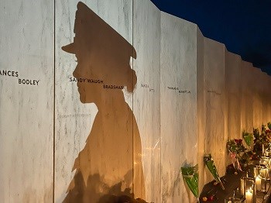
Wall of Names at Flight 93 National Memorial
The nation changed forever on September 11, 2001. Many Americans remember a country before and a country after, and for many young Americans, only a country after. Terrorist attacks causing tragic loss of life at the World Trade Center in New York City, the Pentagon in sight of the nation’s capital, and a quiet field in southern Pennsylvania led to conversations and reflection on American identity, patriotism, security, and service that resonate today.
A National Day of Remembrance
For months following September 11, 2001, people came together to grieve family, friends, and strangers. More than 20 years later, we still do. Sometimes called “Patriots Day” or “Day of Remembrance”, September 11 has become an annual day for many Americans to remember, reflect, honor, and mourn.
Memorials were created in communities around the country and at the three main sites of the attack. Flight 93 National Memorial in Shanksville, Pennsylvania, is part of the National Park System as a memorial to 40 passengers and crew who thwarted an additional attack preventing the loss of more lives. Consider visiting a national park for remembrance.
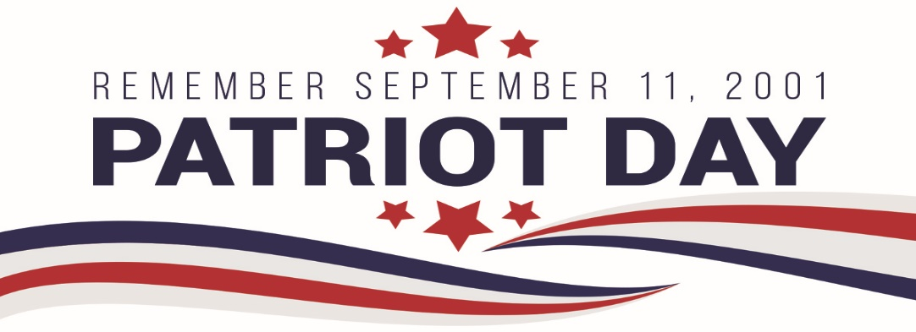

September 22, 2025
Fall. Autumn. Pumpkin spice season. Whatever name you prefer, there's no denying the magic of this transition from sizzling summer afternoons to crisp, cool evenings. It's pretty much the best time of year—just ask Ree Drummond, who calls autumn her absolute favorite season. "There's something truly special about this time of year, when the relentless heat fades away and life settles back into a comforting routine," she says.
And it’s not just the return to routine that feels so cozy. There's the excitement of tailgating season, pumpkin spice lattes finally reappearing at your local café, and sweaters you've almost forgotten about emerge from your closet. Autumn also brings an abundance of delicious produce, making it peak season for indulgent recipes like spiced pumpkin pie and warm apple cinnamon bread. Before you dive headlong into baking sessions and cozy movie marathons, though, it's helpful to know exactly when fall officially begins in 2025.
So, when is the first day of fall. this year? It all hinges on the fall equinox, which shifts slightly from year to year. Maybe you've heard the term "equinox" but aren't totally clear on what it means. Simply put, there are two equinoxes each year—autumnal and vernal. During these events, Earth's axis isn't tilted toward or away from the sun, creating a unique balance: nearly equal daylight and darkness worldwide. Unlike solstices, which mark the longest and shortest days, the equinoxes signal the starts of spring and fall.

LOCAL NEWS
- Are you in need of grocery delivery service? Call 620-228-5570 for more information on this new service.

- Did you know that you can watch the city council meetings on the city website; www.cityoflaharpe.org you can find the recording of the meeting the following business day after the meeting.

- Don’t forget, we have a community food box in front of City Hall…. Take what you need, leave what you can.

If you need assistance after-hours please call the Iola Dispatch Center at (620) 365-1437, they will notify the proper personnel.
 HAPPY BIRTHDAY TO ALL LAHARPE CITIZENS CELEBRATING A BIRTHDAY THIS MONTH!!!! MAY YOUR DAY BE AS SPECIAL AS YOU ARE TO US!





Dates to remember:

 September 1st: City Hall closed in observance of Labor Day
September 10th: Council Meeting at City Hall at 7:00 pm

 September 15th: PRIDE Meeting at 7:00 p.m. at the City Hall

 September 25th: Past due Utility shut off date.

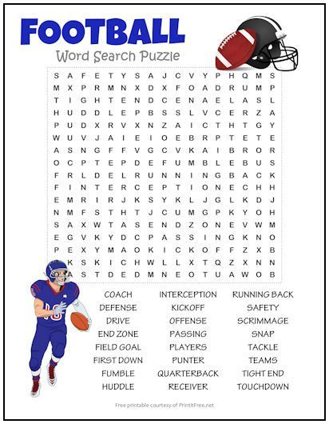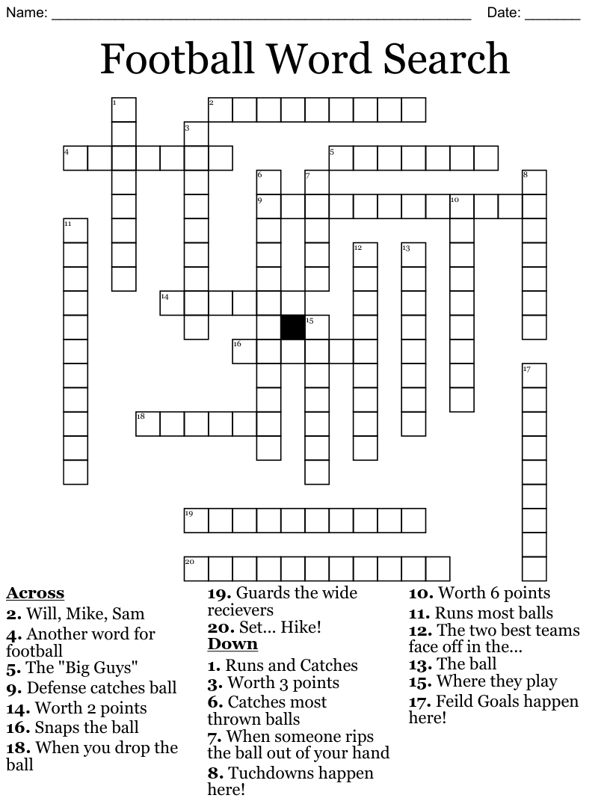

CITY COUNCIL NEWS
2026 BUDGET HEARING
Mayor Crowell opened the budget hearing for public comment. David Lee asked if money was set aside for cleanup. Mayor Crowell stated money is set aside for demolition of properties, that amount is $6500.00, and the city normally can remove 2 structures. Last year 1 structure was removed and this year the city has removed 3 structures, with a couple of them being pretty large so we went over budget this year. David Lee mentioned, if you will budget more you can cleanup more, now is the time to do it if you’re going to. Fred Works stated, if the city needs a little extra, they can move money from another fund. David Lee asked the council to reconsider the budget and put more money in the demo fund. Richard Luken asked what the mill levy was for La Harpe. Michelle Altis stated; in 2024 it was 64.253, 2025 it is 74.252 and the proposed levy for 2026 is 68.639. Savannah Flory asked if the sales tax will be added to the ballot explaining the question on the ballot last year seemed like the city was requesting to add 1.5% to the 1% already imposed, if it was worded differently, I think it would have passed. Mayor Crowell stated, we could add it to the ballot, not sure on the time frame but will have Michelle look into that. David Lee expressed concerns on the sales tax, stating there is a better way to get more money other than sales tax, sometimes you have to raise taxes. No other comments were made; Mayor Crowell closed the hearing. Mayor Crowell requested a motion to adopt the budget as proposed. Cynthia Carr voted yes, Sharlyn Thompson voted yes, Angela Barker voted yes, and Ron Knavel voted yes.
Mayor Crowell requested a motion on the city sales tax. Sharlyn Thompson made the motion to pursue the 1.5% sales tax if we can get it on the November ballot. Ron Knavel seconded. Motion carried 4-0.

CITIZENS CALL FOR BUSINESS
- Camille Lavon, economic director for Thrive Allen County was present to introduce herself to La Harpe and is looking forward to working with La Harpe and getting to know the community.
- Floyd Thompson expressed concerns about not having a police officer; on July 29th a small SUV ran a stop sign and almost hit me, at 6th & Main a golf cart slid into an intersection, almost hitting me again. No one is stopping at stop signs, cars parked throughout town that has not moved in 8 ½ years, cars driving in the park, dirt bike running around town, fireworks going off, and people living in tents. There is also an empty house that no one lives in but the lights are on and cars in and out of there, we need a police officer. Floyd asked if he noticed someone running a stop sign could he follow and get tag information to bring them to court. Fred stated if he would be willing to testify then yes, the driver could be cited.
- Kendra Michael also stated she would like a cop in town and would like to see it on the agenda until it is resolved. Kendra also asked about the rural and city fire department, wondering if the city is paying for dual coverage, stating she would like information on that and code enforcement is laxed in my neighborhood.
- David Lee expressed concerns with the code issues stating you need to do a better job, how long do you work with people on cleaning their properties. Fred stated the judge will give them time, normally 60 days and if progress stops, she will issue a failure to comply through the courts but not too much you can do. The city staff could go in and clean property, bill the homeowner, if left unpaid then it is turned into the county to be placed on the property taxes, the city may eventually be reimbursed or may not, it’s a serious budget issue. David shared a printout of a Kansas statue #12-1617e in regards to nuisances, collects of costs, procedures and the disposition of motor vehicles. He stated the weeds are easy to take care of, it’s the vehicles making the mess we have now. David addressed the council with frustration for allowing our property values to go down because of the code issues and it’s not fair to your citizens. You are failing your citizens if you don’t have the money to take care of this, the city is not enforcing code issues.
- Austin Lee mentioned two homes in town that have burnt, one was 7 months ago and nothing has been done, why would anyone come to the city looking like this. Austin asked Angela Barker would anyone come to the city with the way it looks now. Angela had no response.
- Richard Luken shared, the Pride Meeting on October 20th will hold a candidate forum for all candidates on the upcoming election at 7pm at city hall.
- Austin Lee expressed concerns over the vacant council seat, it has been vacated for months what are you waiting for. Mayor Crowell stated she was waiting for more interest, I have a valid reason for what I did; two of the interested parties are on the ballot and if elected we would still have the vacant seat. Fred stated, it is the mayor’s decision to fill a vacated seat, if the council does not agree then the appointed seat would take place in 45 days.

UNFINISHED BUSINESS
No unfinished business discussed.

NEW BUSINESS
- Cyndi Maley – Mayor Crowell stated Cyndi will be eligible to take seat on August 23rd, we do not need a special meeting she can come up to city hall after that date and Michelle can swear her in. Sharlyn Thompson expressed concerns about Cyndi not being a registered voter, Mayor Crowell stated she is now registered.
- Past Employee Training Costs – Michelle shared a report of money owed to the city to cover training costs for past employees. Mayor Crowell stated our biggest problem is we never had a time frame on when to pay back and we need that. Sharlyn Thompson stated we need to send them a demand letter. Mayor Crowell mentioned that Fred sent them letters in April but have received no response so now he will send a demand letter.
- Braden Westervelt Tree Costs – Mayor Crowell mentioned to Fred the city has not heard anything back or received payment. Fred advised to file a small claim judgement.
- Court Collections – Michelle stated, before we can send court documents in for collection we need a module on the court software. That module has an installation fee of $950.00 and a yearly fee of $50.00. Fred suggested the money come out of his diversion fund to pay for the software.
- Adair Fire Report – The report was given to the council as requested.
- Speed bumps & signage in park – Mayor Crowell mentioned that people are going through the park to avoid the speed bumps and recommends putting 2 speed bumps in the park. Ron Knavel made the motion to add 2 speed bumps and purchase the signs. Cynthia Carr seconded. Motion carried 4-0. Cyndi Maley and Savannah Flory complained about the speed bump on Jackson stating no kids play along that street so there is no sense in having it there. Angela Barker made the motion to remove the speedbump on Jackson and place in on 7th street, west of Jackson and toad an additional speed bump on 6th street, east of Jackson. Ron Knavel seconed. Motion carried 4-0.

REPORTS OF CITY OFFICERS
- Fred Works, City Attorney – Requested an Attorney/Client executive session at the end of the meeting.

- Roy Caler, Water Representative – Nothing to report.

- Penny Miller, Code/Animal Control –monthly report and building permits submitted to mayor.

- Marc Waggoner, Fire Chief- Did not have minutes to share. Marc stated the fire department is working on the valve exercise program and thinks they have come up with a way to measure the water used. Cynthia Carr asked about the landfill fire and how many gallons of water did you use from the city. Marc said 18,000 gallons were used. Mayor Crowell instructed Michelle to bill the county for the water. Cynthia Carr also expressed concerns about the landfill being in the county an was wondering if you ask for assistance when needed, Marc said yes, we do. Sharlyn Thompson asked about the hydrant at the landfill, Marc said it was to small and full of turbid water that I don’t want in my trucks.

- Maintenance Department - The workorders were shared.

- Michelle Altis, City Clerk – KMU is hosting the electric overhead class in McPherson in September which Keith is attending, we have been asked if we would be willing to bring our bucket truck for training. I asked Keith, and he is fine with driving it to McPherson, I just need council approval to have the truck out of town from September 23rd thru the 26th. All council members said that would be okay to do. Michelle shared a bid from Ray’s Metal Depot for the building on McKinley stating, I noticed the trailer was down so I called Mike and told him the bid was to clear the entire property, he did not realize it went over to 4th street. When I looked at the ad I placed, I only stated 406 McKinley and did not mention the other 2 addresses to that property so that is on me. Mayor Crowell opened the bid and it was $800.00 to remove the buildings. Sharlyn Thompson made the motion to accept the bid. Cynthia Carr seconded. Motion carried 4-0.

DISCUSSION ON AGENDA ITEMS –
Mayor Crowell requested a motion to go into executive session for attorney client for 10 minutes followed by an executive session for non-elected personnel for 10 minutes. Angela Barker made the motion to go into executive session for attorney client for 10 minutes followed by an executive session for non-elected personnel for 10 minutes. Ron Knavel seconded. Motion carried 4-0.


Mayor: Ella Mae Crowell (620) 496-6219
City Attorney: Fred Works
City Municipal Judge: Patty Miklos
Police Chief:
Fire Chief: Marc Waggoner
Assistant Fire Chief: Dennis Sidebottom
City Clerk: Michelle Altis
Assistant Clerk: Teresa Driskel
City Treasurer: Audra Riggins
Maintenance Staff: Keith Knavel & Larry Laird
Code & Animal Control: Penny Miller

City Council Members:
Angela Barker (224-6209) Ron Knavel (496-2508)
Cynthia Carr (496-7500) Sharlyn Thompson (405-0272)
Laharpe City Hall Hours: Monday-Friday
902 S. Washington 8:00-12:00 & 1:00-5:00
P.O. Box 10 Ph. (620) 365-5956
Laharpe, KS. 66751 Fax (620) 365-3944
CHECK OUT OUR WEBSITE; CITYOFLAHARPE.ORG  Follow us on Facebook – City of La Harpe


Touchdown Brat Sliders
Ingredients
- 5 thick-sliced bacon strips, chopped
- 1-pound uncooked bratwurst links, casings removed
- 1 large onion, finely chopped
- 2 garlic cloves, minced
- 1 package (8 ounces) cream cheese, cubed
- 1 cup dark beer or nonalcoholic beer
- 1 tablespoon Dijon mustard
- 1/4 teaspoon pepper
- 16 dinner rolls, split and toasted
- 2 cups cheddar and sour cream potato chips, crushed
Directions
- In a large cast-iron or other heavy skillet, cook bacon over medium heat until crisp. Remove to paper towels with a slotted spoon; drain, reserving drippings. Cook bratwurst and onion in drippings over medium heat until meat is no longer pink, breaking into crumbles. Add garlic; cook 1 minute longer. Drain well.
- Stir in the cream cheese, beer, mustard and pepper. Bring to a boil. Reduce heat; simmer, uncovered, until thickened, 15-20 minutes, stirring occasionally. Stir in bacon. Spoon 1/4 cup onto the bottom half of each roll; sprinkle with chips. Replace tops.


Blue-Ribbon Beef Nachos
Ingredients
- 1 pound ground beef
- 1 small onion, chopped
- 1 can (16 ounces) refried beans
- 1 jar (16 ounces) salsa
- 1 can (6 ounces) ripe olives, chopped
- 1/2 cup shredded cheddar cheese
- 1 green onion, chopped
- 2 tablespoons chili powder
- 1 teaspoon salt
- Tortilla chips
- Optional toppings: Sliced ripe olives, chopped green onions and diced tomatoes
Directions
- In a large skillet, cook the beef and onion over medium heat until meat is no longer pink, breaking beef into crumbles; drain. Stir in next 7 ingredients; heat through. Serve over tortilla chips. Top with olives, onions and tomatoes if desired.


Taco Pinwheels
Ingredients
- 4 ounces cream cheese, softened
- 3/4 cup Seasoned Taco Meat
- 1/4 cup finely shredded cheddar cheese
- 1/4 cup salsa
- 2 tablespoons mayonnaise
- 2 tablespoons chopped ripe olives
- 2 tablespoons finely chopped onion
- 5 flour tortillas (8 inches), room temperature
- 1/2 cup shredded lettuce
- Additional salsa

Directions
- In a small bowl, beat the cream cheese until smooth. Stir in the taco meat, cheese, salsa, mayonnaise, olives and onion. Spread over tortillas. Sprinkle with lettuce; roll up tightly. Wrap securely and refrigerate for at least 1 hour.
- Unwrap and cut into 1-in. pieces. Serve with additional salsa.


Dutch Apple Cake
Ingredients
- 3 medium tart apples, peeled and cut into 1/4-inch slices (3 cups)
- 3 tablespoons plus 1 cup sugar, divided
- 1 teaspoon ground cinnamon
- 2/3 cup butter, softened
- 4 large eggs, room temperature
- 1 teaspoon vanilla extract
- 2 cups all-purpose flour
- 1/8 teaspoon salt
Directions
- In a large bowl, combine the apples, 3 tablespoons sugar and cinnamon; let stand for 1 hour.
- In another bowl, cream butter and remaining sugar until light and fluffy, 5-7 minutes. Add eggs, 1 at a time, beating well after each addition. Add vanilla. Combine flour and salt; gradually add to creamed mixture and beat until smooth.
- Transfer to a greased 9x5-in. loaf pan. Push apple slices vertically into batter, placing them close together.
- Bake at 300° for 1-1/2 to 1-3/4 hours or until a toothpick inserted in the center comes out clean. Cool for 10 minutes before removing from pan to a wire rack. Serve warm.



Reese’s Peanut Butter Cups Stuffed Chocolate Monkey Bread

Ingredients

Bread
- 2cans (8 oz) refrigerated Pillsbury™ Original Crescent Dough Sheet
- 36Reese's Peanut Butter Cups™ minis (from 8-oz bag)
- 1/4cup sugar
- 1/4cup butter, melted

Toppings
- 1/4cup semisweet chocolate chips
- 2tablespoons creamy peanut butter
- 8Reese's Peanut Butter Cups™ minis, halved

Steps
- 1 Heat oven to 350°F. Generously spray 10- or 12-cup fluted tube cake pan with baking spray with flour, or grease pan with shortening and lightly flour.
- 2 Unroll 1 can of dough into 1 large rectangle. Cut rectangle into 6 rows by 3 rows, to make 18 pieces. Place 1 candy, top side down, on center of dough piece. Fold dough over candy (do not stretch dough), and gently pinch to seal around candy; roll into a ball. Repeat with second can of dough.
- 3 In small bowl, place sugar. Roll dough balls in sugar until coated. Place sugar-coated dough balls in pan. Sprinkle any remaining sugar over dough. Pour melted butter on top.
- 4 Bake 28 to 33 minutes or until golden brown and no longer doughy in center. Cool in pan 5 minutes. Turn upside down onto serving plate.
- 5 In small microwavable bowl, microwave chocolate chips uncovered on High 30 to 60 seconds; stir until smooth. Spoon into 1-quart resealable food-storage plastic bag. Cut small opening from 1 corner of bag. Drizzle melted chocolate over top of monkey bread. In another small microwavable bowl, microwave peanut butter uncovered on High 10 to 30 seconds or until thin enough to drizzle. Spoon into 1-quart resealable food-storage plastic bag. Cut small opening from 1 corner of bag. Drizzle melted peanut butter over top of chocolate. Garnish with halved candies. Pull apart to serve.

