NOVEMBER NEWSLETTER
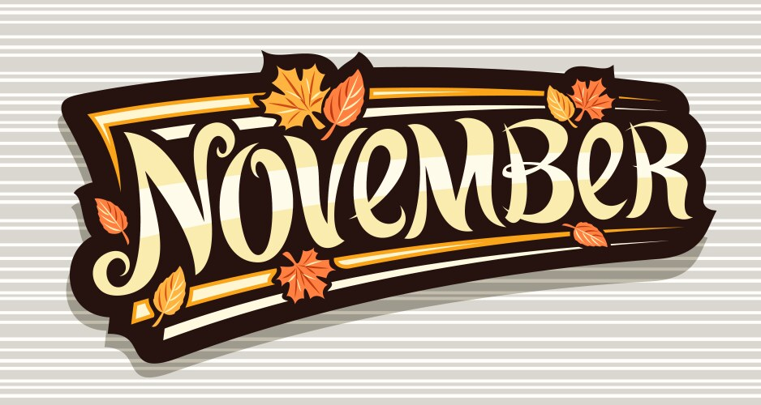
Daylight saving time will end for the year at 2 a.m. local time on Sunday, November, 2nd. This years’ time change comes a day earlier than last year and falls on the second-earliest possible date for the time change. Since daylight saving time falls on the first Saturday in November, the earliest possible date is Nov. 1.
History of Daylight-saving time:
Ancient civilizations adjusted daily schedules to the sun more flexibly than DST does, often dividing daylight into 12 hours regardless of daytime, so that each daylight hour became progressively longer during spring and shorter during autumn. For example, the Romans kept time with water clocks that had different scales for different months of the year; at Rome's latitude, the third hour from sunrise started at 09:02 solar time and lasted 44 minutes at the winter solstice, but at the summer solstice it started at 06:58 and lasted 75 minutes. From the 14th century onward, equal-length civil hours supplanted unequal ones, so civil time no longer varied by season. Unequal hours are still used in a few traditional settings, such as monasteries of Mount Athos and in Jewish ceremonies.
Benjamin Franklin published the proverb "early to bed and early to rise makes a man healthy, wealthy, and wise", and published a letter in the Journal de Paris when

he was an American envoy to France (1776–1785) suggesting that Parisians economize on candles by rising earlier to use morning sunlight. This 1784 satire proposed taxing window shutters, rationing candles, and waking the public by ringing church bells and firing cannons at sunrise. Despite common misconception, Franklin did not actually propose DST; 18th-century Europe did not even keep precise schedules. However, this changed as rail transport and communication networks required a standardization of clocks unknown in Franklin’s Day.
In 1810, the Spanish National Assembly Cortes of Cádiz issued a regulation that moved certain meeting times forward by one hour from 1 May to 30 September in recognition of seasonal changes, but it did not change the clocks. It also acknowledged that private businesses were in the practice of changing their opening hours to suit daylight conditions, but they did so of their volition.
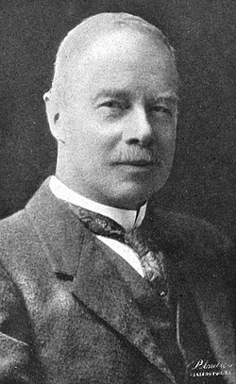

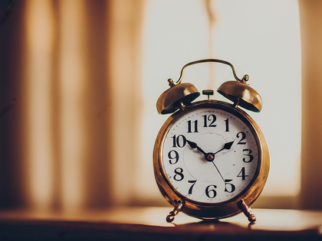
George Hudson was the first to propose modern DST, in 1895.
New Zealand entomologist George Hudson first proposed modern DST. His shift-work job gave him spare time to collect insects and led him to value after-hours daylight. In 1895, he presented a paper to the Wellington Philosophical Society proposing a two-hour daylight-saving shift, and considerable interest was expressed in Christchurch; he followed up with an 1898 paper. Many publications credit the DST proposal to prominent English builder and outdoorsman William Willett, who independently conceived DST in 1907 during a pre-breakfast ride when he observed how many Londoners slept through a large part of a summer day. Willett also was an avid golfer who disliked cutting short his round at dusk. His

solution was to advance the clock during the summer, and he published the proposal two years later. Liberal Party member of parliament Robert Pearce took up the proposal, introducing the first Daylight Saving Bill to the British House of Commons on 12 February 1908. A select committee was set up to examine the issue, but Pearce's bill did not become law and several other bills failed in the following years. Willett lobbied for the proposal in the UK until his death in 1915.

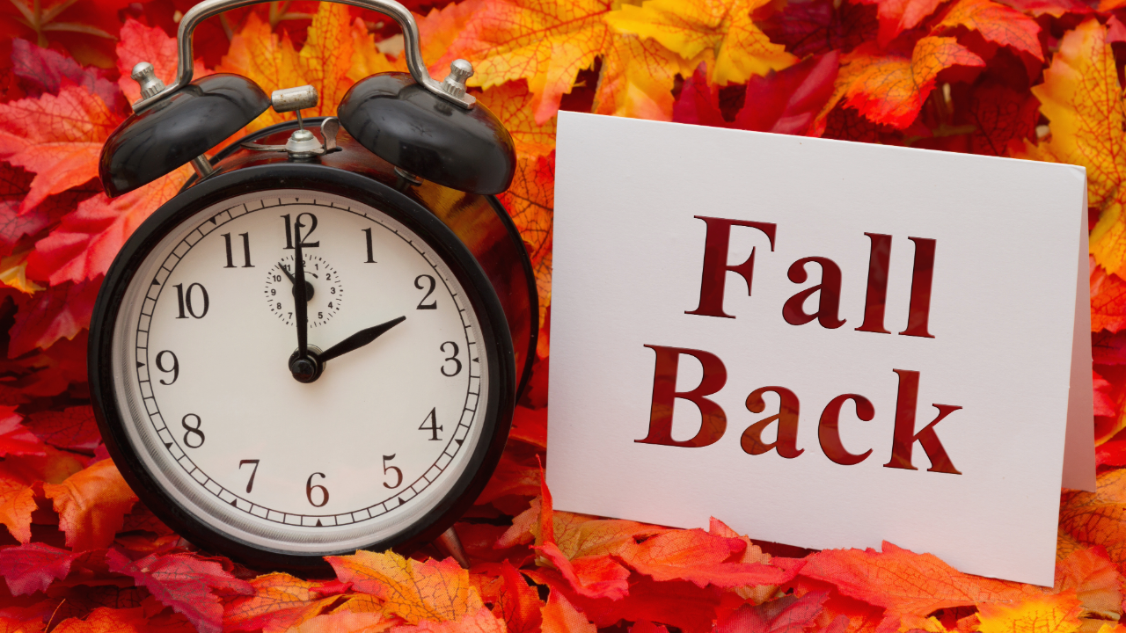

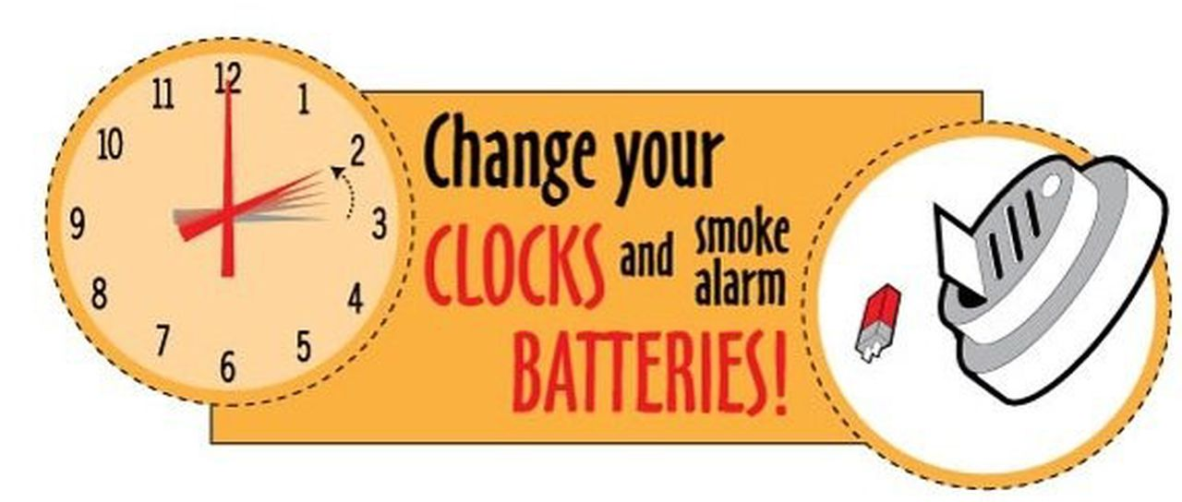


ELECTION DAY NOVEMBER 4TH!!!
There will be 3 open council seats on the voting ballot this election; Cynthia Carr, Sharlyn Thompson, and Ron Knavel’s term is expiring. All 3 are seeking re-election and will be up against Craig Trester, Kendra Michael, and Harry Lee Jr..
Also on the ballot will be the city’s sales tax proposal of 1.5% city sales tax rate. The 1% sales tax the city had expired March 31, 2025, the sales tax proposal did not pass in the 2024 election.
Election polls will be open from 7:00am – 7:00pm
La Harpe residents will vote at the
Gas Community Center– 624 W. Pine Gas, KS.
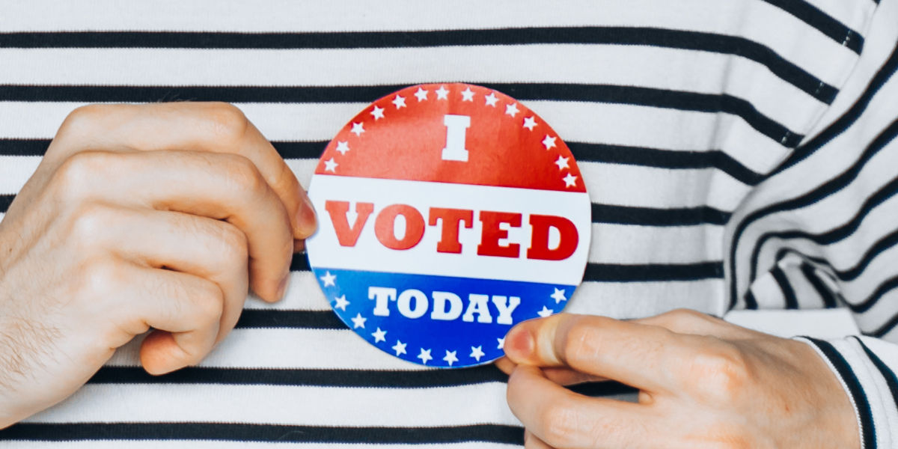


Veterans Day 2025 is a nationally observed holiday in the United States that honors and pays tribute to all military veterans who have served in the U.S. Armed Forces. This day recognizes the bravery, sacrifice, and patriotism of veterans and serves as an opportunity for the nation to express gratitude for their service and dedication.
What is Veterans Day?
Veterans Day, originally known as Armistice Day, was first celebrated on November 11, 1919, to commemorate the end of World War I. It was officially recognized as a federal holiday in 1938 and was renamed Veterans Day in 1954 to honor all American veterans, both living and deceased.
When is Veterans Day 2025?
Veterans Day is observed annually on November 11th, however, if it falls on a weekend, it is typically observed on the nearest weekday (Friday or Monday) to allow for a federal holiday. In 2025, it falls on a Tuesday.
How to Celebrate Veterans Day 2025?
Celebrating Veterans Day provides an opportunity to show appreciation for veterans and recognize their contributions to the nation. Here are ways to participate in the celebrations:

- Attend Parades and Ceremonies: Many cities and communities organize parades and ceremonies to honor veterans. Participate in these events to show your support.
- Visit Veterans Memorials: Pay a visit to local veterans’ memorials or cemeteries to pay your respects and reflect on the sacrifices made by veterans.
- Thank a Veteran: Express your gratitude to veterans you know personally or encounter in your community.
- Volunteer: Offer your time to volunteer with organizations that support veterans, such as VA hospitals or veterans’ service organizations.
- Donate to Veteran Causes: Contribute to charities that provide assistance to veterans and their families.
- Display the Flag: Fly the U.S. flag to honor veterans and show your patriotic spirit.
History of Veterans Day
The history of Veterans Day is rooted in the end of World War I when an armistice, or cease-fire, was declared on the 11th hour of the 11th day of the 11th month in 1918. This event marked the end of hostilities in the war, and November 11th became a day to remember and honor veterans.
Veterans Day was officially designated as a holiday to honor all veterans in 1954 by President Dwight D. Eisenhower. It has since been a day of reflection and appreciation for the military service of veterans from all branches of the U.S. Armed Forces.


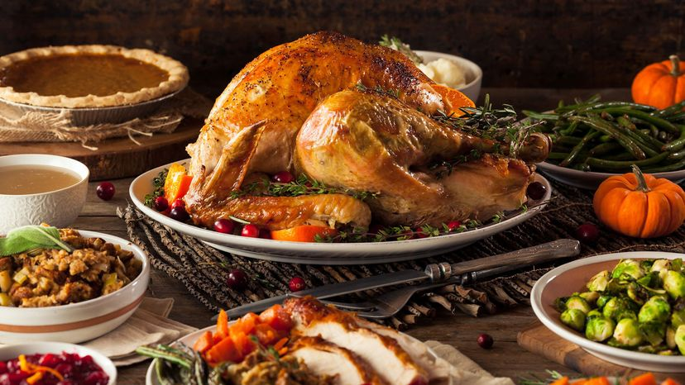
As celebrated in the United States, the holiday of Thanksgiving usually revolves around a bountiful meal. Typical dishes include bread stuffing, potatoes, cranberry sauce, pumpkin pie, and, above all, turkey. How did turkey become the centerpiece of this feast?
It is often assumed that today’s Thanksgiving menu originated in an event commonly referred to as the “first Thanksgiving.” There is indeed evidence of a meal shared between Pilgrim settlers at Plymouth colony (in what is now Massachusetts) and Wampanoag people in late 1621. But there is no indication that turkey was served. For meat, the Wampanoag brought deer, and the Pilgrims provided wild “fowl.” Strictly speaking, that “fowl” could have been turkeys, which were native to the area, but historians think it was probably ducks or geese.
What’s more, the Pilgrims do not appear to have considered this meal a milestone worthy of special commemoration. No 17th-century reference to it exists beyond a letter written by Plymouth colonist Edward Winslow. For the Pilgrims, giving thanks for the autumn harvest wasn’t a new concept. As a tradition with roots in European harvest festivals and Christian religious observances, “days of thanksgiving” were fairly common among the colonists of New England. Throughout America’s colonial era, communities held their own unofficial Thanksgiving celebrations, and few people associated them with the Plymouth settlers.
By the turn of the 19th century, however, turkey had become a popular dish to serve on such occasions. There were a few reasons for this. First, the bird was

rather plentiful. One expert estimated that there were at least 10 million turkeys in America at the time of European contact. Second, turkeys on a family farm were almost always available for slaughter. While live cows and hens were useful as long as they were producing milk and eggs, respectively, turkeys were generally raised only for their meat and thus could be readily killed. Third, a single turkey was usually big enough to feed a family.
Nevertheless, turkeys were not yet synonymous with Thanksgiving. Some people have credited Charles Dickens’s A Christmas Carol (1843) with bolstering the idea of turkey as a holiday meal. But another writer, Sarah Josepha Hale, played an arguably more important role. In her 1827 novel Northwood, she devoted an entire chapter to a description of a New England Thanksgiving, with a roasted turkey “placed at the head of the table.” At about the same time, she also began campaigning to establish Thanksgiving as a national holiday in the United States, which she believed would help unify the country as it teetered toward civil war. Her efforts finally paid off in 1863 with a presidential proclamation by Abraham Lincoln.
As Thanksgiving became an official American holiday, a national mythology formed around it. An 1841 collection of Pilgrim writing had referred to the meal described by Winslow as “the first Thanksgiving.” Although Winslow didn’t specifically mention turkey, his fellow colonist William Bradford did refer to a “great store of wild Turkies” at Plymouth that fall, in a journal that was reprinted in 1856. Before long, the cultural links between Pilgrims, turkeys, and Thanksgiving became an inextricable and integral part of American schoolchildren’s education.
From a more practical perspective, turkey has also remained relatively affordable. Although the wild turkey was considered endangered in the early 20th century, its population once again stands in the millions. In addition, modern breeding practices have helped make turkeys both larger and cheaper than ever, thus ensuring their continued place on the Thanksgiving table.
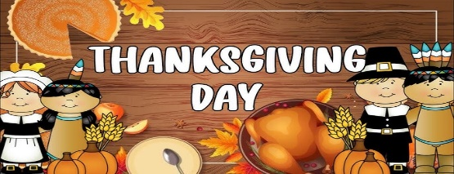

LOCAL NEWS
- Are you in need of grocery delivery service? Call 620-228-5570 for more information on this new service.

- Did you know that you can watch the city council meetings on the city website; www.cityoflaharpe.org you can find the recording of the meeting the following business day after the meeting.

- Don’t forget, we have a community food box in front of City Hall…. Take what you need, leave what you can.

If you need assistance after-hours please call the Iola Dispatch Center at (620) 365-1437, they will notify the proper personnel.
 HAPPY BIRTHDAY TO ALL LAHARPE CITIZENS CELEBRATING A BIRTHDAY THIS MONTH!!!! MAY YOUR DAY BE AS SPECIAL AS YOU ARE TO US!

Dates to remember:

 November 12th: Council Meeting at City Hall at 7:00 pm

 November 17th: PRIDE Meeting at 7:00 p.m. at the City Hall

 November 25th: Past due Utility shut off date.

CITY COUNCIL NEWS
PUBLIC HEARING
Mayor Crowell opens the public hearing for a request on a variance to move in a mobile home that is older than required by city ordinance. Bill Gay expressed concerns of it needs to be nice to come to La Harpe and where will the placement be, where the old one use to sit. Veronica Poffenbarger stated the home will be placed where the old home was and have intentions to put on a new roof, siding, and windows. Ryan Ellis stated it also has copper wire. Veronica shared pictures of the inside and outside. Fred reminded the council and owners, the variance is good only for them, if they sell the property the new buyer would have to request the variance be extended. Fred stated he would write up the variance agreement. Sharlyn Thompson made the motion to grant the variance. Ron Knavel seconded. Motion carried 4-0. Sharlyn Thompson made the motion to close the public hearing. Ron Knavel seconded. Motion carried 4-0.
CITIZENS CALL FOR BUSINESS
- David Lee – Shared a couple of ordinances; 8-201Junk, Trash & Limbs, 8-2A01 Vehicles on private property, and 8-401 Tall grass/weeds. Do we have properties in town that fall under these categories and if so, what is being done. Mayor Crowell stated yes, last month weed notices went out, some that are repeat offenders get one letter a year and after that the city will go in and mow. Mayor Crowell stated there have been a few vehicles she is addressing. Fred stated she had 3 or 4 that have been served to come to court. David Lee asked if the city would work with him on his weed notice, the problem is I only have 10 days. Mayor suggested he call Fred. Fred suggested he call the city and visit with Penny about a possible extension, that’s how you work with people. David stated on weeds we get right on it and other issues take longer. Fred stated cutting weeds isn’t taking any property, going in and removing property requires a different process; hearing in front of council where the city may be able to go in and remove or the other way is to cite them in court. David asked how many properties in the last 4 months have been cleaned up. Mayor Crowell stated she would have to get that information from Penny. Fred stated there is a process to issue notification on a violation and sometimes can take up to 60 days. David would like to know how many people are in that 60-day process. Mayor Crowell stated Penny will have that information available at the next council meeting.
- Carey Dean – Complaining of loose dogs running around town and nothing being done, Penny just picks them up and takes them home with no fines or fees. Fred stated there are many dog cases in court and suggested if she has a complaint on a dog to submit a complaint form to animal control.
- Savannah Flory – She stated she has been having varmint problems, capturing 5 groundhogs and 3 opossum and wanted to know what the city is doing to fix this problem. Mayor Crowell stated, there is nothing the city can do about them, we have traps that you are allowed to use to capture and then your responsibility to dispose of them. Savannah asked if anything could be done with the abandoned houses where the varmints seem to be living. Mayor Crowell stated the city has no right to enter someone’s property without permission to set a trap. Fred stated he would look into that, he

- believes if the property has been abandoned the city may have the right to set a trap.
- Mike Hillibrant – He asked the council about buying the lots on McKinley that are owned by the city. Mayor Crowell stated she would look into the costs and get in touch with him. Fred suggested he Mike and the mayor get together and work up something to bring back to the council.
- Richard Luken – Reminded city council the La Harpe Pride clean-up is November 1st and we are looking for more volunteers and we are also feeding all of the volunteers. October 20th I would like to invite the candidates running for council to attend the Pride meeting at 6pm for an open interview, we would also like to have someone from the city there to talk about the proposed sales tax.

UNFINISHED BUSINESS
- Police Officer – Fred stated he will be visiting with the Sheriff on Tuesday.

NEW BUSINESS
- Emergency Water Supply Plan – Sharlyn Thompson made the motion to approve the plan. Cynthia Carr seconded. Motion carried 4-0.
- Mowing – Ron Knavel asked why we had a bill for $300.00. Mayor Crowell stated it through a spindle. Ron asked when he was going to stop mowing and stated he is mowing it to short and shouldn’t be mowing when it is wet. He should be mowing in the afternoon after the morning dew is gone.
- Core & Main quote – A quote was shared in the amount of $2,043.60 for 12 water meters. Cynthia Carr made the motion to purchase the 12 water meters. Cyndi Maley seconded. Motion carried 4-0.
- BG Bid approval – Michelle stated that Bruce was wanting the council authorization to move forward, after KDHE is done with the proposal, to seek bids for the project and then bring those bids back to council in a special meeting to review. Ron Knavel made the motion to have BG move forward with the bid process. Sharlyn Thompson seconded. Motion carried 4-0.

REPORTS OF CITY OFFICERS
- Fred Works, City Attorney – Nothing to report.

- Roy Caler, Water Representative – Nothing to report.

- Penny Miller, Code/Animal Control –monthly report and building permits submitted to mayor.

- Marc Waggoner, Fire Chief- Absent from meeting but minutes were shared: The La Harpe Volunteer Fire Department met for the monthly meeting. Present: Marc Waggoner Sr., Matthew Waggoner, Dennis Sidebottom, Bill Gay and Jason Teeple. Absent were Pamela Waggoner, Josh Sparks, Kiefer Endicott, Meghan Sparks, and Justin Pritchard. Started meeting, went and did hydrant testing result was 322 gallons per minute. Talked about upcoming events, Farm City Days parade and the fire department will be having a trunk or treat on October 31st from 5pm to 7pm. Had to relieve Trevor Stover of his duties because he lost his license, then ended meeting.

- Maintenance Department - The workorders were shared. Mayor Crowell stated we are having issues with one of our lift stations that are causing our crew to have to babysit it every day. Keith is getting prices on fixing it and would like authorization to move forward once we know the costs, and I will share those costs with you as well. Cyndi Maley made the motion to spend the money to fix it. Cynthia Carr seconded. Motion carried 4-0.

- Michelle Altis, City Clerk – Michelle shared to different companies; Text My Gov and Dial My Calls that are communication tools to help keep the public better informed of issues in town, such as temporary electric or water disruptions. Ron Knavel was not interested in spending the money right now. Other council members agreed so no action will be taken on this.

DISCUSSION ON AGENDA ITEMS –
Mayor Crowell requested a motion to go into executive session for attorney/client 15 minutes. Cynthia Carr made the motion to go into executive session for attorney/client for 15 minutes. Sharlyn Thompson seconded. Motion carried 4-0. Sarah Aiello requested the next steps taken about our complaint. Fred stated he will submit a letter for approval to the mayor.


Mayor: Ella Mae Crowell (620) 496-6219
City Attorney: Fred Works
City Municipal Judge: Patty Miklos
Fire Chief: Marc Waggoner
Assistant Fire Chief: Dennis Sidebottom
City Clerk: Michelle Altis
Assistant Clerk: Teresa Driskel
City Treasurer: Audra Riggins
Maintenance Staff: Keith Knavel & Larry Laird
Code & Animal Control: Penny Miller

City Council Members:
Angela Barker (224-6209) Ron Knavel (496-2508)
Cynthia Carr (496-7500) Sharlyn Thompson (405-0272)
Cyndi Maley (228-4867)
Laharpe City Hall Hours: Monday-Friday
902 S. Washington 8:00-12:00 & 1:00-5:00
P.O. Box 10 Ph. (620) 365-5956
Laharpe, KS. 66751 Fax (620) 365-3944
CHECK OUT OUR WEBSITE; CITYOFLAHARPE.ORG  Follow us on Facebook – City of La Harpe
CHECK OUT OUR WEBSITE; CITYOFLAHARPE.ORG

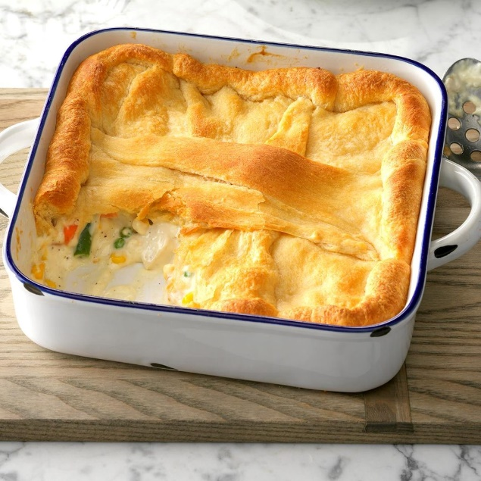
Crescent Turkey Casserole
Ingredients
- 1/2 cup mayonnaise
- 2 tablespoons all-purpose flour
- 1 teaspoon chicken bouillon granules
- 1/8 teaspoon pepper
- 3/4 cup 2% milk
- 2 cups frozen mixed vegetables (about 10 ounces), thawed
- 1-1/2 cups cubed cooked turkey breast
- 1 tube (4 ounces) refrigerated crescent rolls

Directions
- Preheat oven to 375°. In a saucepan, mix first 4 ingredients until smooth; gradually stir in milk. Bring to a boil over medium heat; cook and stir until thickened, about 2 minutes. Add vegetables and turkey; cook and stir until heated through. Transfer to a greased 8-in. square baking pan.
- Unroll crescent dough and separate into 8 triangles; arrange over turkey mixture. Bake until casserole is heated through and topping is golden brown, 15-20 minutes.



Pumpkin Roll

Ingredients

3 large eggs, separated, room temperature

1 cup sugar, divided

2/3 cup canned pumpkin

3/4 cup all-purpose flour

1 teaspoon baking soda

1/2 teaspoon ground cinnamon

1/8 teaspoon salt

FILLING:

8 ounces cream cheese, softened

2 tablespoons butter, softened

1 cup confectioners' sugar

3/4 teaspoon vanilla extract

Additional confectioners' sugar, optional

Directions

Line a 15x10x1-in. baking pan with parchment or waxed paper; grease the paper and set aside. In a large bowl, beat egg yolks on high speed until thick and lemon-colored. Gradually add 1/2 cup sugar and pumpkin, beating on high until sugar is almost dissolved.

In a small bowl, beat egg whites until soft peaks form. Gradually add remaining 1/2 cup sugar, beating until stiff peaks form. Fold into egg yolk

mixture. Combine the flour, baking soda, cinnamon and salt; gently fold into pumpkin mixture. Spread into prepared pan.

Bake at 375° until cake springs back when lightly touched, 12-15 minutes. Cool for 5 minutes. Turn cake onto a kitchen towel dusted with confectioners’ sugar. Gently peel off waxed paper. Roll up cake in the towel jelly-roll style, starting with a short side. Cool completely on a wire rack.

In a small bowl, beat the cream cheese, butter, confectioners' sugar and vanilla until smooth. Unroll cake; spread filling evenly to within 1/2 in. of edges. Roll up again, without towel. Cover and freeze until firm. Cake may be frozen for up to 3 months. Remove from the freezer 15 minutes before cutting. If desired, dust with confectioners’ sugar.

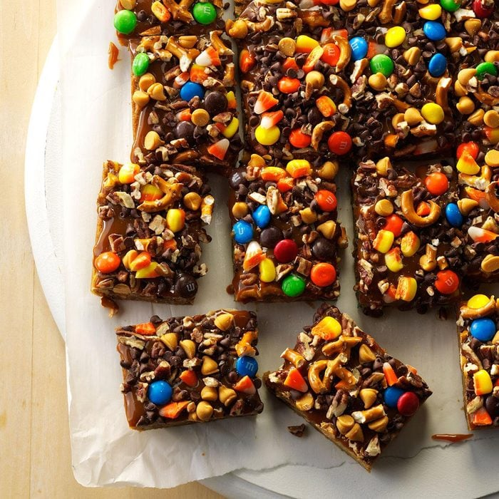

Crazy Halloween Blondies

Ingredients

1 cup butter, melted

2 cups packed brown sugar

2 large eggs, room temperature

2 teaspoons vanilla extract

2 cups all-purpose flour

1/2 teaspoon baking powder

1/4 teaspoon salt

1 cup chopped pecans, divided

2/3 cup milk chocolate M&M's, divided

2/3 cup chopped candy corn, divided

2/3 cup coarsely chopped miniature pretzels, divided

2/3 cup miniature semisweet chocolate chips, divided

2/3 cup butterscotch chips, divided

1 jar (12 ounces) hot caramel ice cream topping

Directions

Preheat oven to 375°. Line a 13x9-in. baking pan with parchment, letting ends extend up sides; grease paper.

In a large bowl, beat melted butter and brown sugar until blended. Beat in eggs and vanilla. In a large bowl, mix flour, baking powder and salt; gradually

add to brown sugar mixture, mixing well. Stir in half the pecans, M&M's, candy corn, pretzels, chocolate chips and butterscotch chips.

Spread into prepared pan. Bake 20-25 minutes or until a toothpick inserted in center comes out clean. Cool completely in pan on a wire rack.

Spread caramel topping over bars; sprinkle with remaining pecans, M&M's, candy corn, pretzels, chocolate chips and butterscotch chips. Lifting with parchment, remove from pan. Cut into bars.

