DECEMBER NEWSLETTER


A Christmas Adventure

(Summary: A young boy, devastated by rumors that Santa isn’t real, embarks on a heartfelt Christmas mission with his grandmother. Armed with ten dollars, he buys a coat for a needy classmate, Bobby Decker, and delivers it secretly. The experience reaffirms his belief in Santa, teaching him the true spirit of Christmas and the joy of giving.)

I remember my first Christmas adventure with Grandma. I was just a kid. I remember tearing across town on my bike to visit her on the day my big sister dropped the bomb: “There is no Santa Claus,” she jeered. “Even dummies know that!”

My Grandma was not the gushy kind, never had been. I fled to her that day because I knew she would be straight with me. I knew Grandma always told the truth, and I knew that the truth always went down a whole lot easier when swallowed with one of her “world-famous” cinnamon buns. I knew they were world-famous, because Grandma said so.

It had to be true.

Grandma was home, and the buns were still warm. Between bites, I told her everything. She was ready for me. “No Santa Claus?” She snorted….”Ridiculous! Don’t believe it. That rumor has been going around for years, and it makes me mad, plain mad!! Now, put on your coat, and let’s go.”

“Go? Go where, Grandma?” I asked. I hadn’t even finished my second world-famous cinnamon bun.

“Where” turned out to be Kerby’s General Store, the one store in town that had a little bit of just about everything. As we walked through its doors, Grandma handed me ten dollars.

That was a bundle in those days. “Take this money,” she said, “and buy something for someone who needs it. I’ll wait for you in the car.” Then she turned and walked out of Kerby’s.

I was only eight years old. I’d often gone shopping with my mother, but never had I shopped for anything all by myself.

The store seemed big and crowded, full of people scrambling to finish their Christmas shopping. For a few moments I just stood there, confused, clutching that ten-dollar bill, wondering what to buy, and who on earth to buy it for. I thought of everybody I knew: my family, my friends, my neighbors, the kids at school, and the people who went to my church.

I was just about thought out, when I suddenly thought of Bobby Decker. He was a kid with bad breath and messy hair, and he sat right behind me in Mrs. Pollock’s grade-two class.

Bobby Decker didn’t have a coat. I knew that because he never went out to recess during the winter. His mother always wrote a note, telling the teacher that he had a cough, but all we kids knew that Bobby Decker didn’t have a cough; he didn’t have a good coat. I fingered the ten-dollar bill with growing excitement. I would buy Bobby Decker a coat!

I settled on a red corduroy one that had a hood to it. It looked real warm, and he would like that.

“Is this a Christmas present for someone?” the lady behind the counter asked kindly, as I laid my ten dollars down.

“Yes, ma’am,” I replied shyly. “It’s for Bobby.”

The nice lady smiled at me, as I told her about how Bobby really needed a good winter coat. I didn’t get any change, but she put the coat in a bag, smiled again, and wished me a Merry Christmas.

That evening, Grandma helped me wrap the coat (a little tag fell out of the coat, and Grandma tucked it in her Bible) in Christmas paper and ribbons and wrote, “To Bobby, From Santa Claus” on it. Grandma said that Santa always insisted on secrecy. Then she drove me over to Bobby Decker’s house, explaining as we went that I was now and forever officially, one of Santa’s helpers.

Grandma parked down the street from Bobby’s house, and she and I crept noiselessly and hid in the bushes by his front walk.

Then Grandma gave me a nudge. “All right, Santa Claus,” she whispered, “get going.”

I took a deep breath, dashed for his front door, threw the present down on his step, pounded his door and flew back to the safety of the bushes and Grandma.

Together we waited breathlessly in the darkness for the front door to open. Finally it did, and there stood Bobby.

Fifty years haven’t dimmed the thrill of those moments spent shivering, beside my Grandma, in Bobby Decker’s bushes.

That night, I realized that those awful rumors about Santa Claus were just what Grandma said they were – ridiculous. Santa was alive and well, and we were on his team. I still have the Bible, with the coat tag tucked inside it of $19.95.



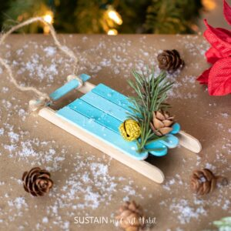

DIY Popsicle Stick Sled Ornament
MATERIALS
- X6 Wooden Popsicle Sticks
- X1 Wooden Coffee Stir Sticks
- Cutters
- Pencil
- Ruler
- Hot Glue gun and clear glue sticks
- Acrylic paint in blue and white Americana Acrylics Indian Turquoise and Snow White
- Paintbrush
- Decorative accessories such as greenery, mini pinecone and a gold bell
- Twine cut to 8” long
Instructions
Measure, mark and cut two popsicle sticks 3” long and two at 2 ¾” long.
- Measure, mark and cut one coffee stick at 1 ¾” and two at 1 ¼” long.
- Leave two remaining popsicle sticks at full length.

- Paint the surface of the popsicle sticks in two shades of blue, mixing blue and white together for the lighter shade. Leave the full-length popsicle sticks unpainted.
- Gently flick white paint over top of the painted pieces to represent snowflakes.
- Once dry, assemble the pieces into a sled. Lay the shorter popsicle sticks with the splatter side facing down on a flat surface with cut edges lined up and longest pieces in the middle.
- Glue the shortest sticks across the back side to hold all the pieces together.
- Glue the long unpainted popsicle sticks along the length of the sled on both sides. Turn the glued piece right side up.
- Glue the last piece across the front of the sled.
- Glue a piece of greenery, a mini pinecone and a gold bell to the top of the sled.
- Tie a 10” long piece of twine to the front of the sled.

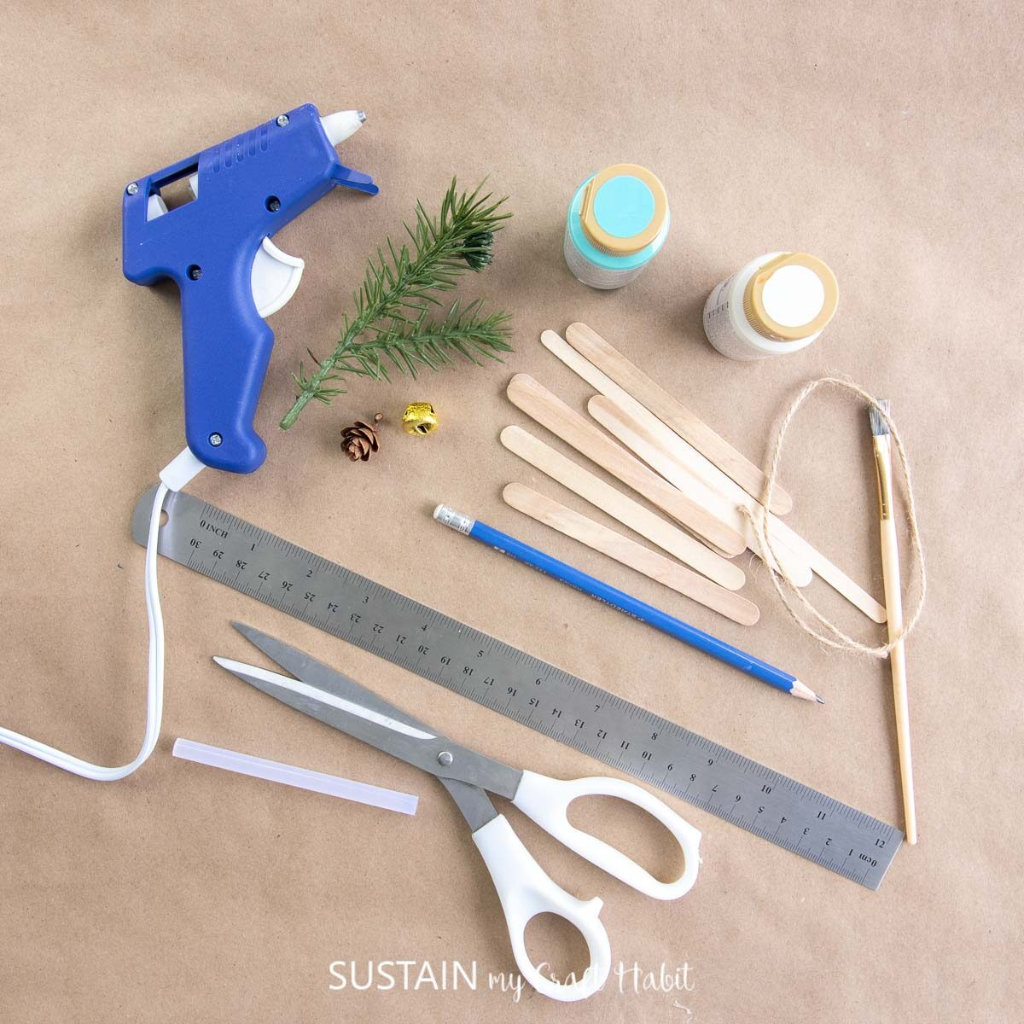

COLOR ME FOR CHRISTMAS!!

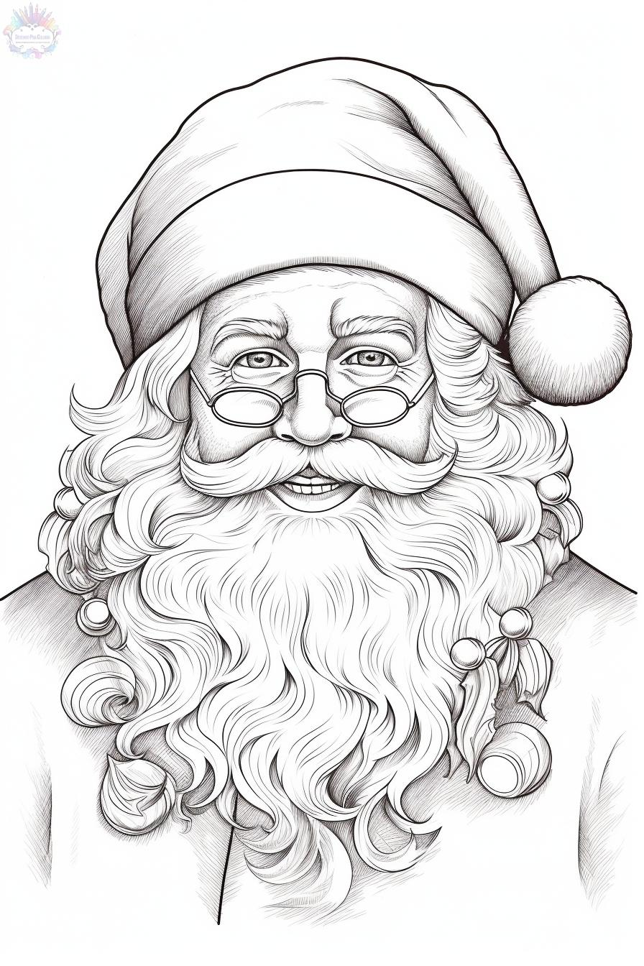

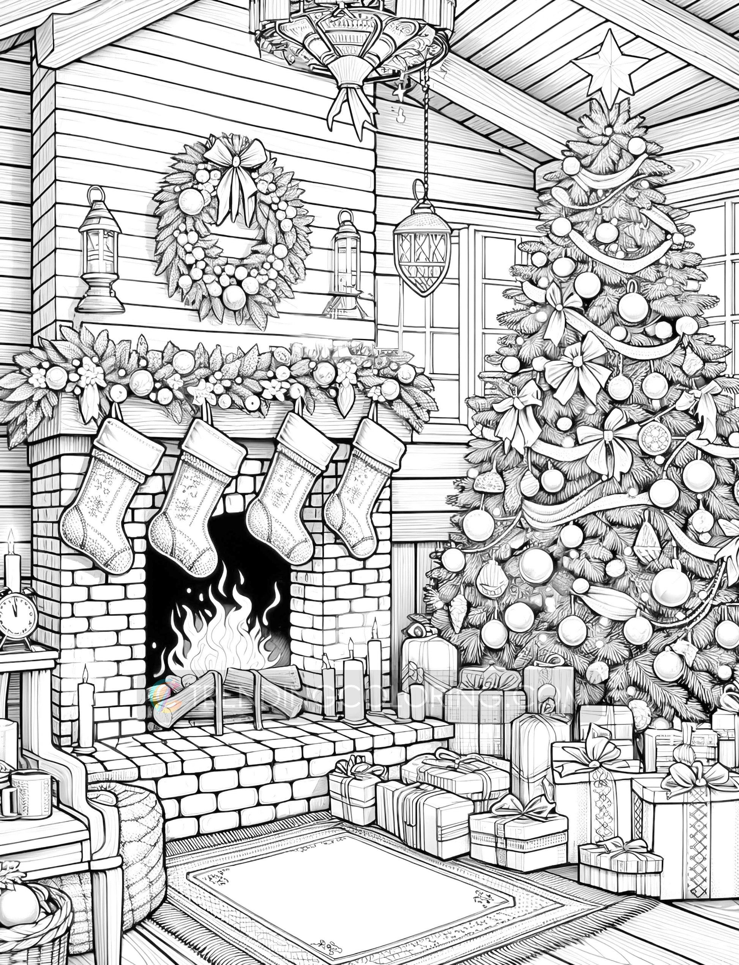

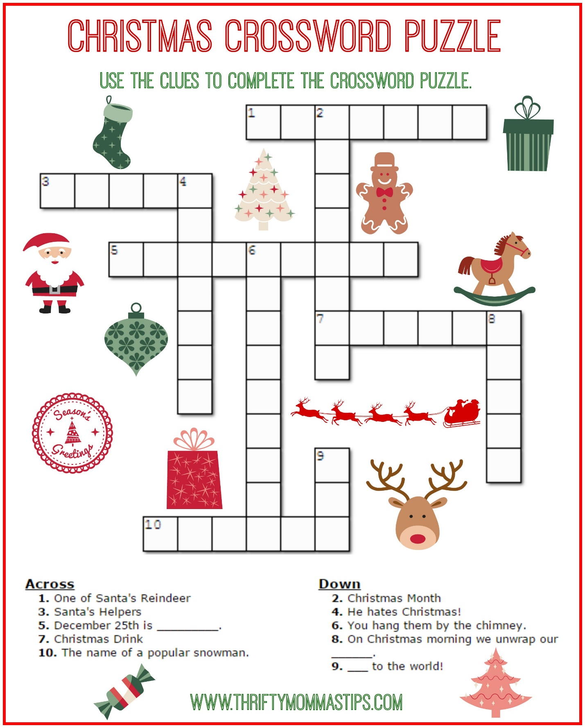

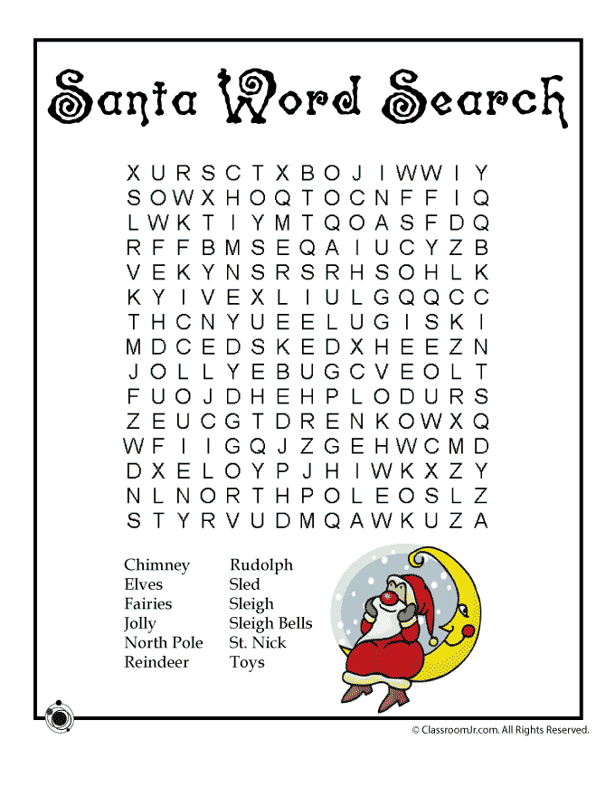

LOCAL NEWS

- Are you in need of grocery delivery service? Call 620-228-5570 for more information on this new service.

If you need assistance after-hours please call the Iola Dispatch Center at (620) 365-1437, they will notify the proper personnel.
 HAPPY BIRTHDAY TO ALL LAHARPE CITIZENS CELEBRATING A BIRTHDAY THIS MONTH!!!! MAY YOUR DAY BE AS SPECIAL AS YOU ARE TO US!



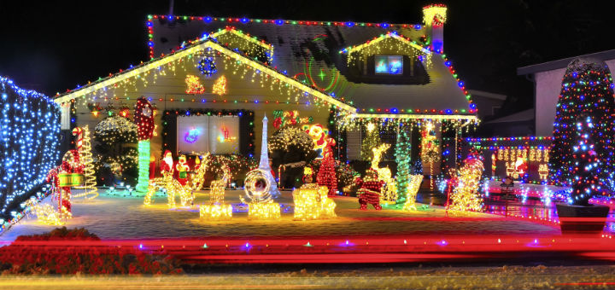


Dates to remember:
 December 10th: COUNCIL MEETING AT CITY HALL AT 7:00 P.M.
 December 15TH: PRIDE Meeting at 7:00 p.m. at the City Hall
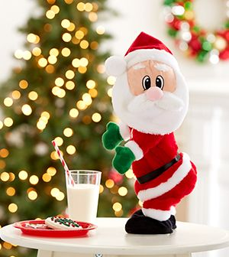 December 25th: City Hall will be Closed for Christmas and the Friday after.

The city staff would like to wish everyone a VERY MERRY CHRISTMAS!!

December 30th: Past due Utility shut off date.

CITY COUNCIL NEWS
PUBLIC HEARING
Mayor Crowell opens the public hearing for rezoning of 902 S. Main from residential to commercial. Dwayne Bearden, which is the pastor of church, asked what type of business. Byron Redifer stated the build custom homes and barns. Dwayne Bearden had no concerns with the rezoning. David Lee asked if the property to the south was zoned as commercial, it is listed as commercial and he suggested the city look into that. Mayor Crowell closed the hearing. Angela Barker made the motion to approve the rezoning of 902 S. Main from residential to commercial. Ron Knavel seconded. Motion carried 5-0. Fred Works stated there will be a 10-day grace period to allow others to voice opinion and after the 10 days the council will pass an ordinance for the rezoning, which can be done at a special meeting or the meeting in December.

CITIZENS CALL FOR BUSINESS
- Nicole Henry requested the use of city hall, at no charge, on Wednesday, November 26th and Thursday, November 27th for a community Thanksgiving dinner. Angela Barker made the motion to waive the rental fees for the community dinner. Ron Knavel seconded. Motion carried 5-0.
- David Lee addressed the council about the nuisance properties and the inoperable vehicles asking what are you doing moving forward. Mayor Crowell stated, notices are sent out and then if not in compliance they are issued a citation to appear in court. Sharlyn Thompson noted, we had several in court today on those issues and I think we are making progress. David Lee appreciated the report from Penny Miller and noted, to keep up the good work.
- Kendra Michael asked Michelle Altis how many people were signed up for the La Harpe Pride clean-up. Michelle stated, I think 8 homes. She asked why the city doesn’t have a clean-up. Mayor Crowell stated we do, it’s in the spring.
- Carey Dean was upset with having to pay a $50.00 reconnect fee on her water meter at the pasture. Michelle stated the payment was for $210.00 which is the required payment for your other account but I will look into it.
- Mayor Crowell shared, there is some interest in a few people hosting a gun show at city hall in July. I have spoke with Fred about this and he has suggested a contract that will state, they will abide by all federal gun laws. There will be 3 people here to register the guns online. All guns entering will be safety locked before entering building.

UNFINISHED BUSINESS
- Police Officer – Fred stated he has been working on it and making progress which I discuss in the executive session.

NEW BUSINESS
- Bow & Arrow request- No action was taken
- Federal Reserve – Angela Barker shared the penny is no longer being made and with that being said how can we make it easier for Michelle with cash transactions. Michelle stated she has talked to other clerks and they are handling cash payments as a credit on customers account with no coin currency being returned only paper currency if the customer is wanting the difference back.
- 813 S. Washington – Mayor Crowell shared a deed from USD 257 stating apparently the buildings sitting at this address still belong to USD 257 and they have no use for them and are willing to sale to city for $1.00. Sharlyn Thompson made the motion to purchase and pay any fees. Cyndi Maley seconded. Motion carried 5-0.

REPORTS OF CITY OFFICERS
- Fred Works, City Attorney – Nothing to report.

- Roy Caler, Water Representative – Nothing to report.

- Penny Miller, Code/Animal Control –monthly report and building permits submitted to council. Angela Barker stated, I don’t think we need the entire year each month, just what has been sent the previous month.

- Marc Waggoner, Fire Chief- Absent from meeting but minutes were shared: The La Harpe Volunteer Fire Department met for the monthly meeting. Present: Marc Waggoner Sr., Matthew Waggoner, Dennis Sidebottom, Kiefer Endicott, Josh Sparks, Meghan Sparks, Bill Gay, Dillon Brownback and Jason Teeple. Absent were Pamela Waggoner, and Justin Pritchard. Fire department held a Trunk or Treat on Halloween then attended a dinner at the Colony Fire department with Joey Bernstein as a way to say thank you for saving his life, then ended meeting.

- Maintenance Department - The workorders were shared.

- Michelle Altis, City Clerk – Had nothing to report

DISCUSSION ON AGENDA ITEMS –
Mayor Crowell requested a motion to go into executive session for attorney/client 15 minutes. Angela Barker made the motion to go into executive session for attorney/client for 15 minutes. Sharlyn Thompson seconded. Motion carried 5-0. Note: the session last for 20 minutes.
After returning to regular session, Sharlyn Thompson made the motion to sale the city lots on McKinley in the amount of $2,600.00 to Michael Hillbrant with an 18-month restrictions contract. Ron Knavel seconded. Motion carried 5-0. Fred suggested the council amend the vote to include the cost of title insurance of $150.00. Sharlyn Thompson made the motion to amend the original vote to also include the title insurance of $150.00. Ron Knavel seconded.


Mayor: Ella Mae Crowell (620) 496-6219
City Attorney: Fred Works
City Municipal Judge: Patty Miklos
Fire Chief: Marc Waggoner
Assistant Fire Chief: Dennis Sidebottom
City Clerk: Michelle Altis
Assistant Clerk: Teresa Driskel
City Treasurer: Audra Riggins
Maintenance Staff: Keith Knavel & Larry Laird
Code & Animal Control: Penny Miller

City Council Members:
Angela Barker (224-6209) Ron Knavel (496-2508)
Cynthia Carr (496-7500) Sharlyn Thompson (405-0272)
Cyndi Maley (228-4867)
Laharpe City Hall Hours: Monday-Friday
902 S. Washington 8:00-12:00 & 1:00-5:00
P.O. Box 10 Ph. (620) 365-5956
Laharpe, KS. 66751 Fax (620) 365-3944
CHECK OUT OUR WEBSITE; CITYOFLAHARPE.ORG  Follow us on Facebook – City of La Harpe
CHECK OUT OUR WEBSITE; CITYOFLAHARPE.ORG



Ham Chowder

Ingredients

10 bacon strips, diced

1 large onion, chopped

1 cup diced carrots

3 tablespoons all-purpose flour

3 cups whole milk

1-1/2 cups water

2-1/2 cups cubed potatoes

1 can (15-1/4 ounces) whole kernel corn, drained

2 teaspoons chicken bouillon granules

Pepper to taste

3 cups shredded cheddar cheese

2 cups cubed fully cooked ham

Minced fresh parsley, optional

Directions

In a Dutch oven, cook the bacon over medium heat until crisp. Using a slotted spoon, remove to paper towels to drain. In drippings, saute onion and carrots until tender. Stir in flour until blended. Gradually add milk and water. Bring to a boil; cook and stir for 2 minutes or until thickened.

Add the potatoes, corn, bouillon and pepper. Reduce heat; simmer, uncovered, for 20 minutes or until potatoes are tender. Add cheese and ham; heat until cheese is melted. Stir in bacon. If desired, garnish with parsley and additional bacon.



Homemade Eggnog

Ingredients

12 large eggs

1-1/2 cups sugar

1/2 teaspoon salt

8 cups whole milk, divided

2 tablespoons vanilla extract

1 teaspoon ground nutmeg

2 cups heavy whipping cream

Additional nutmeg, optional

Directions

In a heavy saucepan, whisk together eggs, sugar and salt. Gradually add 4 cups milk; cook and stir over low heat until a thermometer reads 160°-170°, 30-35 minutes. Do not allow to boil. Immediately transfer to a large bowl.

Stir in vanilla, nutmeg and remaining milk. Place bowl in an ice-water bath, stirring until milk mixture is cool. (If mixture

separates, process in a blender until smooth.) Refrigerate, covered, until cold, at least 3 hours.

To serve, beat cream until soft peaks form. Whisk gently into cooled milk mixture. If desired, sprinkle with additional nutmeg before serving.

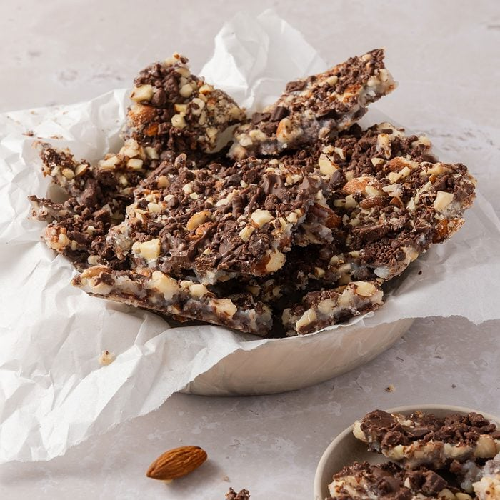
Aunt Rose’s Fantastic Butter Toffee

Ingredients
- 2 cups unblanched whole almonds
- 11 ounces milk chocolate, chopped
- 1 cup butter, cubed
- 1 cup sugar
- 3 tablespoons cold water
Directions
- Preheat oven to 350°. In a shallow baking pan, toast almonds until golden brown, 5-10 minutes, stirring occasionally. Cool. Pulse chocolate in a food processor until finely ground (do not overprocess); transfer to a bowl. Pulse almonds in food processor

- until coarsely chopped. Sprinkle 1 cup almonds over bottom of a greased 15x10x1-in. pan. Sprinkle with 1 cup chocolate.

- In a heavy saucepan, combine butter, sugar and water. Cook over medium heat until a candy thermometer reads 290° (soft-crack stage), stirring occasionally.

- Immediately pour mixture over almonds and chocolate in pan. Sprinkle with remaining chocolate and almonds. Refrigerate until set; break into pieces.



 Twas the night before Christmas, when all through the house
Not a creature was stirring, not even a mouse.
The stockings were hung by the chimney with care,
In hopes that St Nicholas soon would be there.
The children were nestled all snug in their beds,
While visions of sugar-plums danced in their heads.
And mamma in her ‘kerchief, and I in my cap,
Had just settled our brains for a long winter’s nap.
When out on the lawn there arose such a clatter,
I sprang from the bed to see what was the matter.
Away to the window I flew like a flash,
Tore open the shutters and threw up the sash.
The moon on the breast of the new-fallen snow
Gave the lustre of mid-day to objects below.
When, what to my wondering eyes should appear,
But a miniature sleigh, and eight tinny reindeer.
With a little old driver, so lively and quick,
I knew in a moment it must be St Nick.
More rapid than eagles his coursers they came,
And he whistled, and shouted, and called them by name!
"Now Dasher! now, Dancer! now, Prancer and Vixen!
On, Comet! On, Cupid! on, on Donner and Blitzen!
To the top of the porch! to the top of the wall!
Now dash away! Dash away! Dash away all!"
As dry leaves that before the wild hurricane fly,
When they meet with an obstacle, mount to the sky.
So up to the house-top the coursers they flew,
With the sleigh full of Toys, and St Nicholas too.

And then, in a twinkling, I heard on the roof
The prancing and pawing of each little hoof.
As I drew in my head, and was turning around,
Down the chimney St Nicholas came with a bound.
He was dressed all in fur, from his head to his foot,
And his clothes were all tarnished with ashes and soot.
A bundle of Toys he had flung on his back,
And he looked like a peddler, just opening his pack.
His eyes-how they twinkled! his dimples how merry!
His cheeks were like roses, his nose like a cherry!
His droll little mouth was drawn up like a bow,
And the beard of his chin was as white as the snow.
The stump of a pipe he held tight in his teeth,
And the smoke it encircled his head like a wreath.
He had a broad face and a little round belly,
That shook when he laughed, like a bowlful of jelly!
He was chubby and plump, a right jolly old elf,
And I laughed when I saw him, in spite of myself!
A wink of his eye and a twist of his head,
Soon gave me to know I had nothing to dread.
He spoke not a word, but went straight to his work,
And filled all the stockings, then turned with a jerk.
And laying his finger aside of his nose,
And giving a nod, up the chimney he rose!
He sprang to his sleigh, to his team gave a whistle,
And away they all flew like the down of a thistle.
But I heard him exclaim, ‘ere he drove out of sight,
"Happy Christmas to all, and to all a good-night!"

