
JANUARY NEWSLETTER

Happy New Year! Ever wondered why January starts the new year? Find out all about New Year’s Day, popular customs, and how we celebrate the beginning of a new year in the United States and Canada.
Celebrating the New Year
It’s safe to say that we’re all ready to celebrate the start of a new year. This time around, New Year’s Eve is Wednesday, December 31, 2025, and New Year’s Day is Thursday, January 1, 2026. We look forward to watching the grand fireworks displays that will mark the start of 2026—hopefully, a better year for all!
What Day Is New Year’s?
January 1 is a federal holiday in the United States and Canada (as well as many countries worldwide). The general population has a day off, and schools and most businesses are closed.
January 1 starts the New Year according to the Gregorian calendar, which is the calendar in use today. In 45 B.C., New Year’s Day was celebrated on January 1 for the first time in history when the Julian calendar took effect (thanks to Julius Caesar’s reforms). Today’s Gregorian calendar was introduced in 1582 by Pope Gregory XIII to correct some slight inaccuracies but continues to start the year in January.
The month of “January” is named for Janus, the ancient Roman god. Often depicted as having two faces—one looking forward and one looking back—Janus was the god of beginnings and endings, doors and gates, passageways and transitions.
In ancient Roman times, the gates of the temple of Janus were open in times of war and closed in times of peace. While Janus is linked to war, the temple symbolized a way to protect and welcome returning warriors; at other times, Janus symbolized peace.
Janus am I; oldest of potentates;
Forward I look, and backward, and below
I count, as god of avenues and gates,
The years that through my portals come and go.


.
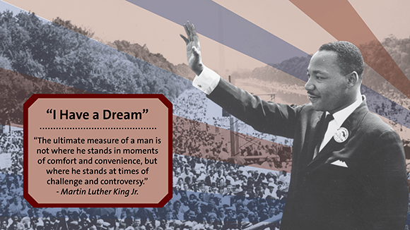
Martin Luther King Jr. Day, January 19, 2026
On November 2, 1983, President Ronald Reagan signed the King Holiday Bill into law, designating the third Monday in January a federal holiday in observance of civil rights leader Dr. Martin Luther King, Jr. The legislation to recognize Martin Luther King Jr. Day was first introduced just four days after his assassination on April 4, 1968. Still, it would take 15 years of persistence by civil rights activists for the holiday to be approved by the federal government and an additional 17 years for it to be recognized in all 50 states. Today, it is the only federal holiday designated as a National Day of Service to encourage all Americans to volunteer and improve their communities.
Despite the national fervor inspired by King's death, the bill to create a holiday in his honor languished for years with limited congressional support. However, Democratic Michigan Congressman, John Conyers, who first proposed the bill on April 8, 1968, was not deterred. He continued to reintroduce the legislation every year with the support of the Congressional Black Caucus, which Conyers helped found.
In 1979, on the 50th anniversary of King’s birth, the bill finally came to a vote in the House. However, even with a petition of 300,000 signatures in support, the backing of President Jimmy Carter, and testimonials from King’s widow, Coretta Scott King, the bill still was rejected by five votes in the House. Republican Missouri Congressman Gene Taylor led the opposition, which cited the costs of an additional federal holiday and traditions which exclude private citizens from receiving recognition with public holidays named in their honor.
Even though it failed to pass in the House, public support for the bill continued to grow, in no small part due to musician Stevie Wonder. The Motown singer and songwriter’s 1980 album “Hotter Than July” featured the song “Happy Birthday,” which served as an ode to King's vision and a rallying cry for recognition of his achievements with a national holiday.
Wonder continued to spread his message with regular appearances alongside Coretta Scott King at rallies. He also capped a four-month tour with a benefit concert on the National Mall, where King delivered his famous “I have a Dream” speech 18 years earlier.
When the bill again made it to the house floor in 1983, fifteen years after King’s murder, support was overwhelming. Working together, Coretta Scott King, the Congressional Black Caucus, and Stevie Wonder amassed a six million signature petition in favor of the holiday. The bill easily passed in the House with a vote of 338 to 90. However, when the bill moved onto the Senate, Republican North Carolina Senator, Jesse Helms attempted to dismiss the legislation by submitting documents alleging that the civil rights leader harbored ties to the communist party. Outraged by the personal attack on King's character, Democratic New York Congressman Daniel Patrick Moynihan threw the more than 300-page binder to the ground and stomped on what he described as a "packet of filth." After two days of debate, the bill passed in the Senate and President Ronald Regan reluctantly agreed to sign it into law.
Despite the holiday’s federal recognition, statewide observance of Martin Luther King Jr. Day is far from uniform. Some states include additional holidays, which are celebrated concurrently with Martin Luther King Jr. Day. Arizona and New Hampshire, for example, celebrate “Civil Rights Day” and Wyoming celebrates “Wyoming Equality Day.” Other states, like Alabama and Mississippi, have combined the King holiday with “Robert E. Lee Day” to honor the birthday of Confederate General Robert E. Lee, who was born on January 19. However, Martin Luther King Day has been recognized in all 50 states since early 2000.
On August 23, 1994, the King Holiday and Service Act was signed into law by President Bill Clinton. Inspired by King’s life of service, Congressman John Lewis and former Senator Harris Wofford proposed the legislation to encourage Americans to find common causes and methods of improving their communities. In honor of Congressman Lewis’ initiative to make the Martin Luther King, Jr. holiday “a day on, not a day off” the National Museum of African American History and Culture has organized donation drives to those in need and partnered with corporations to provide music, film screenings and interactive activities to the public. If you are interested in giving back to your community this year, we encourage you to explore our website for volunteer opportunities or participate in the transcription of the Freedmen’s Bureau papers.
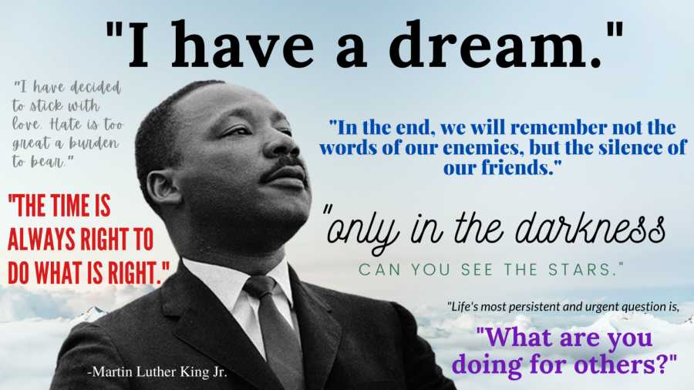



Please joining me in congratulating the city council candidates;
Harry Lee Jr., Ronald Knavel, and Sharlyn Thompson.



LOCAL NEWS

- Don’t forget, we have a community food box in front of City Hall…. Take what you need, leave what you can.

- 2026 City Dog Tags available for purchase. Please bring proof of rabies vaccination.

If you need assistance after-hours, please call the Iola Dispatch Center at (620) 365-1437, they will notify the proper personnel.
 HAPPY BIRTHDAY TO ALL LAHARPE CITIZENS CELEBRATING A BIRTHDAY THIS MONTH!!!! MAY YOUR DAY BE AS SPECIAL AS YOU ARE TO US!

Dates to remember:

 City Hall will be closed January 1st in observance of New Years Day. Happy New Years!!!
 January 14th: Council Meeting at City Hall at 7:00 pm

 January 19th: PRIDE Meeting at 7:00 p.m. at the City Hall
 January 27th: Past due Utility shut off date.

CITY COUNCIL NEWS
CITIZENS CALL FOR BUSINESS
- Citizen, Carey Dean, asked how does Penny decide who gets tickets. Mayor Crowell stated, I am not sure what you are asking. Carey mentioned a dog in town that has frozen water or no water and no shelter, people living in town with too many dogs and nothing being done about it. Mayor Crowell reminded her of the city ordinance which allows 3 dogs. Carey also expressed concerns of trees growing right next to homes. Mayor Crowell stated that is a lifestyle and the city has no authority on telling people where they can plant a tree, we have ordinances we have to go by and if you’re concerned you can fill out a complaint form.

UNFINISHED BUSINESS
- No unfinished business.

NEW BUSINESS
- 2026 Holidays – A list was presented requesting the following as 2026 holidays: New Years Day, Washington’s Birthday, Memorial Day, July 4th, Labor Day, Columbus Day, Thanksgiving and the Friday after, and Christmas eve & Christmas day. Cyndi Maley made the motion to approve the requested 2026 holiday schedule. Angela Barker seconded. Motion carried 5-0.
- 2026 COLA – Sharlyn Thompson made the motion to give Michelle the 2026 COLA of 2.8% effective January 1, 2026. Ron Knavel seconded. Motion carried 5-0.
- Fire Department Insurance – Mayor Crowell mentioned, we looked into the coverage and the county does not pay, just the city.
- Christmas Employee Bonus – Sharlyn Thompson made the motion to do the same as last year; full-time will receive $150.00 with taxes withheld and part-time will receive $100.00 with taxes withheld. Cynthia Carr seconded. Motion carried 5-0.

REPORTS OF CITY OFFICERS
- Fred Works, City Attorney – Nothing to report.

- Roy Caler, Water Representative – Nothing to report.

- Penny Miller, Code/Animal Control –monthly report and building permits submitted to council. Michelle asked on Penny’s behalf how many properties the city wanted to condemn in 2026. Mayor Crowell recommended to start with two properties and see where we are after that.

- Marc Waggoner, Fire Chief- Absent from meeting but minutes were shared: The La Harpe Volunteer Fire Department gathered to attend the funeral of chief Waggoner’s grandson, Parker Waggoner. Have 5 firefighters signed up for grain entrapment training.

- Maintenance Department - The workorders were shared. Michelle mentioned that Keith missed his water test by 2 points and will try again at the next available date.

- Michelle Altis, City Clerk – Had nothing to report

DISCUSSION ON AGENDA ITEMS –
Mayor Crowell requested a motion to go into executive session for attorney/client 10 minutes. Cyndi Maley made the motion to go into executive session for attorney/client for 10 minutes. Sharlyn Thompson seconded. Motion carried 5-0.


Mayor: Ella Mae Crowell (620) 496-6219
City Attorney: Fred Works
City Municipal Judge: Patty Miklos
Police Chief:
Fire Chief: Marc Waggoner
Assistant Fire Chief: Dennis Sidebottom
City Clerk: Michelle Altis
Assistant Clerk: Teresa Driskel
City Treasurer: Audra Riggins
Maintenance Staff: Keith Knavel & Larry Laird
Code & Animal Control: Penny Miller
City Council Members:
Angela Barker (224-6209) Cyndi Maley (228-4867)
Cynthia Carr (496-7500) Sharlyn Thompson (405-0272)
Ron Knavel (496-2508)
Laharpe City Hall Hours: Monday-Friday
902 S. Washington 8:00-12:00 & 1:00-5:00
P.O. Box 10 Ph. (620) 496-2241
Laharpe, KS. 66751 Fax (620) 496-2240

CHECK OUT OUR WEBSITE; CITYOFLAHARPE.ORG  Follow us on Facebook



Beef and Mushrooms with Smashed Potatoes

Ingredients
- 1-1/2 pounds red potatoes (about 6 medium), cut into 1-1/2-inch pieces
- 1 pound ground beef
- 1/2 pound sliced fresh mushrooms
- 1 medium onion, halved and sliced
- 3 tablespoons all-purpose flour
- 3/4 teaspoon pepper, divided
- 1/2 teaspoon salt, divided
- 1 can (14-1/2 ounces) beef broth
- 2 tablespoons butter, softened
- 1/2 cup half-and-half cream
- 1/2 cup french-fried onions
Directions
- Place potatoes in a large saucepan; add water to cover. Bring to a boil. Reduce heat to medium; cook, uncovered, until tender, 10-15 minutes.
- Meanwhile, in a large skillet, cook and crumble beef with mushrooms and onion over medium-high heat until no longer pink, 6-8 minutes; drain. Stir in flour, 1/2 teaspoon pepper and 1/4 teaspoon salt until blended. Gradually stir in broth; bring to a boil. Reduce heat; simmer, uncovered, until thickened, about 5 minutes, stirring occasionally.
- Drain potatoes; return to pan. Mash potatoes to desired consistency, adding butter, cream and the remaining salt and pepper. Spoon into bowls; top with beef mixture. Sprinkle with fried onions.



Makeover Beef & Potato Soup

Ingredients
- 1-1/2 pounds lean ground beef (90% lean)
- 3/4 cup chopped onion
- 1/2 cup all-purpose flour
- 2 cans (14-1/2 ounces each) reduced-sodium chicken broth, divided
- 5 medium potatoes, peeled and cubed
- 5 medium carrots, chopped
- 3 celery ribs, chopped
- 3 teaspoons dried basil
- 2 teaspoons dried parsley flakes
- 1 teaspoon garlic powder
- 1/2 teaspoon pepper
- 12 ounces reduced-fat process cheese (Velveeta), cubed
- 1-1/2 cups 2% milk
- 1/2 cup reduced-fat sour cream

Directions
- In a large skillet, cook beef and onion over medium heat until meat is no longer pink; drain. Combine flour and 1 can broth until smooth. Add to beef mixture. Bring to a boil; cook and stir until thickened, about 2 minutes.
- Transfer to a 5-qt. slow cooker. Stir in the potatoes, carrots, celery, seasonings and remaining broth. Cover and cook on low for 6-8 hours or until vegetables are tender.
- Stir in cheese and milk. Cover and cook until cheese is melted, about 30 minutes longer. Just before serving, stir in sour cream.


Honey Cinnamon Roll-Ups
Ingredients
- 2 cups ground walnuts, toasted
- 1/4 cup sugar
- 2 teaspoons ground cinnamon
- 12 sheets frozen phyllo dough, thawed
- 1/2 cup butter, melted

SYRUP:
- 1/2 cup honey
- 1/2 cup sugar
- 1/2 cup water
- 1 tablespoon lemon juice
Directions
- Preheat oven to 350°. Combine walnuts, sugar and cinnamon.
- Place 1 sheet of phyllo dough on a 15x12-in. piece of waxed paper; brush with butter. Place a second phyllo sheet on top, brushing it with butter. (Keep remaining phyllo covered with a damp towel to prevent it from drying out.) Sprinkle with 1/4 cup walnut mixture. Using waxed paper, roll up tightly jelly-roll style, starting with a long side, removing paper as you roll. Slice roll into 4 smaller rolls; transfer rolls to a greased 13x9-in. baking dish. Repeat with remaining phyllo dough and walnut mixture, by 1/4 cupful’s. Bake until light brown, 14-16 minutes. Cool dish on a wire rack.
- Meanwhile, in a small saucepan, combine all syrup ingredients. Bring to a boil. Reduce heat; simmer 5 minutes. Cool 10 minutes. Drizzle cinnamon rolls with syrup; sprinkle with remaining walnut mixture.



