FEBRUARY NEWSLETTER

Groundhog Day is celebrated every year on February 2. What does a groundhog have to do with weather? We explain.

Groundhog Day 2026 falls on a Monday, February 2, 2026 (always occurs on February 2). On this day, townsfolk in Punxsutawney, Pennsylvania, gather in Gobbler’s Knob to watch as an unsuspecting furry marmot is plucked from his burrow to predict the weather for the rest of the winter.
First, What Does The Farmers’ Almanac Say?
Whether or not you follow the groundhog, or simply enjoy the folklore (don’t worry, we don’t mind), we’re here to tell you: winter isn’t going anywhere any time soon. Generally speaking, our long-range predictions say this wet winter whirlwind will take a moment to unwind.
No matter what the weather, spring will officially arrive with the Vernal Equinox on March 20, 2026 at 10:46 a.m. However, the warmer, spring-like weather may not come until a little later.
How Does the Almanac Do it?
The Farmers’ Almanac uses a mathematical and astronomical formula to make our long-range weather predictions, not folklore. We look at sunspot activity, tidal action of the Moon, positions of the planets, and many other factors to carefully craft a year’s worth of weather forecasts. Fans of the Almanac say our weather forecasts are accurate 80-85% of the time.
Even though Phil is wrong on occasion, we still respect the groundhog and a “holiday” that’s stuck around for more than a century, and one in which we are reminded to put down our high-tech gadgets and consult with nature.
Shadow vs. No Shadow Folklore
People often get confused about what it means if the groundhog sees his shadow or not. Let’s clear it up. According to folklore:
- If Phil does see his shadow (meaning the Sun is shining) on Groundhog Day, winter will not end early, and we’ll have another 6 weeks of it.
- If Phil doesn’t see his shadow (cloudy) we’ll have an early spring.

 Whether you love Valentine's Day or hate it, one thing is clear: The holiday goes way back. And while it's now known for kissing, Valentine's Day gifts, and hard-to-get dinner reservations, the origins of the holiday are far less romantic. Here, the Valentine's Day history that wouldn't make it into a rom-com, including a martyred saint and a massacre.

When Is Valentine’s Day?
First, a quick refresher: Valentine's Day always falls on February 14, but the day of the week varies by year. In 2026, Valentine's Day will be on a Saturday.

How Did Valentine’s Day Start?
Some historians believe it has roots in the ancient Roman festival of Lupercalia. Held yearly on February 15, Lupercalia celebrated the coming of spring and fertility. It involved animal sacrifice, lots of drunken revelry, and possibly a ritual in which men and women were paired off by choosing names from a jar.
As Christianity spread, pagan rituals fell out of favor. At the end of the 5th century AD, Pope Gelasius I outlawed the celebration. He's sometimes credited with implementing St. Valentine's Day, a holy feast day, to replace it, but we don't have definitive proof of that. Regardless, the Christian holiday eventually overtook the riotous Lupercalia.

Who Was St. Valentine?
St. Valentine is the patron saint of lovers, people with epilepsy, and beekeepers, among other things, but the real-life history of the man is unknown. There are various legends about a Christian figure named Valentine or Valentinus who was martyred on February 14 in the 3rd century AD.
In one story, St. Valentine was a Roman priest and physician who refused to convert to paganism and was executed by Emperor Claudius II in about 270 AD. Prior to his execution, he miraculously healed the daughter of his jailer. As the legend goes, he then fell in love with the daughter and, on the day of his execution, wrote her a letter signed "from your Valentine."
In another story, St. Valentine was executed because he secretly performed weddings for soldiers, who were forbidden to marry according to an edict from Claudius II.
The facts are so murky that the Catholic Church removed him from the General Liturgical Calendar in 1969, though it still recognizes him as a saint. Whoever the man was, the feast day in his name replaced the pagan Roman festival of Lupercalia.
Before the 14th century, St. Valentine's Day was primarily about honoring a Christian martyr. The English poet Geoffrey Chaucer is credited with connecting St. Valentine's Day to the idea of romance. Chaucer lived in the Middle Ages, the era of courtly love, when broad, romantic statements of devotion—poems, songs, paintings—celebrated partnership. In his circa 1382 poem "The Parliament of Fowls," possibly written to commemorate the engagement of King Richard II, he envisions birds gathering on St. Valentine's Day to choose their mates. The goddess Nature declares: "You know that on Saint Valentine's Day / By my statute and through my governance / You come to choose — and then fly your way — / Your mates, as I your desires enhance." From then on, Valentine's Day was seen as a day of romantic love. So, we can thank poetry—the ultimate romantic art form—for our modern-day idea of the holiday.
Yet the romantic holiday isn't immune to tragedy. During Prohibition in Chicago, seven men were killed by a gang organized by Al Capone on February 14, 1929. The Valentine's Day Massacre became a flashpoint in Prohibition history, with police and lawmakers going after the gangs and mobs that had formed in cities to control then-illegal substances like alcohol.

Why Do We Send Valentines?
Love letters, of course, go way back; if the legend of St. Valentine is true, his missive to the jailer's daughter probably counts as the first valentine. But historians say that the earliest valentines as we think of them today came about in Europe and the United States in the 17th century. They were possibly inspired by the German tradition of exchanging Freundschaftskarten, or friendship cards. These early valentines were handmade—sometimes very elaborately with lace and ribbons—and inscribed with sentimental messages. Over time, as printing and postal services advanced, valentines became a big commercial business. Today, according to Hallmark, about 145 million valentines are sold every year, not counting the boxed sets often used for classroom exchanges. We think DIY Valentine's card ideas are still worth trying, though!

What's the Meaning of Valentine’s Day?
Over the centuries, Valentine's Day has been a religious feast day and a secular day of romance. In its earliest incarnation, it was even a ritual celebrating fertility and springtime. Given how much it's changed over time, we say the meaning of Valentine's Day can be whatever you want. You can skip the celebrations completely, buy yourself some chocolate or flowers, or express your love and appreciation for the people in your life, whether they're coworkers, romantic partners, friends, or family members.

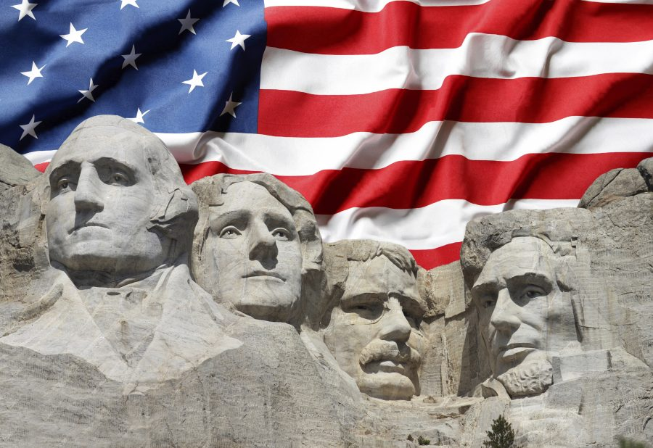

Presidents' Day, officially Washington's Birthday at the federal governmental level, is a holiday in the United States celebrated on the third Monday of February. It is often celebrated to honor all those who served as presidents of the United States and, since 1879, has been the federal holiday honoring Founding Father George Washington, who led the Continental Army to victory in the American Revolutionary War, presided at the Constitutional Convention of 1787, and served as the first U.S. president from 1789 to 1797.
The day is an official state holiday in most states under various names. Depending upon the specific law, the state holiday may officially celebrate Washington alone, Washington and Abraham Lincoln, or some other combination of U.S. presidents (such as Washington and Thomas Jefferson, who was born in April).
George Washington was born on February 22, 1732 (N.S.). Washington's Birthday was celebrated on this date from 1879 until 1970. To give federal employees a three-day weekend, in 1968 the Uniform Monday Holiday Act moved it to the third Monday in February, which can occur between February 15 and 21, starting in 1971. The day soon became known as Presidents(') Day (the presence and placement of the apostrophe varies) and provides an occasion to remember all the U.S. presidents, to honor Abraham Lincoln's and Washington's birthdays together, or any single president of choice.
As many states and cities followed suit, some states that had been celebrating Lincoln's birthday on February 12 combined the two into Presidents' Day. Lincoln led the nation through the American Civil War, preserved the Union, abolished slavery, bolstered the federal government, and modernized the U.S. economy.

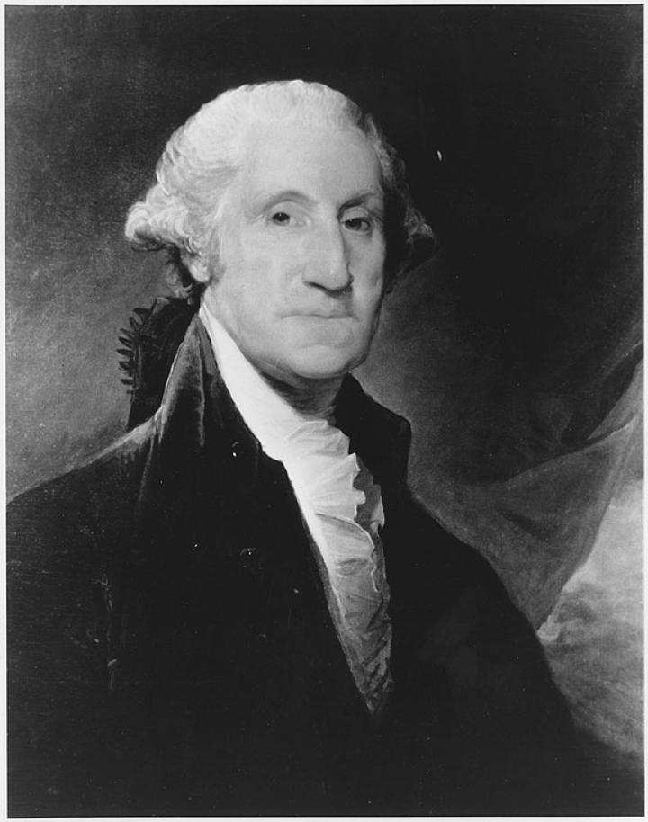

Washington’s birthday was celebrated on February 22 until well into the 20th century. In 1968, Congress passed the Monday Holiday Law to “provide uniform annual observances of certain legal public holidays on Mondays.” By creating more 3-day weekends, Congress hoped to “bring substantial benefits to both the spiritual and economic life of the Nation.”

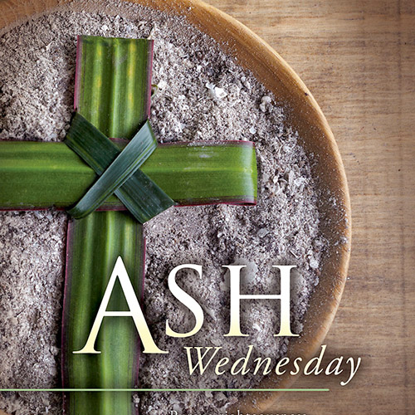
What is Ash Wednesday?
Ash Wednesday is the first day of Lent—and a wonderful opportunity to make yourself 100% available to God!
How available to God are you? 50%? 75%? 96.4%? No matter what your answer, Ash Wednesday is the perfect time to decide that you will spend this Lent increasing that number.
On Ash Wednesday, you can get your forehead blessed with ashes at Mass or a prayer service. These ashes are a reminder that we need to repent.
Repentance is a powerful invitation. When John the Baptist first appeared in the desert of Judea, this was his message: “Repent, prepare the way of the Lord” (Matthew 3:2). Later, when Jesus began his ministry, he led with this message: “Repent, for the kingdom of heaven is at hand” (Matthew 4:17).
But what does it mean for us to repent, here and now, more than two thousand years later? It means the same as it did to the people walking around the dusty pathways in their sandals, trying to inch closer to Jesus as he passed through their town or village. Repent means “to turn back to God.”
We all find ourselves needing to turn back to God many times a day, in ways small and large. It is not a matter of guilt and it is not a shameful thing. It is simply that we are a better version of ourselves when we return to his side!
When is Ash Wednesday 2026?
This year Ash Wednesday is on February 18, 2026.
The History of Ashes on Ash Wednesday
You might be wondering why we get ashes on our foreheads for Ash Wednesday. Throughout history, ashes have been a powerful outward symbol of interior repentance and spiritual awareness. Here are some examples of ashes in the Bible:
- "Therefore I disown what I have said, and repent in dust and ashes." (Job 42:6)
- "Daughter of my people, dress in sackcloth, roll in the ashes." (Jeremiah 6:26)
- "I turned to the Lord God, to seek help, in prayer and petition, with fasting, sackcloth, and ashes." (Daniel 9:3)
- "When the news reached the king of Nineveh, he rose from his throne, laid aside his robe, covered himself with sackcloth, and sat in ashes. Then he had this proclaimed throughout Nineveh: “By decree of the king and his nobles, no man or beast, no cattle or sheep, shall taste anything; they shall not eat, nor shall they drink water. Man and beast alike must be covered with sackcloth and call loudly to God; they all must turn from their evil way and from the violence of their hands." (Jonah 3: 6-8)
The Early Christians used ashes to show repentance as well, but not just on Ash Wednesday! After going to confession, it was common for the priest to give the person ashes on their forehead. Catholics have been receiving ashes on Ash Wednesday since the time of St. Gregory the Great. In 1091, Pope Urban II encouraged the entire Church to use ashes on Ash Wednesday.
If you want to get blessed with ashes this Ash Wednesday, be sure to check with your local parish. Most churches celebrate Mass or have a prayer service on Ash Wednesday, and all are welcome to attend and be blessed with ashes.


Note from the animal control officer:

To whom it may concern

It’s a new year and time to get your dog(s) tagged with the city. There is an ordinance that tells you what you need to register your dog(s) and the ordinance that clearly states that you can’t have more than (3) three dogs per household.
If your dog(s) are not tagged and registered by April 30, 2026 you will be given a NTA (Notice to Appear in court)
If you have any questions, please contact us by phone (620) 365-5956.

Respectfully,
City of La Harpe

City dog tag fees:
Neutered/Spayed = $5.00 a dog
Unneutered/Unspayed = $7.50 a dog
Must have proof of current rabies vaccination to purchase city dog tags.

A copy of the ordinance, in its entirety, can be viewed at www.cityoflaharpe.org

LOCAL NEWS
- Are you in need of grocery delivery service? Call 620-228-5570 for more information on this new service.

- Don’t forget, we have a community food box in front of City Hall…. Take what you need, leave what you can.

- 2026 City Dog Tags available for purchase. Please bring proof of rabies vaccination.

 Food pantry available to the La Harpe community on the 3rd Friday of each month! Address for pickup is the Light of La Harpe Church – 901 S. Main and pickup start at 4:00pm. Any questions on the food pantry, please call 620-228-3069.

If you need assistance after-hours please call the Iola Dispatch Center at (620) 365-1437, they will notify the proper personnel.

 HAPPY BIRTHDAY TO ALL LAHARPE CITIZENS CELEBRATING A BIRTHDAY THIS MONTH!!!! MAY YOUR DAY BE AS SPECIAL AS YOU ARE TO US!

Dates to remember:

 February 11th: Council Meeting at City Hall at 7:00 pm

 February 16th: City office will be closed to honor Presidents’ Day.

 February 16th: PRIDE Meeting at 7:00 p.m. at the City Hall

 February 25th: Past due Utility shut off date.

CITY COUNCIL NEWS
CITIZENS CALL FOR BUSINESS
- Charlie Bise approached the council on behalf of Linda Sprague and her variance contract. He stated after further research they have found they are required to have a block/cement foundation and will be working on getting that done. Charlie asked if the permit for the deck and ramp could be approved because they are worried, they will miss the grant opportunity to have it built. Mayor Crowell stated, the permit was stopped because of the foundation not being placed and the contract for the variance has not been signed. Charlie stated he wording in the contract is misworded. Mayor Crowell suggested having the city attorney get a hold of them. Ron Knavel suggested granting the permit since they will be placing a foundation. Other council members agreed to approve the permit for a deck and a ramp to the home.

UNFINISHED BUSINESS
- No unfinished business.

NEW BUSINESS
- Swearing in of council members: Ronald Knavel and Sharlyn Thompson took their oaths before the council meeting. City clerk, Michelle Altis, swore in Harry Lee Jr. which replaced Cynthia Carr’s seat.
- Presentation of lift station bids with BG Consultants: Wes Weishaar went over the sewer project update; mechanical & electrical equipment at lift stations #1,2,4,5,6 will be replaced. Rehabilitation or replacement of existing structures at lift stations #1,4,5,6. Electrical and SCADA upgrades to all lift stations. 6 bids were opened on December 16, 2025 and Cardinal Sitework was lowest bid of $779,618.75. Notice of award will take place January 2026, Pre-Construction meeting in February 2026, notice to proceed in March 2026, Construction to begin in March 2026, and construction completed in November 2026. Wes recommended the council award contract to Cardinal Sitework and give the mayor permission to sign documents once KDHE has approved everything. Harry Lee Jr. questioned oversight on the project. Wes stated that KDHE requires construction observation so someone will be here on a weekly basis providing updates and summaries and there will be progress meetings monthly. Harry asked about the warranty terms; Bruce Boettcher stated there is a 1-year warranty on the contractor’s correction period after completion but the mechanical components usually have a 5-year prorated warranty. Harry asked how the city would be protected after the first year. Wes stated the neighboring communities had very similar equipment and the vendors the city has is less that an hour away. Ron Knavel asked if the employees would get any training. Wes stated yes, someone will have a training session with the city staff. Sharlyn Thompson made the motion to award Cardinal Sitework the contract and allow the mayor to sign documents pertaining to this project upon receiving approval from KDHE. Ron Knavel seconded. Motion carried 5-0.
- Water Tower: Sharlyn Thompson was inquiring the time frame to get the tower fixed. Mayor Crowell stated there is not a time frame.
- 2025 GAAP Waiver: Harry Lee Jr. made the motion to approve the 2025 GAAP Waiver. Ron Knavel seconded. Motion carried 5-0.
- Manufactured Home Ordinance: Ron Knavel stated we have paperwork that is very confusing; we give them the manufacture home guidelines that state skirting is allowed and then we have Ordinance #1807 stating it must be block/cement foundation. Sharlyn Thompson reminded Ron the city needs the manufacture home guidelines for the specs of the home. Harry Lee Jr. suggested that ordinance #1807 should read to incorporate the manufacture home guidelines. Ron Knavel was suggesting read through it and only just have one. Mayor Crowell asked Michelle to get with Fred on this.

REPORTS OF CITY OFFICERS
- Fred Works, City Attorney – Absent from meeting.

- Roy Caler, Water Representative – Absent from meeting.

- Penny Miller, Code/Animal Control –monthly report submitted to council.

- Marc Waggoner, Fire Chief- Meeting minutes were shared: The La Harpe Volunteer Fire Department met for the monthly meeting. Present: Marc Waggoner Sr., Matthew Waggoner, Kiefer Endicott, Josh Sparks, Meghan Sparks, Bill Gay, Dillon Brownback and Pamela Waggoner. Absent were Dennis Sidebottom, Jason Teeple, and Justin Pritchard. Started meeting, firefighters trained on rope training for grain bin rescue and then ended the meeting.

- Maintenance Department - The workorders were shared. Sharlyn Thompson stated, the crew is not putting addresses on the work orders they do. Mayor Crowell stated she would address it.

- Michelle Altis, City Clerk – Mentioned the city audit will be February 24th.

DISCUSSION ON AGENDA ITEMS –
Sharlyn Thompson stated work orders dated from 4-2025 that haven’t been done. Mayor Crowell stated she would look into it.


Mayor: Ella Mae Crowell (620) 496-6219
City Attorney: Fred Works
City Municipal Judge: Patty Miklos
Police Chief:
Fire Chief: Marc Waggoner
Assistant Fire Chief: Dennis Sidebottom
City Clerk: Michelle Altis
Assistant Clerk: Teresa Driskel
City Treasurer: Audra Riggins
Maintenance Staff: Larry Laird & Keith Knavel
Code & Animal Control: Penny Miller
City Council Members:
Angela Barker (224-6209) Ron Knavel (496-2508)
Cyndi Maley (380-6600) Sharlyn Thompson (405-0272)
Harry Lee Jr. (496-2233)
Laharpe City Hall Hours: Monday-Friday
902 S. Washington 8:00-12:00 & 1:00-5:00
P.O. Box 10 Ph. (620) 365-5956
Laharpe, KS. 66751 Fax (620) 365-3944

CHECK OUT OUR WEBSITE; CITYOFLAHARPE.ORG  Follow us on Facebook



Hamburger Stew

Ingredients
- 2 pounds ground beef
- 2 medium onions, chopped
- 4 cans (14-1/2 ounces each) stewed tomatoes, undrained
- 8 medium carrots, thinly sliced
- 4 celery ribs, thinly sliced
- 2 medium potatoes, peeled and cubed
- 2 cups water
- 1/2 cup uncooked long grain rice
- 3 teaspoons salt
- 1 teaspoon pepper
Directions
- In a Dutch oven, cook beef and onions over medium heat until meat is no longer pink, breaking it into crumbles; drain. Add the tomatoes, carrots, celery, potatoes, water, rice, salt and pepper; bring to a boil. Reduce heat; cover and simmer 30 minutes or until vegetables and rice are tender.
- Uncover; simmer 20-30 minutes longer or until thickened to desired consistency.

Valentine Heart Brownies
Ingredients
- 1 package fudge brownie mix (13x9-in. pan size)
- 1/4 teaspoon mint extract
- 1/2 cup butter, softened
- 1-1/2 cups confectioners' sugar
- 1/4 teaspoon vanilla extract
- Red paste food coloring, optional
- 1/4 cup baking cocoa
- Heart-shaped sprinkles, optional
Directions
- Prepare brownie mix according to package directions, adding mint extract to batter. Transfer to a greased 13x9-in. baking pan. Bake at 350° for 20-25 minutes or until a toothpick inserted in the center comes out clean. Cool completely on a wire rack.
- Meanwhile, in a small bowl, cream the butter, confectioners' sugar, vanilla and, if desired, food coloring until light and fluffy, 3-4 minutes. Transfer to a pastry bag. Set aside.
- Line a baking sheet with parchment. Dust with cocoa; set aside. Cut brownies into 15 rectangles. Using a 1-1/2-in. heart-shaped cookie cutter, cut out a heart from the center of each brownie. Reserve cutout centers for another use. Place brownies on prepared baking sheet. Pipe frosting into centers of brownies. If desired, top with sprinkles.

Party Cheese Balls
Ingredients
- 1 package (8 ounces) cream cheese, softened
- 2 cups shredded cheddar cheese
- 1 jar (5 ounces) sharp American cheese spread
- 1 jar (5 ounces) pimiento spread
- 3 tablespoons finely chopped onion
- 1 tablespoon lemon juice
- 1 teaspoon Worcestershire sauce
- Dash garlic salt
- 1/2 cup minced fresh parsley
- 1/2 cup chopped pecans, toasted
- Assorted crackers

Directions
- In a large bowl, beat the first 8 ingredients until blended. Cover and refrigerate until easily handled, about 45 minutes.
- Shape into 2 balls; roll in parsley and pecans. Cover and refrigerate. Remove from the refrigerator 15 minutes before serving with crackers.

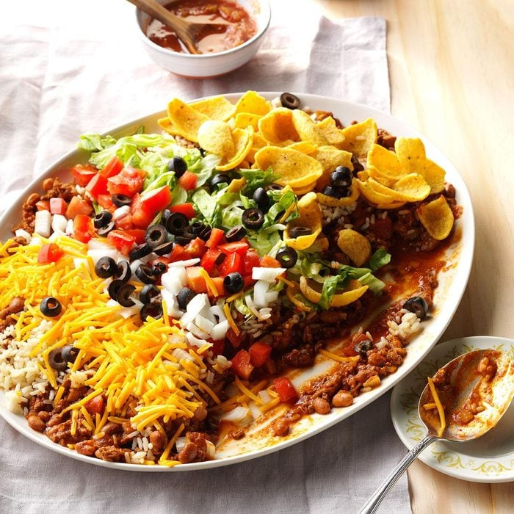
Texas Taco Dip Platter

Ingredients

2 pounds ground beef

1 large onion, chopped

1 can (14-1/2 ounces) diced tomatoes, undrained

1 can (12 ounces) tomato paste

1 can (15 ounces) tomato puree

2 tablespoons chili powder

1 teaspoon ground cumin

1/2 teaspoon garlic powder

2 teaspoons salt

2 cans (15 ounces each) Ranch Style beans (pinto beans in seasoned tomato sauce)

2 cups hot cooked rice

1 package (9-1/4 ounces) corn chips, crushed

1 medium head iceberg lettuce, shredded

2 cups shredded cheddar cheese

3 medium tomatoes, chopped

1 medium onion, chopped

1 can (2-1/4 ounces) sliced ripe olives, drained

1 cup picante sauce, optional

Directions

In a Dutch oven, cook beef and onion over medium heat until meat is no longer pink, breaking meat into crumbles; drain. Add next 7 ingredients; cover and simmer for 1-1/2 hours.

Add beans and heat through. On a platter, layer the meat mixture, rice, corn chips, cheese, onion, lettuce, tomatoes and olives. If desired, serve with picante sauce and additional corn chips.


Party Cheese Bread
Ingredients
- 1 round loaf sourdough bread (1 pound)
- 1 pound Monterey Jack cheese, sliced
- 1/2 cup butter, melted
- 2 tablespoons lemon juice
- 2 tablespoons Dijon mustard
- 1-1/2 teaspoons garlic powder
- 1/2 teaspoon onion powder
- 1/2 teaspoon celery salt
- Minced fresh chives, optional

Directions
- Preheat oven to 350°. Cut bread into 1-in. slices to within 1/2 in. of bottom of loaf. Repeat cuts in opposite direction. Insert cheese in cuts.
- Mix all remaining ingredients except chives; drizzle over bread. Wrap in foil; place on a baking sheet.
- Bake 20 minutes. Unwrap; bake until cheese is melted, about 10 minutes longer. If desired, sprinkle with chives.

