MARCH NEWSLETTER

March, the third month in the Gregorian calendar, is well-known for its unpredictable spring weather (“in like a lion and out like a lamb”), NCAA basketball (a.k.a. “March Madness”), and, of course, St. Patrick’s Day and Mardi Gras celebrations. But March is also tied to ancient beginnings, historic events and even animal antics. Here’s a closer look.
The Origins of March
The name March comes from the Latin “Martius,” named for Mars, the Roman god of war, as military actions often resumed after winter. Initially, it was the first month of the ancient Roman 10-month calendar. But in the 7th century B.C.E., March became the third month after Numa Pompilius, Rome’s second king, added January and February, creating a 12-month lunar calendar.

Seasonal Oddities & Astronomical Facts
March ushers in the vernal, or spring, equinox—a.k.a. the first day of spring—usually falling between March 19 and 22, when the length of day and night are nearly equal. Celebrations observing the equinox and its symbolism of rebirth, renewal and balance have taken place since ancient times. In the ancient Mesoamerican city of Chichén Itzá, Mexico, people have gathered for centuries to witness an optical illusion during the spring equinox at the Kukulcán pyramid, where a snake appears to slither down the pyramid as a sign of the snake god’s return to earth.
Additionally, daylight saving time takes place every second Sunday of March, when clocks spring forward one hour to allow for longer daylight in the summer. Meanwhile, March’s full moon is known as the Worm Moon, named by Native Americans for worms that emerge in spring.

March’s Most Unexpected Natural Disasters
March has seen its share of dramatic weather events. The Great Blizzard of 1888 paralyzed the eastern U.S. with as much as 58 inches of snow in some regions, killing 400 people—half in New York City. Heavy winds created snow drifts as high as 50 feet and melting snow caused severe flooding. The storm paralyzed trains, downed telephone, telegraph and electrical wires, blacked out gas street lamps and trapped people in their homes. Undeterred, however, the Barnum & Bailey Circus still performed two shows at Madison Square Garden—though few besides P.T. Barnum himself attended.

Fascinating Historical Events
- March has witnessed some unusual events throughout history. Take March 3, 1876, in Olympia Springs, Kentucky, when hunks of red meat fell from the sky in what became known as the Great Kentucky Meat Shower. “Two gentlemen, who tasted the meat, express the opinion that it was either mutton or venison,” The New York Times reported. The meat was later identified as lung, muscle and cartilage tissue, possibly regurgitated by vultures.
- On March 9, 1953, the tiny Grand Principality of Outer Baldonia, a 4-acre island near Nova Scotia, humorously declared war on the U.S.S.R. after a Russian newspaper took its silly Declaration of Independence seriously, denouncing its policies that included “the inalienable right to lie and be believed; to drink, swear and gamble; to sleep all day and stay up all night.” The land’s owner struck back at the superpower in mock protest, but the Soviets simply ignored the non-country, which was eventually sold to the Nova Scotia Bird Society in 1973.
- On March 3, 2007, some 170 Swiss soldiers accidentally “invaded” Liechtenstein during a training mission when they got lost in the rain, prompting an official apology from Swiss authorities. Liechtenstein, a small and peaceful country with neutral neighbors, wasn’t troubled by the incident, noting such occurrences have happened before.
- And March 23, 1965, will forever live on as the day astronaut John Young smuggled a corned beef on rye into space on Gemini 3, sharing the sandwich with fellow astronaut Gus Grissom.


Daylight Saving Time will be here before you know it! In March, March 8th, we “spring forward” 1 hour! So, why DO we observe DST? Here’s the surprising history of this clock-changing practice. And no, it’s not due to farmers! Why is it Daylight “Saving” Time—not “Savings” Time?
What Is Daylight Saving Time?
Daylight Saving Time (“DST”) is the practice of moving the clocks forward one hour from Standard Time during the summer months and changing the time back again in the fall.
The general idea is that this allows us all to use natural daylight better: moving the clocks forward 1 hour in the spring grants us more daylight during summer evenings, while moving clocks back 1 hour in the fall grants us more daylight during winter mornings.
However, DST has many detractors—and rightfully so!


St. Everyone is Irish on St. Patrick’s Day! When is St. Patrick’s Day? Who was the real St. Patrick? Why are shamrocks a symbol of this day? Enjoy St. Patrick’s Day history, legends, and lore.
Celebrate St. Patrick’s Day 2026!
This year, St. Patrick’s Day will be observed on Tuesday, March 17.
Although the holiday originally started as a Christian feast day celebrating the life of St. Patrick and the spreading of Christianity to Ireland, today, it is a day of revelry and a celebration of all things Irish. Don’t forget to wear green!


St. Patrick's Day in America
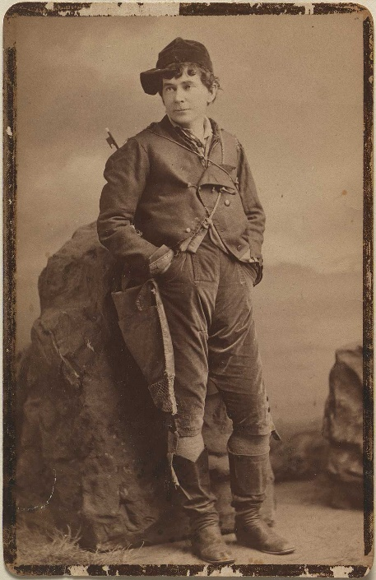
St. Patrick’s Day as we now know is not as it always was. Saint Patrick was originally celebrated for bringing Christianity to Ireland in the fifth century. In Ireland, up until the mid-twentieth century, the holiday remained modest and grounded in religion. It was not until the 1960s that in Ireland, St. Patrick’s Day came to even resemble what we, here in the USA, celebrate today.
In America, St. Patrick’s Day is recognized by shamrocks, leprechauns, parades, and all things green. Irish soldiers—often indentured servants—in the British Army brought the holiday to America as early as 1762 when the first St. Patrick’s day parade was held in New York City. As Irish immigration to America increased throughout the 19th and 20th centuries, the holiday evolved into the celebration of Irish pride that we observe today. However, in Ireland, there was a time when wearing the color green was punishable, as illustrated by the Irish nationalist ballad, “The Wearing of the Green.” The first stanza of the song reads:
“O Paddy dear, and did ye hear the news that's goin' round?
The shamrock is by law forbid to grow on Irish ground!
No more Saint Patrick's Day we'll keep, his color can't be seen
For there's a cruel law ag'in the Wearin' o' the Green."
I met with Napper Tandy, and he took me by the hand
And he said, "How's poor old Ireland, and how does she stand?"
"She's the most distressful country that ever yet was seen
For they're hanging men and women there for the Wearin' o' the Green."
During the Irish Rebellion of 1798, rebels retaliated against British rule in Ireland. The color green became a signifier for the Society of United Irishmen. Napper Tandy refers to James Napper Tandy, a leading figure in the insurrection who helped to form the Dublin branch of the Society for United Irishmen.
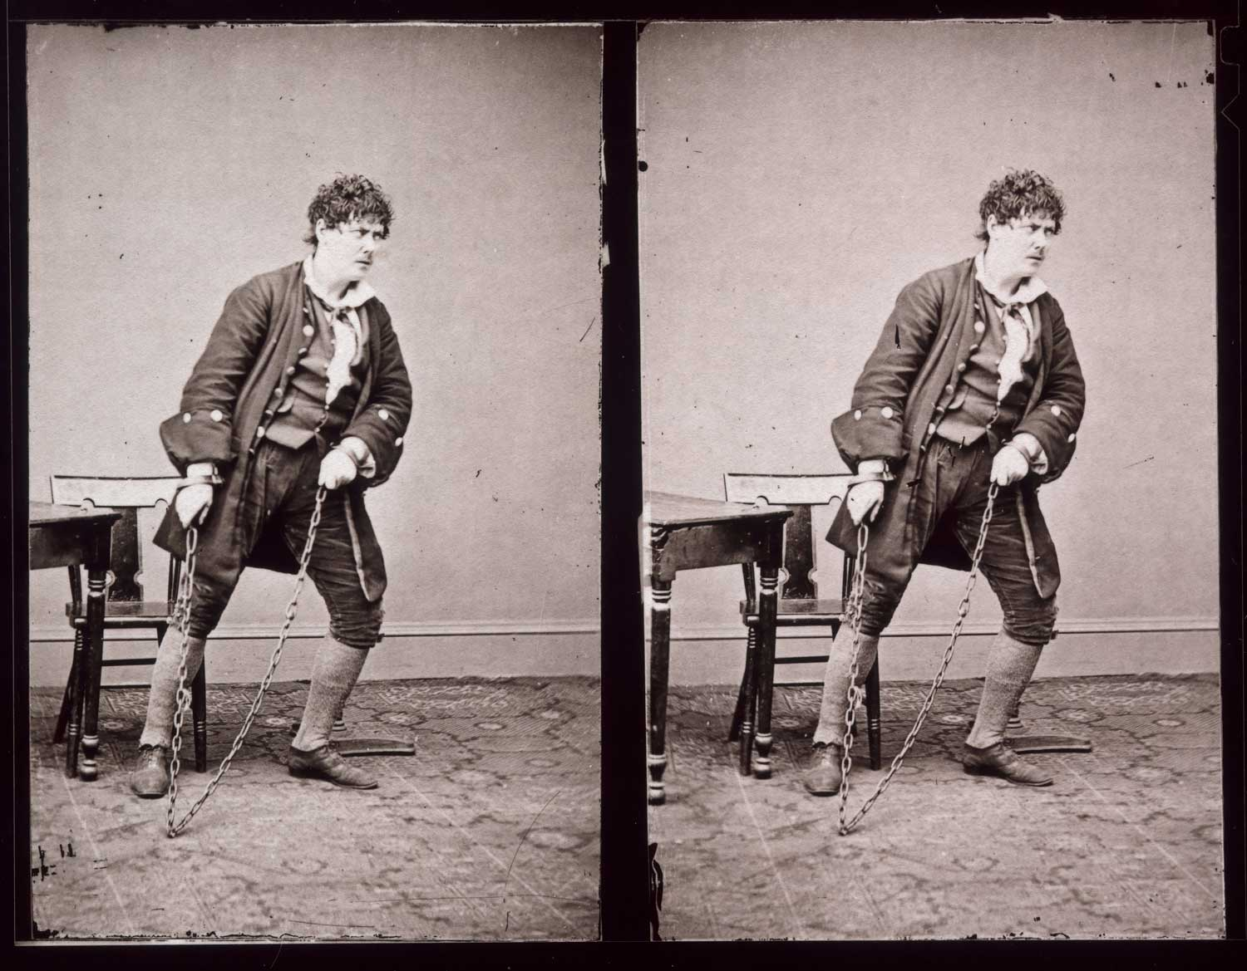
One of the best-known renditions of the song was written by Dion Boucicault for the 1864 play Arrah-na-Pogue, which takes place during the Rebellion. Playwright and actor Dion Boucicault was born in Dublin, Ireland in 1820. He wrote plays from a young age and found success with works like London Assurance (1841) which established his reputation. After the death of his wife in 1848 and ensuing financial distress, Boucicault came to New York City with actor and love interest, Agnes Robertson. The couple married and had six children, becoming American citizens in 1873. Their marriage deteriorated around that time and Robertson left the United States for London. However, 1874 brought Boucicault success with The Shaughraun, an Irish play that would be the crown jewel of his career. The duration of Boucicault’s career saw great successes and failures, however his hands-on engagement with his productions and audiences made great impact on dramatists to come.



Spring is in the air! Here is a small list of some fun ideas to start planning for spring:
- Start that home spring cleaning! Okay, maybe it doesn’t sound fun but the reward is worth it when you are all done
- Purchase baseball tickets and plan a day with the family soaking up the sun while eating hotdogs and popcorn!
- Play a sport
- Volunteer, maybe your neighbor or a family friend could use some help. Don’t forget to ask your local organizations!
- Clean off your patio furniture or replace it. Get that patio ready for some fun gatherings!
- Buy a new book!
- Plan a trip! Family spring break trip away from school & work! How relaxing!
- Put out your bird feeders
- Get outdoors and start walking.
- Build a kite and take it flying
- Plant a garden filled with all of your favorites.




Palm Sunday, March 29th, in the Christian tradition, the first day of Holy Week and the Sunday before Easter, commemorating Jesus Christ’s triumphal entry into Jerusalem. It is associated in many churches with the blessing and procession of palms (leaves of the date palm or twigs from locally available trees).
 What is Palm Sunday? Palm Sunday is celebrated by Christian communities on the Sunday before Easter.
These special ceremonies were taking place toward the end of the 4th century in Jerusalem and are described in the travelogue Peregrinatio Etheriae (The Pilgrimage of Etheria). In the West the earliest evidence of the ceremonies is found in the Bobbio Sacramentary (8th century). During the Middle Ages the ceremony for the blessing of the palms was elaborate: the procession began in one church, went to a church in which the palms were blessed, and returned to the church in which the procession had originated for the singing of the liturgy. The principal feature of the liturgy that followed the procession was the chanting by three deacons of the account of the Passion of Christ (Matthew 26:36–27:54). Musical settings for the crowd parts were sometimes sung by the choir. After reforms of the Roman Catholic liturgies in 1955 and 1969, the ceremonies were somewhat simplified in order to emphasize the suffering and death of Christ.

LOCAL NEWS
- Are you in need of grocery delivery service? Call 620-228-5570 for more information on this new service.

- Don’t forget, we have a community food box in front of City Hall…. Take what you need, leave what you can.

- 2026 City Dog Tags available for purchase. Please bring proof of rabies vaccination.

-  Food pantry available to the La Harpe community on the 3rd Friday of each month! Address for pickup is the Light of La Harpe Church – 901 S. Main and pickup start at 4:00pm. Any questions on the food pantry, please call 620-228-3069.

If you need assistance after-hours please call the Iola Dispatch Center at (620) 365-1437, they will notify the proper personnel.
 HAPPY BIRTHDAY TO ALL LAHARPE CITIZENS CELEBRATING A BIRTHDAY THIS MONTH!!!! MAY YOUR DAY BE AS SPECIAL AS YOU ARE TO US!


Note from the animal control officer:

To whom it may concern

It’s a new year and time to get your dog(s) tagged with the city. There is an ordinance that tells you what you need to register your dog(s) and the ordinance that clearly states that you can’t have more than (3) three dogs per household.
If your dog(s) are not tagged and registered by April 30, 2026 you will be given a NTA (Notice to Appear in court)
If you have any questions, please contact us by phone (620) 365-5956 here at city hall.

Respectfully,
City of La Harpe

City dog tag fees:
Neutered/Spayed = $5.00 a dog
Unneutered/Unspayed = $7.50 a dog
Must have proof of current rabies vaccination to purchase city dog tags.
A copy of the ordinance, in its entirety, can be viewed at www.cityoflaharpe.org
The city will host a dog clinic at city hall on April 4, 2026, from 1:30pm to 3:00pm
Bronson Vet, Lora Holman, will be on site to administer. This will be by appointment only. Contact city hall for more information (620) 365-5956.


Note from the La Harpe Code Officer:
To whom it may concern,
I would like to share a friendly reminder to the La Harpe citizens;
- Vehicles parked in yards must have active registration and insurance and kept neatly maintained.
- Stock cars must be on a trailer or covered up.
- Roofs & windows must be intact and not covered with tarps, boards or like materials.
- Broken appliances and or furniture do not belong outdoors.
- Brush piles must be maintained; a burn permit can be obtained by calling city hall at 620-365-5956.
- Grass clippings, in street, will not be tolerated. If you do get grass in the street, please use your mower or broom to get it out of street. If seen intentionally blowing grass in street a notice to appear in La Harpe Municipal court will be issued.
- Grass can not be any taller than 12 inches anywhere on property, maintaining the ditch is on the homeowner. If you are wanting to hay your property, you must have 1 acre to hay and a hay permit needs to be approved by April 1st.
- If you have a dead tree near the city powerlines, and the tree falls over and does damage to the city powerlines, you will be charged for the damage.
- Trash belongs in a dumpster or at the Allen County landfill not in your yard.
- Dog pens need to be cleaned at least once a week and have clean water every day, and adequate shelter.

I will be sending out letters if your property is not in compliance with the La Harpe city code, if you have any issues with the La Harpe city code, please attend your regular council meeting held the 2nd Wednesday of every month at 7:00pm at city hall to discuss a resolution to your code violation. If the request to have your property in compliance with the La Harpe city code is not met by the time stated in your letter, a notice to appear in the La Harpe Municipal court will be issued.
A copy of the ordinance, in its entirety, can be viewed at www.cityoflaharpe.org
Dates to remember:

 March 11th: Council Meeting at City Hall at 7:00 pm

 March 16th: PRIDE Meeting at 7:00 p.m. at the City Hall

 March 25th: Past due Utility shut off date.

CITY COUNCIL NEWS
CITIZENS CALL FOR BUSINESS
- Marcia Davis, with Thrive, shared that Thrive was awarded a $1.4 million grant for home improvements in Allen County and stated this is for low income to moderate income families. Applications can be requested on February 17th and will be available at city hall or the Thrive office. Marcia stated this grant will last for four years and Thrive is working hard to spread the dollars out all over the county. The goal is to help people get energy efficient appliances, making homes more livable, roofs, windows, HVAC, decking with handicap accessibility. If anyone is requesting more details they are encouraged to reach out to Patrick at Thrive. The goal is to help a minimum of 50 homes and the maximum dollar amount will be $28,000.00 per home. Contractors will look at homes beforehand and look into the value of those homes. All completed applications should be returned to Thrive or city hall. If you submit an application, you are agreeing to meet with a navigator from Thrive to see if there are any other services you may benefit from. Will also be required to take a Habitat for Humanity class, which will be about a 2-hour class.
Thrive also received a grant trust for civic life to help libraries in the county and La Harpe will get $1,000.00 to purchase new computers, furniture, hold a reading program which the Liberian will get paid for doing so, order books for a book club reading, supplies that are needed, we ask that you save all receipts and money needs to be used by December 1, 2026. Teresa Driskel will oversee the spending of the grant money.
Thrive will host the La Harpe community conversation on March 24th at 6:00pm at city hall and all are encouraged to attend and ask questions or share ideas to help grow La Harpe.
Thrive is participating in a digital survey, people can scan the QR code and do the survey online or pick up a printed survey at city hall. This survey helps us identify the need of availability and connectivity of internet within the county, those that complete the survey will be entered in a drawing for prizes. The engagement from this survey will also help Thrive get more grants to help with improvements.
- Cynthia Carr asked about the progress on street improvements this year. Mayor Crowell stated, she has been in touch with the county and they will be starting this spring.

UNFINISHED BUSINESS
- No unfinished business.

NEW BUSINESS
- KRWA voting delegate. Michelle stated last year’s voting delegates were Sharlyn and Angela. Harry Lee, Jr. made the motion to have Sharlyn and Angela be the voting delegates this year. Ron Knavel seconded. Motion carried 5-0.
- Snow Blade – Tabled. Ron Knavel mentioned the dump truck has a lot of issues that need to be addressed. Mayor Crowell mentioned looking into the purchase of a new dump truck and a backhoe as well, she and Keith will look into both items and bring information and pricing back to you at the next meeting.
- Utilities – Harry Lee, Jr inquired about the water leak between Ray’s Metal and Ed Cole’s place asking the cost associated with the repair. Michelle stated she would have to look at that invoice but have not received payment on it. Council suggested we have Fred get in touch with the company for payment.
Harry requested a list of names that applied for the tax abatement for the past two years. Michelle stated she would get in touch with the county appraiser for that information.
- Angela Barker asked council what direction they wanted to go with the library grant. Sharlyn Thompson asked what will be done with the grant. Angela stated, like Marcia said, use it to by supplies or host a reading program and pay the librarian for her wages in doing that. Angela Barker made the motion to allow the mayor to sign the presented document. Sharlyn Thompson seconded. Harry Lee, Jr stated that the librarian should be running the program. Motion carried 5-0.
Sharlyn Thompson shared with Harry information the city has on a water fund for those users on the west side of La Harpe, stating that money will be used to repair that line only, if needed. Sharlyn requested the council see reports on all city accounts going forward.

REPORTS OF CITY OFFICERS
- Fred Works, City Attorney – Absent from meeting.

- Roy Caler, Water Representative – Nothing to report.

- Penny Miller, Code/Animal Control –Nothing to report.

- Marc Waggoner, Fire Chief- Meeting minutes were shared: The La Harpe Volunteer Fire Department met for the monthly meeting. Present: Marc Waggoner Sr., Matthew Waggoner, Kiefer Endicott, Josh Sparks, Meghan Sparks, Bill Gay, Dillon Brownback and Dennis Sidebottom. Pamela Waggoner. Absent were Pamela Waggoner, Jason Teeple, and Justin Pritchard. Started meeting, got members of fire department ready for grain entrapment. 5 fire fighters taking a class on February 21, 2026.
Angela Barker mentioned she has seen other communities receiving grants for their fire department and was wondering if Marc has reached out to Thrive about La Harpe possibly getting grant dollars. Marc stated he hasn’t had time but will make the time to go to Thrive and see what we can get.

- Maintenance Department - The workorders were shared.

- Michelle Altis, City Clerk – Nothing to report.

DISCUSSION ON AGENDA ITEMS –
Ron Knavel made the motion to go into executive session on non-elected personnel for 15 minutes. Harry Lee, Jr. seconded. Motion carried 5-0. Ron Knavel made the motion to return to regular session. Sharlyn Thompson seconded. Motion carried 5-0.
TREASURER’S REPORT – File for audit. Sharlyn questioned the difference in the general fund on all reports presented. Michelle explained, the 2025 report is all of last year and what each fund ended with, the monthly report covers the previous month expenses, the year-to-date report will cover from January 1st to the end of each month, and the other report is the same just shows the outstanding invoices that are being approved this evening. Michelle went through the year to date and monthly, line by line to find the discrepancy and stated, the monthly has the sales tax which is included in the year to date. Sharlyn suggested getting rid of the sales tax line so the general fund will read the same on reports presented.
APPROVAL OF BILLS
Harry Lee, Jr. made the motion to approve bills as presented. Cyndi Maley seconded.
Harry Lee, Jr. had some questions on a few of the bills; Verizon- why is the city paying $50.00 on a phone we don’t use. Mayor Crowell stated we kept it in case we get something going and the council voted to keep the phone. Ron Knavel said he wants an ad placed in the paper for a police officer. Harry questioned Fred being paid $1,100.00 when he is not here. Harry was informed of the stuff Fred does for the city and doesn’t bill us for it. Waters Hardware – Harry said a lot of small electrical stuff was being purchased which has added up to a lot of money, wondering if the city could contact Locke Supply or Stanion and buy in bulk to save some money. Mayor Crowell stated she would look at the invoice and talk to the crew. Control panel – why is the city paying $6,100.00 on a control panel when lift stations will be replaced. Mayor Crowell stated, we had no choice, it had to be replaced. Michelle mentioned that she talked with the installer and he said the new panel should work on the new lift station and if not, the company will make it right with us. Ron Knavel made the motion to place an ad for a full-time and part-time police officer. Sharlyn Thompson seconded. Motion carried 5-0.
ADJOURNMENT
Angela Barker made the motion to adjourn. Ron Knavel seconded. Motion carried 5-0. Adjourned at 8:18 pm.


Mayor: Ella Mae Crowell (620) 496-6219
City Attorney: Fred Works
City Municipal Judge: Patty Miklos
Police Chief:
Fire Chief: Marc Waggoner
Assistant Fire Chief: Dennis Sidebottom
City Clerk: Michelle Altis
Assistant Clerk: Teresa Driskel
City Treasurer: Audra Riggins
Maintenance Staff: Larry Laird & Keith Knavel
Code & Animal Control: Penny Miller
City Council Members:
Angela Barker (224-6209) Ron Knavel (496-2508)
Cyndi Maley (380-6600) Sharlyn Thompson (405-0272)
Harry Lee Jr. (496-2233)
Laharpe City Hall Hours: Monday-Friday
902 S. Washington 8:00-12:00 & 1:00-5:00
P.O. Box 10 Ph. (620) 365-5956
Laharpe, KS. 66751 Fax (620) 365-3944

CHECK OUT OUR WEBSITE; CITYOFLAHARPE.ORG  Follow us on Facebook


Cuban Sliders

Ingredients

2 packages (12 ounces each) Hawaiian sweet rolls

1-1/4 pounds thinly sliced deli ham

9 slices Swiss cheese (about 6 ounces)

24 dill pickle slices

TOPPING:

1/2 cup butter, cubed

2 tablespoons finely chopped onion

2 tablespoons Dijon mustard

Directions

Preheat oven to 350°. Without separating rolls, cut each package of rolls in half horizontally; arrange bottom halves in a greased 13x9-in. baking pan. Layer with ham, cheese and pickles; replace top halves of rolls.

In a microwave, melt butter; stir in onion and mustard. Drizzle over rolls. Bake, covered, 10 minutes. Uncover; bake until golden brown and heated through, 5-10 minutes longer.



Slow-Cooker Corned Beef and Cabbage
Ingredients
- 1 medium onion, cut into wedges
- 4 large red potatoes, quartered
- 1 pound baby carrots
- 3 cups water
- 3 garlic cloves, minced
- 1 bay leaf
- 2 tablespoons sugar
- 2 tablespoons cider vinegar
- 1/2 teaspoon pepper
- 1 corned beef brisket with spice packet (2-1/2 to 3 pounds), cut in half
- 1 small head cabbage, cut into wedge

Directions
- Place the onion, potatoes and carrots in a 6- to 7-qt. slow cooker. Combine the water, garlic, bay leaf, sugar, vinegar, pepper and contents of spice packet; pour over vegetables. Top with brisket and cabbage.
- Cover and cook on low for 8-9 hours or until meat and vegetables are tender. Discard bay leaf before serving.



Chili Cornbread Salad
Ingredients
- 1 package (8-1/2 ounces) cornbread/muffin mix
- 1 can (4 ounces) chopped green chiles, undrained
- 1/8 teaspoon ground cumin
- 1/8 teaspoon dried oregano
- Pinch rubbed sage
- 1 cup mayonnaise
- 1 cup sour cream
- 1 envelope ranch salad dressing mix
- 2 cans (15 ounces each) pinto beans, rinsed and drained
- 2 cans (15-1/4 ounces each) whole kernel corn, drained
- 3 medium tomatoes, chopped
- 1 cup chopped green pepper
- 1 cup chopped green onions
- 10 bacon strips, cooked and crumbled
- 2 cups shredded cheddar cheese

Directions
- Prepare cornbread batter according to package directions. Stir in chiles, cumin, oregano and sage. Spread in a greased 8-in. square baking pan. Bake at 400° until a toothpick inserted in the center comes out clean, 20-25 minutes. Cool.
- In a small bowl, combine mayonnaise, sour cream and dressing mix; set aside. Crumble half of the cornbread into a 13x9-in. dish. Layer with half of the beans, mayonnaise mixture, corn, tomatoes, green pepper, onions, bacon and cheese. Repeat layers (dish will be very full). Cover and refrigerate for 2 hours.


Chocolate Chip Cookie Delight
Ingredients

1 tube (16-1/2 ounces) refrigerated chocolate chip cookie dough

1 package (8 ounces) cream cheese, softened

1 cup confectioners' sugar

1 carton (12 ounces) frozen whipped topping, thawed, divided

3 cups cold 2% milk

1 package (3.9 ounces) instant chocolate pudding mix

1 package (3.4 ounces) instant vanilla pudding mix

Optional: Chopped nuts and miniature semisweet chocolate chips or chocolate curls

Directions

Let cookie dough stand at room temperature for 5-10 minutes to soften. Press into an ungreased 13x9-in. baking pan. Bake at 350° until golden brown, 14-16 minutes. Cool on a wire rack.

In a large bowl, beat cream cheese and confectioners' sugar until smooth. Fold in 1-3/4 cups whipped topping. Spread over crust.

In another large bowl, whisk milk and pudding mixes for 2 minutes. Spread over cream cheese layer. Top with remaining whipped topping. Sprinkle with nuts and chocolate chips or curls if desired.

Cover and refrigerate until firm, 8 hours or overnight.

