MAY NEWSLETTER

May is named after the Greek goddess Maia, representing fertility, and is unique because no other month starts or ends on the same day of the week. It marks the peak of spring with blooming flowers, the emerald as its birthstone, and famous birthdays like John F. Kennedy, Adele, and Dwayne "The Rock" Johnson.
History and Origins
- Name Origin: The month is named for the Greek goddess Maia, who was the goddess of fertility.
- Old English Name: In Old English, May was called "Tri-milchi" or "Month of Three Milkings," because cows could be milked three times a day
- May Day: Traditionally a celebration of spring, May 1st was also known for "maypoles" and was once banned in England in 1644.
- Labor Day Roots: May 1 is now recognized internationally as Workers' Day, stemming from labor protests in Chicago in 1886.
Fun Historical Facts
- Empire State Building: Opened on May 1, 1931.
- Golden Gate Bridge: Opened on May 27, 1937.
- First US Mail: Regular air mail service began on May 15, 1918.
- Mount Everest: Jim Whittaker became the first American to reach the summit on May 1, 1963.
- Surveyor 1: This craft landed on the moon on May 30, 1966, the first American spacecraft to do so.

Nature and Astronomy
- Flowers: The birth flowers for May are the Lily of the Valley and the Hawthorn.
- 6 Months of Day: At the North Pole, May marks the beginning of six months of 24-hour daylight.
- Meteor Showers: The Eta Aquariids meteor shower is visible in early May.
Common Misconceptions & Superstitions
- Cinco de Mayo: Contrary to popular belief, May 5th is not Mexico's Independence Day (which is in September); it celebrates the victory over France at the Battle of Puebla.
- Wedding Superstition: An old proverb says, "Marry in May and you'll rue the day," as it was considered an unlucky month for weddings.
Celebrity Birthdays in May
- Adele, Dwayne "The Rock" Johnson, John F. Kennedy, Audrey Hepburn, George Clooney, Bob Dylan, and Queen Victoria.
Zodiac Signs
- Taurus (April 20 – May 20): Known for being strong, determined, and loyal.
- Gemini (May 21 – June 20): Known for being curious, social, and fun.
Special Observances
- Star Wars Day: May 4th ("May the 4th Be With You").
- International No Diet Day: May 6th.
- Mother’s Day: Often celebrated on the second Sunday in May.
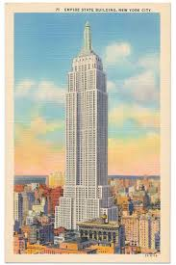





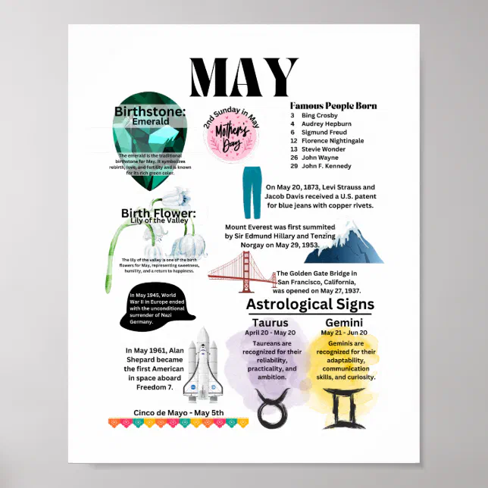


Mother’s Day, May 10th, holiday in honor of mothers that is celebrated in countries throughout the world. In its modern form the holiday originated in the United States. It was established by Anna Jarvis, who sought to honor her own mother. The first Mother’s Day church service was held in 1908. The day became a national holiday six years later, and it is observed on the second Sunday in May. Mother’s Day is celebrated with cards, flowers, and family dinners, among other activities.
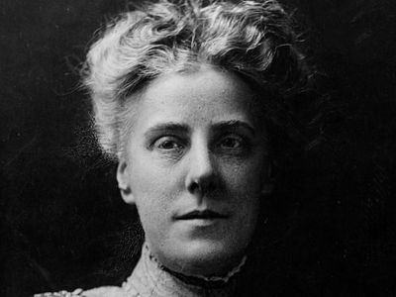
Many other countries also celebrate the holiday on this date, while some mark the observance at other times of the year. During the Middle Ages the custom developed of allowing those who had moved away to visit their home parishes and their mothers on Laetare Sunday, the fourth Sunday of Lent. This became Mothering Sunday in Britain, where it continued into modern times, although it has largely been replaced by Mother’s Day.
History in the U.S.
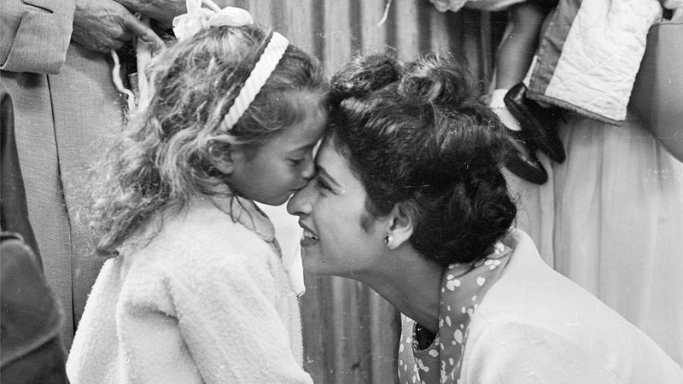
Who created Mother's Day? On May 10, 1908, American activist Anna Jarvis held what is considered to be the first Mother's Day celebration.
Jarvis was inspired to create the holiday by her mother, Ann Jarvis, who organized women’s groups to promote friendship and health. In 1868, three years after the end of the Civil War, Ann Jarvis reportedly organized a Mothers’ Friendship Day to promote reconciliation between Union veterans and Confederate veterans and their families. In 1876, when she was 12 years old, Anna Jarvis witnessed her mother offer a prayer at the close of a Sunday school class: “I hope and pray that someone, sometime, will found a memorial mother’s day commemorating her for the matchless service she renders to humanity in every field of life,” her mother said. “She is entitled to it.” Anna Jarvis never forgot her mother’s prayer. After Ann Jarvis died in 1905, her daughter began a letter-writing and public-speaking campaign directed at local, state, and national figures and organizations. She and her supporters advocated a Mother’s Day to be observed on the second Sunday of May, which matched the day on which Ann Jarvis died.
On May 12, 1908, a Mother’s Day service was held at Jarvis’s late mother’s church in Grafton, West Virginia. Within five years virtually every state was observing the day, and in 1914 U.S. Pres. Woodrow Wilson made it a national holiday. Although Jarvis had promoted the wearing of a white carnation (her mother’s favorite flower), the custom developed of wearing a red or pink carnation to represent a living mother or a white carnation for a mother who was deceased. Over time the day was expanded to include others, such as grandmothers and aunts, who played mothering roles.
Did You Know?
While first celebrated in 1910, Father’s Day did not become a national holiday until 1972.
Traditions
Jarvis had conceived of the holiday as a “personal day,” which is why Mother’s is singular rather than plural. Early celebrations included family dinners and religious services, both of which have continued. However, the day also quickly became associated with sending cards and the giving of gifts. In fact, more than 100 million Mother’s Day cards are bought annually in the United States. When it comes to gifts, flowers are especially popular, and carnations remain the official flower of the holiday.




National Memorial Day in the USA is celebrated on the last Monday in May.
All men and women, who gave their lives while serving in the United States Armed Forces, are commemorated on this day. National Memorial Day is formally known as Decoration Day, the day that commemorated the Union and Confederate soldiers, who died during the American Civil War. Later the day extended to honor all American soldiers, who died while in the military service.
Traditionally, the flag of the USA is raised briskly to the top of the flagstaff, then it is lowered to the half-staff position. This position is chosen in remembrance of those people, who died for their country. At noon the flag is raised to full-staff as the symbol that the memory of dead soldiers is being raised by the living. Their sacrifice was not in vain, that is why we rise up in their honor and continue fighting for liberty and justice.
Thousands of parades are held during National Memorial Day in all large and small cities. Most parades feature marching bands, servicemen, veterans and military vehicles from various wars also participate.
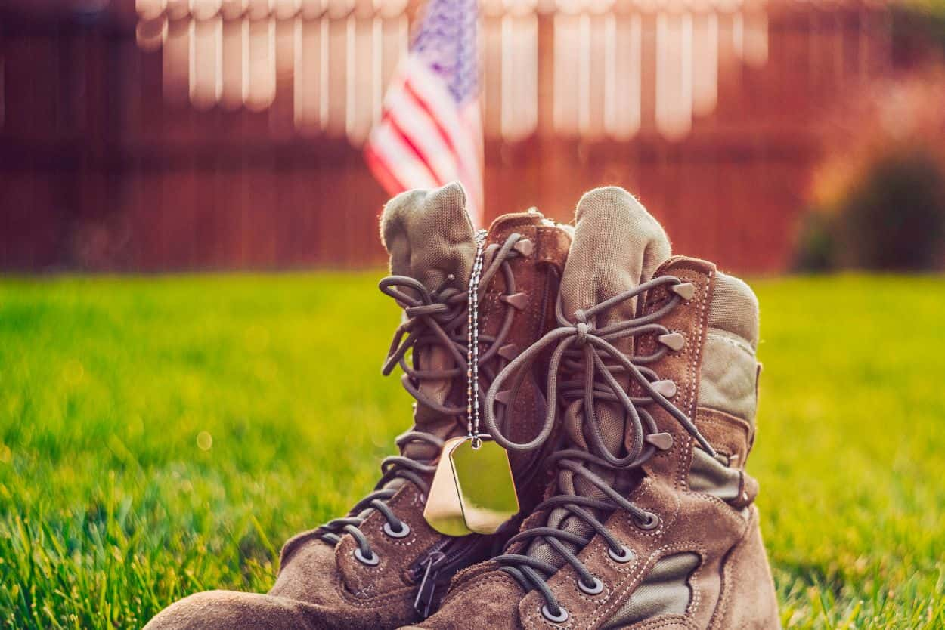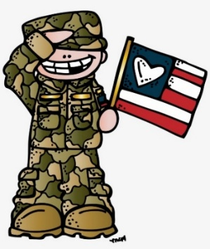
Originally called Decoration Day, from the early tradition of decorating graves with flowers, wreaths and flags, Memorial Day is a day for remembrance of those who have died in service to our country. It was first widely observed on May 30, 1868 to commemorate the sacrifices of Civil War soldiers, by proclamation of Gen. John A. Logan of the Grand Army of the Republic, an organization of former Union sailors and soldiers.
During that first national commemoration, former Union Gen. and sitting Ohio Congressman James Garfield made a speech at Arlington National Cemetery, after which 5,000 participants helped to decorate the graves of the more than 20,000 Union and Confederate soldiers who were buried there.
This national event galvanized efforts to honor and remember fallen soldiers that began with local observances at burial grounds in several towns throughout the United States following the end of the Civil War, such as the May 1, 1865 gathering in Charleston, South Carolina organized by freed slaves to pay tribute and give proper burial to Union troops.
In 1873, New York was the first state to designate Memorial Day as a legal holiday. By the late 1800s, many more cities and communities observed Memorial Day, and several states had declared it a legal holiday.
After World War I, it became an occasion for honoring those who died in all of America’s wars and was then more widely established as a national holiday throughout the United States.

In 1971, Congress passed the Uniform Monday Holiday Act and established that Memorial Day was to be commemorated on the last Monday of May. Several southern states, however, officially commemorate an additional, separate day for honoring the Confederate war dead, sometimes referred to as a Confederate Memorial Day: January 19 in Texas; third Monday in Jan. in Arkansas; fourth Monday in Apr. in Alabama and Mississippi; April 26 in Florida and Georgia; May 10 in North and South Carolina; last Monday in May in Virginia; and June 3 in Louisiana and Tennessee.
Memorial Day is commemorated at Arlington National Cemetery each year with a ceremony in which a small American flag is placed on each grave. Traditionally, the President or Vice President lays a wreath at the Tomb of the Unknown Soldier. About 5,000 people attend the ceremony annually.

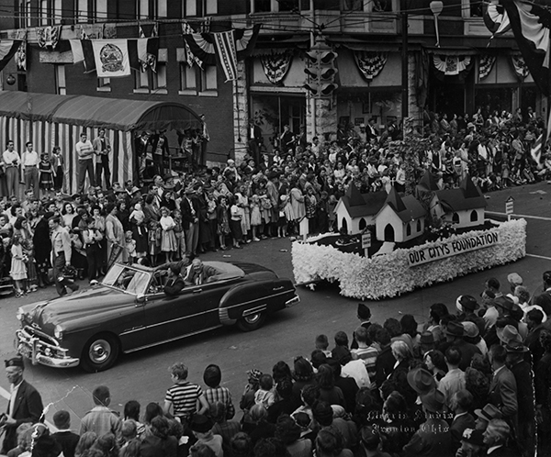

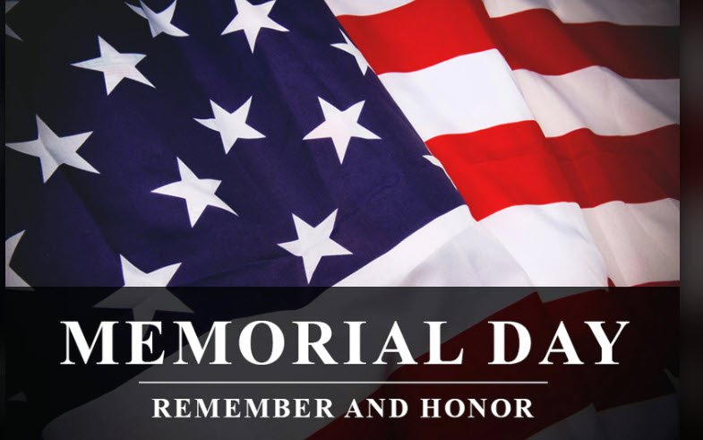

THANK YOU TO ALL MEN AND WOMEN WHO HAVE SERVED OR ARE STILL SERVING OUR COUNTRY.
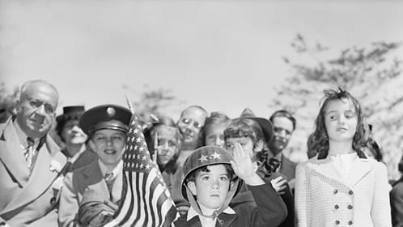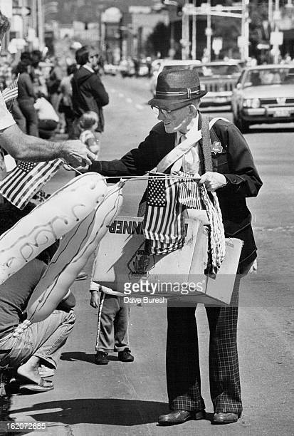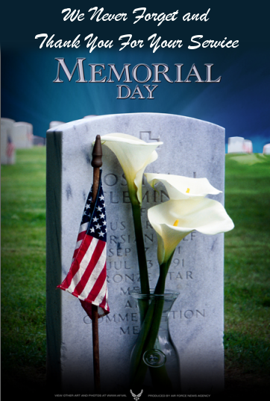
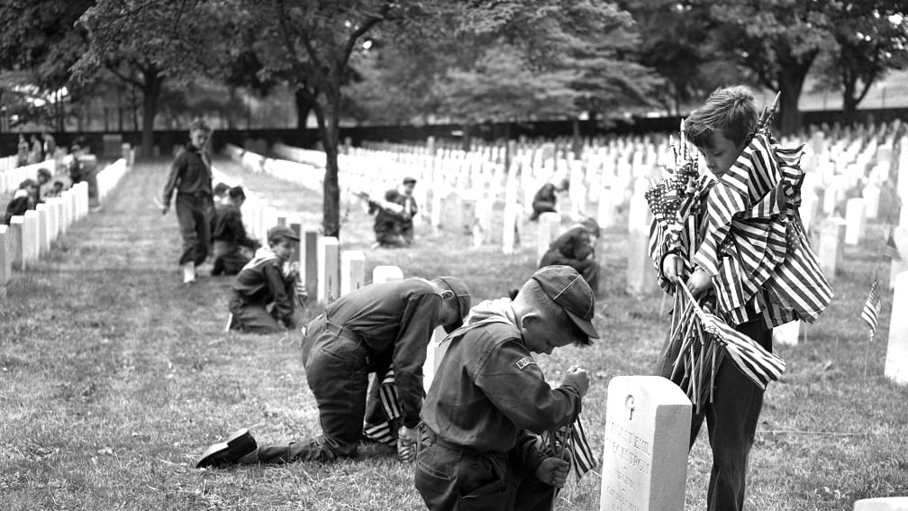




Congratulations to the Class of 2026!!! 
LOCAL NEWS
- Are you in need of grocery delivery service? Call 620-228-5570 for more information on this new service.

- Don’t forget, we have a community food box in front of City Hall…. Take what you need, leave what you can.

- 2026 City Dog Tags available for purchase. Please bring proof of rabies vaccination. If purchased after April 30th, you will be charged $1.00 late fee per dog per each month late on obtaining tags and a possibility of receiving a notice to appear in La Harpe municipal court which will add an $80.00 court cost fee on top of the dog tag purchase.

-  Food pantry available to the La Harpe community on the 3rd Friday of each month! Address for pickup is the Light of La Harpe Church – 901 S. Main and pickup start at 4:00pm. Any questions on the food pantry, please call 620-228-3069.

If you need assistance after-hours please call the Iola Dispatch Center at (620) 365-1437, they will notify the proper personnel.
 HAPPY BIRTHDAY TO ALL LAHARPE CITIZENS CELEBRATING A BIRTHDAY THIS MONTH!!!! MAY YOUR DAY BE AS SPECIAL AS YOU ARE TO US!

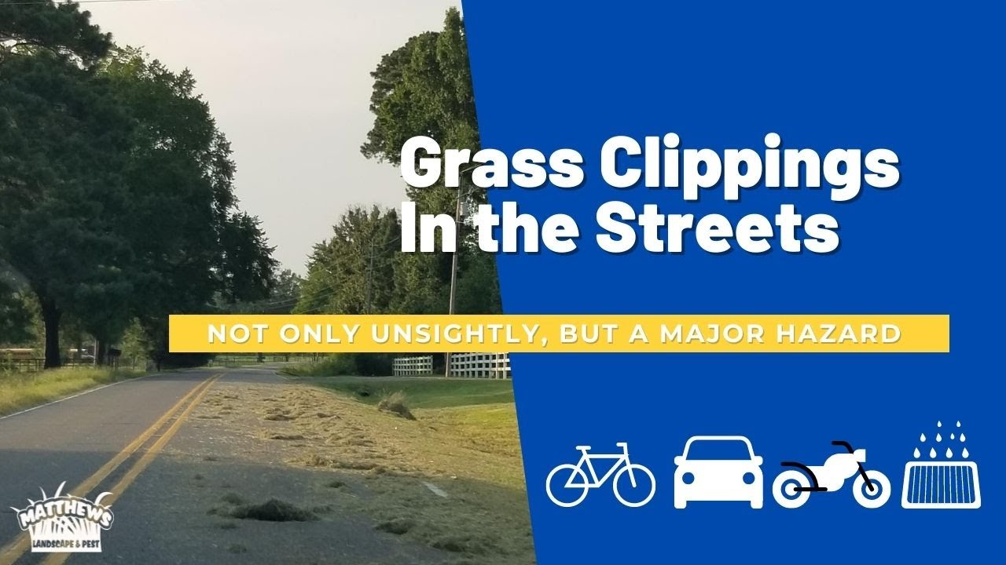

TO ALL CITIZENS IN LA HARPE
It is in the city ordinance that you are not to blow your grass in the street. If you happen to get grass in the street, I’m asking you to blow or sweep the grass back into your yard or you will receive a Notice to Appear in Court. That will be an $80.00 court cost and whatever the Judge fines you. Please don’t blow grass in the street when you mow or at any time.
If you have any questions, please contact us by phone (620) 365-5956 here at City Hall.

Sincerely,
Animal and Code Officer

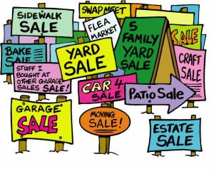
City of LaHarpe City Wide Garage Sales
June 13th
To be added to the list you must sign-up at city hall by 5:00 pm on
June 8th
These lists will be available June 9th and may be picked up at the post office or the City Hall.

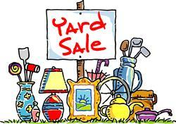


June 25, 2026
You must sign-up at city hall before 5:00 pm on
Friday, June 19th to schedule your pickup.
We need name, address, and list of items you want picked up.

No tires, batteries, household trash or items with Freon.

Items must be out by the road by 8:00 a.m. Thursday, June 25th.
Please keep items separated in corresponding piles.

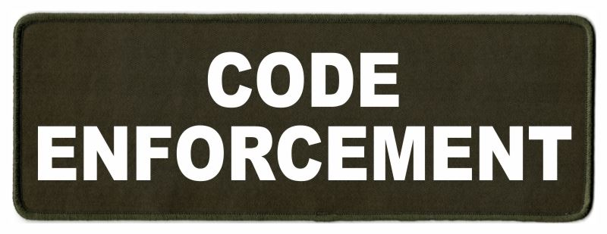
Note from the La Harpe Code Officer:
To whom it may concern,
I would like to share a friendly reminder to the La Harpe citizens;
- Vehicles parked in yards must have active registration and insurance and kept neatly maintained.
- Stock cars must be on a trailer or covered up.
- Roofs & windows must be intact and not covered with tarps, boards or like materials.
- Broken appliances and or furniture do not belong outdoors.
- Brush piles must be maintained; a burn permit can be obtained by calling city hall at 620-365-5956.
- Grass clippings, in street, will not be tolerated. If you do get grass in the street, please use your mower or broom to get it out of street. If seen intentionally blowing grass in street a notice to appear in La Harpe Municipal court will be issued.
- Grass can not be any taller than 12 inches anywhere on property, maintaining the ditch is on the homeowner. If you are wanting to hay your property, you must have 1 acre to hay and a hay permit needs to be approved by April 1st.
- If you have a dead tree near the city powerlines, and the tree falls over and does damage to the city powerlines, you will be charged for the damage.
- Trash belongs in a dumpster or at the Allen County landfill not in your yard.
- Dog pens need to be cleaned at least once a week and have clean water every day, and adequate shelter.

I will be sending out letters if your property is not in compliance with the La Harpe city code, if you have any issues with the La Harpe city code, please attend your regular council meeting held the 2nd Wednesday of every month at 7:00pm at city hall to discuss a resolution to your code violation. If the request to have your property in compliance with the La Harpe city code is not met by the time stated in your letter, a notice to appear in the La Harpe Municipal court will be issued.
A copy of the ordinance, in its entirety, can be viewed at www.cityoflaharpe.org

Dates to remember:
 May 13th: Council Meeting at City Hall at 7:00 pm

 May 18th: PRIDE Meeting at 7:00 p.m. at the City Hall

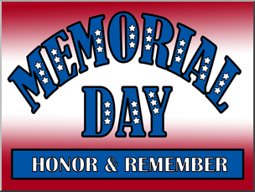 May 25th: City Hall closed in observance of Memorial Day

 May 27th: Past due Utility shut off date.

CITY COUNCIL NEWS
CITIZENS CALL FOR BUSINESS
- Phil Ebert presented ideas to the council about having a soccer field(s) in La Harpe. He stated, the area in the ball field would be a good place but designing a field isn’t all you need because different age groups require different things. He had a few printouts showing the differences in fields for youth 6 & below, youth 8 & below, and youth 10 & below all have differences with the average field being the size of the youth 10 & below. He stated he would like to talk with the Iola director about a possible chance of having a field(s) for practice or even a tournament. Phil shared, I think it would be a great asset to have one and it doesn’t cost a lot. Biggest issues would be insurance and maintenance. Phil urged the council to get more youth in town; they are the future and would also be willing to bring my son to town to start something. My son has been playing soccer since he was 5 years old, he even took 30 kids to London to play soccer. Phil also suggested having a multi court, where people can play tennis, pickleball, basketball, and other activities to provide exercise for our youth. Ron Knavel mentioned a few other areas for soccer fields, behind the city hall and East end of park. City attorney, Fred Works, shared with the council the fields need to be smooth and level surface. Mayor Lee asked Phil Ebert, if we have the opportunity to pursue, you would be willing to help and Phil stated interest.
- Dereck Jones addressed the council with an event he would like to have in La Harpe, in August, with Midwest Demo Kings, which is a competition of car audio and exhaust that gets pretty loud and intense and would like to bring a food truck vendor as well. He stated there would probably be 20-30 cars, it’s a family friendly event and they compete for trophies. Mayor Lee stated the objective is to see who can make the most noise, Dereck stated, you are correct and it’s also about bringing people to La Harpe. Mayor Lee suggested, it is a good activity for the community, citizens in a 3-block radius should be notified of the noise it will create. Fred reminded the council; the only city involvement would be making sure city codes are followed. He recommended an agreement be drafted and the city is responsible to make sure all safety protocols are being followed. Cynthia Carr suggested a plan be presented to the council. Mayor Lee suggested Dereck come back to the next meeting with a plan for the event.
- Richard Luken shared a big thank you for a successful Easter Egg hunt, stating there were about 85 kids in attendance and thanked Robin Manbeck and her daycare for filling the Easter eggs. Altogether, it was a great turnout with about 250 people in attendance.
- Harry Lee Jr. shared his vision for La Harpe, our community has effectively raised property taxes and utility rates because we are losing people; that’s the problem, now we need to find the solution. The solution would be more houses and more people buying utilities, we have to fill the vacant lots back up, the community needs to work together to make it a better situation. First thing; we need to clean up the town, second thing; fix up what we have, and third thing; spruce up with a fresh coat of paint and make it look nice. Harry stated, my vision we all need to be a team and work together to get it done. Need to volunteer your time to your community, need to talk to your neighbors and let them know that you don’t want to lose the tax base. Ron Knavel shared, there are a lot of empty houses that the owners are interested in selling. Mayor Lee suggested the city might be able to help with that. Fred Works mentioned, the city only has the authority to protect the public safety. Mayor Lee reminded everyone in attendance that we all need to be a team, on the same page and willing to step up and solve problems. Debbie Bearden addressed the council reminding them of a grant the city had about 15 years ago where people could get their homes fixed up and wondering if the city could do something like that. Angela Barker reminded those that Thrive has that grant, all people have to do is apply. Angela expressed concerns addressing homes and missing opportunities on new businesses coming to town, stating we need more businesses. Mayor Lee suggested, being positive will accomplish more than being negative.

UNFINISHED BUSINESS
- Dump Truck – A spreadsheet sharing year, model and pricing of dump trucks was presented to the council. Mayor Lee asked if there was a rush on the truck and maintenance worker, Keith Knavel, stated the city would have to be getting more cold patch and our truck won’t make that trip. Cynthia Carr expressed concerns on the trucks; the history, what they were used for, and why they were traded in with low mileage. Angela Barker suggested Keith go to Oklahoma and look at the trucks. Angela Barker made the motion to send Keith to Collinsville, OK to look at the vehicles and report back to council. Ron Knavel seconded. Motion carried 4-0.
- Sprague variance agreement – Fred stated, the issue we have has nothing to do with the variance, they are simply not in compliance with the code. Fred mentioned he would like an executive session on Attorney/ client at the end of the meeting to discuss.

NEW BUSINESS
- Vacant council seat – Mayor Lee shared that 3 citizens are showing interest in taking the vacant council seat; Kendra Michael, Craig Trester, and Scott Kroenke. Angela Barker mentioned, in the past council was seated, if on the voting ballot then that person would be next to take seat because the citizens voted for them. Mayor Lee asked each council member their opinion for the vacant seat; Ron Knavel shared that Scott Kroenke’s qualifications were excellent. Angela Barker stated; Kendra has been at several meetings and have never seen Scott attend a meeting. Cyndi Maley asked doesn’t the mayor pick for the open seat. Cynthia Carr stated a vote is valid, Kendra ran and has been at meetings so that carries some weight for me. Kendra intervened and appreciated the opportunity but chose to withdrawal her interest in sitting on council, stating she is too busy and recommended the mayor appoint Scott Kroenke for the vacant seat. Mayor Lee recommended that Scott Kroenke be appointed as a council member to fill vacant seat. Ron Knavel made the motion to consent to the mayor’s appointment of Scott Kroenke. Cyndi Maley seconded. Motion carried 4-0. City clerk, Michelle Altis, swore in Scott Kroenke.
- Wesley Weishaar with BG Consultants gave an update on the sewer lift station project and to answer any questions the new council or mayor may have. Lift stations 1,2,4, 5 & 6 we are replacing mechanical and electrical equipment and lift stations 1, 4, 5 & 6 will be completely rehabilitated or replaced. All lift stations electrical and SCADA will be upgraded. Cardinal Sitework was awarded the contract for project in the amount of $779,618.75. The city has the KWO grant in the amount of $750,000.00 leaving almost $30,000.00 that will be used from the KDHE loan with 30% of principal forgiveness. There is a pre-construction meeting scheduled for April 14th at 10:30am at city hall, we will get the notice to proceed sometime in May with construction starting soon after that, and construction should be completed by December. The next phase of this project will be the collection system to start in late 2026 and complete by 2028. Mayor Lee asked if the mains will be repaired with a sleeve, Wesley said yes, it most areas, there are a few areas that need total replacement. There is a total of 47,700 linear feet of main we need to focus on with approximately 180 manholes and approximately 240 sewer taps. The second phase will be between $3.6 million to $4 million with funding we can evaluate through KDHE, USDA, CDBG and KWO. Mayor Lee stated that each council member has an area of responsibility and Ron Knavel will be appointed to the sewer fund, so any issues will need to be addressed with him.
- President of the council – Angela Barker nominated Cynthia Carr. Ron Knavel nominated Cynthia Carr. No other nominations were mentioned so Cynthia Carr was chosen to be the president of the council.
- City Treasurer appointment – Mayor Lee shared, with the resignation of the former city treasurer, I appointed Teresa Driskel to fill that position because she was Treasurer before and knows the job. Angela Barker made the motion to accept the appointment. Cynthia Carr seconded. Motion carried 5-0.
- KMEA Board of Directors and KRWA Voting delegate – Michelle stated, with the resignation of Sharlyn Thompson, we need a replacement to take her spot. Scott Kroenke offered to take the spots as needed. Cynthia Carr made the motion for Scott to replace Sharlyn on both KMEA and KRWA forms as needed. Ron Knavel seconded. Motion carried 5-0.
- Update bank account signatures – Michelle stated that all city bank accounts have been updated, just need it documented to remove Sharlyn Thompson and add Harry Lee to all city bank accounts. Cynthia Carr made the motion to change the required signatures by replacing Sharlyn Thompson with Harry Lee Jr. Angela Barker seconded. Motion carried 5-0.
- Park Seating – Mayor Lee would like the aluminum bleachers placed at the park and secure them rather than transport them back and forth. Scott stated they could be secured at park and still be portable. Angela Barker stated the bleachers have been used at city hall for indoor tournaments and think they should be kept inside. Ron Knavel suggested moving them to the park. Michelle suggested the council look at the bleachers, stating she wasn’t sure if they would hold up in the weather. Mayor Lee asked the council to look at the bleachers and make a decision next month.
- Mowing city properties – Mayor Lee proposed we mow with the city employees we have on hand. Angela Barker questioned not bringing John back at $12.00 an hour. Mayor Lee stated he had heard the equipment was not being taken care of. Cynthia Carr said we can see how it goes.
- Mayor phone – Mayor Lee suggested the old mayor phone be discontinued as he was not interested in carrying two phones and paying the extra $50.00 a month. Cynthia Carr made the motion to discontinue phone number 620-496-6219. Scott Kroenke seconded. Motion carried 5-0.
- Text My Gov. – No action was taken.

REPORTS OF CITY OFFICERS

- Fred Works, City Attorney – Fred shared back on the mayor’s vision, that there was a 5-year program that included volunteers, county and city and twice a year they would clean up the community by hauling items off for people or buying paint and having volunteers paint homes that needed it. Fred stated, people need help and most can’t fix themselves but a volunteer group could get the word out and the work done. He applauded the mayor on his vision for the future of La Harpe.

- Roy Caler, Water Representative – Nothing to report.

- Penny Miller, Code/Animal Control –shared reports and requested approval to move forward on condemning 309 E. 10th and 1001 S. Main. The council agreed to move forward.

d) Marc Waggoner, Fire Chief- Shared the meeting minutes: The LaHarpe Volunteer Fire Department met for the monthly meeting. Present: Marc Waggoner Sr., Matthew Waggoner, Kiefer Endicott, Josh Sparks, Meghan Sparks, Bill Gay, and Dennis Sidebottom. Absent were Jason Teeple, Pamela Waggoner, Dillon Brownback, and Justin Pritchard. Had a fire at 3000, West Virginia. We used this fire for training on disbursement of foam and use of mutual aid from several fire departments. It was a good fire training fire.

e) Maintenance Department - The workorders were shared. Mayor Lee expressed concerns on an electrical issue the city experienced this past weekend; the person on call couldn’t fix it, called the next person and they couldn’t fix it, then called the third person and they couldn’t fi it but all 3 employees got paid 2 hours at time and half. We have a policy issue we need to address.

f) Michelle Altis, City Clerk – Shared the city insurance policy has a $4,285.00 lower premium than 2025. She also shared that the city received a dividend check in the amount of $4,751.30. Michelle also requested the mayor and council give her updated phone numbers. Michelle shared a quote she received from Keith on the 6th street whistles in the amount of $678.00. Scott stated he would like a second quote on the concrete. Cynthia Carr made the motion to move forward with the project using the cheapest quote of concrete. Scott Kroenke seconded. Motion carried 5-0.

DISCUSSION ON AGENDA ITEMS –
Mayor Lee asked for a motion to go into executive session for attorney/client followed by an executive session on non-elected personnel for 10 minutes. Cynthia Carr made the motion to go into executive session for attorney/client followed by an executive session on non-elected personnel for 10 minutes. Cyndi Maley seconded. Motion carried 5-0. Cynthia Carr mentioned La Harpe has a few properties listed in the newspaper that have a tax delinquency and suggested the council look at those addresses to see if there is any interest in purchasing them in the future. Michelle said she will send the list of addresses to everyone. Cyndi asked where we were on the streets. Michelle stated, I’ll call the county and find out more and let you know. I will also send you the proposed streets so you can review them as well.


Mayor: Harry Lee Jr. 620-496-7000
City Attorney: Fred Works
City Municipal Judge: Patty Miklos
Police Chief:
Fire Chief: Marc Waggoner
Assistant Fire Chief: Dennis Sidebottom
City Clerk: Michelle Altis
Assistant Clerk: Teresa Driskel
City Treasurer: Teresa Driskel
Maintenance Staff: Larry Laird & Keith Knavel
Code & Animal Control: Penny Miller
City Council Members:
Angela Barker (620-224-6209) Ron Knavel (620-496-2508)
Cyndi Maley (620-380-6600) Cynthia Carr (620-496-7500)
Scott Kroenke (915-205-0735)
Laharpe City Hall Hours: Monday-Friday
902 S. Washington 8:00-12:00 & 1:00-5:00
P.O. Box 10 Ph. (620) 365-5956
Laharpe, KS. 66751 Fax (620) 365-3944

CHECK OUT OUR WEBSITE; CITYOFLAHARPE.ORG  Follow us on Facebook



Caesar Chicken

Ingredients
- 6 boneless skinless chicken breast halves (6 ounces each)
- 1/4 teaspoon salt
- 1/4 teaspoon pepper
- 1/4 teaspoon garlic powder
- 1 cup creamy Caesar salad dressing
- 1/2 cup sour cream
- 1 cup Caesar salad croutons, crushed
- 1/4 cup grated Parmesan cheese
- 3 tablespoons butter, melted
- Chopped fresh parsley

Directions
- Preheat oven to 350°. Pat chicken dry sprinkle with salt, pepper and garlic powder. Place chicken in a greased 13x9-in. baking dish. In a small bowl, combine salad dressing and sour cream; spread over chicken.
- In a small bowl, combine crushed croutons, Parmesan cheese and melted butter; sprinkle over chicken. Bake, uncovered, until a thermometer reads 165°, 45-55 minutes. Sprinkle with parsley.

Broccoli Cheddar Pasta

Ingredients
- 16 ounces fusilli or cellentani pasta
- 3 cups fresh broccoli florets
- 1/4 cup butter
- 2 garlic cloves, minced
- 2 tablespoons all-purpose flour
- 1 cup chicken broth
- 1 teaspoon salt
- 1/2 teaspoon onion powder
- 1/4 teaspoon paprika
- 1/4 teaspoon pepper
- 1 cup half-and-half cream, warmed
- 1-1/2 cups shredded cheddar cheese
- 1/2 cup grated Parmesan cheese

Directions
- Bring a large pot of water to a boil. Add pasta; cook according to the package directions. One minute before pasta is fully cooked, add broccoli florets; boil with the pasta for the last minute of cooking. Scoop out 1 cup pasta water; set aside. Drain pasta and broccoli; set aside.
- In the same pot, melt butter over medium heat. Stir in garlic; cook 30-60 seconds or until fragrant. Stir in flour; cook 1-2 minutes or until a thick paste forms, stirring constantly.
- Add chicken broth, salt, onion powder, paprika and pepper. Slowly stir in warmed half-and-half cream; bring to a low simmer. Cook until the sauce has thickened, about 3-4 minutes, stirring frequently. Remove from the heat. Stir in cheeses until melted.
- Stir in cooked pasta and broccoli until combined. Add pasta water to smooth out the sauce, if desired. Serve hot.


Lime-Honey Fruit Salad
Ingredients
- 1 teaspoon cornstarch
- 1/4 cup lime juice
- 1/4 cup honey
- 1/2 teaspoon poppy seeds
- 3 medium gala or Red Delicious apples, cubed
- 2 medium pears, cubed
- 2 cups seedless red grapes
- 2 cups green grapes

Directions
- In a small microwave-safe bowl, combine cornstarch and lime juice until smooth. Microwave, uncovered, on high for 20 seconds; stir. Cook until slightly thickened, 10-15 seconds longer. Stir in honey and poppy seeds.
- In a large bowl, combine the apples, pears and grapes. Pour dressing over fruit; toss to coat. Cover and refrigerate overnight.

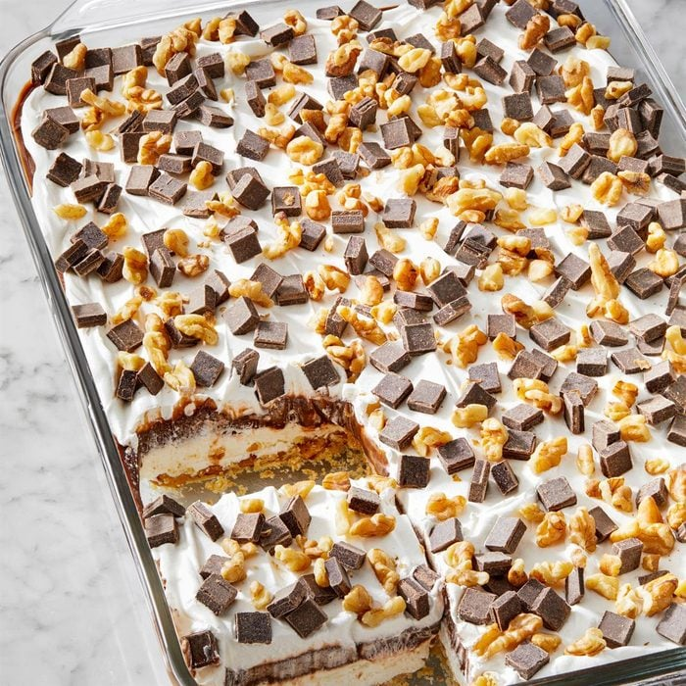
Chocolate Delight
Ingredients
- 1 cup all-purpose flour
- 1/2 cup cold butter
- 1 cup chopped walnuts, toasted, divided
- 1 package (8 ounces) cream cheese, softened
- 1 cup confectioners' sugar
- 2 cartons (8 ounces each) frozen whipped topping, thawed, divided
- 2-1/2 cups 2% milk
- 2 packages (3.9 ounces each) instant chocolate pudding mix
- 1 cup semisweet chocolate chunks
- Chocolate syrup

Directions
- Preheat oven to 350°. Place flour in a small bowl; cut in butter until crumbly. Stir in 1/2 cup walnuts. Press onto bottom of an ungreased 13x9-in. baking dish. Bake until light golden brown, 12-15 minutes. Cool completely on a wire rack.
- In a small bowl, beat cream cheese and confectioners' sugar until smooth; fold in 1 carton whipped topping. Spread over crust. In a large bowl, whisk milk and pudding mix for 2 minutes. Gently spread over cream cheese layer. Top with remaining whipped topping. Sprinkle with chocolate chunks and remaining walnuts. Refrigerate until cold.
- Cut into bars. Just before serving, drizzle with chocolate syrup.

