JUNE NEWSLETTER

The month of June is known as the time schools let out for the summer, and June 20, 21, or 22 (depending on the year) is the longest day of the year with the most daylight hours in the Northern Hemisphere.

Juno is the ancient Roman goddess of marriage and childbirth. And the month of June is still a popular month for weddings today! As a natural extension of marriage, Juno was also the goddess of childbirth. Another interpretation of the origins of “June” says that the name came from the Latin juvenis, “young people,” who were celebrated at this time.
Juno, in Roman religion, was the chief goddess and female counterpart of Jupiter, similar to the relationship between the Greek Hera and Zeus. Perhaps not surprisingly, given her role of protector of women and children, this powerful queen of the gods was also considered the fierce protector and special counselor of the state and a guardian angel warning those in times of danger.

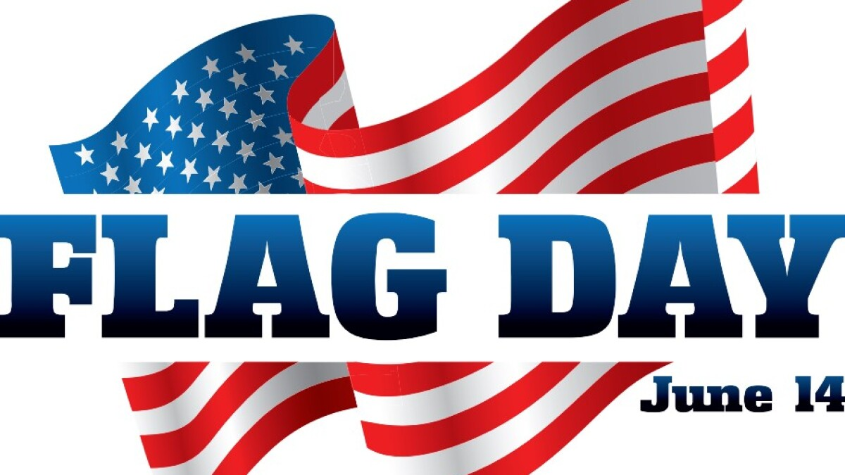
Many Americans celebrate Flag Day by displaying the Red, White and Blue in front of homes and businesses. The day commemorates the adoption of the Stars and Stripes as the official flag of the United States.

What we know fondly as the “Stars and Stripes” was adopted by the Continental Congress as the official American flag on June 14, 1777, during the Revolutionary War. Colonial troops fought under many different flags with various symbols—rattlesnakes, pine trees, and eagles—and slogans—” Don’t Tread on Me,” “Liberty or Death,” and “Conquer or Die,” to name a few.
The Declaration of Independence made the adoption of an American flag necessary. Previously, each colony or special interest had its own flag.

On that 14th of June, Congress made the Flag Resolution of 1777, stating: “The flag of the United States shall be thirteen stripes, alternate red and white, with a union of thirteen stars of white on a blue field …” Official announcement of the new flag was not made until Sept. 3, 1777.

” Flag Day” has been celebrated as a patriotic occasion for many decades, but President Woodrow Wilson made the observance official on May 30, 1916, by a presidential proclamation.

Who Made the First American Flag?
The origins of the Stars and Stripes have become part of American folklore. Although many people believe that Betsy Ross designed and sewed the first flag, there is no true proof of this.
However, records do indicate that Betsy Ross most definitely made ensigns and pennants for the Philadelphia Navy during the war, and she certainly inspired the design of the current flag.
Based on colonial folklore, it has also been stated that the American flag was first flown in battle during the Revolutionary War at the Battle of Cooch’s Bridge in 1777. This may also be the stuff of legend.

However, what we do know is this:
- The original 1777 flag was designed to represent the 13 original colonies. It had 13 white stars on a blue field and 13 alternating red and white stripes.
- One of the first flag designs had the stars arranged in a circle, based on the idea that all colonies were equal.
- In 1818, after a few design changes, the United States Congress decided to retain the flag’s original 13 stripes and add new stars to reflect each new state that entered the union.
- Each time a state was added to the union, a star was added. Today, there are 50 stars, one for each state in the union, but the 13 stripes remain.

Interestingly, the current American flag was designed by a high school student from Lancaster, Ohio, named Bob G. Heft! Even though Bob’s history teacher gave him a “B-” for not knowing how many states the Union had, Bob submitted his design to the White House (unprompted) in anticipation of Hawaii and Alaska joining the Union. To his surprise, President Eisenhower called him! Today, it’s Bob Heft’s 1958 design—showing 50 stars in a field that included five rows of six stars and four rows of five stars—which is now our 50-star American flag (and history teacher changed his grade to an “A”!).

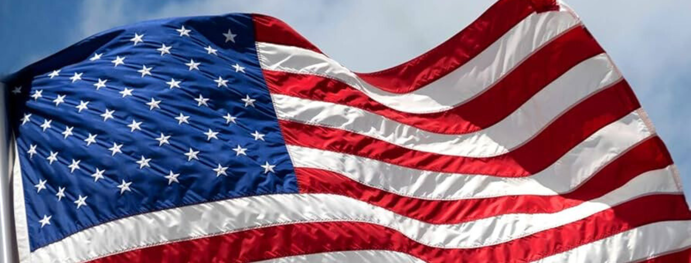

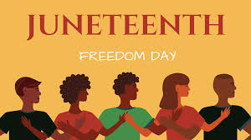
What Is Juneteenth?
On January 1, 1863, during the Civil War, U.S. President Abraham Lincoln issued the Emancipation Proclamation. It granted freedom to “all persons held as slaves” in 10 Confederate-controlled states.

However, for the most part, the order was not enforced until Union soldiers were able to advance into these areas after the end of the war, the beginning of which came in April 1865 with the surrender of Confederate Gen. Robert E. Lee after the Battle of Appomattox Court House in Virginia.

First Recognized in Texas
On June 19, 1865, U.S. Maj. Gen. Gordon Granger delivered to the people of Galveston, Texas, General Order No. 3, which read, in part:
“The people of Texas are informed that, in accordance with a proclamation from the Executive of the United States, all slaves are free. This involves an absolute equality of personal rights and rights of property between former masters and slaves, and the connection heretofore existing between them becomes that between employer and hired labor.”

This day became known as “Juneteenth,” a verbal shorthand for June 19. It is also known as “Freedom Day,” “Juneteenth National Independence Day,” or “Emancipation Day.”
Slavery in the United States would be formally abolished with the ratification of the 13th Amendment on December 6, 1865.
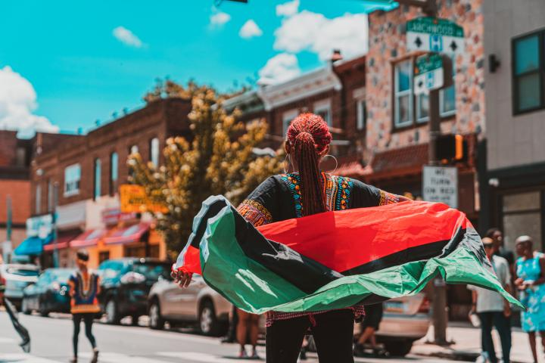

Recognition of Juneteenth
Did you know that Texas was the first state to recognize Juneteenth? In 1980, Texas called it “Emancipation Day.” Since then, at least 48 states and the District of Columbia have acknowledged Juneteenth as a holiday or observance.

Amid the worldwide civil rights protests that took place in 2020, many companies began to recognize Juneteenth as a paid holiday for employees.

In June of 2021, the city of Galveston, in partnership with the Juneteenth Legacy Project, unveiled “Absolute Equality,” a 5,000-square-foot public art mural that overlooks the spot where U.S. Maj. Gen. Granger read General Order No. 3.

On June 17, 2021, U.S. President Joseph R. Biden signed into law the Juneteenth National Independence Act, which establishes June 19th as a federal holiday.

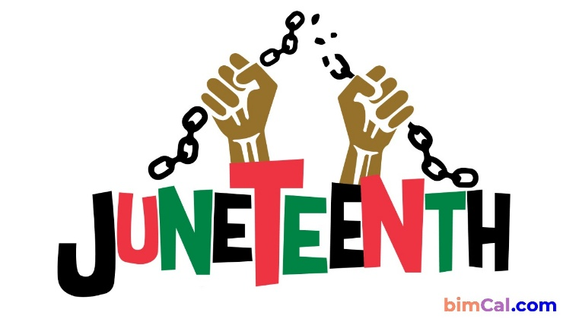

FATHER’S DAY – JUNE 21, 2026
The campaign to celebrate the nation’s fathers did not meet with the same enthusiasm–perhaps because, as one florist explained, “fathers haven’t the same sentimental appeal that mothers have.”
On July 5, 1908, a West Virginia church sponsored the nation’s first event explicitly in honor of fathers, a Sunday sermon in memory of the 362 men who had died in the previous December’s explosions at the Fairmont Coal Company mines in Monongah, but it was a one-time commemoration and not an annual holiday.
The next year, a Spokane, Washington, woman named Sonora Smart Dodd, one of six children raised by a widower, tried to establish an official equivalent to Mother’s Day for male parents. She went to local churches, the YMCA, shopkeepers and government officials to drum up support for her idea, and she was successful: Washington State celebrated the nation’s first statewide Father’s Day on June 19, 1910.
Slowly, the holiday spread. In 1916, President Wilson honored the day by using telegraph signals to unfurl a flag in Spokane when he pressed a button in Washington, D.C. In 1924, President Calvin Coolidge urged state governments to observe Father’s Day.
Today, the day honoring fathers is celebrated in the United States on the third Sunday of June.

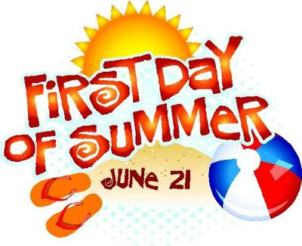
Summer Days are here! Summer begins with the solstice on Sunday, June 21, 2026, marking the astronomical first day of summer in the Northern Hemisphere. What exactly IS the summer solstice? Is it really the longest day of the year? Welcome the solstice with some interesting facts and folklore.

The June Solstice
In the Northern Hemisphere, the June solstice (aka summer solstice) occurs when the Sun travels along its northernmost path in the sky. This marks the astronomical start of summer in the northern half of the globe. (In the Southern Hemisphere, it’s the opposite: the June solstice marks the astronomical start of winter when the Sun is at its lowest point in the sky.)

When is the Summer Solstice?
The June solstice occurs on Sunday, June 21, at 3:24 A.M. CDT.
This solstice marks the official beginning of summer in the Northern Hemisphere, occurring when Earth arrives at the point in its orbit where the North Pole is at its maximum tilt (about 23.5 degrees) toward the Sun, resulting in the longest day and shortest night of the calendar year. (By longest “day,” we mean the longest period of sunlight hours.) On the day of the June solstice, the Northern Hemisphere receives sunlight at the most direct angle of the year.
In the Southern Hemisphere, the June solstice marks the beginning of winter.


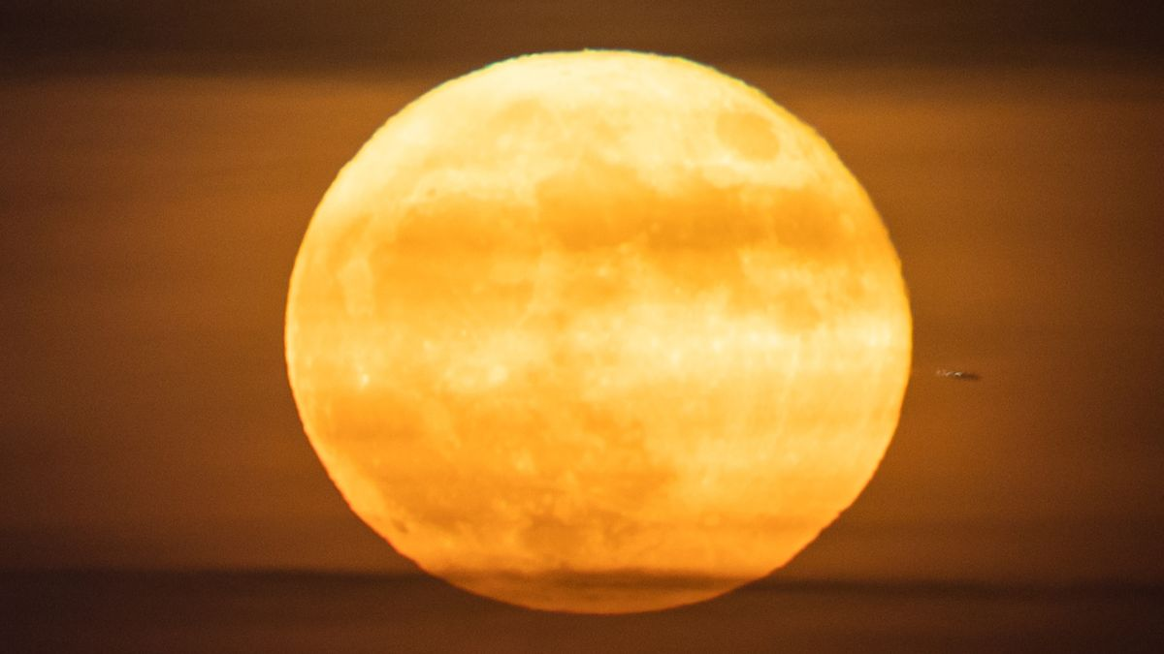June full moon 2026: When, where and how to see the Strawberry Moon
The June full moon occurs at 6:57 p.m. CDT on June 29. That's when the lunar disk will pass opposite the sun in Earth's sky, appearing fully lit by the sun's rays.
This month's full moon is also known as the "Strawberry Moon," reflecting the time of year when Native American tribes harvest the ripened fruit. It is also the first full moon of summer, following soon after the June 21 summer solstice, which marks the astronomical start of the season and the longest day of the year.
June's full moon tracks the lowest path of any full moon throughout the year, and that's thanks to its proximity to the summer solstice — when the sun is at its highest in the daytime sky.
Look to the southeastern horizon at sunset on June 29 to see the Strawberry Moon climb into the early summer sky, embedded among the stars of the constellation Sagittarius. Seeing those stars may prove a challenge, in fact, due to the deluge of moonlight pouring from the lunar disk.
Beyond brightness, Earth's natural satellite will also appear particularly large to the unaided eye as it rests close to the horizon because of a phenomenon known as the moon illusion. You may also see the lunar disk adopt a yellow-orange glow in the period directly following moonrise, when its light will be scattered and filtered by the atmosphere.

LOCAL NEWS

- CCR Report available at http://krwa.net/ccr/LaHarpe and www.cityoflaharpe.org

- Are you in need of grocery delivery service? Call 620-228-5570 for more information on this new service.

- Don’t forget, we have a community food box in front of City Hall…. Take what you need, leave what you can.

- 2026 City Dog Tags available for purchase. Neutered or spayed is $6.00, intact is $8.50. Failure to purchase your city dog tag could result in a possibility of receiving a notice to appear in La Harpe municipal court which will add an $80.00 court cost fee on top of the dog tag purchase.

-  Food pantry available to the La Harpe community on the 3rd Friday of each month! Address for pickup is the Light of La Harpe Church – 901 S. Main and pickup start at 4:00pm. Any questions on the food pantry, please call 620-228-3069.

If you need assistance after-hours please call the Iola Dispatch Center at (620) 365-1437, they will notify the proper personnel.
 HAPPY BIRTHDAY TO ALL LAHARPE CITIZENS CELEBRATING A BIRTHDAY THIS MONTH!!!! MAY YOUR DAY BE AS SPECIAL AS YOU ARE TO US!
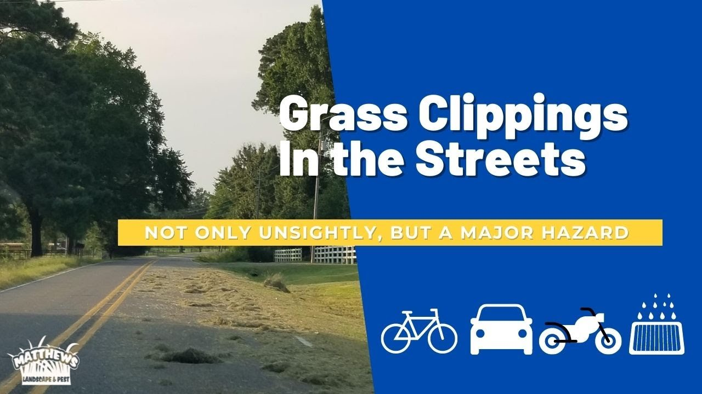
TO ALL CITIZENS IN LA HARPE
It is in the city ordinance that you are not to blow your grass in the street. If you happen to get grass in the street, I’m asking you to blow or sweep the grass back into your yard or you will receive a Notice to Appear in Court. That will be an $80.00 court cost and whatever the Judge fines you. Please don’t blow grass in the street when you mow or at any time.
If you have any questions, please contact us by phone (620) 365-5956.

Sincerely,
Animal and Code Officer

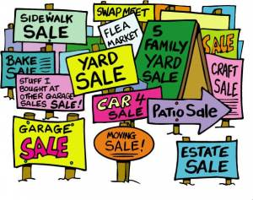
City of LaHarpe City Wide Garage Sales
June 13th
To be added to the list you must sign-up at city hall by 5:00 pm on
June 8th
These lists will be available June 9th and may be picked up at the City Hall.

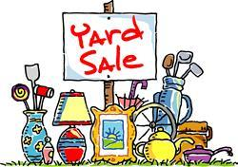


June 25, 2026
You must sign-up at city hall before 5:00 pm on
Friday, June 19th to schedule your pickup.
We need name, address, and list of items you want picked up.

No tires, batteries, household trash or items with Freon.

Items must be out by the road by 8:00 a.m. Thursday, June 25th.
Please keep items separated in corresponding piles.

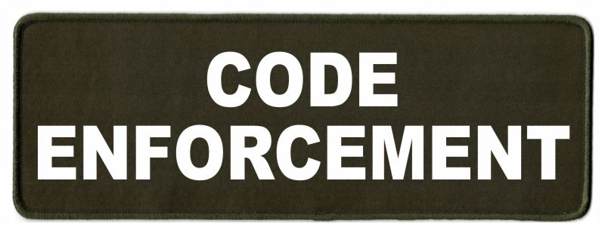
Note from the La Harpe Code Officer:
To whom it may concern,
I would like to share a friendly reminder to the La Harpe citizens;
- Vehicles parked in yards must have active registration and insurance and kept neatly maintained.
- Stock cars must be on a trailer or covered up.
- Roofs & windows must be intact and not covered with tarps, boards or like materials.
- Broken appliances and or furniture do not belong outdoors.
- Brush piles must be maintained; a burn permit can be obtained by calling city hall at 620-365-5956.
- Grass clippings, in street, will not be tolerated. If you do get grass in the street, please use your mower or broom to get it out of street. If seen intentionally blowing grass in street a notice to appear in La Harpe Municipal court will be issued.
- Grass can not be any taller than 12 inches anywhere on property, maintaining the ditch is on the homeowner. If you are wanting to hay your property, you must have 1 acre to hay and a hay permit needs to be approved by April 1st.
- If you have a dead tree near the city powerlines, and the tree falls over and does damage to the city powerlines, you will be charged for the damage.
- Trash belongs in a dumpster or at the Allen County landfill not in your yard.
- Dog pens need to be cleaned at least once a week and have clean water every day, and adequate shelter.

I will be sending out letters if your property is not in compliance with the La Harpe city code, if you have any issues with the La Harpe city code, please attend your regular council meeting held the 2nd Wednesday of every month at 7:00pm at city hall to discuss a resolution to your code violation. If the request to have your property in compliance with the La Harpe city code is not met by the time stated in your letter, a notice to appear in the La Harpe Municipal court will be issued.
A copy of the ordinance, in its entirety, can be viewed at www.cityoflaharpe.org
Dates to remember:
 June 10th: Council Meeting at City Hall at 7:00 pm

 June 15th: PRIDE Meeting at 7:00 p.m. at the City Hall

 June 25th: Past due Utility shut off date.

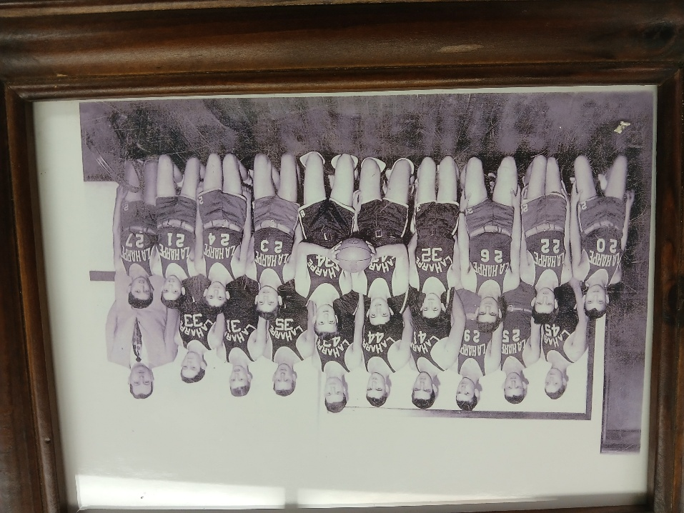
La Harpe Alumni will be gathering at city hall Saturday, June 27, 2026!!

CITY COUNCIL NEWS
CITIZENS CALL FOR BUSINESS
- Debbie Bearden shared information on the Allen County Farmers Market, that takes place on Thursday evenings on the Iola square, that they are not excepting SNAP and double up food bucks as payment.
- Jack Whiting addressed the council on a code letter he received about his skirting on his mobile home. Mayor Lee suggested Jack and two council members; Ron Knavel and Cyndi Maley offered, sit down and go over the city ordinance with Jack, then those council members will bring their recommendation to the next meeting. Mayor Lee suspended the 30-day deadline that Jack Whiting was given until after conversation with Ron and Cyndi.

UNFINISHED BUSINESS
- Dereck Jones presented his plan for the car audio and exhaust competition with a date of July 25th from 11:00am – 4:00pm. A few council members were concerned about the parking he had mapped out and suggested parking areas. Dereck stated they will not block the tank water or the fire barn. Ron Knavel made the motion to allow this event to take place on Main Street. Cyndi Maley seconded. Motion carried 4-0.
- Park seating – Scott Kroenke made the motion to install the bleachers at the park during the summer and store indoors during the winter. Ron Knavel seconded. Motion carried 4-0.
- Dump Truck – Tabled.

NEW BUSINESS
a) Sam Boaz with KDHE was present to share with council that his group will be in La Harpe collecting soil samples from a few properties to see if any lead is present. He stated he would like to access 5 areas in town because of the smelters that were on each side of La Harpe in the past. This program is federally funded and the larger lead sites are ran by the EPA. He shared that he needs to collect 10% data to present and if the city scores high enough for potential lead the EPA would pick up. Joesph Nolan was also present stating; we are here to help the city and no cost to you. If lead is found the yard(s) could be replaced with nice looking grass, the same work was conducted in Iola. Sam stated the code officer will be assisting them by getting permission slips signed to access soil from private properties, he also shared, if anyone is interested, he would leave agreement forms with the code officer, call or stop by city hall if interested in having your soil tested for lead.
b) After hour call out policy – Tabled.
c) Compensatory time versus overtime – Tabled.
d) Storm Shelters – Mayor Lee suggested other people other than city employees be assigned to unlocking the storm shelters during severe weather warnings. Marc Waggoner will be responsible for the storm shelter on 9th street which sits East of the church. Cynthia Carr will be responsible for the shelter at the park. And Scott Kroenke will be responsible for the shelter at the northeast corner of 10th & Broadway. Ron Knavel and Cynthia Carr suggested the city look into get a couple more shelters, perhaps through grant funding.
e) NRP plan – Tabled.
f) Appointments: Mayor Lee appointed the following:
Michelle Altis , City Clerk
Jacob Manbeck, City Attorney
Patty Boyd, Municipal Judge
Marc Waggoner, Fire Chief
Penny Miller, Code and animal control officer
Bank – Community National Bank & Trust
Official Newspaper – Iola Register
Scott Kroenke made the motion to accept all appointments. Ron Knavel seconded. Motion carried 3-1 with Cynthia Carr opposing.
g) City council pay by fund: Mayor lee put Scott Kroenke over the street fund, Ron Knavel over the sewer fund, Cyndi Maley over the electric fund and Angela Barker over the water fund. Mayor Lee stated that each council member would have responsibilities with this appointment of funds.
h) Roads- Scott Kroenke shared a map of the city streets and a 4-year plan to do all the streets in La Harpe. Scott stated he had gone through about 90% of the town the last few weeks and came up with a plan; the proposed streets for 2026 will be; Broadway, 6th, 10th, 11th, 12th, 13th, and 14th. He shared that several streets are showing signs of deterioration, surface cracking, potholes, edge failures and loss of roadway integrity. Inadequate drainage caused by clogged ditches and culverts are a huge culprit to our deteriorating streets, without proper drainage of the standing water, the streets will never be like they should be. Scott mentioned, by re-establishing the ditches and culverts will: improve stormwater runoff, reduce roadway damage caused by standing water, minimize erosion, improve roadway longevity and reduce future maintenance expenses. City Clerk, Michelle Altis, commend Scott on a well written plan but stated, it should look like an 8-year plan instead of 4 years because the city will not be able to afford the oil prices to chip seal the roads 4 years in a row. The last chip seal job in 2023 cost over $100,000.00. Scott shared the next step will be to coordinate with the county to get the proposed streets completed in 2026. Scott mentioned the city will pay for some of the rock. Cynthia Carr stated, the county has never charged for rock in the past, just the oil. She asked if they were holding up their responsibility of the lagoons or the city of Gas, are they helping. Michelle stated she was unsure on the answer to that. Mayor Lee suggested the contract for lagoons be shared at next council meeting.

REPORTS OF CITY OFFICERS
- Fred Works, City Attorney – Absent from meeting.

- Roy Caler, Water Representative – Nothing to report.

- Penny Miller, Code/Animal Control –shared reports and requested approval of resolution #2026-1 and resolution #2026-2 condemning properties at 309 E. 10th and 1001 S. Main. Cynthia Carr made the motion to pass and publish resolution numbers 2026-1 and 2026-2. Cyndi Maley seconded. Motion carried 4-0. Michelle mentioned, there will be a public hearing at a special meeting on June 30, 2026 at 6:00pm.

- Marc Waggoner, Fire Chief- Shared the meeting minutes: The LaHarpe Volunteer Fire Department met for the monthly meeting. Present: Marc Waggoner Sr., Matthew Waggoner, Kiefer Endicott, Josh Sparks, Meghan Sparks, Bill Gay, Marc Waggoner Jr., and Dennis Sidebottom. Absent were Jason Teeple, Josh Sparks, Pamela Waggoner, Dillon Brownback, and Justin Pritchard. Started meeting, took out 363 unit and did water training exercises, then went back to station and ended meeting. Marc stated all fire hydrants have been flushed.

- Maintenance Department - The workorders were shared. Electrical help was not discussed. One bid for utility poles and one bid for anchors was shared; the council requested more bids. Electric meters on homes were discussed; Mayor Lee shared the city purchased fuses for a disconnect box because the box was on the pole but the meter was on the house. Harry stated, the meter is not where it needs to be, if the house catches fire we need to be able to kill electric but if on the house it can’t be done safely. Mayor Lee asked, who is responsible for getting this right, what is the best way to serve people in a safe manner.

- Michelle Altis, City Clerk – Shared an advantage computer contract that she needed authorization to sign, she stated it was for the email accounts that city has. Cynthia Carr made the motion to authorize Michelle to sign contract. Scott Kroenke seconded. Motion carried 4-0. Michelle shared an advertising application; no action was taken at this time.

DISCUSSION ON AGENDA ITEMS –
Mayor Lee asked for a motion to go into executive session on non-elected personnel for 15 minutes. Cyndi Maley made the motion to go into executive session on non-elected personnel for 15 minutes. Scott Kroenke seconded. Motion carried 4-0. After returning to regular session, Cynthia Carr asked about the property at 410 S. McKinley, stating the city could buy it back for $900.00 if he didn’t have something built within 18 months. Michelle stated she would pull that contract and share at next meeting.


Mayor: Harry Lee Jr. 620-496-7000
City Attorney: Jacob Manbeck
City Municipal Judge: Patty Miklos
Police Chief:
Fire Chief: Marc Waggoner
Assistant Fire Chief: Dennis Sidebottom
City Clerk: Michelle Altis
Assistant Clerk: Teresa Driskel
City Treasurer: Teresa Driskel
Maintenance Staff: Larry Laird & Keith Knavel
Code & Animal Control: Penny Miller
City Council Members:
Angela Barker (620-224-6209) Ron Knavel (620-496-2508)
Cyndi Maley (620-380-6600) Cynthia Carr (620-496-7500)
Scott Kroenke (915-205-0735)
La Harpe City Hall Hours: Monday-Friday
902 S. Washington 8:00-12:00 & 1:00-5:00
P.O. Box 10 Ph. (620) 365-5956
La Harpe, KS. 66751 Fax (620) 365-3944

CHECK OUT OUR WEBSITE; CITYOFLAHARPE.ORG  Follow us on FacebookACON AND EGG HASH



Soda Pop Chops with Smashed Potatoes
Ingredients
- 1-1/2 pounds small red potatoes, halved
- 1 cup root beer
- 1 cup ketchup
- 1 tablespoon brown sugar
- 2 teaspoons chili powder
- 2 teaspoons Worcestershire sauce
- 1/2 teaspoon garlic powder, divided
- 2 tablespoons all-purpose flour
- 3/4 teaspoon pepper, divided
- 1/2 teaspoon salt, divided
- 4 bone-in pork loin chops (7 ounces each)
- 2 tablespoons olive oil
- 2 tablespoons butter
Directions
- Place potatoes in a large saucepan and cover with water. Bring to a boil over high heat. Reduce heat to medium; cover and cook until tender, 15-20 minutes.
- Meanwhile, in a small bowl, combine the root beer, ketchup, brown sugar, chili powder, Worcestershire sauce and 1/4 teaspoon garlic powder; set aside. In a large resealable plastic bag, combine the flour, 1/2 teaspoon pepper and 1/4 teaspoon salt. Add pork chops, one at a time, and shake to coat.
- In a large cast-iron or other ovenproof skillet, cook chops in oil over medium heat until chops are lightly browned, 2-3 minutes on each side. Drain. Add root beer mixture; bring to a boil. Reduce heat; cover and simmer until a thermometer reads 145°, 6-8 minutes. Remove pork and keep warm. Let stand for 5 minutes before serving.
- Bring sauce to a boil; cook until liquid is reduced by half. Meanwhile, drain potatoes; mash with butter, remaining garlic powder and remaining salt and pepper. Serve with pork chops and sauce.



Strawberry Shortcake Biscuits
Ingredients
- 2 cups all-purpose flour
- 3 tablespoons sugar, divided
- 1 tablespoon baking powder
- 1/2 teaspoon salt
- 1/4 cup cold butter
- 1 cup 2% milk
- 2 pints strawberries, chopped
- 1 tablespoon orange juice
- 1-1/2 cups whipped topping
Directions
- In a large bowl, combine flour, 2 tablespoons sugar, baking powder and salt. Cut in butter until mixture resembles coarse crumbs. Gradually stir in milk until a soft dough forms.
- Drop the dough by heaping tablespoonfuls into 8 mounds on a lightly greased baking sheet. Bake at 425° until lightly browned, 12-15 minutes. Cool on a wire rack.
- Meanwhile, place strawberries, orange juice and remaining 1 tablespoon sugar in a bowl; toss gently. Split shortcakes in half horizontally. Place bottom halves on serving plates; top with whipped topping and strawberries. Replace shortcake tops.

