JULY NEWSLETTER
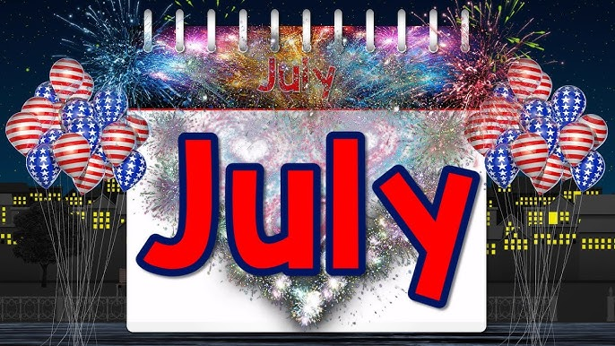
Hey everyone! It’s officially summertime, and that means lots of fun in the sun. When most people think of July, they think of fireworks, hot weather, and patriotic holidays. Did you know there are some interesting things about July that most people don’t know?
July comes with a lot of excitement. It’s filled with holidays, fun outdoor activities, and plenty of opportunities to enjoy time with family and friends.
Here are some fascinating (and even some wacky) fun facts about July that will help you appreciate this particular month even more!


 July 1st!

Creative Ice Cream Flavors Day

Summer is in full swing. It’s hot and sizzling. You need something to help cool off. What a perfect time for Creative Ice Cream Flavors Day. This July 1 holiday gives you the chance to create a new flavor of ice cream. Maybe, your new creation will be a hit and become wildly popular. Then, you can sell your secret formula to manufacturers and make a fortune.

Just how many flavors of ice cream are there? Those of you old enough to remember will recall the “28 Flavors” of Howard Johnson’s restaurant. Howard Johnson’s actually had far more than 28 flavors. They always had 28 flavors in stock (hopefully) at a time. Those 28 flavors are just the tip of the iceberg. The combinations are seemingly endless.



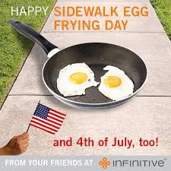 JULY 4TH!

Sidewalk Egg Frying Day

When is Sidewalk Egg Frying Day? This holiday is always celebrated on July 4
Sidewalk Egg Frying Day is today. Hmmm…. Do you wonder why we have such a day? Just take one step out of your air-conditioned home into the sweltering summer heat and humidity, and you’ll understand why this July 4 holiday exists.
It’s July, the middle of summer. The weather is hotter than blazes. It’s steamy, unbearable heat. Everything you touch is hot, sizzling hot. Why, it’s so hot that you could fry an egg on the sidewalk. You can also throw some bacon or sausage on the sidewalk, to fry up along with your eggs.


 JULY 11TH!
Today is National Blueberry Muffins Day, a July 11 holiday. Now here is a special day you can sink your teeth into. Blueberry Muffins are one of America’s favorite muffins. And, the blueberry harvest is occurring right now!
European settlers brought with them a recipe for “Bilberry Muffins”. Bilberries were not to be found in the New World. Wild blueberries, native to the Americas, were both plentiful and delicious. The wild blueberries were substituted for Bilberries, and the Blueberry Muffin recipe was born.
Did You Know? Native Americans called blueberries “star berries”.
In addition to tasting delicious, blueberries are very healthy for you. They are one of the best foods you can eat. Blueberries can help fight or avoid many ailments, including cancer, and dementia, promote heart health, and much, much more.



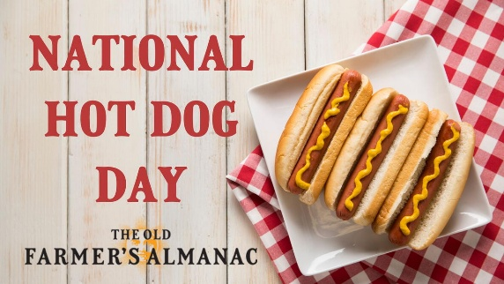 July 15TH!

Hot-diggity-dog! Summer is synonymous with backyard barbecues, crackling bonfires, and, of course, the iconic hot dog! But did you know there’s a dedicated day to celebrate this delicious and versatile food? Mark your calendars for National Hot Dog Day!

We love traditions, and National Hot Dog Day is one we can all support. So, fire up the grill, grab your favorite toppings, and get ready to relish (pun intended!) everything hot dog-related—from hot dog history to weiner jokes!

Brief History of Hotdogs

We “mustard” you a question: Do you like hot dogs?

Where did the weiner come from? Hot dogs, America’s favorite summer staple, boast a surprisingly long history. Their origin is debated, with Frankfurt, Germany (frankfurters) and Vienna, Austria (wieners) vying for credit. German immigrants brought these sausages to America in the 1800s. Sold by street vendors as “dachshund sausages” due to their shape, the term “hot dog” emerged, likely as a playful jab. By the 1890s, hot dogs were a staple at baseball games and amusement parks, forever linked to those carefree summer days.



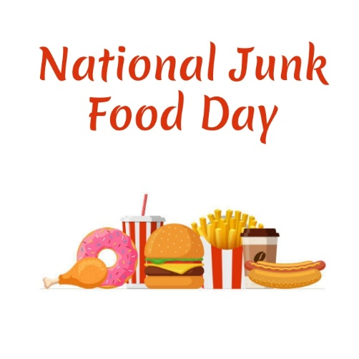 JULY 21ST!
For some of us, every day is Junk Food Day. For the rest of us, National Junk Food Day, a July 21 holiday, is an opportunity to guiltlessly eat your favorite junk food.
Dietitians will tell you that junk food is any food that contains little nutritional value. That means most snacks and candies are junk food. We also include foods that are high in salts, fats, and sugars. In other words, junk food is all that tasty stuff that the dietitians, and Mom, say is bad for us.
On National Junk Food Day, you get to eat anything you want. Eat any amounts that you want, too. Tomorrow, however, it’s back to a healthy diet.
Please Note: Junk food may be hazardous to your health. After all, mom knows what’s best for you. Do so at your own risk. That risk includes Mom saying: “I told you so!”

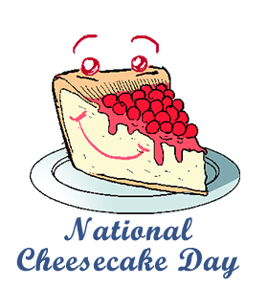 JULY 30TH!
National Cheesecake Day is observed annually on July 30.
It is celebrated across the United States as a dedicated day to indulge in the rich, creamy treat. If you want to celebrate, you can usually check out deals at major chains; for instance, The Cheesecake Factory traditionally celebrates by offering rewards members half-price slices.



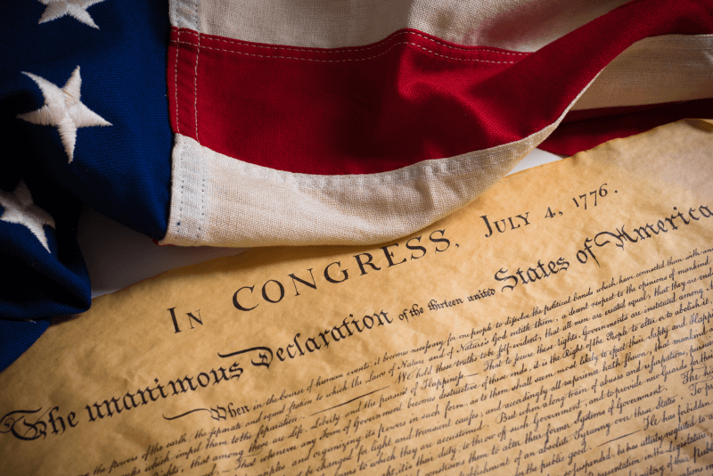

The Fourth of July—also known as Independence Day or July 4th—celebrates the birth of American independence from the British Empire. On July 2, 1776, the Continental Congress voted in favor of independence, and two days later delegates from the 13 colonies adopted the Declaration of Independence.
Designated as a federal holiday across the United States in 1938, Independence Day celebrations have existed as far back as the 18th century and even the American Revolution. Festivities range from fireworks, parades and concerts to more casual family gatherings and barbecues.
Fourth of July History
When the initial battles in the Revolutionary War broke out in April 1775, few colonists desired complete independence from Great Britain. Those who did were considered radical. By the middle of the following year, however, many more colonists had come to favor independence, thanks to growing hostility against Britain and the spread of revolutionary sentiments such as those expressed in the bestselling pamphlet “Common Sense,” published by Thomas Paine in early 1776.
On June 7, when the Second Continental Congress met at the Pennsylvania State House (later Independence Hall) in Philadelphia, the Virginia delegate Richard Henry Lee introduced a motion calling for the colonies’ independence. Amid heated debate, the Congress postponed the vote on Lee’s resolution but appointed a five-man committee—including Thomas Jefferson of Virginia, John Adams of Massachusetts, Roger Sherman of Connecticut, Benjamin Franklin of Pennsylvania and Robert R. Livingston of New York—to draft a formal statement justifying the break with Great Britain.
On July 2, the Continental Congress approved Lee’s resolution for independence in a near-unanimous vote (the New York delegation abstained but later voted affirmatively). The following day, John Adams wrote to his wife, Abigail, that July 2 “will be celebrated, by succeeding Generations, as the great anniversary Festival” and that the celebration should include “Pomp and Parade…Games, Sports, Guns, Bells, Bonfires and Illuminations from one End of this Continent to the other.”
On July 4, the Continental Congress formally adopted the Declaration of Independence, which Jefferson largely wrote. Although the vote for actual independence took place on July 2, from then on the Fourth of July became the day that was celebrated as the start of American independence.
Did you know?
John Adams believed July 2 was the correct date on which to celebrate the birth of American independence and reportedly turned down invitations to appear at July 4th events in protest. Adams and Thomas Jefferson both died on July 4, 1826—the 50th anniversary of the adoption of the Declaration of Independence.

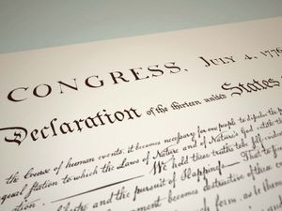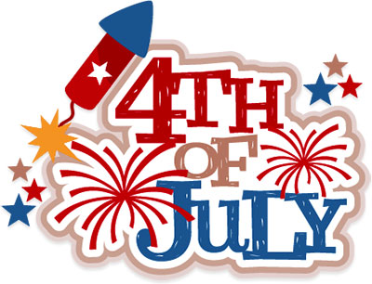

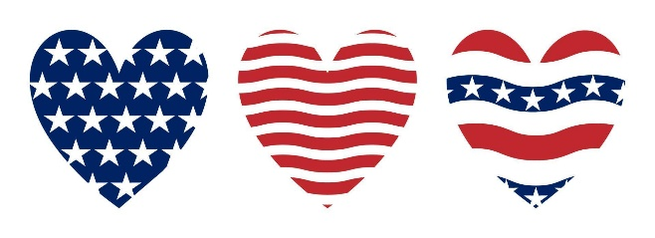



Hard to believe it is July already, summer is flying by!! As you are getting ready to celebrate Independence Day, please remember to be safe at all times. If you are planning to light fireworks, I would like to share a few reminders and safety tips with you; you are allowed to light fireworks:

June 27th – July 3rd - Between the hours of 10:00 AM and 10:00 PM
July 4th - Between the hours of 10:00 AM and 12:00 AM
July 5th – Between the hours of 10:00 AM and 5:00 PM

Lighting fireworks in the street, alley or public property is prohibited, keep a fire extinguisher or a water hose close by.
We want all of our citizens to enjoy the beautiful fireworks without the danger that could follow. Please keep in mind, anything that shoots up in the air can be potentially hazardous for your nearby neighbors, think before you light!!
Please remember to dispose any firework that has been discharged, the city is not responsible in cleaning left over debris.

Have A Very Safe And Happy 4TH Of July!!!!


LOCAL NEWS

- Are you in need of grocery delivery service? Call 620-228-5570 for more information on this new service.

- Don’t forget, we have a community food box in front of City Hall…. Take what you need, leave what you can.

- 2026 City Dog Tags available for purchase. Neutered or spayed is $8.00, intact is $9.50. Failure to purchase your city dog tag could result in a possibility of receiving a notice to appear in La Harpe municipal court which will add an $80.00 court cost fee on top of the dog tag purchase.

- 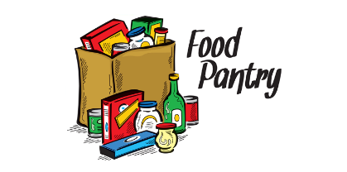 Food pantry available to the La Harpe community on the 3rd Friday of each month! Address for pickup is the Light of La Harpe Church – 901 S. Main and pickup start at 4:00pm. Any questions on the food pantry, please call 620-228-3069.

If you need assistance after-hours please call the Iola Dispatch Center at (620) 365-1437, they will notify the proper personnel.
 HAPPY BIRTHDAY TO ALL LAHARPE CITIZENS CELEBRATING A BIRTHDAY THIS MONTH!!!! MAY YOUR DAY BE AS SPECIAL AS YOU ARE TO US!

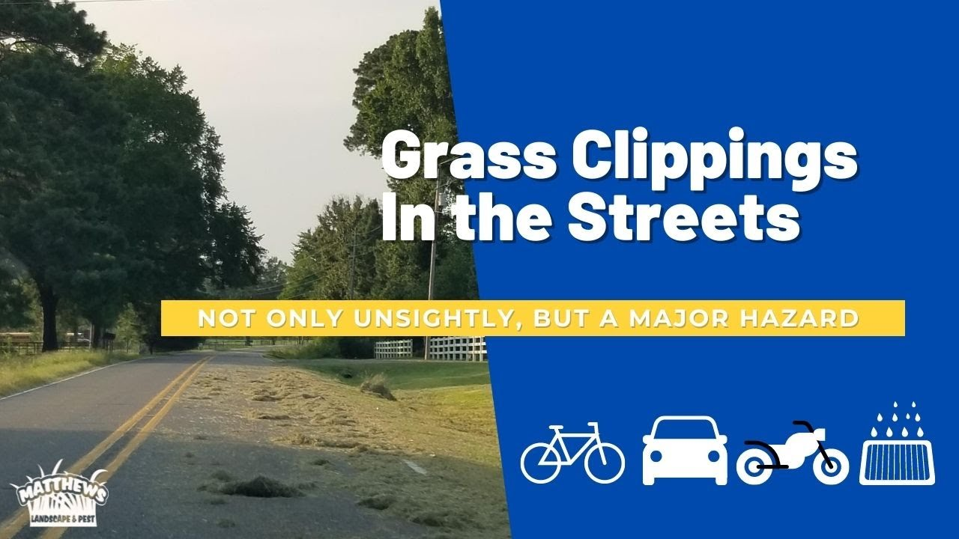

TO ALL CITIZENS IN LA HARPE
It is in the city ordinance that you are not to blow your grass in the street. If you happen to get grass in the street, I’m asking you to blow or sweep the grass back into your yard or you will receive a Notice to Appear in Court. That will be an $80.00 court cost and whatever the Judge fines you. Please don’t blow grass in the street when you mow or at any time.
If you have any questions, please contact us by phone (620) 496-2241 here at City Hall.

Sincerely,
Animal and Code Officer

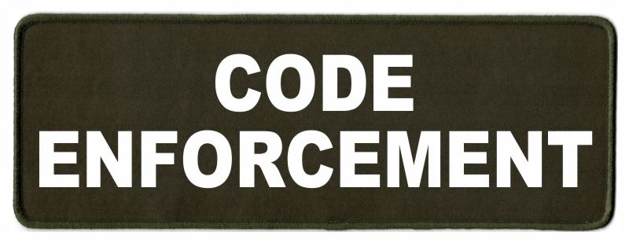
Note from the La Harpe Code Officer:
To whom it may concern,
I would like to share a friendly reminder to the La Harpe citizens;
- Vehicles parked in yards must have active registration and insurance and kept neatly maintained.
- Stock cars must be on a trailer or covered up.
- Roofs & windows must be intact and not covered with tarps, boards or like materials.
- Broken appliances and or furniture do not belong outdoors.
- Brush piles must be maintained; a burn permit can be obtained by calling city hall at 620-365-5956.
- Grass clippings, in street, will not be tolerated. If you do get grass in the street, please use your mower or broom to get it out of street. If seen intentionally blowing grass in street a notice to appear in La Harpe Municipal court will be issued.
- Grass can not be any taller than 12 inches anywhere on property, maintaining the ditch is on the homeowner. If you are wanting to hay your property, you must have 1 acre to hay and a hay permit needs to be approved by April 1st.
- If you have a dead tree near the city powerlines, and the tree falls over and does damage to the city powerlines, you will be charged for the damage.
- Trash belongs in a dumpster or at the Allen County landfill not in your yard.
- Dog pens need to be cleaned at least once a week and have clean water every day, and adequate shelter.

I will be sending out letters if your property is not in compliance with the La Harpe city code, if you have any issues with the La Harpe city code, please attend your regular council meeting held the 2nd Wednesday of every month at 7:00pm at city hall to discuss a resolution to your code violation. If the request to have your property in compliance with the La Harpe city code is not met by the time stated in your letter, a notice to appear in the La Harpe Municipal court will be issued.
A copy of the ordinance, in its entirety, can be viewed at www.cityoflaharpe.org
Dates to remember:

 July 3rd: City office closed. Have a safe and happy 4th of July!!

 July 8th: Council Meeting at City Hall at 7:00 pm

 July 18th: Gun show at city hall

 July 20th: PRIDE Meeting at 7:00 p.m. at the City Hall

 July 28th: Past due Utility shut off date.

CITY COUNCIL NEWS
CITIZENS CALL FOR BUSINESS
- Rachel Anderson – No appearance.

- Carey Dean asked when the city will be getting police coverage. Scott Kroenke asked Carey what the concerns were that we need law enforcement other than the Allen County sheriff department. Carey stated, they won’t enforce city ordinances, we need someone over here that will make people slow down and stop running stop signs. Rick Noyes mentioned he seen a city employee run a stop sign. Scott thanked her for expressing her concerns and stated this will change my mind set about the issue. Jacob Manbeck explained to the council; the sheriff department really can’t do anything if they don’t actually see it.

UNFINISHED BUSINESS
- Jack Whiting update – This item was tabled to the special meeting on June 30, 2026 at 6:00pm.

- Dump Truck – Tabled.

- After hour call out policy – Cynthia Carr asked who do we call for after hour issues. Scott Kroenke suggested the city educate the employees we have, a CDL is required, the council needs to offer training and the employees need to do their jobs. We are setting up for failure by not protecting our infrastructure. Mayor Lee stated, the city can offer training and if they refuse, we’ll look for other employees. Scott asked the council permission to clean-up the job description and share with you and then sit down with each city employee to go over the expectation of their job.

- Compensatory Time Versus Overtime – No action taken.
- Utility Poles & Anchors – Scott Kroenke made the motion to purchase anchors from Border States and poles from Stella Jones in the quantity specified. Ron Knavel seconded. Motion carried 5-0.

- Street Maintenance Plan – Scott shared he had no update from county and will probably approach the county commissioners to see what we can get done to work out a plan. Scott also shared a piece of equipment he was looking into to help with the ditch work. This topic will be on the July agenda.

- Neighborhood Revitalization Plan – NRP’s for Iola and La Harpe was shared with the council. Cynthia Carr suggested leave La Harpe’s as is and review it in 2027. Council agreed.

NEW BUSINESS
a) 410 S. McKinley – Scott Kroenke made the motion to send the owner a letter that construction needs to be started within 9 months and completed in 14 months or the city will enforce option #8 of the contract. Angela Barker seconded. Motion carried 5-0.

b) Sheriff Tax Sale – No action taken.

c) Lagoon Contract for City of Gas & County – Council requested the mayor meet with the Gas city mayor and have a conversation about maintenance of the lagoons and report back. Nothing was discussed about meeting with the county.

d) Speed Bump – No action was taken.

e) Wastewater Contract Operator – Scott Kroenke made the motion to hire Joe Stotler as the city’s wastewater contract operator effective June 10, 2026. Ron Knavel seconded. Motion carried 5-0.

f) Carr Security Light – Cynthia suggested the city use the security light as extra lighting on Main Street because she was no longer needing it. Ron Knavel made the motion to turn light towards main street. Scott Kroenke seconded. Motion carried 4-0 Cynthia Carr abstained.

g) Bleachers – Angela Barker shared a post of bleachers advertised by the city of Lyndon and if interested to submit a letter of intent. Scott Kroenke made the motion to write the letter for 4 sets of bleachers. Angela Barker seconded. Motion carried 5-0.

REPORTS OF CITY OFFICERS
- Jacob Manbeck, City Attorney – Nothing to report.

- Roy Caler, Water Representative – Nothing to report.

- Penny Miller, Code/Animal Control –shared reports. City clerk, Michelle Altis, asked the attorney about a resolution that was passed and published and is scheduled for a condemning hearing at the end of this month after the sheriff tax sale, is there anything the city needs to do differently. Jacob suggested, at the hearing, if it sales just make note the property was purchased and now has new owners.

- Marc Waggoner, Fire Chief- Shared the meeting minutes: Present: Marc Waggoner Sr., Matthew Waggoner, Kiefer Endicott, Josh Sparks, Meghan Sparks, Bill Gay, Marc Waggoner Jr., Pamela Waggoner, and Dennis Sidebottom. Absent were Jason Teeple, Dillon Brownback, and Justin Pritchard. Started meeting, took out took out fire trucks and flushed out 2 whistles which need replaced at 6th & Monroe and 10th Street between Jefferson & Harrison, then ended meeting. On another note, spoke with Ron Knavel wanted to bring to the council’s attention, think we should keep storm shelters open between April until September for liability stakes. The council discussed the storm shelters and thought it be best and safer to keep them locked and council can unlock when issued a storm watch. Angela Barker stated we need 3 more keys made for myself, Cyndi Maley and possibly mayor Lee.

- Maintenance Department - The workorders were shared. Transit and tilt blade were tabled. Bids were shared to repair old tamper or purchase new one. Scott Kroenke made the motion to purchase the Greenlee tamper in the amount of $2,515.00 and do not repair current tamper, try to sale as is. Cyndi Maley seconded. Motion carried 5-0. Michelle shared an invoice from JCI for trouble shooting two lift stations and asked if it was to be paid from the sewer fund or the sewer project fund. Council agreed to pay out of sewer fund.

- Michelle Altis, City Clerk – Shared a quote for a pump for lift station #5 and stated right now it is running on one pump and Wesley, with BG Consultants, is looking for a spare pump we can borrow until the sewer project gets started. Michelle mentioned the auditors were working on the city’s budget and was wondering if there are any large expenses coming up in 2026 or 2027. Cynthia suggested send them what they are needing and when it’s time for the budget discussion we may know more. Michelle reminded the council of the 4th of July coming up and we need to do something to make sure all are following the city ordinances pertaining to shooting fire works from June 27th until July 5th. Michelle stated, back in March, Joe Stotlker reached out to the mayor offering patrol on a parttime basis and suggested this would be a good time to look into that offer.

DISCUSSION ON AGENDA ITEMS –
Mayor Lee asked for a motion to go into executive session on non-elected personnel for 20 minutes with Michelle Altis invited. Scott Kroenke made the motion to go into executive session on non-elected personnel for 20 minutes with Michelle Altis invited. Ron Knavel seconded. Motion carried 5-0. Angela Barker made the motion to stay in executive session for another 20 minutes. Scott Kroenke seconded. Motion carried 5-0. Scott Kroenke made the motion to return to regular session. Cyndi Maley seconded. Motion carried 5-0. Scott Kroenke made the motion that write-ups will fall off after 6 months. Ron Knavel seconded. Motion carried 5-0. Angela Barker made the motion to pay Jacob Manbeck $1,000.00 for the June meeting. Cyndi Maley seconded. Motion carried 5-0.


Mayor: Harry Lee Jr. 620-496-7000
City Attorney: Jacob Manbeck
City Municipal Judge: Patty Miklos
Police Chief:
Fire Chief: Marc Waggoner
Assistant Fire Chief: Dennis Sidebottom
City Clerk: Michelle Altis
Assistant Clerk: Teresa Driskel
City Treasurer: Teresa Driskel
Maintenance Staff: Larry Laird & Keith Knavel
Code & Animal Control: Penny Miller
City Council Members:
Angela Barker (620-224-6209) Ron Knavel (620-496-2508)
Cyndi Maley (620-380-6600) Cynthia Carr (620-496-7500)
Scott Kroenke (915-205-0735)
La Harpe City Hall Hours: Monday-Friday
902 S. Washington 8:00-12:00 & 1:00-5:00
P.O. Box 10 Ph. (620) 365-5956
La Harpe, KS. 66751 Fax (620) 365-3944

CHECK OUT OUR WEBSITE; CITYOFLAHARPE.ORG  Follow us on FacebookACON AND E CHESY BAC AND EGG HASH

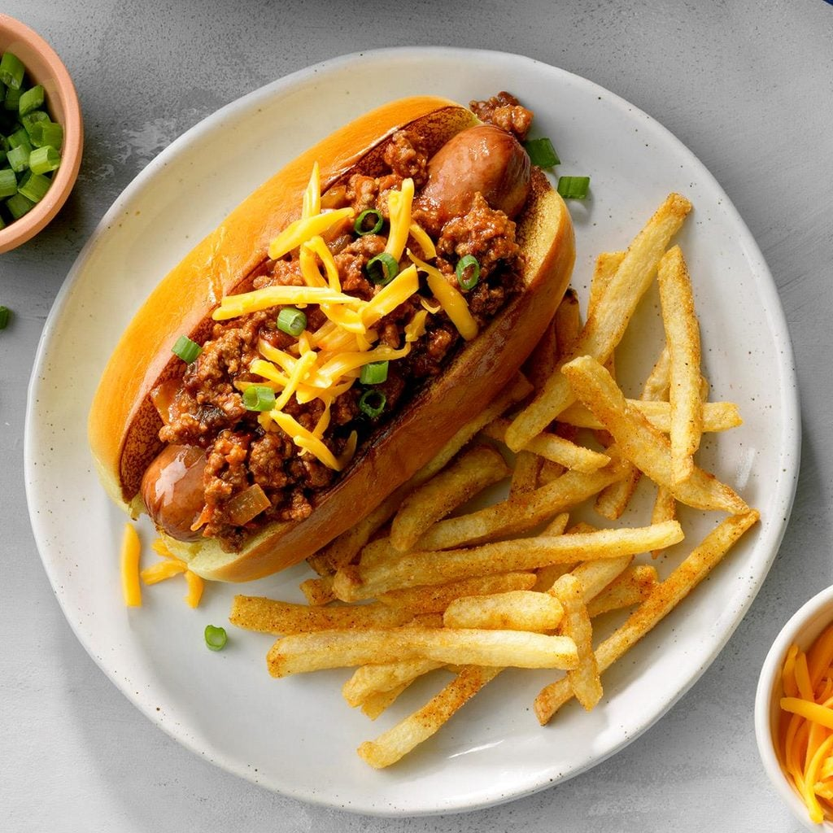

Chipotle Chili Dogs

Ingredients

6 hot dogs

1/2 pound ground beef

1/4 cup chopped onion

1 garlic clove, minced

1 can (8 ounces) tomato sauce

2-1/2 teaspoons minced chipotle peppers in adobo sauce

3/4 teaspoon chili powder

1/4 teaspoon salt

1/8 teaspoon pepper

6 hot dog buns, split

3/4 cup shredded cheddar cheese

2 green onions, chopped

Directions

Cook hot dogs according to package directions. Meanwhile, in a large cast-iron or other heavy skillet, cook the beef, onion and garlic over medium heat until meat is no longer pink; drain. Stir in the tomato sauce, chipotle peppers, chili powder, salt and pepper. Bring to a boil. Reduce heat; simmer, uncovered, until flavors are blended, 4-5 minutes.

Place hot dogs in buns. Spoon chili over hot dogs. Sprinkle with cheese and green onions.

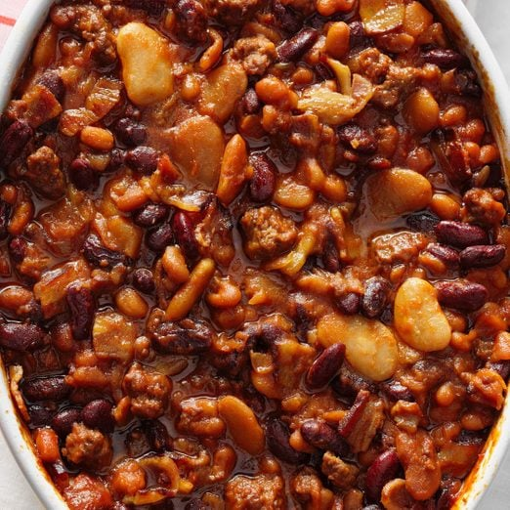

Three-Bean Baked Beans

Ingredients

1/2-pound ground beef
5 bacon strips, diced
1/2 cup chopped onion
1/3 cup packed brown sugar
1/4 cup sugar
1/4 cup ketchup
1/4 cup barbecue sauce
2 tablespoons molasses
2 tablespoons prepared mustard
1/2 teaspoon chili powder
1/2 teaspoon salt
2 cans (15 ounces each) pork and beans, undrained
1 can (16 ounces) butter beans, rinsed and drained
1 can (16 ounces) kidney beans, rinsed and drained

Directions
- Preheat oven to 350°. In a large skillet, cook and crumble beef with bacon and onion over medium heat until beef is no longer pink; drain.

- Stir in sugars, ketchup, barbecue sauce, molasses, mustard, chili powder and salt until blended. Stir in beans. Transfer to a greased 2-1/2-qt. baking dish. Bake, covered, 1 hour or until beans reach desired thickness.

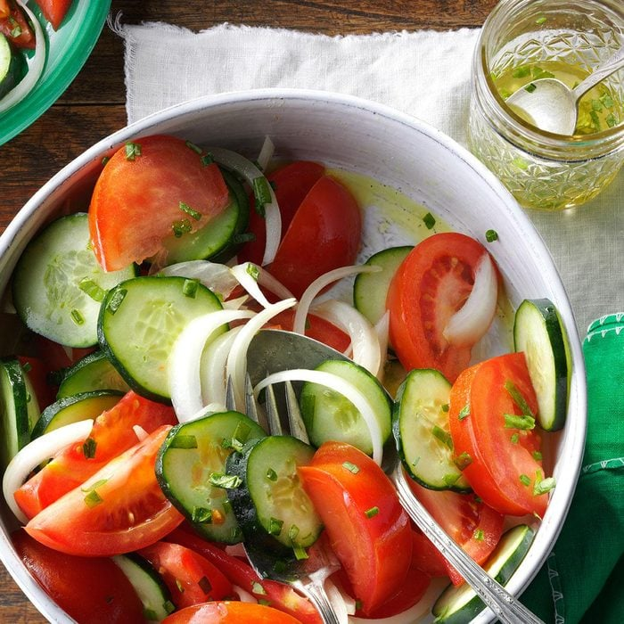
Garden Tomato Salad

Ingredients
- 3 large tomatoes, cut into wedges
- 1 large sweet onion, cut into thin wedges
- 1 large cucumber, sliced

- DRESSING:
- 1/4 cup olive oil
- 2 tablespoons cider vinegar
- 1 garlic clove, minced
- 1 teaspoon minced fresh basil
- 1 teaspoon minced chives
- 1/2 teaspoon salt

Directions
- In a large bowl, combine tomatoes, onion and cucumber. In a small bowl, whisk dressing ingredients until blended. Drizzle over salad; gently toss to coat. Serve immediately.


Coconut-Lemon Ice Cream Cake
Ingredients
- 1 package (11.2 ounces) shortbread cookies
- 1/2 cup sweetened shredded coconut, toasted
- 1/4 cup macadamia nuts, coarsely chopped and toasted
- 1 teaspoon grated lemon zest
- 1 can (15 ounces) cream of coconut
- 1/2 cup lemon juice
- 1-1/2 quarts vanilla ice cream, softened
- 1 carton (8 ounces) frozen whipped topping, thawed, divided
- Optional: Fresh blueberries, raspberries and strawberries

Directions
- Reserve 10 cookies for decoration. Crush remaining cookies; transfer to a bowl. Stir in coconut, macadamia nuts and lemon zest. Reserve 2 tablespoons crumb mixture for topping. In a large bowl, whisk cream of coconut and lemon juice until combined. Stir in softened ice cream until smooth. Fold in 1 cup whipped topping.
- Sprinkle 1 cup crumb mixture onto bottom of a greased 9-in. springform pan. Top with half the ice cream mixture. Layer with remaining crumbs and ice cream mixture. Place reserved whole cookies around edge of pan. Top with remaining 2-1/2 cups whipped topping; sprinkle with reserved 2 tablespoons crumb mixture. Freeze, covered, until firm, at least 8 hours or overnight. If desired, serve with berries.







