SEPTEMBER NEWSLETTER

Observed the first Monday in September, Labor Day is an annual celebration of the social and economic achievements of American workers. The holiday is rooted in the late nineteenth century, when labor activists pushed for a federal holiday to recognize the many contributions workers have made to America’s strength, prosperity, and well-being.

Before it was a federal holiday, Labor Day was recognized by labor activists and individual states. After municipal ordinances were passed in 1885 and 1886, a movement developed to secure state legislation. New York was the first state to introduce a bill, but Oregon was the first to pass a law recognizing Labor Day, on February 21, 1887. During 1887, four more states – Colorado, Massachusetts, New Jersey and New York – passed laws creating a Labor Day holiday. By the end of the decade Connecticut, Nebraska and Pennsylvania had followed suit. By 1894, 23 more states had adopted the holiday, and on June 28, 1894, Congress passed an act making the first Monday in September of each year a legal holiday.
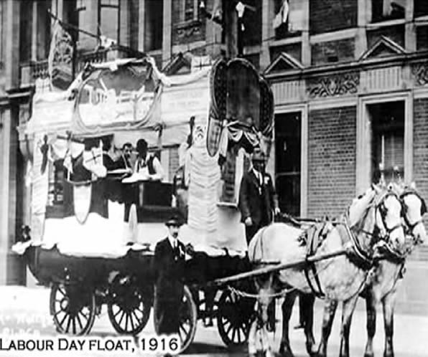
Who first proposed the holiday for workers? It’s not entirely clear, but two workers can make a solid claim to the Founder of Labor Day title.
Some records show that in 1882, Peter J. McGuire, general secretary of the Brotherhood of Carpenters and Joiners and a co-founder of the American Federation of Labor, suggested setting aside a day for a "general holiday for the laboring classes" to honor those "who from rude nature have delved and carved all the grandeur we behold."
But Peter McGuire's place in Labor Day history has not gone unchallenged. Many believe that machinist Matthew Maguire, not Peter McGuire, founded the holiday.
Recent research seems to support the contention that Matthew Maguire, later the secretary of Local 344 of the International Association of Machinists in Paterson, New Jersey, proposed the holiday in 1882 while serving as secretary of the Central Labor Union in New York.
According to the New Jersey Historical Society, after President Cleveland signed the law creating a national Labor Day, the Paterson Morning Call published an opinion piece stating that "the souvenir pen should go to Alderman Matthew Maguire of this city, who is the undisputed author of Labor Day as a holiday." Both Maguire and McGuire attended the country’s first Labor Day parade in New York City that year.
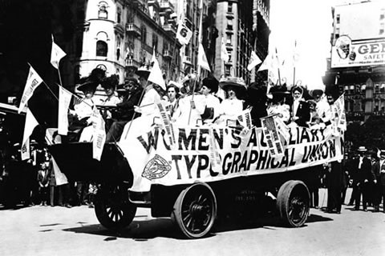 The first Labor Day holiday was celebrated on Tuesday, September 5, 1882, in New York City, in accordance with the plans of the Central Labor Union. The Central Labor Union held its second Labor Day holiday just a year later, on September 5, 1883.
By 1894, 23 more states had adopted the holiday, and on June 28, 1894, President Grover Cleveland signed a law making the first Monday in September of each year a national holiday.
Many Americans celebrate Labor Day with parades, picnics and parties – festivities very similar to those outlined by the first proposal for a holiday, which suggested that the day should be observed with – a street parade to exhibit "the strength and esprit de corps of the trade and labor organizations" of the community, followed by a festival for the recreation and amusement of the workers and their families. This became the pattern for the celebrations of Labor Day.
Speeches by prominent men and women were introduced later, as more emphasis was placed upon the economic and civic significance of the holiday. Still later, by a resolution of the American Federation of Labor convention of 1909, the Sunday preceding Labor Day was adopted as Labor Sunday and dedicated to the spiritual and educational aspects of the labor movement.
American labor has raised the nation’s standard of living and contributed to the greatest production the world has ever known and the labor movement has brought us closer to the realization of our traditional ideals of economic and political democracy. It is appropriate, therefore, that the nation pays tribute on Labor Day to the creator of so much of the nation's strength, freedom, and leadership – the American worker.

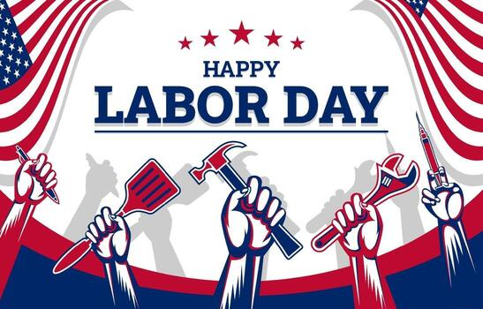


In the United States, Patriot Day occurs on September 11 of each year in memory of the victims killed in the September 11 terrorist attacks in 2001. In the immediate aftermath of the attacks, carried out by terrorists from Al-Qaeda, President George W. Bush proclaimed Friday, September 14, 2001, as a National Day of Prayer and Remembrance for the Victims of the Terrorist Attacks on September 11, 2001.^{[1]}
A bill to make September 11 a National Day of Mourning was introduced in the U.S. House on October 25, 2001, by Rep. Vito Fossella (R-NY) with 22 co-sponsors. The result was the resolution to proclaim September 11, 2002, as the first Patriot Day.
The flag of the United States is flown at half-mast at the White House and on all U.S. government buildings and establishments throughout the world;^{[24]} Americans are also encouraged to display flags in and outside their homes. Additionally, a moment of silence is observed to correspond with the attacks, beginning at 8:46 a.m. (Eastern Daylight Time), the time the first plane, American Airlines Flight 11, struck the North Tower of the World Trade Center on September 11, 2001.

 We celebrate Grandparents Day each September on the first Sunday after Labor Day, usually the second Sunday of the month.
National Grandparents Day originated largely through the efforts of Marian Lucille Herndon McQuade of West Virginia, a dedicated advocate for the elderly. Beginning in the early 1970s, Marian McQuade advocated for a formal Grandparents Day, encouraging people to “adopt a grandparent” and celebrating senior citizens’ wisdom and contributions to society.
Some anecdotal accounts also credit Michael Goldgar of Atlanta with advocating for his aunt in a nursing home. He allegedly spent about $11,000 of his own money and traveled multiple times to Washington to promote the idea of officially recognizing National Grandparents Day.
In 1978, President Jimmy Carter issued Proclamation 4580, designating Sunday, September 10 as National Grandparents Day for that year.
The following year, President Carter established the observance as recurring annually on the first Sunday after Labor Day, with the first such observance occurring on September 9, 1979.
Since then, it has become customary for each President to issue an annual proclamation every year designating that day and calling on Americans to observe it with “appropriate ceremonies and activities,” in line with the statute.



Welcome, fall! The autumnal equinox—also called the September equinox or the fall equinox—arrives on Tuesday, September 22. Not only do temperatures drop, but plant life slows down, and so do we. Read about the first day of fall, plus some fun facts and folklore.
When Is the First Day of Fall 2026?
The fall equinox and the first day of autumn arrive on Tuesday, September 22, 2026, at 8:04 P.M. EDT in the Northern Hemisphere. The equinox occurs at the same moment worldwide.

What Is the Autumnal Equinox?
The autumnal equinox is an astronomical event that marks the start of autumn (or fall). In the Northern Hemisphere, the autumnal equinox occurs in September; in the Southern Hemisphere, it occurs in March.

What Is an Equinox?
During an equinox, the Sun crosses what we call the “celestial equator”—an imaginary extension of Earth’s equator line into space. The equinox occurs precisely when the Sun’s center passes through this line.
For those in the Northern Hemisphere, when the Sun crosses the equator going from north to south, this marks the autumnal equinox; when it crosses from south to north, this marks the vernal equinox. In the Southern Hemisphere, it’s the reverse.
After the autumnal equinox, days become shorter than nights as the Sun continues to rise later and nightfall arrives earlier. This ends with the winter solstice, after which days start to grow longer once again.
The word “equinox” comes from the Latin aequus, meaning “equal,” and nox, “night.” On the equinox, day and night are roughly equal in length.

LOCAL NEWS
- Are you in need of grocery delivery service? Call 620-228-5570 for more information on this new service.

- Don’t forget, we have a community food box in front of City Hall…. Take what you need, leave what you can.

- 2026 City Dog Tags available for purchase. Neutered or spayed is $10.00, intact is $11.50. Failure to purchase your city dog tag could result in a possibility of receiving a notice to appear in La Harpe municipal court which will add an $80.00 court cost fee on top of the dog tag purchase.

-  Food pantry available to the La Harpe community on the 3rd Friday of each month! Address for pickup is the Light of La Harpe Church – 901 S. Main and pickup start at 4:00pm. Any questions on the food pantry, please call 620-228-3069.

If you need assistance after-hours please call the Iola Dispatch Center at (620) 365-1437, they will notify the proper personnel.
 HAPPY BIRTHDAY TO ALL LAHARPE CITIZENS CELEBRATING A BIRTHDAY THIS MONTH!!!! MAY YOUR DAY BE AS SPECIAL AS YOU ARE TO US!

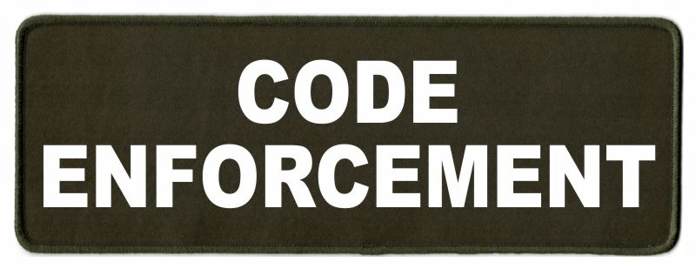
Note from the La Harpe Code Officer:
To whom it may concern,
I would like to share a friendly reminder to the La Harpe citizens;
- Vehicles parked in yards must have active registration and insurance and kept neatly maintained.
- Stock cars must be on a trailer or covered up.
- Roofs & windows must be intact and not covered with tarps, boards or like materials.
- Broken appliances and or furniture do not belong outdoors.
- Brush piles must be maintained; a burn permit can be obtained by calling city hall at 620-365-5956.
- Grass clippings, in street, will not be tolerated. If you do get grass in the street, please use your mower or broom to get it out of street. If seen intentionally blowing grass in street a notice to appear in La Harpe Municipal court will be issued.
- Grass can not be any taller than 12 inches anywhere on property, maintaining the ditch is on the homeowner. If you are wanting to hay your property, you must have 1 acre to hay and a hay permit needs to be approved by April 1st.
- If you have a dead tree near the city powerlines, and the tree falls over and does damage to the city powerlines, you will be charged for the damage.
- Trash belongs in a dumpster or at the Allen County landfill not in your yard.
- Dog pens need to be cleaned at least once a week and have clean water every day, and adequate shelter.

I will be sending out letters if your property is not in compliance with the La Harpe city code, if you have any issues with the La Harpe city code, please attend your regular council meeting held the 2nd Wednesday of every month at 7:00pm at city hall to discuss a resolution to your code violation. If the request to have your property in compliance with the La Harpe city code is not met by the time stated in your letter, a notice to appear in the La Harpe Municipal court will be issued.
A copy of the ordinance, in its entirety, can be viewed at www.cityoflaharpe.org

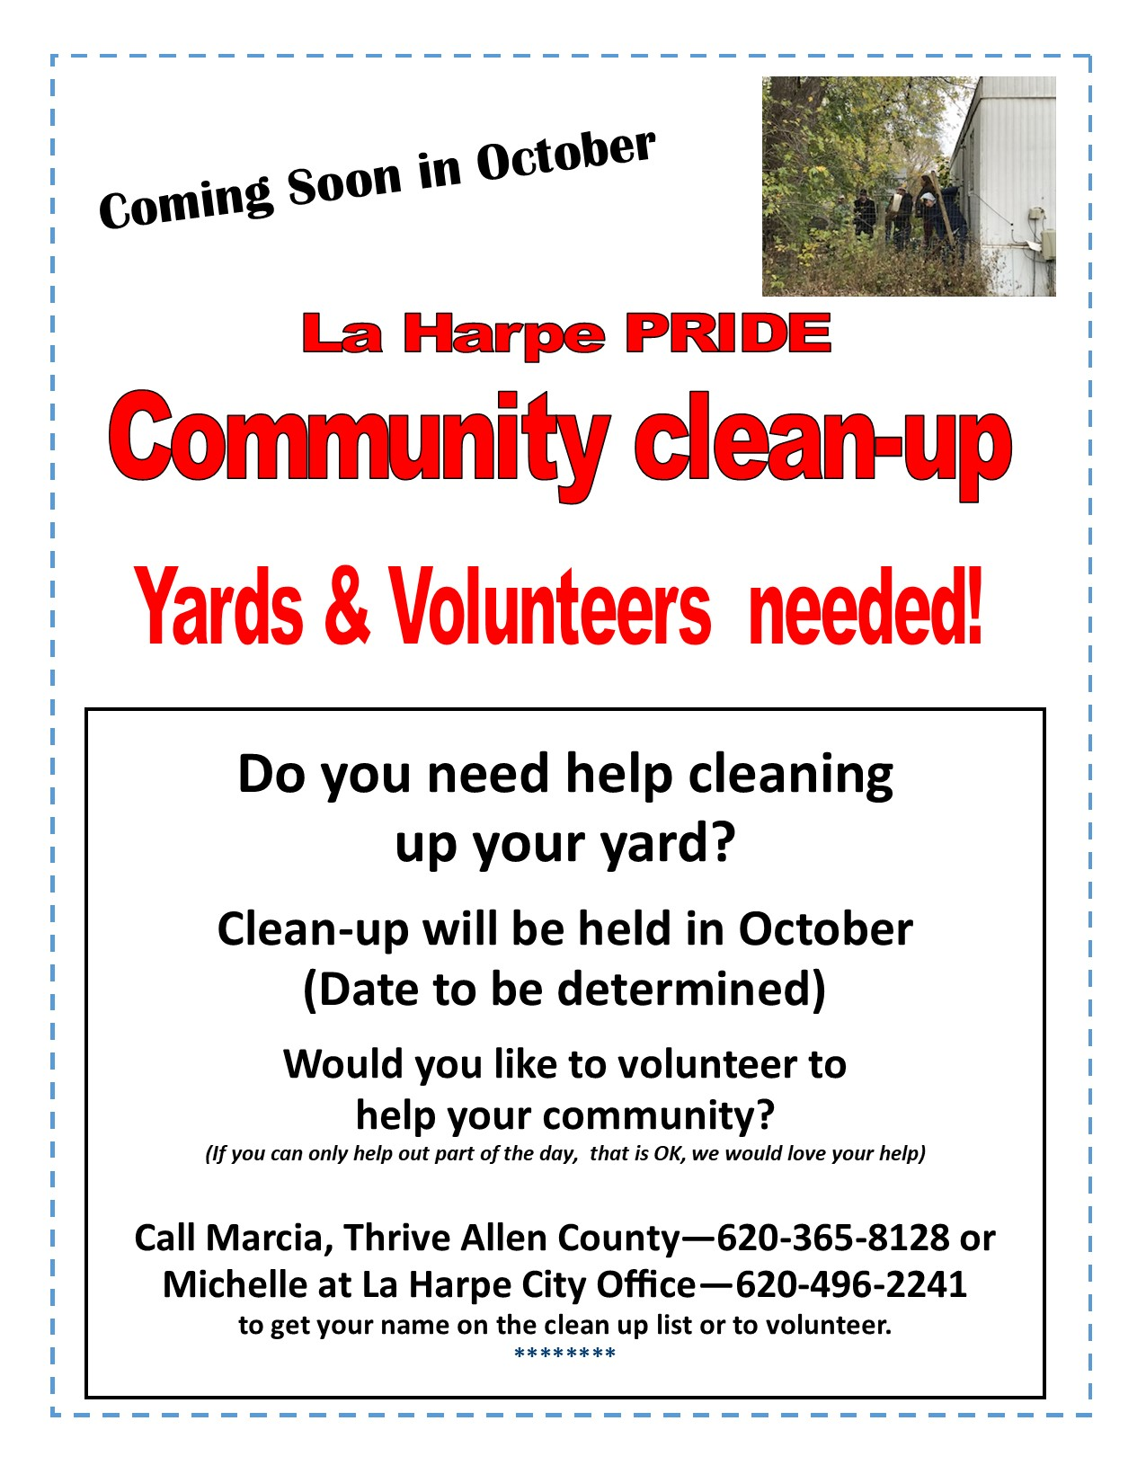

Dates to remember:

 September 7th: City Hall closed in observance of Labor Day
 September 9th: Council Meeting at City Hall at 7:00 pm

 September 21st: PRIDE Meeting at 7:00 p.m. at the City Hall

 September 25th: Past due Utility shut off date.

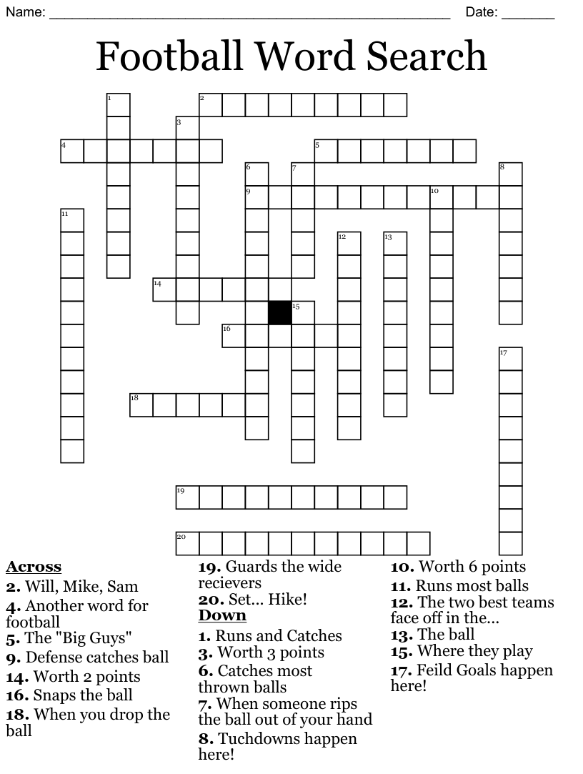

CITY COUNCIL NEWS
2027 BUDGET HEARING
Mayor Lee opened the budget hearing for public comment. No comments from the public in attendance. Council member, Cynthia Carr stated, the city did not exceed the revenue neutral rate which means the mill levy will remain close to the same as the previous year. Cynthia Carrl requested a motion to adopt the budget as proposed. Ron Knavel voted yes, Angela Barker voted yes, Cyndi Maley voted yes, Scott Kroenke voted yes, and Cynthia Carr voted yes.
Cynthia Carr requested a motion to close the hearing. Cyndi Maley made the motion to close the public hearing. Ron Knavel seconded. Motion carried 5-0.

CITIZENS CALL FOR BUSINESS
- Richard Luken – La Harpe Pride, shared concerns over the Pride committee; stating the last few meetings only 3 citizens have attended; Harry & Joyce Lee and myself. Richard is sending an appeal to the community for more involvement; La Harpe Pride does a lot for the community with the annual clean-up, Easter celebration, Christmas celebration, and we just don’t have enough hands to continue to make this happen, and fear that La Harpe Pride will just run its course until nothing left. Richard asked the council to reach out to the community about being a La Harpe Pride member and joining a group that wants to see La Harpe better. Richard reminded; the next Pride meeting is @ 7pm at city hall and the public is invited. City Clerk, Michelle Altis, aske Richard when the fall clean-up will take place. Richard stated he would have to get in touch with K-State and Nelsons to figure out everyone’s schedules.

UNFINISHED BUSINESS
- Variance Application – Whiting: Scott Kroenke made the motion to accept the variance application as written. Ron Knavel seconded. Motion carried 4-1 with Angela Barker opposing.

- Demo Bid – 309 E. 10th: A bid for demo, clearing property and removing vehicle was shared from Ray’s Metal Depot in the amount of $2,500.00. Cynthia Carr made the motion to accept the bid. Ron Knavel seconded. Scott Kroenke was fine with demo on the structure but suggested the city wait for legal counsel on removing the vehicle, council agreed. Motion carried 5-0.

- Water Tower: Tabled to September 9, 2026.

NEW BUSINESS
a) City Hall: Mayor Lee expressed concerns over the thermostat settings in city hall, stating the city could save about 5% on utilities if they were set at a certain temperature. Council agreed to set thermostats at 75 degrees and monitor it from there.

b) Council utility bills/payroll: Mayor Lee shared, the city could save money if council members would pick up their utility bills and paychecks, or you also have the option of having your utility bill emailed to you. He asked the council to think about it and let the city clerk know.

c) Fitness Center – Utilities/Membership: Tabled to September 9, 2026.

d) Mayor report: Mayor Lee shared; the tank water is not working properly causing unnecessary call-outs at a rate of time and a half. It doesn’t pay for itself and not making money, what would the council like to do. Cynthia Carr suggested looking into a new coin mechanism. Ron Knavel suggested a credit card machine. Michelle stated, in the past we have put up a sign reading: Use at your own risk, no call-outs after hours. Law enforcement – mayor Lee stated Joe Stotler submitted a letter of intent. Council requested this item be added to the executive session. Mayor Lee shared that the only council member that was elected was Ron Knavel, the others have been appointed to fill vacancies. Mayor Lee stated that Gateway has been billed for past occurrences and that has been paid in full and Gas city has received their bill for 50% of the lagoon maintenance, but no payment has been made. Hopefully both items will bring revenue to the city. Citizen, Phil Ebert, submitted a letter concerned about health issues and one of those issues was the mosquito spraying. Scott Kroenke mentioned, he had been doing research on this and spraying is not primary means of getting rid of mosquitos; need to figure out where the breeding areas are, remove standing water and fix drainage. The swimming pools and water bowls for animals need to be cleaned out on a daily basis, it’s not the city’s responsibility for mosquito control, it’s the whole towns responsibility to clean around their properties and get rid of the standing water. Mayor Lee asked if there was a motion to begin spraying again. Scott Kroenke made the motion to buy 12 gallons of BioMist from Van Diest to get us by until next meeting so that we can do some more research. Ron Knavel seconded. Scott shared that the CDC and EPA are using a repellant called naled, he also suggested reaching out to Iola to see what they use. Motion carried 4-1 with Cyndi Maley opposing.

e) Employee Safety during excessive heat: Ron Knavel suggested the employees do something besides mowing in the afternoon to stay cool, I want to make sure our employees are staying safe in the heat. Larry Laird mentioned that he and Keith take breaks throughout the day as needed. Scott Kroenke recommended the maintenance staff work from 6:00am – 3:00pm until the next council meeting and we can see what the weather is doing then. Scott made the motion to have one employee work from 6:00am to 3:00pm and the other work from 8:00am to 5:00pm, so that the city has someone here for business hours, until the September 9th council meeting which we can reevaluate then. Ron Knavel seconded. Motion carried 5-0.

f) Mosquitos: Discussed earlier.

g) Road Maintenance: Scott shared that he has not heard anything from county and is looking at 3 different options; 1) write a letter to the county commissioners. 2) take said letter to a county commissioners meeting, and 3) call Bettis for a quote. Angela Barker suggested he attend a commissioners meeting. Cynthia Carr stated that Moran was getting ready to do chip seal.

REPORTS OF CITY OFFICERS
- Jacob Manbeck, City Attorney – Absent from meeting but shared his contract for services. Council requested this item be moved to the end of meeting under the executive session.

- Roy Caler, Water Representative – Nothing to report.

- Penny Miller, Code/Animal Control –shared reports. Scot Kroenke shared a report that he organized from Penny’s report that puts the addresses together. He also shared a purchase request form for council to review and note any changes or additions. Scott mentioned as he was driving the town he noticed 1003 S. Broadway had tall weeds but didn’t see this address on Penny’s list, 910 S. Jackson has a couple of goats and 1003 S. Washington has chickens, stating I thought La Harpe had an ordinance against farm animals. Michelle stated, anyone that had the animal before the ordinance was passed, is grandfathered in but once that animal passes or leaves the property they can not replace it. The council like the report that Scott shared on Penny’s notices and would like her to use this report going forward. Council would also like to have documented a date property was in compliance and if appearing in court, the court date.

- Marc Waggoner, Fire Chief- Absent from meeting but shared the meeting minutes: The LaHarpe Volunteer Fire Department met for the monthly meeting. Present: Marc Waggoner Sr., Kiefer Endicott, Josh Sparks, Meghan Sparks, Marc Waggoner Jr., and Dennis Sidebottom. Absent were Bill Gay, Pamela Waggoner, Matthew Waggoner, Jason Teeple, Dillon Brownback, and Justin Pritchard. La Harpe fire had a structure fire at 3046 North Dakota Rd., we used this fire as part of our training at an active fire.

- Maintenance Department - The workorders were shared. Mayor Lee shared, I have been bringing forth items that need to be done in the city, I ask that each of you be the eyes and ears, if you see things that need to be done let Michelle know. Cynthia Carr asked if any other equipment in the city was having at issues. Penny Miller stated; the explorer is dying; the dodge and Larry’s truck has the engine light on. Council suggested those vehicles go to AutoZone to get diagnosed. Scott Kroenke stated, I would like a list of all equipment with motor size.

- Michelle Altis, City Clerk – Michelle shared a contract from Advantage computer for the city’s utility billing software, stating this is a yearly contract and I just need approval to sign. She mentioned, we will should be getting an updated contract for our court software as well. Cynthia Carr made the motion to accept the contract and authorized Michelle to sign. Scott Kroenke seconded. Motion carried 5-0.


Mayor: Harry Lee Jr. 620-496-7000
City Attorney: Jacob Manbeck
City Municipal Judge: Patty Miklos
Police Chief:
Fire Chief: Marc Waggoner
Assistant Fire Chief: Dennis Sidebottom
City Clerk: Michelle Altis
Assistant Clerk: Teresa Driskel
City Treasurer: Teresa Driskel
Maintenance Staff: Larry Laird & Keith Knavel
Code & Animal Control: Penny Miller
City Council Members:
Angela Barker (620-224-6209) Ron Knavel (620-496-2508)
Cyndi Maley (620-380-6600) Cynthia Carr (620-496-7500)
Scott Kroenke (915-205-0735)
La Harpe City Hall Hours: Monday-Friday
902 S. Washington 8:00-12:00 & 1:00-5:00
P.O. Box 10 Ph. (620) 365-5956
La Harpe, KS. 66751 Fax (620) 365-3944

CHECK OUT OUR WEBSITE; CITYOFLAHARPE.ORG  Follow us on FacebookACON AND E CHESY BAC AND EGG HASH



Meatball Sliders

Ingredients

2 pounds lean ground beef (90% lean)

1 cup Italian-style bread crumbs

3 tablespoons prepared pesto

1 large egg, lightly beaten

1 jar (24 ounces) pasta sauce

1 package (12 ounces) Hawaiian sweet rolls

12 slices part-skim mozzarella cheese

1/2 teaspoon dried oregano

1/4 cup melted butter

1 tablespoon olive oil

3 garlic cloves, minced

1 teaspoon Italian seasoning

1/2 teaspoon crushed red pepper flakes

2 tablespoons grated Parmesan cheese

1 cup shredded part-skim mozzarella cheese or shredded Italian cheese blend

Minced fresh basil

Directions

Preheat oven to 350°. Combine ground beef, bread crumbs, pesto and egg; mix lightly but thoroughly. Shape into 12 meatballs; place on a greased rack in a 15x10x1-in. baking pan. Bake until browned and a thermometer reads 160°, about 35 minutes. Toss meatballs with sauce; set aside.

Meanwhile, without separating rolls, cut in half horizontally; arrange bottom halves in a greased 13x9-in. baking dish. Place 6 cheese slices over roll bottoms; sprinkle with oregano. Add meatballs and sauce. Top with remaining 6 cheese slices and bun tops.

Combine butter, olive oil, garlic, Italian seasoning and red pepper flakes; brush over buns. Bake, covered, for 20 minutes. Uncover; sprinkle with Parmesan and shredded mozzarella.

Bake, uncovered, until cheese is melted, 10-15 minutes longer. Sprinkle with fresh basil before serving.


Pulled Pork Taters
Ingredients
- 1 boneless pork loin roast (2 to 3 pounds)
- 1 medium onion, chopped
- 1 cup ketchup
- 1 cup root beer
- 1/4 cup cider vinegar
- 2 tablespoons Worcestershire sauce
- 1 tablespoon Louisiana-style hot sauce
- 2 teaspoons salt
- 2 teaspoons pepper
- 1 teaspoon ground mustard
- 6 large russet potatoes
- 1 tablespoon cornstarch
- 1 tablespoon cold water
- 6 tablespoons butter
- 6 tablespoons sour cream
- 1-1/2 cups shredded cheddar cheese
- Thinly sliced green onions, optional

Directions
- Place roast in a 5-qt. slow cooker. Top with onion. Combine the ketchup, root beer, vinegar, Worcestershire sauce, hot sauce, salt, pepper and mustard; pour over top. Cover and cook on low until meat is tender, 6-8 hours.
- Meanwhile, scrub and pierce potatoes. Bake at 400° until tender, 50-55 minutes.
- Remove pork; shred meat with 2 forks and set aside. Skim fat from cooking juices; transfer juices to a large saucepan. Bring liquid to a boil. Combine cornstarch and water until smooth; gradually stir into the pan. Return to a boil; cook and stir until thickened, 2 minutes. Return shredded meat to cooking juices; heat through.
- With a sharp knife, cut an "X" in each potato; fluff with a fork. Top each with butter, pork mixture and sour cream. Sprinkle with cheese and, if desired, green onions.


Texas Taco Dip Platter
Ingredients
- 2 pounds ground beef
- 1 large onion, chopped
- 1 can (14-1/2 ounces) diced tomatoes, undrained
- 1 can (12 ounces) tomato paste
- 1 can (15 ounces) tomato puree
- 2 tablespoons chili powder
- 1 teaspoon ground cumin
- 1/2 teaspoon garlic powder
- 2 teaspoons salt
- 2 cans (15 ounces each) Ranch Style beans (pinto beans in seasoned tomato sauce)
- 2 cups hot cooked rice
- 1 package (9-1/4 ounces) corn chips, crushed
- 1 medium head iceberg lettuce, shredded
- 2 cups shredded cheddar cheese
- 3 medium tomatoes, chopped
- 1 medium onion, chopped
- 1 can (2-1/4 ounces) sliced ripe olives, drained
- 1 cup picante sauce, optional

Directions
- In a Dutch oven, cook beef and onion over medium heat until meat is no longer pink, breaking meat into crumbles; drain. Add next 7 ingredients; cover and simmer for 1-1/2 hours.
- Add beans and heat through. On a platter, layer the meat mixture, rice, corn chips, cheese, onion, lettuce, tomatoes and olives. If desired, serve with picante sauce and additional corn chips.


S’mores Brownies
Ingredients
- 1-1/2 cups graham cracker crumbs (about 10 whole crackers)
- 1/4 cup sugar
- 1 teaspoon ground cinnamon
- 1/2 cup butter, melted
- BROWNIES:
- 1-ounce unsweetened baking chocolate
- 1/2 cup butter, softened
- 1-1/4 cups sugar
- 3 large eggs, room temperature
- 1 teaspoon vanilla extract
- 1-1/4 cups all-purpose flour
- 1/3 cup dark baking cocoa
- 1/2 teaspoon baking powder
- 1/4 teaspoon salt
- 1 cup miniature marshmallows
- TOPPING:
- 1 cup miniature marshmallows
- 5 whole graham crackers, broken into bite-sized pieces

Directions
- Preheat oven to 350°. Combine cracker crumbs, sugar and cinnamon. Stir in melted butter. Press onto bottom of an ungreased 13x9-in. baking pan. Bake until lightly browned, 7-9 minutes. Cool on a wire rack.
- For brownies, melt unsweetened chocolate on high in a microwave, stirring every 30 seconds. Cool slightly. Cream butter and sugar on medium speed until light and fluffy, 5-7 minutes. Add eggs, 1 at a time, beating well after each addition; beat in melted chocolate and vanilla. In another bowl, whisk together flour, cocoa, baking powder and salt; stir into creamed mixture. Fold in 1 cup miniature marshmallows.
- Spread batter over graham cracker crust. Top with 1 cup marshmallows and broken graham crackers. Bake until center is set, 18-22 minutes (do not overbake).

