NOVEMBER NEWSLETTER
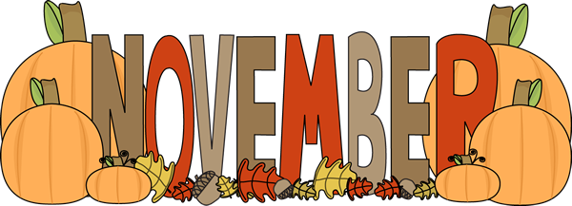
November 2026 starts on a Sunday, features the U.S. Midterm Elections on November 3, and ends on a Monday with 30 total days.
Calendar & Key Dates
- Nov 1: Daylight Saving Time ends at 2:00 AM and All Saints' Day begins.
- Nov 3: U.S. Midterm Elections take place to elect all House members and one-third of the Senate.
- Nov 11: Veterans Day (marking the armistice ending WWI in 1918).
- Nov 26: U.S. Thanksgiving Day.
- Nov 27: Black Friday.
- Nov 30: Cyber Monday.
Traditional Symbols & Science
- Birthstones: Topaz and Citrine, symbolizing strength and hope.
- Birth Flower: Chrysanthemum, representing cheerfulness.
- Zodiac Signs: Scorpio (until November 21) and Sagittarius (starting November 22).
- Trivia Note: A famous 1960 mathematical paper on population doomsday humorously predicted human extinction via overcrowding for Friday, November 13, 2026—a mathematical quirk averted by shifting global demographics.

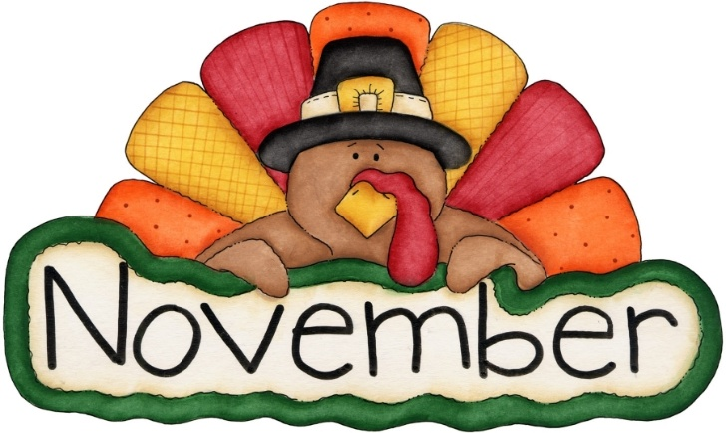 November is such a lovely month…. daylight savings time changes, elections take place, our Veterans get their day of remembrance and families gather for a Thanksgiving feast!

Daylight savings time ends November 1st, don’t forget to set your clocks back and change the batteries in your smoke & carbon monoxide detectors.
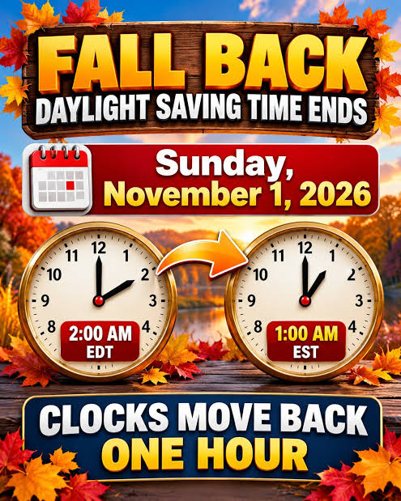

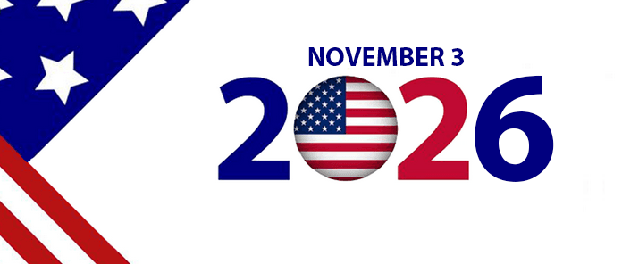
Elections are scheduled to be held, in large part, on November 3, 2026, in the United States. In these midterm elections, scheduled to occur during Republican president Donald Trump's second term, all 435 seats in the U.S. House of Representatives and 35 of the 100 seats in the U.S. Senate will be contested to determine the 120th United States Congress. 39 state and territorial U.S. gubernatorial elections, attorney general elections, and numerous state and local elections, will also be contested.
Prior to the elections, Trump called on Republican-led states to enact rare mid-decade redistricting to boost the party's chances of holding power ahead of historical losses for the incumbent party during midterm elections. The moves prompted reciprocal redistricting from Democratic-led states through measures such as California's Election Rigging Response Act. In April 2026, the Supreme Court ruled in Louisiana v. Callais that parts of the Voting Rights Act of 1965 which enabled the creation of majority-minority districts were unconstitutional. The Trump administration has made repeated false claims of voter fraud.
Leading issues in the election include widespread opposition to rapid progress in artificial intelligence, including the construction of data centers; corruption; economic policy, particularly inflation, healthcare, and tariffs; foreign policy, including relations with American allies, the ongoing Iran war, and the Israeli–Palestinian conflict, along with proposed expansionism.

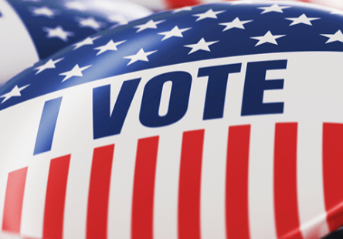
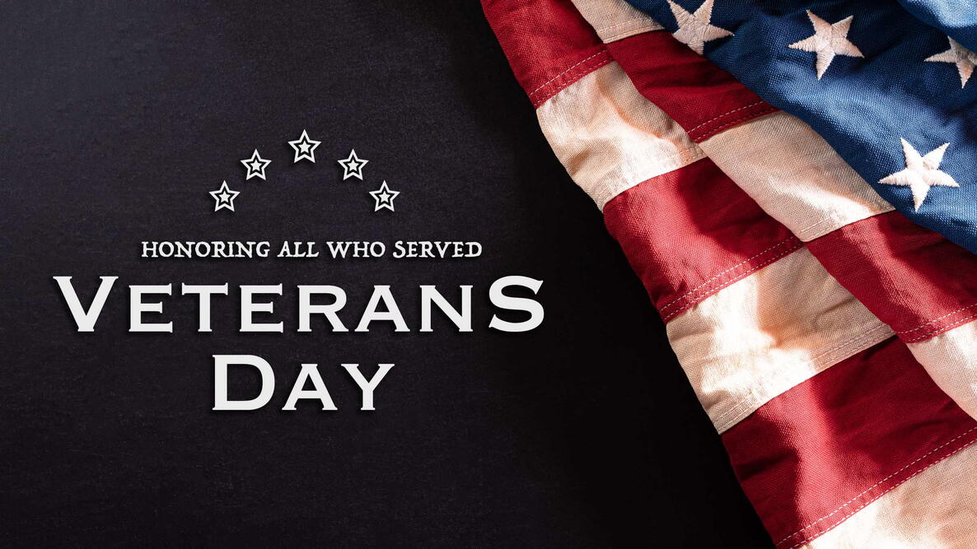 Veterans Day is a holiday dedicated to American veterans of all wars, and Veterans Day 2026 occurs on Wednesday, November 11.
In November 1918 during World War I—at the 11th hour of the 11th day of the 11th month of that year—an armistice, or temporary cessation of hostilities, was declared between the Allied nations and Germany.
Commemorated the following year as Armistice Day in many countries, November 11th became a federal holiday in the United States in 1938. In the aftermath of World War II and the Korean War, Armistice Day became known as Veterans Day.
Armistice Day
The Treaty of Versailles was signed on June 28, 1919, marking the official end of World War I. Nonetheless, the armistice date of November 11, 1918, remained in the public imagination as the date that marked the end of the conflict.
One year later, in November 1919, U.S. President Woodrow Wilson proclaimed November 11 as the first commemoration of Armistice Day. The day’s observation included parades and public gatherings, as well as a brief pause in business and school activities at 11 a.m.
On November 11, 1921, an unidentified American soldier killed in the war was buried at Arlington National Cemetery near Washington, D.C. On the same day the previous year, unidentified soldiers were laid to rest at Westminster Abbey in London and at the Arc de Triomphe in Paris.
On June 4, 1926, Congress passed a resolution that the “recurring anniversary of November 11, 1918, should be commemorated with thanksgiving and prayer and exercises designed to perpetuate peace through good will and mutual understanding between nations,” and that the president should issue an annual proclamation calling for the observance of Armistice Day.
By that time, 27 state legislatures had already made November 11 a legal holiday. An act approved May 13, 1938, made November 11 a federal holiday, “dedicated to the cause of world peace and to be hereafter celebrated and known as ‘Armistice Day.'”
From Armistice Day to Veterans Day
America's war effort during World War II saw the greatest mobilization of the U.S. Army, Navy and Air Force in the nation’s history (more than 16 million people); some 5.7 million more served in the Korean War.
In 1954, after lobbying efforts by veterans’ service organizations, the 83rd U.S. Congress amended the 1938 act that had made Armistice Day a holiday, striking the word “Armistice” in favor of “Veterans.” President Dwight D. Eisenhower signed the legislation on June 1, 1954. From then on, November 11 became a day to honor American veterans of all wars.
The next development in the story of Veterans Day unfolded in 1968, when Congress passed the Uniform Monday Holiday Act, which sought to ensure three-day weekends for federal employees—and encourage tourism and travel—by celebrating four national holidays (Washington’s Birthday, Memorial Day, Veterans Day and Columbus Day) on Mondays.
The observation of Veterans Day was set as the fourth Monday in October. The first Veterans Day under the new law was Monday, October 25, 1971; confusion ensued, as many states disapproved of this change, and continued to observe the holiday on its original date.
In 1975, after it became evident that the actual date of Veterans Day carried historical and patriotic significance to many Americans, President Gerald Ford signed a new law returning the observation of Veterans Day to November 11th beginning in 1978.
If November 11 falls on a Saturday or Sunday, the federal government observes the holiday on the previous Friday or following Monday, respectively. Most local, state and federal government offices are closed on Veterans Day.


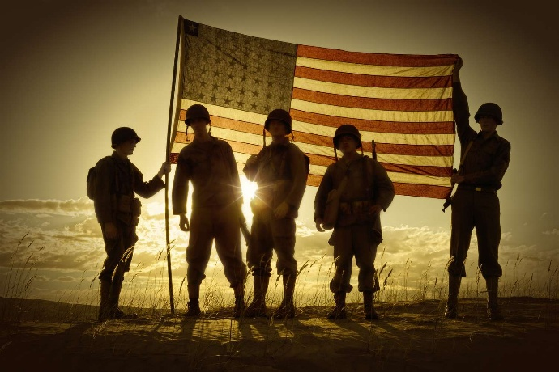

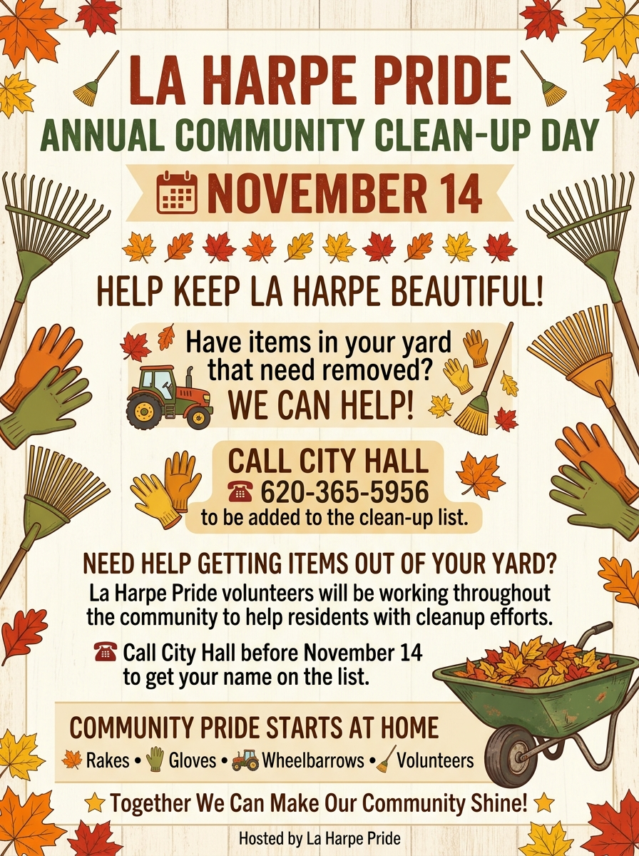
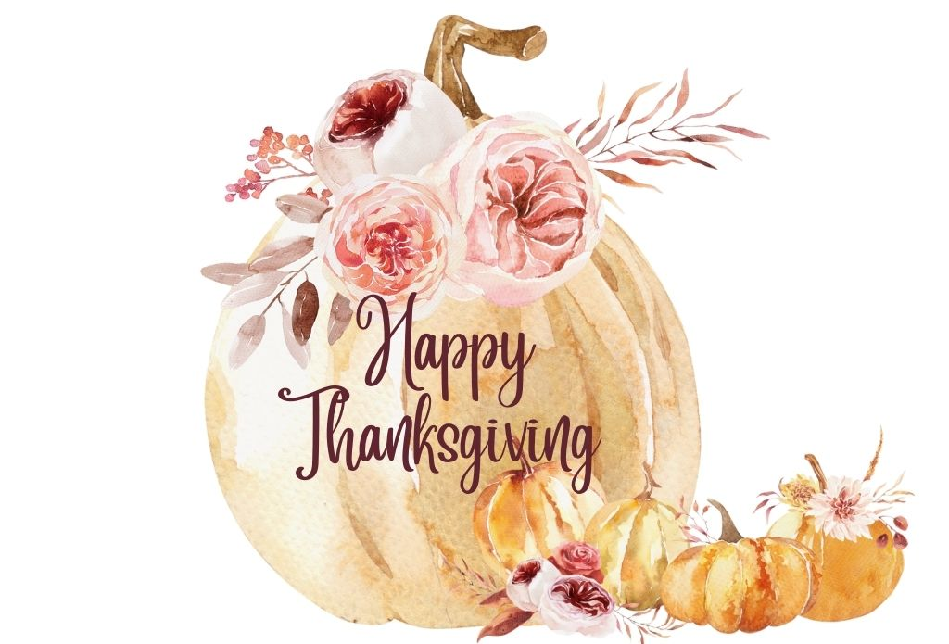
Most Americans are familiar with the Pilgrim's Thanksgiving Feast of 1621, but few realize that it was not the first festival of its kind in North America. Long before Europeans set foot in the Americas, native peoples sought to insure a good harvest with dances and rituals such as the Green Corn Dance of the Cherokees.
The first Thanksgiving service known to be held by Europeans in North America occurred on May 27, 1578, in Newfoundland, although earlier Church-type services were probably held by Spaniards in La Florida. However, for British New England, some historians believe that the Popham Colony in Maine conducted a Thanksgiving service in 1607 (see Sources: Greif, 208-209; Gould, and Hatch). In the same year, Jamestown colonists gave thanks for their safe arrival, and another service was held in 1610 when a supply ship arrived after a harsh winter. Berkley Hundred settlers held a Thanksgiving service in accordance with their charter which stated that the day of their arrival in Virginia should be observed yearly as a day of Thanksgiving, but within a few years an Indian uprising ended further services (Dabney). Thus, British colonists held several Thanksgiving services in America before the Pilgrim's celebration in 1621.
The Pilgrims, with a puritanical rejection of public religious display, held a non-religious Thanksgiving feast, aside from saying grace. In fact, they seem to have used the three days for feasting, playing games, and even drinking liquor.
In 1623, the Pilgrims at Plymouth Plantation, Massachusetts, held another day of Thanksgiving. As a drought was destroying their crops, colonists prayed and fasted for relief; the rains came a few days later. And not long after, Captain Miles Standish arrived with staples and news that a Dutch supply ship was on its way. Because of all this good fortune, colonists held a day of Thanksgiving and prayer on June 30. This 1623 festival appears to have been the origin of our Thanksgiving Day because it combined a religious and social celebration.
Festivals of Thanksgiving were observed sporadically on a local level for more than 150 years. They tended to be autumn harvest celebrations. But in 1789, Elias Boudinot, New Jersey, member of the House of Representatives, moved that a day of Thanksgiving be held to thank God for giving the American people the opportunity to create a constitution to preserve their hard-won freedoms. A Congressional Joint Committee approved the motion, and informed President George Washington. On October 3, 1789, the President proclaimed that the people of the United States observe "a day of public thanksgiving and prayer" on Thursday, the 26th of November.
The next three Presidents proclaimed, at most, two days of thanksgiving sometime during their terms of office, either on their own initiative or at the request of a joint Resolution of Congress. One exception was Thomas Jefferson, who believed it was a conflict of church and state to require the American people hold a day of prayer and thanksgiving. President James Madison proclaimed a day of Thanksgiving to be held on April 13, 1815, the last such proclamation issued by a President until Abraham Lincoln did so in 1862.
Most of the credit for the establishment of an annual Thanksgiving holiday may be given to Sarah Josepha Hale. Editor of Ladies Magazine and Godey's Lady's Book, she began to agitate for such a day in 1827 by printing articles in the magazines. She also published stories and recipes, and wrote scores of letters to governors, senators, and presidents. After 36 years of crusading, she won her battle. On October 3, 1863, buoyed by the Union victory at Gettysburg, President Lincoln proclaimed that November 26, would be a national Thanksgiving Day, to be observed every year on the fourth Thursday of November.
Only twice has a president changed the day of observation. President Franklin D. Roosevelt, in order to give depression-era merchants more selling days before Christmas, assigned the third Thursday to be Thanksgiving Day in 1939 and 1940. But he was met with popular resistance, largely because the change required rescheduling Thanksgiving Day events such as football games and parades. In 1941, a Congressional Joint Resolution officially set the fourth Thursday of November as a national holiday for Thanksgiving.
Today, Thanksgiving is a time when many families come together, and many churches are open for special services. We have both Native Americans and immigrants to thank for the opportunity to observe a day of thanksgiving.


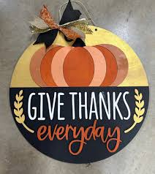
LOCAL NEWS
- Are you in need of grocery delivery service? Call 620-228-5570 for more information on this new service.

- Don’t forget, we have a community food box in front of City Hall…. Take what you need, leave what you can.

- 2027 City Dog Tags available for purchase. Neutered or spayed is $5.00, intact is $6.50. Must have proof of current rabies vaccination on file.

-  Food pantry available to the La Harpe community on the 3rd Friday of each month! Address for pickup is the Light of La Harpe Church – 901 S. Main and pickup start at 4:00pm. Any questions on the food pantry, please call 620-228-3069.

If you need assistance after-hours please call the Iola Dispatch Center at (620) 365-1437, they will notify the proper personnel.
 HAPPY BIRTHDAY TO ALL LAHARPE CITIZENS CELEBRATING A BIRTHDAY THIS MONTH!!!! MAY YOUR DAY BE AS SPECIAL AS YOU ARE TO US!

Dates to remember:

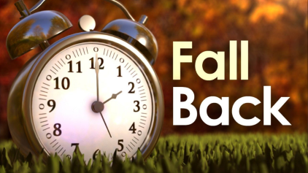 November 1st: Daylight savings time ends, don’t forget to turn those clocks back one hour!
 November 11th: Council Meeting at City Hall at 7:00 pm

 November 16th: PRIDE Meeting at 7:00 p.m. at the City Hall
 November 25th: Past due Utility shut off date.

 November 26th: City hall will be closed Thursday (11/26) and Friday (11/27) in observance of Thanksgiving.
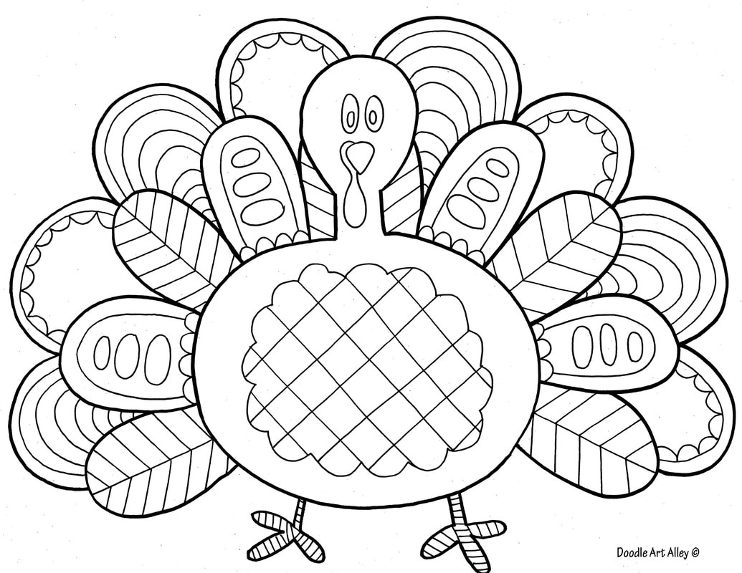

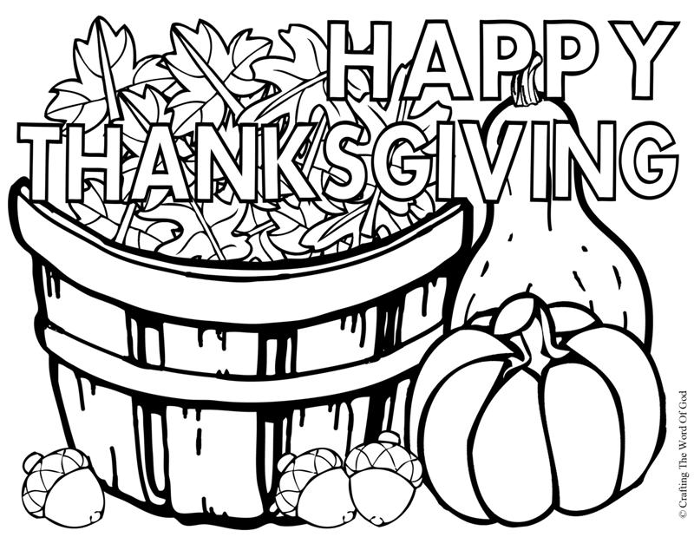
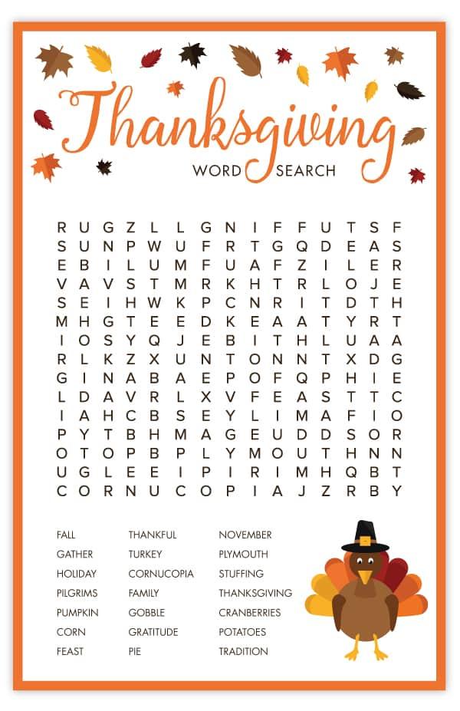

CITY COUNCIL NEWS
CITIZENS CALL FOR BUSINESS
- Winona English addressed the council with frustration on a property she owns in La Harpe, she stated I feel like I being harassed. Winona shared that code had mowed her pasture without her consent and she shared a variance request to allow livestock on her property. Mayor Lee mentioned, you didn’t have a hay permit this year. Scott Kroenke expressed concerns about the request for a variance that stated “livestock” stating, I am not willing to approve an open-ended livestock request, you have to be more specific. Winona would prefer to hay her property but the hay permit states twice a year, and sometimes you can get two cuts. Cynthia Carr and Ron Knavel suggested the ordinance, permit and language be reviewed. Cynthia Carr made the motion to review. Cyndi Maley seconded. Motion carried 4-0.
- Ray Maloney shared that he bought the home on the east side of his business and is planning to extend his business. He mentioned the trailer home sitting on the property he would like to move to a different location and asked the city if they would have any interest placing it on a lot owned by the city. Ray mentioned the trailer is now 14 years old but has been sitting in city limits, just want to move to a different location, what steps need to happen to do so. City attorney, Jacob Manbeck, stated he would read into the ordinance to see if there are any exclusions.

UNFINISHED BUSINESS
- Water Tower: Tabled

- City wide clean-up: La Harpe Pride will be hosting a clean-up on November 14th and looking for volunteers.
- Cold Patch: Cynthia Carr made the motion to purchase cold patch from Whittaker. Ron Knavel seconded. Motion carried 2-2 with Cyndi Maley and Scott Kroenke opposing. Mayor Lee broke the tie vote in favor of not purchasing cold patch.
- Maintenance trucks: Tabled

NEW BUSINESS
- Mayor Lee made an appointment for Mike Hedman to the vacated council seat mentioning his decision was because of Mike’s experience as a former city employee and also brings different experiences. Council agreed with the appointment of Mike Hedman. Mike was sworn in and took seat.
- Vicki Moss – Thrive: Shared with the city council of a grant opportunity, through the Kansas Housing Resources Corporation, to build homes in La Harpe, the city was unsuccessful the last two years and now there is another opportunity. Vicki asked if the city will agree to move forward and offer the same incentives, Thrive will administer the grant. Vicki stated there will be a couple of resolutions the city will have to adopt and sign. Cynthia Carr asked, what happens if the grant succeeds. Vicki stated that thrive and Harry Lee would do the paperwork. Ron Knavel made the motion to apply. Scott Kroenke seconded. Motion carried 5-0.
- Emergency Water supply plan - Cynthia Carr made the motion to approve. Scott Kroenke seconded. Motion carried 5-0.
- Gateway water tower lease – No action taken
- Incentive Ordinance – Tabled
- Streets – Cynthia Carr asked where we were with the county. City clerk, Michelle Altis, stated she talked with Jeremy and he is wanting La Harpe to pick 10 blocks of roads that need to be reclaimed, submit those to the county, the county will come over in February, March or April to reclaim; they ask that the city maintains them until it’s time to chip seal which will be June or July. Michelle shared, the roads originally discussed; Broadway (from hwy 54 to 5th), 6th Street (from Jackson to Monroe), 10th Street (from Jackson to Main) and Broadway (from 9th to 7th) has been approved by Jeremy. Cynthia Carr suggested the city could find out more details about asphalt but for now get on the calendar with the county. Council agreed.
- City building on Main Street – Mayor Lee mentioned the building needs to be power washed and sealed and would like council approval. Scott Kroenke made the motion to pressure wash and seal by city staff. Mike Hedman seconded. Motion carried 5-0.
- Public areas in city hall – No action taken
- Street lights – Mayor Lee mentioned the city needs to clear trees around street lights for better lighting. Cyndi Maley made the motion to hire a part-time city superintendent or supervisor. Scott Kroenke seconded. Motion carried 3-2 with Cynthia Carr and Mike Hedman opposing.
- Job Descriptions – Scott Kroenke shared job descriptions. Cynthia Carr suggested a workshop to go over them; there are a few things that need cleaned up.
- Lease space – No action taken
- Ditches – Mayor Lee stated, we need to come up with a plan on ditches and when it rains find the problem areas.

REPORTS OF CITY OFFICERS
- Jacob Manbeck, City Attorney – Shared a public hearing notice pertaining to the floodplain management ordinance, the public hearing will be at 7:00pm on November 11th, here at city hall. The council needs to motion to approve and publish the notice. Cynthia Carr made the motion to approve and publish the public hearing notice. Scott Kroenke seconded. Motion carried 5-0.

- Roy Caler, Water Representative – Nothing to report.

- Penny Miller, Code/Animal Control –shared reports.

- Marc Waggoner, Fire Chief- Shared the meeting minutes: The LaHarpe Volunteer Fire Department met for the monthly meeting. Present: Marc Waggoner Sr., Kiefer Endicott, Josh Sparks, Matthew Waggoner, Pamela Waggoner, Meghan Sparks, Marc Waggoner Jr., and Dennis Sidebottom. Absent was Bill Gay. Started meeting, discussed about participating in Farm City Days parade and having a trunk or treat on October 31st and operating a new truck we acquired from Forestry Service then ended the meeting. Marc stated the fire department will begin flushing hydrants on October 23rd.

- Maintenance Department - The workorders were shared.

- Michelle Altis, City Clerk – Nothing to report.

DISCUSSION ON AGENDA ITEMS –
Nothing discussed.
Mayor Lee requested an executive session for non-elected personnel, for 20 minutes, to interview Joe Stotler as a part-time police officer. Scott Kroenke made a motion to go into executive session on non-elected personnel for 20 minutes. Cynthia Carr seconded. Motion carried 5-0.

Scott Kroenke made a motion to go into executive session for attorney/client for 5 minutes. Cyndi Maley seconded. Motion carried 5-0.

After returning to regular session Mike Hedman made the motion to hire Joe Stotler as a part-time police officer. Scott Kroenke seconded. Discussion: $25.00 an hour, 20 hours capped per week, holidays will be flexible, daytime job needs will take precedence, and police car will be taken home. Cynthia Carr asked about the 2027 budget for law enforcement, Michelle stated there is not one. Mayor Lee suggested the city amend the 2027 budget, Michelle stated she would look into it. Motion carried 4-1 with Cynthia Carr opposing.


Mayor: Harry Lee Jr. 620-496-7000
City Attorney: Jacob Manbeck
City Municipal Judge: Patty Miklos
Police Chief: Joe Stotler
Fire Chief: Marc Waggoner
Assistant Fire Chief: Dennis Sidebottom
City Clerk: Michelle Altis
Assistant Clerk: Teresa Driskel
City Treasurer: Teresa Driskel
Maintenance Staff: Larry Laird & Keith Knavel
Code & Animal Control: Penny Miller
City Council Members:
Ron Knavel (620-496-2508) Scott Kroenke (915-205-0735)
Cyndi Maley (620-380-6600) Cynthia Carr (620-496-7500)
Mike Hedman (620-405-0342)
La Harpe City Hall Hours: Monday-Friday
902 S. Washington 8:00-12:00 & 1:00-5:00
P.O. Box 10 Ph. (620) 365-5956
La Harpe, KS. 66751 Fax (620) 365-3944
CHECK OUT OUR WEBSITE; CITYOFLAHARPE.ORG
Follow us on FacebookACON



Amish Breakfast Casserole

Ingredients
- 1-pound sliced bacon, diced
- 1 medium sweet onion, chopped
- 6 large eggs, lightly beaten
- 4 cups frozen shredded hash brown potatoes, thawed
- 2 cups shredded cheddar cheese
- 1-1/2 cups 4% cottage cheese
- 1-1/4 cups shredded Swiss cheese

Directions
- 1. Preheat oven to 350°. In a large skillet, cook bacon and onion over medium heat until bacon is crisp; drain. In a large bowl, combine remaining ingredients; stir in bacon mixture. Transfer to a greased 13x9-in. baking dish.
- 2. Bake, uncovered, until a knife inserted in the center comes out clean, 35-40 minutes. Let stand 10 minutes before cutting.



Hearty Potato Soup

Ingredients
- 6 medium potatoes, peeled and sliced
- 2 carrots, chopped
- 6 celery ribs, chopped
- 8 cups water
- 1 onion, chopped
- 6 tablespoons butter, cubed
- 6 tablespoons all-purpose flour
- 1 teaspoon salt
- 1/2 teaspoon pepper
- 1-1/2 cups 2% milk

Directions
- 1. In a Dutch oven, cook the potatoes, carrots and celery in water until tender, 15-20 minutes. Drain, reserving liquid and setting vegetables aside.
- 2. In the same pan, saute onion in butter until tender. Stir in the flour, salt and pepper; gradually add milk. Bring to a boil, cook and stir for 2 minutes or until thickened. Gently stir in cooked vegetables. Add 1 cup or more of reserved cooking liquid until soup is desired consistency.

Rotisserie Chicken and Stuffing Casserole
INGREDIENTS
Cooking spray
1 ½ cups water
¼ cup butter 1
(6 ounce) package quick-cooking stuffing mix (such as Stove Top®), or more to taste
1 tablespoon butter
1 medium onion, diced
3 stalks celery, diced, or more to taste
1 (10.5 ounce) can low-sodium cream of chicken soup
½ (10.5 ounce) can low-sodium cream of mushroom soup
1 (8 ounce) container sour cream
1 whole cooked rotisserie chicken - skinned, boned, and meat shredded
salt and ground black pepper to taste

DIRECTIONS
Step 1 Preheat the oven to 375 degrees F (190 degrees C). Spray a 9x13-inch baking dish with cooking spray.
Step 2 Bring water and 1/4 cup butter to a boil in a saucepan over medium heat. Add stuffing mix and stir to combine. Remove the saucepan from the heat, cover, and let sit until water is absorbed, about 5 minutes. Fluff stuffing with a fork.
Step 3 While you are preparing the stuffing, melt 1 tablespoon butter in a skillet over medium heat. Add onion and celery; cook and stir until softened, 5 to 10 minutes.
Step 4 Mix both condensed soups with sour cream in a bowl until well combined.
Step 5 Spread shredded chicken in the bottom of the prepared baking dish. Layer onion mixture over the chicken and season with salt and pepper. Top with soup mixture and spread stuffing evenly over top.
Step 6 Bake in the preheated oven until filling is bubbly and topping is golden brown, about 1 hour



Pumpkin Dump Cake
Ingredients
- 1 can (15 ounces) pumpkin
- 1 can (12 ounces) evaporated milk
- 3 large eggs, room temperature
- 1 cup sugar
- 4 teaspoons pumpkin pie spice
- 1 package yellow cake mix (regular size)
- 3/4 cup butter, melted
- 1-1/2 cups chopped walnuts
- Vanilla ice cream or whipped cream
Directions
- In a large bowl, beat first 5 ingredients until smooth.
- Transfer to a greased 13x9-in. baking dish. Sprinkle with cake mix and drizzle with butter. Top with walnuts.
- Bake at 350° for 1 hour or until a knife inserted in the center comes out clean. Serve with ice cream or whipped cream.

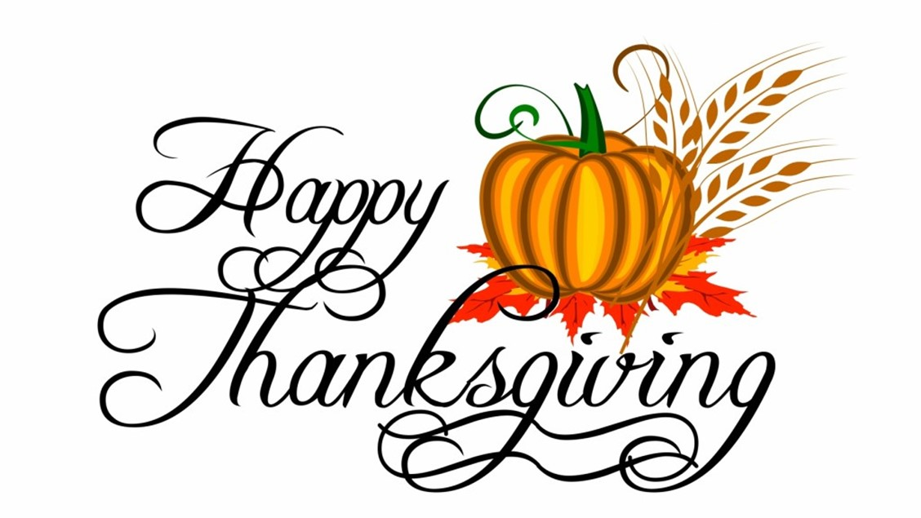

From the City of La Harpe crew & staff, we wish you a very nice Thanksgiving!

