OCTOBER NEWSLETTER

Columbus Day, a U.S. holiday that commemorates the landing of Christopher Columbus in the Americas in 1492, was unofficially celebrated in a number of cities and states as early as the 18th century, but did not become a federal holiday until 1937. For many, the holiday is a way of both honoring Columbus’ achievements and celebrating Italian-American heritage.
But throughout its history, Columbus Day and the man who inspired it have generated controversy, and many alternatives to the holiday have proposed since the 1970s, including Indigenous Peoples' Day, now celebrated in many U.S. cities, states and territories.
When Is Columbus Day 2026?
Columbus Day 2026 occurs on Monday, October 12. The holiday was originally observed every October 12 but was changed to the second Monday in October beginning in 1971.
In some parts of the United States, Columbus Day has evolved into a celebration of Italian-American heritage. Local groups host parades and street fairs featuring colorful costumes, music and Italian food.

Christopher Columbus
Christopher Columbus was an Italian-born explorer who set sail in August 1492, bound for Asia with backing from the Spanish monarchs King Ferdinand and Queen Isabella aboard the ships Niña, Pinta and Santa Maria.
Columbus intended to chart a western sea route to China, India and the fabled gold and spice islands of Asia. Instead, on October 12, 1492, he landed in the Bahamas, becoming the first European to explore the Americas since the Vikings established colonies in Greenland and Newfoundland during the 10th century.
Later that month, Columbus sighted Cuba and believed it was mainland China; in December the expedition found Hispaniola, which he thought might be Japan. There, he established Spain’s first colony in the Americas with 39 of his men.
In March 1493, Columbus returned to Spain in triumph, bearing gold, spices and “Indian” captives. The explorer crossed the Atlantic to the Americas several more times before his death in 1506.





Halloween has been around for more than a thousand years. Originally a religious observance, it became increasingly secular over the centuries until its religious trappings all but disappeared. Today Halloween is considered a holiday for dress-up and fun, especially for children.
Halloween’s origins can be traced back to the ancient Celtic festival known as Samhain, which was held on November 1 in contemporary calendars. It was believed that on that day, the souls of the dead returned to their homes, so people dressed in costumes and lit bonfires to ward off spirits. In this way, popular Halloween tropes such as witches, ghosts, and goblins became associated with the holiday.
In the 7th century CE, Pope Boniface IV created All Saints Day, originally celebrated on May 13. A century later, Pope Gregory III moved the holiday to November 1, likely as a Christian substitute for the pagan festival of Samhain. The day before the saintly celebration became known as All Hallows Eve, or Halloween.
Though the holiday began in Celtic regions of Ireland, the United Kingdom, and France, it quickly spread to other parts of the world. The first American colonists in New England were forbidden to celebrate it for religious reasons, though it enjoyed some popularity in the Southern colonies. By the 1800s, fall festivals marking the seasonal harvest incorporated Halloween elements, and Irish immigrants escaping the devastating Potato Famine brought with them many Halloween traditions that remain today.
The custom of trick-or-treating, in which children dress up in costume and solicit treats from neighbors, became popular in the United States in the early 20th century as Irish and Scottish communities revived the Old World custom of “guising,” in which a person would dress in costume and tell a joke, recite a poem, or perform some other trick in exchange for a piece of fruit or other treat. By 1950, trick-or-treating for candy had become one of Halloween’s most popular activities. Today, Halloween is one of the biggest holidays for candy sales in the United States, exceeding $2.5 billion annually.



LOCAL NEWS
- Are you in need of grocery delivery service? Call 620-228-5570 for more information on this new service.

- Don’t forget, we have a community food box in front of City Hall…. Take what you need, leave what you can.

- 2027 City Dog Tags available for purchase. Neutered or spayed is $5.00, intact is $6.50. Must have proof of current rabies vaccination on file.

-  Food pantry available to the La Harpe community on the 3rd Friday of each month! Address for pickup is the Light of La Harpe Church – 901 S. Main and pickup start at 4:00pm. Any questions on the food pantry, please call 620-228-3069.

If you need assistance after-hours please call the Iola Dispatch Center at (620) 365-1437, they will notify the proper personnel.
 HAPPY BIRTHDAY TO ALL LAHARPE CITIZENS CELEBRATING A BIRTHDAY THIS MONTH!!!! MAY YOUR DAY BE AS SPECIAL AS YOU ARE TO US!

Dates to remember:

 October 12th: City Hall closed in observance of Columbus Day

 October 14th: Council Meeting at City Hall at 7:00 pm

 October 19th: PRIDE Meeting at 7:00 p.m. at the City Hall

 October 27th: Past due Utility shut off date.

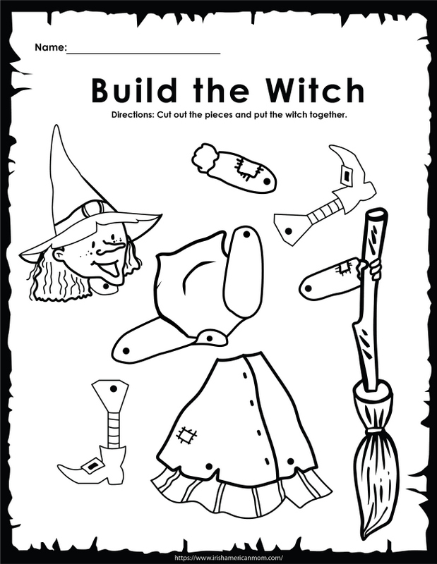

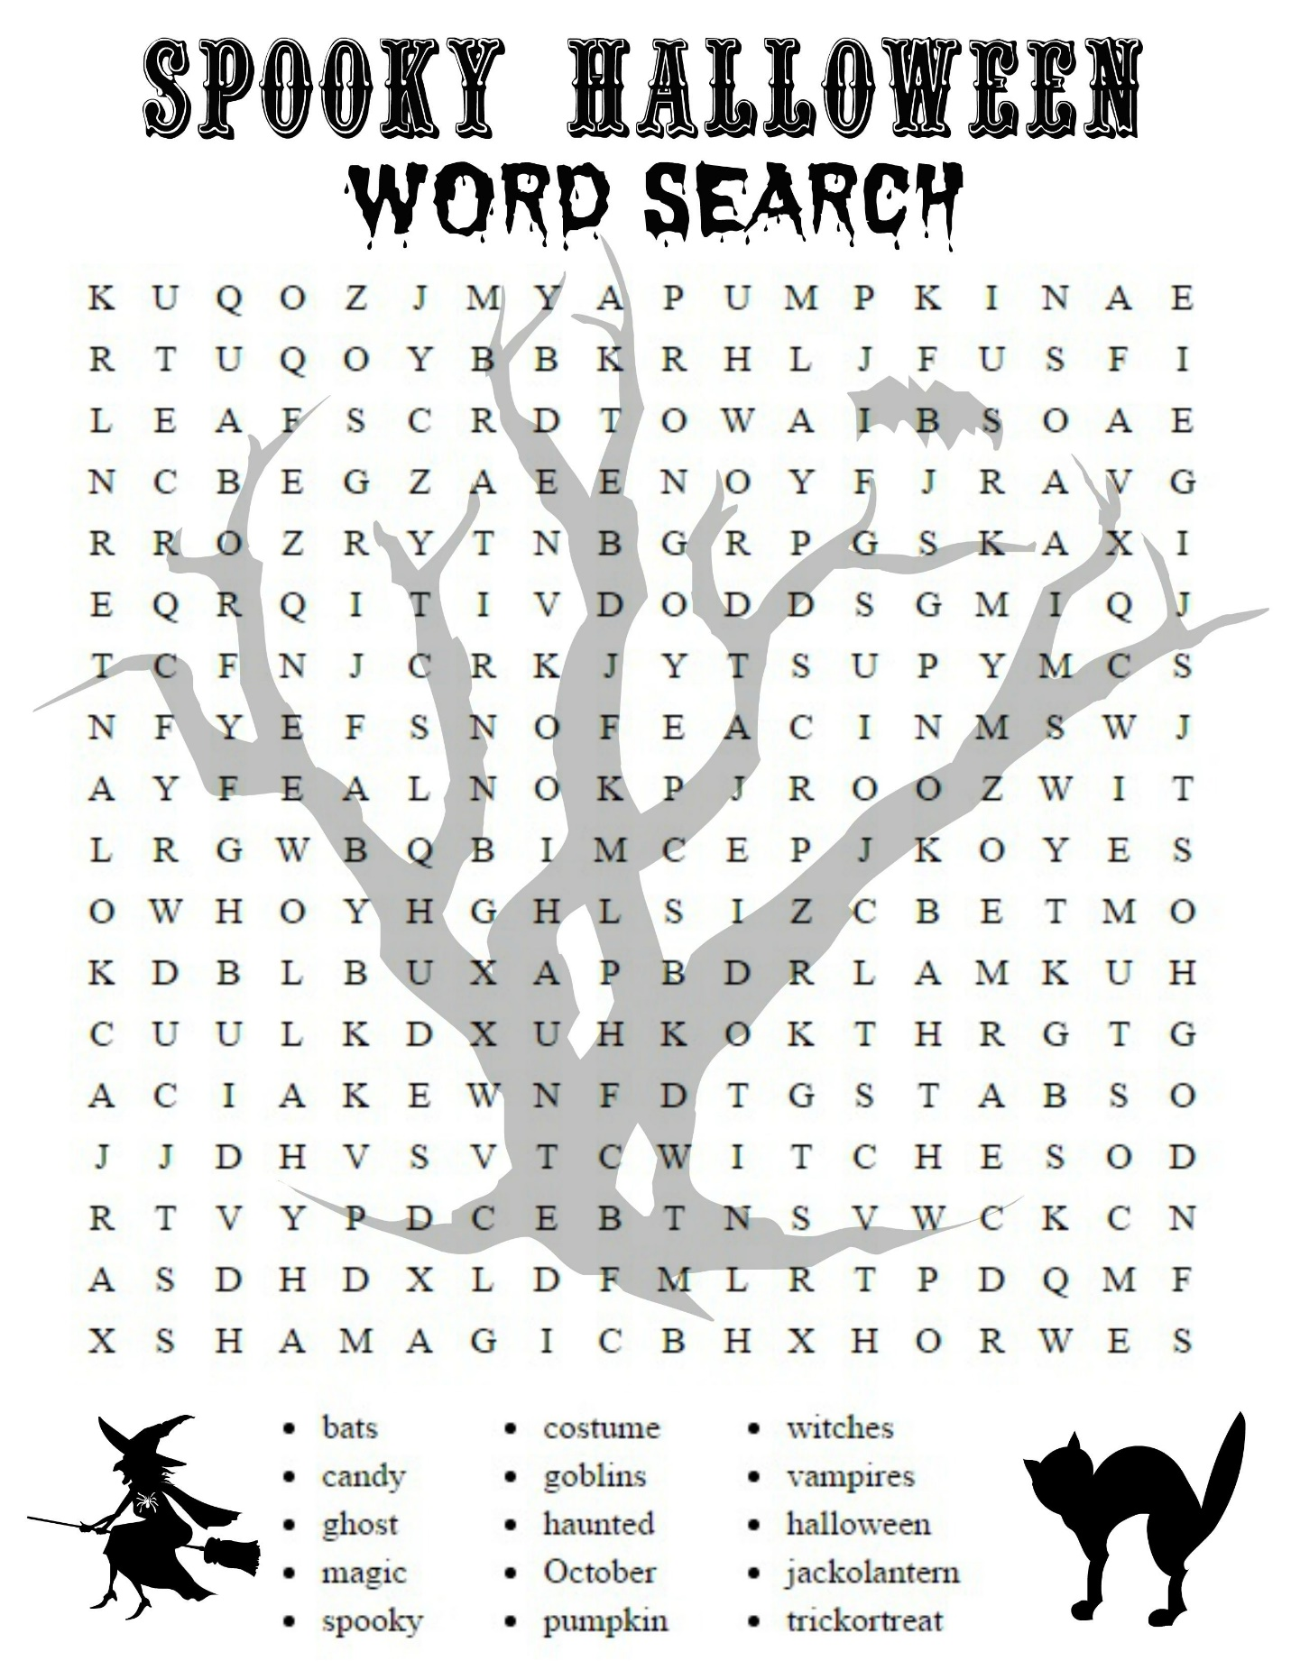

CITY COUNCIL NEWS
CITIZENS CALL FOR BUSINESS
- Richard Luken – La Harpe Pride, shared the committee is meeting Monday night and encouraged the public to attend, stating they will be discussing the fall cleanup. The K-State kids that have helped in the past has disbanded but we may have another option which Marcia Davis is looking into and hope to share more information Monday evening. Richard also shared some possible funding for park improvements, grant funding opportunities are out there for $25,000.00, this item will be discussed Monday. The meeting will start at 7:00pm.

- Jack Whiting – addressed the council about use of the dump truck. Michelle stated he can call city hall and reserve as needed if available.

- Carrie Dean – addressed the council with concerns on the animal ordinance, stating it’s been hard to sell my property because of the ordinance. Cynthia Carr suggested interested parties address the council with interest to purchase and request a variance on the city ordinance.

UNFINISHED BUSINESS
- Water Tower: Tabled

- Fitness Center: City Attorney shared an updated clause in the contract; On the Terms of Membership, I deleted key fobs and added Entry Code, also added that in the event an individual causes damage to the fitness center facility, costs to repair such damage will be assessed to the member whose entry code such individual used to enter. Jake asked the council to approve these modifications with a vote. Cyndi Maley made the motion to approve the updates as presented. Cynthia Carr seconded. Motion carried 4-0. Cyndi Maley made a motion the 35% of monthly membership fees will go towards the expenses, such as utilities, at city hall effective on the October 1, 2026 billing cycle. Cynthia Carr seconded. Motion carried 4-0.

- City Attorney, Jacob Manbeck, shared a revised letter of service. Cynthia Carr made the motion to approve as presented and authorized Cynthia Carr too sign document. Ron Knavel seconded. Motion carried 4-0.

- Mosquito Spraying: Council decided to discontinue the spraying and revisit next spring. Cyndi Maley made the motion to stop spraying, effective immediately. Scott Kroenke seconded. Motion carried 4-0.

- Beat the heat working hours: Scott Kroenke made the motion to return to original hours on Monday. Ron Knavel seconded. Motion carried 4-0.

NEW BUSINESS
a) Lights at Park: Ron stated the shelter house and the flag light is on 24/7 and they only need to be on at night. Ron Knavel made the motion to fix the issues. Scott Kroenke seconded. Motion carried 4-0.

b) City wide clean-up: Tabled.

c) Equipment Issues: Scott Kroenke shared his frustrations on how general maintenance needs to be done; stuff is not being taken care of. Ron Knavel stated that oil changes need to happen here, not go in to Iola. Cyndi Maley suggested a city superintendent in charge of what needs to be done and get it done. Scott shared that some work orders are hanging on the board for 3 months. Council suggested the mayor sit down with maintenance and share what the expectations are. Mayor Lee agreed he would meet with the on Tuesday morning.

d) Cold Patch: Tabled.

e) Water Valve: No motion was made.

f) Floodplain Management Ordinance #2601: Jake shared ordinance #2601 with the council and stated; the adoption of this ordinance will make the city compliant with FEMA. Scott Kroenke made the motion to adopt ordinance #2601. Ron Knavel seconded. Motion carried 4-0.

g) Placement of Electric Meters: Mayor Lee shared that Iola has a policy; if it’s underground the meter goes on the pole and overhead the meter goes on the house. Mayor Lee suggested the city get something similar in the books for projects going forward. City Attorney, Jake Manbeck said he would draft something and share at next meeting.

h) Sewer Contract Payment Authorization: City clerk, Michelle Altis shared a document from Cardinal Sitework requesting a partial payment for equipment with the payment amount being $116,434.37 and a letter needing the mayor’s signature for this payment. Cynthia Carr made the motion to make the first payment and authorized the mayor to sign required documents as needed. Ron Knavel seconded. Motion carried 4-0.

i) Mayor Lee shared that Angela Barker submitted her resignation and I feel it would be appropriate to send her a letter, on behalf of the community, of appreciation for her service.

j) Scott Kroenke shared; The Allen County Veteran's Fam Tour will be in the Iola and Humboldt area on September 24th to showcase what the community has to offer and encourage veterans to relocate after separating from the military. The tour will consist of tours of the Iola and Humboldt areas and a Speed Networking and Job Fair. The smaller towns within the county are represented at the tour. Scott asked what La Harpe needs: a city superintendent or police officer; I'm willing to call and visit with them. Council was pleased with the idea of Scott looking into this a little more on the city's behalf.

REPORTS OF CITY OFFICERS
- Jacob Manbeck, City Attorney – Nothing to report.

- Roy Caler, Water Representative – Absent from meeting.

- Penny Miller, Code/Animal Control –shared reports. Mayor Lee requested that Jake look at Penny’s code letters and spruce them up a little.

- Marc Waggoner, Fire Chief- Shared the meeting minutes: The LaHarpe Volunteer Fire Department met for the monthly meeting. Present: Marc Waggoner Sr., Kiefer Endicott, Josh Sparks, Matthew Waggoner, Pamela Waggoner, Meghan Sparks, Marc Waggoner Jr., and Dennis Sidebottom. Absent were Bill Gay, Jason Teeple, Dillon Brownback, and Justin Pritchard. Started meeting, we serviced fire trucks then also on 8/20/2026 we had a landfill fire which also doubled as a training for fire fighters. Marc stated the fire department will be flushing hydrants next month.

- Maintenance Department - The workorders were shared. Maintenance trucks were tabled.

- Michelle Altis, City Clerk – Michelle shared a contract from Advantage computer for the city’s court software, stating this is a yearly contract and I just need approval to sign. Cynthia Carr made the motion to accept the contract and authorized Michelle to sign. Ron Knavel seconded. Motion carried 4-0.

DISCUSSION ON AGENDA ITEMS –
Nothing discussed. Cyndi Maley made a motion to go into executive session for attorney/client for 15 minutes with Jason Maley invited. Scott Kroenke seconded. Motion carried 4-0. Scott Kroenke made the motion to return to regular session. Ron Knavel seconded. Motion carried 4-0. Mayor Lee shared the discussion was an issue regarding the application for the incentive program that was not properly fulfilled and Jason and Cyndi Maley are requesting reimbursement of $7,017.46 for monies spent to get utilities to their home. Scott Kroenke made the motion to pay the Maley’s the amount being requested to recoup fees from the incentive program as allocated to budget and appropriate departments. Ron Knavel seconded. Motion carried 3-0 with Cyndi Maley abstaining.

Scott Kroenke made a motion to go into executive session on non-elected personnel for 15 minutes. Cyndi Maley seconded. Motion carried 4-0. Cyndi Maley made the motion to return to regular session. Scott Kroenke seconded. Motion carried 4-0. Mayor Lee shared that Larry Laird had concerns about his $.50 per hour raise and I value Larry as an employee and advocate to increase his hourly rate. Scott Kroenke made the motion to raise Larry’s hourly rate by $1.00 per hour effective immediately. Cyndi Maley seconded. Motion carried 4-0.


Mayor: Harry Lee Jr. 620-496-7000
City Attorney: Jacob Manbeck
City Municipal Judge: Patty Miklos
Police Chief:
Fire Chief: Marc Waggoner
Assistant Fire Chief: Dennis Sidebottom
City Clerk: Michelle Altis
Assistant Clerk: Teresa Driskel
City Treasurer: Teresa Driskel
Maintenance Staff: Larry Laird & Keith Knavel
Code & Animal Control: Penny Miller
City Council Members:
Ron Knavel (620-496-2508) Scott Kroenke (915-205-0735)
Cyndi Maley (620-380-6600) Cynthia Carr (620-496-7500)
La Harpe City Hall Hours: Monday-Friday
902 S. Washington 8:00-12:00 & 1:00-5:00
P.O. Box 10 Ph. (620) 365-5956
La Harpe, KS. 66751 Fax (620) 365-3944

CHECK OUT OUR WEBSITE; CITYOFLAHARPE.ORG  Follow us on FacebookACON AND E CHESY BAC AND EGG HASH


Potato-Topped Ground Beef Skillet
Ingredients
- 2 pounds lean ground beef (90% lean)
- 1/2 teaspoon salt
- 1/4 teaspoon pepper
- 1 tablespoon olive oil
- 1 large onion, chopped
- 4 medium carrots, sliced
- 1/2 pound sliced fresh mushrooms
- 4 garlic cloves, minced
- 2 tablespoons all-purpose flour
- 2 teaspoons herbes de Provence
- 1-1/4 cups dry red wine or reduced-sodium beef broth
- 1 can (14-1/2 ounces) reduced-sodium beef broth
- TOPPING:
- 1-1/4 pounds red potatoes (about 4 medium), cut into 1/4-inch slices
- 1 tablespoon olive oil
- 1/4 teaspoon salt
- 1/8 teaspoon pepper
- 1/3 cup shredded Parmesan cheese
- Minced fresh parsley, optional
Directions
- In a 12-in. cast-iron or other ovenproof skillet, cook and crumble beef over medium-high heat until no longer pink, 6-8 minutes. Stir in salt and pepper; remove from pan.
- In same pan, heat oil over medium-high heat; saute onion, carrots, mushrooms and garlic until onion is tender, 4-6 minutes. Stir in flour and herbs; cook 1 minute. Stir in wine; bring to a boil. Cook 1 minute, stirring to loosen browned bits from pan. Add beef and broth; return to a boil. Reduce heat; simmer, covered, until flavors are blended, about 30 minutes, stirring occasionally. Remove from heat.
- Meanwhile, place potatoes in a large saucepan; add water to cover. Bring to a boil. Reduce heat; cook, uncovered, until tender, 10-12 minutes. Drain; cool slightly.
- Preheat broiler. Arrange potatoes over stew, overlapping slightly; brush lightly with oil. Sprinkle with salt and pepper, then cheese. Broil 5-6 in. from heat until potatoes are lightly browned, 6-8 minutes. Let stand 5 minutes. If desired, sprinkle with parsley.



Buffalo Chicken Dip

Ingredients

1 package (8 ounces) cream cheese, softened

1 cup chopped cooked chicken breast

1/2 cup Buffalo wing sauce

1/2 cup ranch or blue cheese salad dressing

2 cups shredded Colby-Monterey Jack cheese

French bread baguette slices, celery ribs or tortilla chips

Directions

Preheat oven to 350°. Spread cream cheese into an ungreased shallow 1-qt. baking dish. Layer with chicken, wing sauce and salad dressing. Sprinkle with cheese.

Bake, uncovered, until cheese is melted, 20-25 minutes. Serve with baguette slices.



Pumpkin Bars

Ingredients

4 large eggs, room temperature

1-2/3 cups sugar

1 cup canola oil

1 can (15 ounces) pumpkin

2 cups all-purpose flour

2 teaspoons ground cinnamon

2 teaspoons baking powder

1 teaspoon baking soda

1 teaspoon salt

ICING:

6 ounces cream cheese, softened

2 cups confectioners' sugar

1/4 cup butter, softened

1 teaspoon vanilla extract

1 to 2 tablespoons 2% milk

Directions

In a bowl, beat the eggs, sugar, oil and pumpkin until well blended. Combine the flour, cinnamon, baking powder, baking soda and salt; gradually add to pumpkin mixture and mix well. Pour into an ungreased 15x10x1-in. baking pan. Bake at 350° for 25-30 minutes or until set. Cool completely.

For icing, beat the cream cheese, confectioners' sugar, butter and vanilla in a small bowl. Add enough milk to achieve spreading consistency. Spread icing over bars. Store in the refrigerator.

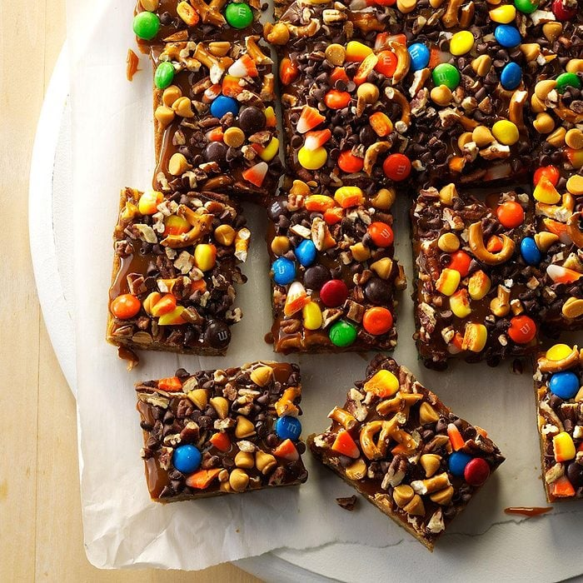

Crazy Halloween Blondies

Ingredients
- 1 cup butter, melted
- 2 cups packed brown sugar
- 2 large eggs, room temperature
- 2 teaspoons vanilla extract
- 2 cups all-purpose flour
- 1/2 teaspoon baking powder
- 1/4 teaspoon salt
- 1 cup chopped pecans, divided
- 2/3 cup milk chocolate M&M's, divided
- 2/3 cup chopped candy corn, divided
- 2/3 cup coarsely chopped miniature pretzels, divided
- 2/3 cup miniature semisweet chocolate chips, divided
- 2/3 cup butterscotch chips, divided
- 1 jar (12 ounces) hot caramel ice cream topping

Directions
- Preheat oven to 375°. Line a 13x9-in. baking pan with parchment, letting ends extend up sides; grease paper.
- In a large bowl, beat melted butter and brown sugar until blended. Beat in eggs and vanilla. In a large bowl, mix flour, baking powder and salt; gradually add to brown sugar mixture, mixing well. Stir in half the pecans, M&M's, candy corn, pretzels, chocolate chips and butterscotch chips.
- Spread into prepared pan. Bake 20-25 minutes or until a toothpick inserted in center comes out clean. Cool completely in pan on a wire rack.
- Spread caramel topping over bars; sprinkle with remaining pecans, M&M's, candy corn, pretzels, chocolate chips and butterscotch chips. Lifting with parchment, remove from pan. Cut into bars.

